FINAL MAJOR PROJECT REPORT
Multimodal AI Framework for OCR-Based Digitization and Intelligent Retrieval of Government Documents
Mid-Term / Final Major Project Development Report
B.Tech in Computer Science and Technology
Specialization in Artificial Intelligence & Machine Learning
The NorthCap University, Gurugram
Version 4.0
Academic Session: 2026

CERTIFICATE / APPROVAL
[Insert university-approved certificate and signatures.]

DECLARATION
This report documents the development of a multimodal AI framework for OCR-based digitization and intelligent retrieval of government documents. It explicitly distinguishes implemented capabilities, Phase-II/final development, proposed extensions, and features outside the project scope.

ACKNOWLEDGEMENT
The final acknowledgement will recognize the supervisor, department, institution, team members, and other contributors according to the university format.

ABSTRACT
Government departments publish large volumes of information through notifications, schemes, reports, circulars, guidelines, forms, policy documents, and administrative records. Finding a precise answer in these documents can be difficult because documents may be lengthy, heterogeneous, multilingual, inconsistently formatted, or partly scanned. Conventional keyword search can also miss relevant passages when the wording of a question differs from the wording of the source.
This project proposes a multimodal AI framework for OCR-based digitization and intelligent retrieval of government documents. The framework combines document ingestion, text extraction, OCR, preprocessing, language detection, chunking, embedding generation, vector storage, semantic retrieval, context building, prompt construction, structured workflow orchestration, and large language model based response generation. ChromaDB forms the current vector-store foundation; LangChain and LangGraph are used as the target structured workflow layer; and Gemini is the selected LLM interface. Document and page metadata are retained for source traceability.
The project follows two phases. Phase I establishes the RAG foundation, including the Flask application, administrative upload workflow, preprocessing, embeddings, ChromaDB storage/retrieval, user querying, and preliminary testing. Phase II extends the system toward broader OCR and multimodal understanding, improved retrieval and workflow orchestration, and within-session conversational querying. Cross-session persistent conversational memory is explicitly outside scope. Basic session context may be maintained through session/workflow state; semantic retrieval of older conversation turns through a separate conversation-history store is an optional advanced extension.
The intended result is an extensible government-document intelligence platform that retrieves relevant evidence and generates grounded answers while retaining source/page traceability.

TABLE OF CONTENTS
[Update automatic Word TOC after final pagination in Microsoft Word.]

LIST OF FIGURES
Proposed System Architecture
Multilingual and Multimodal Processing Flow
End-to-End Processing Pipeline
Mini VLM Visual Understanding Flow
Two-Phase Project Scope
Administrative Document Ingestion Workflow
User Query, Session Context and Retrieval Workflow
Use Case Diagram
Data Flow Diagram
Sequence / Activity Diagram
Project Gantt Chart

LIST OF TABLES
Project Objectives
Literature Comparison
Research Gap Mapping
Technology Stack
Functional Requirements
Non-Functional Requirements
Preliminary Test Cases
Scope Classification

ABBREVIATIONS
Abbreviation | Meaning
AI | Artificial Intelligence
ML | Machine Learning
NLP | Natural Language Processing
OCR | Optical Character Recognition
RAG | Retrieval-Augmented Generation
LLM | Large Language Model
GUI | Graphical User Interface
API | Application Programming Interface
PDF | Portable Document Format
PoC | Proof of Concept
VLM | Vision-Language Model

CHAPTER 1 — INTRODUCTION

1.1 Background
Government documents are an important source of public information. Notifications, schemes, circulars, policy documents, departmental reports, forms and guidelines may contain eligibility rules, deadlines, required documents and procedures. The challenge is not merely accessing these files but locating the correct information efficiently and reliably.
Documents may contain ordinary text, scanned pages, tables, figures, headers and other visual structures. OCR can convert image-based text into machine-readable text, while multimodal processing can be used when understanding depends on visual or layout information. The framework also supports multilingual interaction, allowing users to submit questions in supported languages and receive responses in the same language where supported by the underlying models.

1.2 Project Domain
The project combines document intelligence, OCR, NLP, semantic information retrieval, vector databases, retrieval-augmented generation, workflow orchestration and multimodal AI, with government-document retrieval as the application domain.

1.3 Motivation
The motivation is to reduce the effort required to locate and understand information in lengthy government documents through natural-language questioning, multilingual interaction, evidence retrieval, visual understanding and traceable answer generation.

1.4 Problem Domain and Challenges
- Long and heterogeneous documents require substantial manual inspection.
- Scanned pages may not contain a searchable text layer.
- Relevant information may be distributed across pages or sections.
- Users may use wording different from the source document.
- Multilingual content adds language-processing considerations.
- LLM-only answers can be unsupported without retrieved evidence.
- Users need source/page information to verify answers.

1.5 Illustrative Example
Suppose a 60-page scheme notification states that applicants with annual household income below a specified amount are eligible. A user asks, “What is the income limit for beneficiaries?” The system should retrieve the relevant passage even if the exact phrase “income limit” does not occur in the document, then generate an answer tied to the supporting page.

1.6 Need and Significance
The framework provides an intelligent retrieval layer over official documents. It is academically significant because it integrates OCR, embeddings, vector retrieval, RAG, structured workflows and multimodal extensions in one application.

1.7 Report Organization
The report moves from problem analysis and literature review to gaps, objectives, solution, scope, architecture, pipeline, technology selection, requirements, feasibility, development, implementation, testing, limitations, future scope and conclusion.

CHAPTER 2 — PROBLEM STATEMENT AND DETAILED ANALYSIS

2.1 Existing Scenario
Government information is commonly accessed through websites, PDF search, web search or manual reading. These methods are useful for locating sources but do not necessarily provide semantic question answering over a document collection.

2.2 Detailed Problem Analysis
The problem has four connected layers: document understanding, knowledge representation, retrieval, and grounded generation. Documents must first be converted into usable content; content must then be cleaned, chunked and embedded; queries must retrieve relevant chunks; and the LLM must generate from that evidence.

2.3 Retrieval Example
Source: “Applicants belonging to households with annual income below ₹3 lakh are eligible.” Query: “What is the income limit for beneficiaries?” Semantic retrieval is intended to connect the two because their meanings are related even though the wording differs.

2.4 Limitations of Conventional Approaches
- Exact keyword matching may miss semantically related wording.
- Manual inspection does not scale well.
- Text-only extraction does not solve scanned content.
- LLM-only generation can produce unsupported information.
- Lack of metadata makes answers harder to verify.

2.5 Problem Statement
To develop a multimodal AI framework that digitizes and processes heterogeneous government documents using text extraction and OCR, constructs searchable semantic representations, supports multilingual natural-language queries, uses visual-language understanding for relevant document content, retrieves evidence, generates grounded responses through a structured RAG workflow, provides document/page traceability, and supports within-session conversational querying.

CHAPTER 3 — EXISTING SYSTEMS AND LITERATURE SURVEY

3.1 Existing Approaches
Relevant approaches include conventional document search, OCR, semantic retrieval, vector databases, RAG, layout-aware document models and multimodal document understanding. Each addresses part of the problem; the proposed project integrates these capabilities for government documents.

3.2 Literature Survey
Lewis et al. established Retrieval-Augmented Generation as a framework combining retrieval with generation for knowledge-intensive tasks. This provides the conceptual foundation for retrieving external evidence before generation.
OCR research addresses conversion of text appearing in images into machine-readable representations, which is important for scanned government records.
Layout-aware work such as LayoutLMv3 demonstrates that document understanding can benefit from text, visual and layout information, motivating the project's multimodal extension.
Evidence-grounded generation research motivates connecting generated content to supporting evidence, while multilingual and recent retrieval research motivates attention to language variation and retrieval quality.

3.3 Literature Comparison
Work / Area | Contribution | Project Relevance
Lewis et al. (2020), RAG | Retrieval + generation | Core RAG design
Islam et al. (2017), OCR survey | OCR methods/challenges | Scanned-document digitization
LayoutLMv3 (2022) | Text/image/layout representation | Multimodal extension
Evidence-grounded generation | Generation linked to evidence | Grounding/traceability
Multilingual RAG research | Cross-language retrieval/generation | Multilingual content
Recent retrieval-feedback research | Improved retrieval feedback | Future retrieval improvement

3.4 Literature-to-Project Example
OCR alone converts a scanned page into text but does not answer a semantic question. A vector store can retrieve relevant chunks but does not generate the final answer. RAG connects retrieval with generation, while metadata preserves the link to the source. This illustrates why the proposed system requires multiple coordinated components.

3.5 Summary
The literature supports the project's use of OCR, semantic retrieval, RAG, layout/multimodal understanding, evidence grounding, language-aware processing and multilingual retrieval/generation. The project extends these ideas through a Mini VLM for visual-language understanding of relevant document content.

CHAPTER 4 — RESEARCH GAPS

4.1 Gaps Identified
- Text-centric retrieval does not fully address image-based content.
- Keyword matching does not fully represent semantic similarity.
- RAG quality depends on relevant retrieved evidence.
- Multilingual documents need appropriate language-aware processing.
- Source/page traceability is important for verification.
- Follow-up questions require conversational context.

4.2 Gap Mapping
Gap | Project Response | Phase
Image-based text | OCR | II
Semantic mismatch | Embeddings + retrieval | I
Unsupported generation | Retrieved evidence + RAG | I
Weak traceability | Document/page metadata | I/refinement
Follow-up questions | Within-session state/context | II
Long conversation history | Optional semantic history retrieval | Advanced II
Cross-session persistence | Excluded | Out of scope

4.3 Conversational Scope
The project limits conversational memory to the active session in Phase II. A later session does not automatically receive earlier conversation history. This boundary reduces persistence and privacy complexity while retaining the useful capability of contextual follow-up questions.

CHAPTER 5 — TOPIC SELECTION, OBJECTIVES AND PROJECT RELEVANCE

5.1 Topic Selection
The topic was selected because government documents provide a realistic setting for document processing, OCR, NLP, semantic retrieval, RAG and multimodal AI.

5.2 Research Objectives
- Study government-document retrieval, OCR, RAG and multimodal approaches.
- Identify relevant technical and research gaps.
- Design an architecture combining digitization, semantic retrieval and grounded generation.
- Investigate OCR and visual information as extensions to text RAG.
- Study source/page traceability.
- Investigate within-session conversational context in Phase II.

5.3 Project Objectives
- Develop administrative document upload and processing.
- Clean, detect language where required, and chunk content.
- Generate embeddings and store chunks with metadata in ChromaDB.
- Support semantic user queries.
- Build retrieval context and prompts.
- Generate structured application responses.
- Extend to OCR and multimodal processing.
- Support same-session follow-up questions in Phase II.
- Evaluate functional, retrieval and grounding behavior.

5.4 Example Objective Mapping
Objective | Feature
Semantic retrieval | Query embedding + ChromaDB
Grounded generation | Retrieved context + Gemini
Traceability | Document/page metadata
OCR | Scanned-page digitization
Conversation | Active-session context

CHAPTER 6 — PROPOSED SOLUTION

6.1 Solution Overview
The proposed solution is a multimodal, multilingual government-document RAG framework. The system accepts government documents through an administrative interface, processes textual and visual content using extraction, OCR and Mini VLM based visual-language understanding, stores semantic representations in a vector database, and retrieves relevant evidence for user questions. The query-processing path supports supported user languages, while the generation stage is instructed to produce the final answer in the language of the user's query where supported.
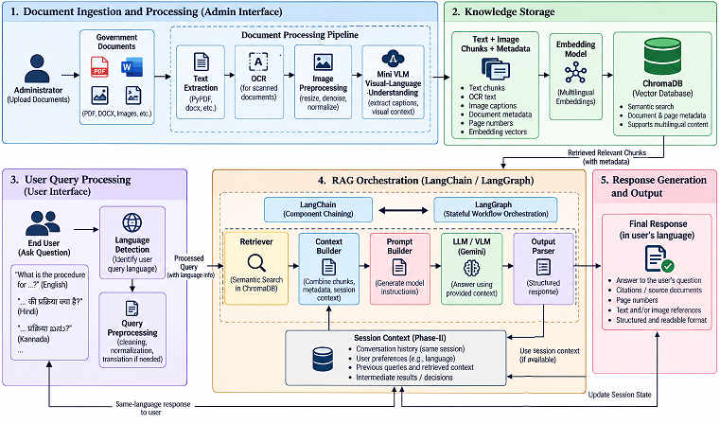
Figure 1. Proposed System Architecture

6.2 Document Ingestion and OCR
The administrative path accepts a document, extracts available text and applies OCR where pages are image-based. Image preprocessing may be used to improve OCR input.
Example: A scanned notification contains “Applicants must submit an income certificate.” OCR converts the visible characters into machine-readable text, after which the text can be cleaned, chunked, embedded and retrieved.
6.3A Mini Vision-Language Model (Mini VLM)
A Mini Vision-Language Model is used for visual-language understanding of relevant document content. OCR primarily converts visible text into machine-readable text, whereas the Mini VLM can interpret visual content together with textual and contextual information. This is useful for visually rich pages containing tables, forms, layout-dependent information, figures or relationships that may not be adequately represented by plain extracted text. The Mini VLM also contributes to multilingual visual-language processing to the extent supported by the selected model.

6.4 Cleaning, Language Detection and Chunking
Cleaning reduces extraction noise. Language detection can identify the language where multilingual processing is needed. Chunking converts long documents into smaller retrieval units. Example: a 50-page notification may produce chunks for eligibility, required documents, application procedure and other sections.
6.4A Multilingual Query and Response Processing
The system supports multilingual interaction for languages supported by the underlying language and vision-language models. A user may submit a question in a supported language. The query language is identified or handled by the language-processing layer, semantic retrieval is performed against the document representations, and the generation stage produces the answer in the same language as the user's query where supported. This capability is intended to improve accessibility for users who prefer languages other than English.

6.5 Embeddings and Vector Storage
Embeddings convert each processed document chunk into a dense numerical vector that captures its semantic meaning. After text extraction/OCR and preprocessing, the document is divided into smaller chunks, and each chunk is passed through the selected multilingual embedding model.
If a document contains chunks C1,C2,…,Cn the embedding model transforms them into vectors:
Ci→E(Ci) =vi
where vi is the embedding vector and d represents the fixed embedding dimension.
The same embedding model is also applied to the user's query:
Q→E(Q)=vq
At query time, the query vector is compared with the stored document vectors using a semantic similarity measure such as cosine similarity. The system then retrieves the Top-K most relevant document chunks rather than relying only on exact keyword matching.
ChromaDB is used as the persistent vector store. Along with each embedding, the corresponding document text and metadata are maintained. Metadata such as document_id, file_name, page_number, chunk_id, section/title and language enables the system to trace retrieved information back to its original document and page.
The retrieved chunks and metadata are subsequently passed to the Context Builder and Prompt Builder, where they become the evidence used by the downstream RAG generation pipeline.
Indexing stage:
Document → Chunking → Embedding Model → Vector → ChromaDB + Metadata
Retrieval stage:
User Query → Query Embedding → Similarity Search → Top-K Chunks → RAG Pipeline

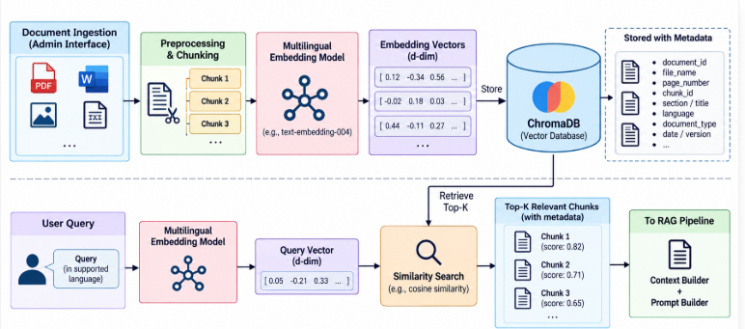
Figure 6.5: Embeddings and Vector Storage using ChromaDB

6.6 Semantic Retrieval
During retrieval, the user query is transformed into a query embedding using the same embedding model used for document chunks. The resulting query vector is compared with the vectors stored in ChromaDB using a semantic similarity measure such as cosine similarity. Based on the similarity scores, the Top-K most relevant document chunks are retrieved along with their associated metadata. These retrieved chunks are then passed to the Context Builder for incorporation into the RAG generation pipeline, refer the above diagram.

6.7 Context Building
The context builder assembles the evidence package supplied to the generation stage. It combines the current user query, relevant document chunks retrieved from the vector store, document and page metadata, and, where applicable, information obtained through OCR and Mini Vision-Language Model (Mini VLM) processing. For conversational queries, relevant same-session context may also be included. In multilingual interaction, the context builder preserves the semantic information required for generating a response in the language of the user's query.
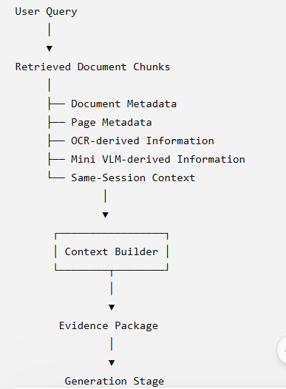
Figure 6.7: Context Building Pipeline

6.8 Prompt Building

The prompt builder converts the user query and assembled evidence into structured model instructions. The prompt can instruct the model to answer only from the supplied context, avoid unsupported claims, preserve source and page information, and generate the response in the same language as the user's query where supported.
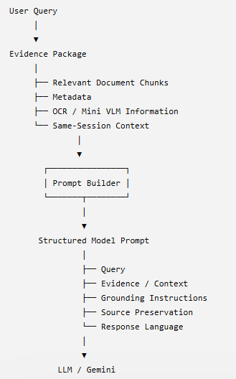
Figure 6.8: Prompt Building Pipeline

6.9 LangChain / LangGraph
LangChain is used to organize the core components of the proposed RAG pipeline into a structured sequence. It can connect the retriever, context builder, prompt builder, LLM/VLM interface, and output parser so that the output of one component can be passed to the next component. In this project, LangChain therefore acts mainly as the component/chaining layer for retrieval and response generation.
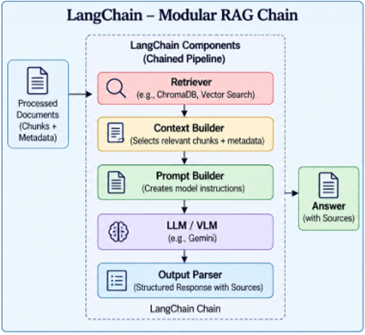
Figure 6.9.1: LangChain Components in the RAG Pipeline
LangGraph extends this approach by representing the application as a stateful workflow. Instead of only following a fixed sequence, the workflow can maintain information about the current conversation session and decide which step should be executed next. For example, a user query can be analysed first, followed by a decision on whether OCR/Mini VLM processing is required. The workflow can then perform retrieval and response generation and update the session state for the next turn.
LangGraph is particularly relevant to Phase-II, where same-session conversational context and more complex multi-step interactions are considered. Thus, LangChain mainly structures the individual RAG components, whereas LangGraph manages the overall flow, state and conditional transitions between these components.
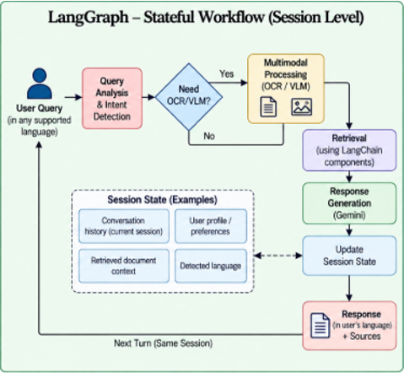
Figure 6.9.2: LangGraph Stateful Workflow for Session-Level Orchestration

6.10 Gemini and Structured Response Building
Gemini generates the answer from the constructed prompt. A structured response builder then formats the model result into a predictable application structure.
Example: {"answer":"Applicants must submit an income certificate.","sources":[{"document":"Scheme_Notification.pdf","page":7}]}
The Flask interface can display the answer separately from its source information.

6.11 Source/Page Traceability
Chunk-level metadata connects retrieved evidence to the original document and page. This allows the application to identify supporting source material.
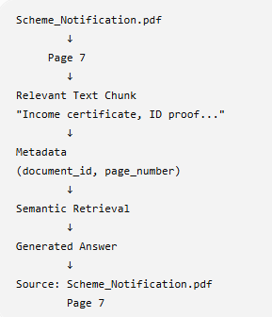

6.12 Within-Session Conversational Context
The proposed system maintains relevant conversational exchanges within the active user session so that follow-up queries can be interpreted using previous interactions. Conversation turns can be temporarily represented as embeddings and stored in a conversation-memory vector store along with session-related metadata.
When a follow-up query is received, the system first performs semantic similarity retrieval over the conversation-memory store to identify relevant previous exchanges. The retrieved conversational context is then used to resolve references such as “they,” “it,” “this scheme,” or “those documents.” Based on this resolved context, the system formulates a context-aware query.
The context-aware query is subsequently used to perform semantic retrieval from the main government-document vector database. The retrieved document chunks provide the authoritative evidence for response generation. Therefore, the conversation-memory store supports context understanding, while the government-document vector database provides the knowledge and evidence for the final grounded response.
Example:
Turn 1: User: “What is the eligibility for the scheme?”
System: “Applicants with annual household income below ₹3 lakh are eligible.”
The interaction is temporarily stored in the conversation-memory vector store.
Turn 2: User: “What documents do they need?”
The system retrieves the relevant Turn 1 information from the conversation-memory store and resolves “they” to “eligible applicants.” It can consequently formulate a context-aware query such as:
“What documents are required for eligible applicants of the scheme?”
This query is then used to retrieve relevant evidence from the government-document vector database before generating the final response.
Conceptual Pipeline
. 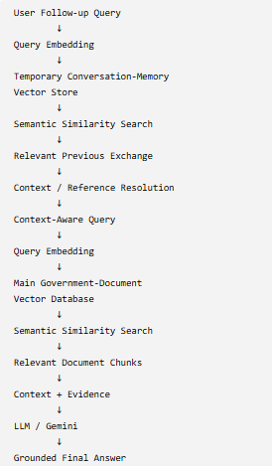

6.13 Cross-Session Boundary
Cross-session persistent conversational memory is outside scope. Ending one session does not cause a later session to automatically receive its history. An advanced future system could store selected conversation turns separately and retrieve them semantically, but this is optional and not required for the current project.

6.14 Expected Outcomes
- Integrated RAG foundation.
- Semantic document retrieval.
- Grounded answers with source/page traceability.
- OCR and multimodal extension.
- Within-session contextual follow-up querying in Phase II.

CHAPTER 7 — PROJECT SCOPE AND PHASED DEVELOPMENT

7.1 Overall Scope
The project covers intelligent retrieval from government documents using a multimodal and multilingual RAG framework incorporating OCR, Mini VLM based visual understanding, multilingual user interaction and within-session conversational context.

7.2 Phase I — Mid-Term
- Problem and literature analysis.
- Gap identification and objectives.
- Architecture and pipeline design.
- Technology selection.
- Document ingestion and preprocessing.
- Chunking, embeddings, ChromaDB storage/retrieval.
- Flask admin and user workflows.
- Initial RAG generation.
- Duplicate-document detection.
- Preliminary testing.

7.3 Phase II — Final Project
- Broader OCR integration.
- Visual/multimodal document processing.
- Improved retrieval and context construction.
- LangChain/LangGraph workflow integration.
- Within-session conversational context and follow-up questions.
- End-to-end integration.
- Comprehensive retrieval/grounding evaluation.
- Performance analysis and refinement.

7.4 Advanced Optional Extension
For long conversations, selected turns could be embedded into a dedicated conversation-history store for semantic retrieval. This is an optional advanced Phase-II/future extension and is separate from the government-document vector store.

7.5 Explicitly Out of Scope
- Persistent cross-session user conversation memory.
- Automatic recall of previous sessions.
- Permanent personal profiles derived from conversations.
- Replacing official government sources.

7.6 Scope Classification
Capability | Scope
Core RAG | Phase I
Document retrieval | Phase I
Context/prompt building | Phase I/refinement
Structured response | Phase I/refinement
OCR | Phase II
Multimodal understanding | Phase II
Within-session memory | Phase II
Semantic conversation history | Advanced II
Cross-session memory | Out of scope
Multilingual query interaction | Phase II / Final
Same-language response | Phase II / Final
Mini VLM visual understanding | Phase II / Final
[ SPACE RESERVED FOR FIGURE 2 ]
Figure 2. Two-Phase Project Scope
Show Phase I, Phase II, and a clearly excluded cross-session-memory boundary.

CHAPTER 8 — SYSTEM ARCHITECTURE

8.1 Overall Architecture
The architecture separates persistent document knowledge from temporary conversational context while integrating multilingual and multimodal processing. The document path prepares text/OCR/VLM-derived information, embeddings and metadata for ChromaDB. The user path handles supported-language queries, retrieves document evidence, and uses active-session context to interpret follow-up questions.
[ SPACE RESERVED FOR FIGURE 3 ]
Figure 3. Overall Proposed System Architecture
Use the final architecture showing ADMIN ingestion, text extraction/OCR, Mini VLM, language processing, embeddings, ChromaDB, USER query path, Session Context, Context Builder, Prompt Builder, LangChain/LangGraph, Gemini, same-language response generation, Structured Response Builder and Traceability.

8.2 Document-Knowledge Layer
Government documents are processed into chunks and embeddings stored with metadata. This layer represents searchable document knowledge.

8.3 User-Query Layer
The user-query layer processes a question, performs retrieval, constructs evidence context, builds the prompt, invokes the workflow and LLM, and formats the final response.

8.4 Session-Context Layer
Phase II maintains relevant previous turns within the active session. This state helps contextualize follow-up questions but is not persistent across sessions.

8.5 Context, Prompt and Response Layers
Context Builder assembles evidence; Prompt Builder creates model input; Gemini generates content; Structured Response Builder organizes the result for the Flask application. Keeping these stages separate improves debugging and evaluation.

8.6 Architecture Rationale
Separating ingestion from querying avoids reprocessing documents for each question. Separating document knowledge from session context avoids conflating persistent corpus information with temporary conversation state.

CHAPTER 9 — END-TO-END PROJECT PIPELINE

9.1 Exact Proposed Pipeline
The pipeline deliberately keeps every major processing stage visible rather than compressing several operations into one box.
[ SPACE RESERVED FOR FIGURE 4 ]
Figure 4. End-to-End Processing Pipeline
Insert the exact finalized pipeline figure manually.

9.2 Phase-I Pipeline
Government Documents → Document Ingestion → Text Extraction/OCR → Image Preprocessing/Mini VLM where required → Cleaning/Language Detection/Chunking → Multilingual Embeddings → ChromaDB → User Query → Query Language Handling → Query Embedding/Retrieval → Relevant Context → Context Builder → Prompt Builder → LangChain/LangGraph → Gemini → Same-Language Answer + Source/Page Traceability.

9.3 Phase-II Extended Pipeline
User Query in a Supported Language → Language Detection/Handling → Session Context → Contextualized Query → Semantic Retrieval → Relevant Text/OCR/VLM-derived Evidence → Context Builder → Prompt Builder → LangChain/LangGraph → Gemini → Same-Language Response → Structured Response Builder → Answer + Source/Page Traceability.
[ SPACE RESERVED FOR FIGURE 5 ]
Figure 5. User Query, Session Context and Retrieval Workflow
Insert manually generated figure here.

9.4 Administrative Example
An administrator uploads Scheme_Notification.pdf. The application checks the document identifier. If it is new, content is processed, chunked, embedded and stored with page metadata. If it already exists, duplicate handling can skip unnecessary reprocessing.
[ SPACE RESERVED FOR FIGURE 6 ]
Figure 6. Administrative Document Ingestion Workflow
Insert manually generated figure here.

9.5 Query Example
A user asks “What documents are required for the scheme?” Relevant chunks are retrieved, assembled into context, placed into a prompt, passed through the workflow to Gemini, and returned as a structured answer with supporting source/page information.

9.6 Conversational Example
Turn 1: “What is the eligibility for the scheme?” Turn 2: “What documents do they need?” Phase-II session context helps resolve “they”; document retrieval remains the evidence source.

9.7 Response Construction
The structured response may contain an answer field and source objects. The GUI can render the answer and source/page information separately.

CHAPTER 10 — TECHNOLOGY STACK AND SELECTION RATIONALE
Technology | Role | Scope
Python 3.12.6 | Primary language | Current
Flask | Web application | Current
PyPDF/loaders | Extraction | Current
OpenCV | Image preprocessing | Current/extension
OCR engine | Image-to-text | Phase II / Final
Embedding model | Semantic representation | Current
ChromaDB | Vector storage/retrieval | Current
LangChain | RAG components | Target/Phase II
LangGraph | Stateful workflow | Target/Phase II
Google Gemini | LLM generation | Current/target
Git/GitHub | Version control | Current
Mini VLM | Visual-language understanding of document content | Phase II / Final
Language-processing component | Language detection and multilingual query/response handling | Phase II / Final

10.1 Selection Rationale
Python provides an integrated ecosystem for document processing, NLP, OCR, embeddings and web development. Flask provides a lightweight application layer. ChromaDB supports persistent vector retrieval and metadata. LangChain/LangGraph provide structured workflow capabilities. Gemini provides the selected LLM interface.

10.2 Example Technology Flow
Flask receives a query → query processing → embedding model → ChromaDB retrieval → Context Builder → Prompt Builder → LangChain/LangGraph → Gemini → Structured Response Builder → Flask display.

CHAPTER 11 — SYSTEM REQUIREMENTS AND DESIGN

11.1 Functional Requirements
ID | Requirement
FR-01 | Admin uploads supported government documents.
FR-02 | Duplicate documents are detected.
FR-03 | Content is extracted and preprocessed.
FR-04 | Chunks and embeddings are generated.
FR-05 | Chunks retain document/page metadata.
FR-06 | Users submit natural-language queries.
FR-07 | Relevant evidence is retrieved.
FR-08 | Context and prompt are constructed.
FR-09 | LLM generates an answer.
FR-10 | Source/page traceability is returned.
FR-11 | Phase II supports within-session follow-up.
FR-12 | Phase II supports OCR/visual content.
FR-13 | The system accepts user queries in supported languages.
FR-14 | The system identifies or handles the language of the user query.
FR-15 | The system generates the final response in the same language as the user query where supported.
FR-16 | The system uses Mini VLM based visual-language understanding for relevant visually rich document content.

11.2 Non-Functional Requirements
Category | Requirement
Accuracy | Retrieved evidence and answers should be relevant.
Grounding | Answers should use supplied evidence.
Traceability | Source/page information should be retained.
Maintainability | Modules remain separated by responsibility.
Scalability | Additional documents can be indexed.
Usability | Admin and user workflows are understandable.
Reliability | API/processing failures are handled.
Session Isolation | Conversation context remains within active session.

11.3 User Roles
- Administrator: uploads/processes documents and views stored-document information.
- User: submits questions in supported languages and receives retrieval-grounded answers in the query language where supported.
[ SPACE RESERVED FOR FIGURE 7 ]
Figure 7. Use Case Diagram
Insert manually generated figure here.
[ SPACE RESERVED FOR FIGURE 8 ]
Figure 8. Data Flow Diagram
Insert manually generated figure here.
[ SPACE RESERVED FOR FIGURE 9 ]
Figure 9. Sequence / Activity Diagram
Insert manually generated figure here.

11.4 Data and Metadata Design
Representative metadata can include document_id, document_name, page_number, chunk_id and processing information. This metadata reconnects a retrieved chunk to its source.

11.5 Session-State Design — Phase II
Active session state may contain recent messages, current query, contextualized query, retrieved chunks, generated answer and source metadata. It is not automatically carried into another session.

11.6 Advanced Conversation Store
A separate conversation-history store can be considered only when semantic retrieval of long conversation history is required. It represents conversation knowledge, not government-document knowledge.

CHAPTER 12 — TECHNICAL FEASIBILITY STUDY

12.1 Technical Feasibility
The project is technically feasible because established libraries, vector databases, vision-language models and APIs support its major components. The modular architecture permits independent development and testing of extraction, OCR, Mini VLM processing, language handling, embeddings, retrieval, context construction, generation, response formatting and GUI.

12.2 Session-Context Feasibility
Basic within-session context does not require a second document vector database. Session/workflow state can retain recent turns. A separate conversation-history vector store becomes useful only for advanced semantic retrieval over long conversations.

12.3 Overall Assessment
The phased design controls technical complexity while allowing incremental extension from the current RAG foundation toward multimodal and conversational capabilities.

CHAPTER 13 — DEVELOPMENT APPROACH

13.1 Methodology
Development follows an incremental approach: problem and literature foundation, architecture, technology selection, core processing, retrieval, application integration, preliminary validation, and Phase-II extension.

13.2 Module Development
- Validate document loaders.
- Implement cleaning, language detection and chunking.
- Generate embeddings and validate ChromaDB storage/retrieval.
- Implement query processing and context construction.
- Integrate prompt building and LLM generation.
- Integrate Flask admin/user workflows.
- Validate duplicate detection and stored-document display.
- Integrate OCR and Mini VLM based multimodal processing.
Validate multilingual query handling and same-language response generation.
- Introduce active-session conversational state.
- Perform end-to-end evaluation.

13.3 Example Incremental Test
First test upload/extraction; then inspect chunks in ChromaDB; then test retrieval; then test generation. This helps determine whether an incorrect answer originates from extraction, chunking, retrieval, context construction or generation.

13.4 Git/GitHub
Git provides version control and GitHub provides remote collaboration. The repository used for the project is named government-rag-assistant. Local government documents should remain outside source control where appropriate.

CHAPTER 14 — PROJECT PLANNING AND MANAGEMENT

14.1 Work Breakdown
- Problem/domain analysis
- Literature and gaps
- Problem statement/objectives
- Architecture/pipeline
- Technology selection
- RAG prototype
- GUI/admin workflow
- Phase-I testing
- OCR/multimodal expansion
- Session-context development
- Advanced retrieval/workflow
- End-to-end testing
- Final documentation

14.2 Gantt Chart
[ SPACE RESERVED FOR FIGURE 10 ]
Figure 10. Project Gantt Chart
Insert final Gantt chart using official project dates.

14.3 Responsibility Chart
Responsibilities should be assigned to actual team members. Integration, testing, documentation and final presentation should have clear ownership.

14.4 Current Progress
Current development includes the RAG foundation, Flask application, administrative processing, vector retrieval, duplicate detection, stored-document display, user-query workflow, OCR/multimodal processing, multilingual interaction, within-session conversational context and end-to-end integration. Cross-session persistent conversation memory remains outside scope.

CHAPTER 15 — IMPLEMENTATION / CURRENT DEVELOPMENT STATUS

15.1 Implementation Overview
The current implementation separates administrative document processing from user querying. Flask coordinates the interface while modules perform loading, preprocessing, chunking, embedding, storage, retrieval, prompt construction and generation.

15.2 Implemented Components
- Flask application and GUI routes.
- Administrative upload workflow.
- Document loaders/extraction.
- Cleaning and chunking.
- Embedding generation.
- Persistent ChromaDB storage/retrieval.
- Prompt/context construction.
- Gemini answer-generation interface.
- Duplicate document checking.
- Stored-document display.
- User-query workflow.
- Git/GitHub management.

15.3 Implementation Example
When a document is uploaded, it is saved to the configured directory and checked against stored document identifiers. A new document proceeds through processing and indexing; a duplicate can be skipped.

15.4 Current RAG Example
A user asks “What is the eligibility criterion?” The query is embedded, relevant chunks are retrieved from ChromaDB, evidence is supplied to generation, and the application can return an answer with source information.

15.5 Phase-II Pending Components
- Broader OCR.
- Visual/multimodal understanding.
- LangChain/LangGraph orchestration.
- Within-session conversational context.
- Optional semantic conversation-history retrieval.
- Comprehensive evaluation.

15.6 Evidence
Final submission should include screenshots of login, admin interface, upload, stored documents, query interface, retrieval, answer and source/page display.

CHAPTER 16 — TESTING AND PRELIMINARY RESULTS

16.1 Testing Strategy
Testing covers module, integration, workflow, retrieval, generation, multilingual interaction, OCR, multimodal understanding, conversational behavior and end-to-end behavior.

16.2 Preliminary Test Cases
ID | Scenario | Expected Result | Scope
TC-01 | Admin login | Admin workflow opens | I
TC-02 | Upload | Document is processed | I
TC-03 | Duplicate upload | Duplicate is detected | I
TC-04 | Storage | Chunks/embeddings stored | I
TC-05 | Semantic query | Relevant context retrieved | I
TC-06 | Generation | Contextual answer produced | I
TC-07 | Source/page | Supporting metadata retained | I/validate
TC-08 | Scanned document | OCR produces usable text | II
TC-09 | Follow-up query | Session context resolves follow-up | II
TC-10 | Cross-session isolation | Previous session not recalled | II/boundary
TC-11 | English query | Answer generated in English with supporting evidence | II/Final
TC-12 | Hindi query | Answer generated in Hindi with supporting evidence | II/Final
TC-13 | Other supported-language query | Answer generated in the corresponding supported language | II/Final
TC-14 | Visually rich document query | OCR/Mini VLM processing contributes relevant evidence | II/Final

16.3 Worked Conversational Test
Turn 1: “What is the eligibility for the scheme?” Turn 2: “What documents do they need?” Expected Phase-II behavior is that the second query uses active-session context and then retrieves evidence from the document corpus. An unrelated previous session should not be used.

16.4 Preliminary Results
The current development demonstrates the core RAG workflow with Flask and ChromaDB. Administrative processing includes duplicate detection, while the user workflow can retrieve relevant context and pass it to generation. Quantitative evaluation should be added after the final dataset and metrics are fixed.

16.5 Final Evaluation Plan
- Retrieval relevance.
- Answer grounding.
- Source/page correctness.
- OCR quality.
- Within-session follow-up accuracy.
- Failure-case analysis.

CHAPTER 17 — LIMITATIONS AND FUTURE SCOPE

17.1 Current Limitations
- OCR quality depends on scan and layout quality.
- Retrieval depends on chunking, embeddings and query formulation.
- LLM answers depend on retrieved evidence.
- External APIs can impose latency and usage limits.
- Multimodal processing is still Phase-II work.
- Within-session memory is planned; cross-session memory is excluded.

17.2 Future Scope
- Improved multilingual OCR.
- Visual understanding of tables/forms/layout.
- Multimodal embeddings and retrieval.
- Hybrid lexical + semantic retrieval.
- Reranking.
- Stateful LangGraph workflows.
- Semantic retrieval over long conversation history.
- Deployment optimization and monitoring.

17.3 Cross-Session Memory as Future Work
A future system requiring persistent conversations would need explicit storage, user/session identification, privacy controls, retention rules and semantic retrieval. These requirements are outside the current project boundary.

CHAPTER 18 — CONCLUSION

18.1 Summary
The project presents a multimodal and multilingual AI framework for OCR-based digitization and intelligent retrieval of government documents. Its foundation combines document processing, OCR, Mini VLM based visual-language understanding, multilingual query handling, embeddings, vector retrieval, context building, prompt construction, workflow orchestration, LLM generation, same-language response generation, structured response formatting and source/page traceability.

18.2 Problem–Gap–Solution
The problem is difficult retrieval from long, heterogeneous and potentially image-based documents. Identified gaps include exact-search limitations, text-only processing, unsupported generation, weak traceability and lack of contextual handling for follow-up questions. The proposed solution addresses these through semantic retrieval, OCR/multimodal extension, evidence-grounded generation, metadata and Phase-II session context.

18.3 Contribution
The contribution is an integrated framework that combines persistent document knowledge with temporary conversational context, multimodal document understanding and multilingual user interaction. It makes context building, prompt building, workflow orchestration, generation, same-language response handling and structured response processing explicit.

18.4 Final Conclusion
The final work establishes a practical multimodal and multilingual RAG framework for government-document intelligence. It combines OCR, Mini VLM based visual understanding, multilingual query/response handling, semantic retrieval, workflow orchestration, within-session conversational context and source/page traceability. Cross-session persistent memory remains outside scope.

REFERENCES
[1] P. Lewis et al., “Retrieval-Augmented Generation for Knowledge-Intensive NLP Tasks,” NeurIPS, 2020.
[2] R. Islam, S. Islam, and J. C. Park, “A Survey of Optical Character Recognition Techniques,” arXiv:1710.05703, 2017.
[3] Y. Huang et al., “LayoutLMv3: Pre-training for Document AI with Unified Text and Image Masking,” ACM Multimedia, 2022.
[4] Research on evidence-grounded/evidentiality-guided text generation, 2022.
[5] H. Fujitake, “LayoutLLM: Layout Instruction Tuning with a Large Language Model for Visually Rich Document Understanding,” 2024.
[6] Recent research on multilingual Retrieval-Augmented Generation, 2026.
[7] Recent research on retrieval/corpus feedback for language-model systems, 2026.
[8] Chroma documentation.
[9] LangChain documentation.
[10] LangGraph documentation.
[11] Google GenAI / Gemini documentation.
[12] Flask documentation.

ANNEXURES

Annexure I — Plagiarism Report
[Insert approved evidence/material here.]

Annexure II — Mentor / Guide Feedback
[Insert approved evidence/material here.]

Annexure III — GitHub Repository
[Insert approved evidence/material here.]

Annexure IV — Project Setup
[Insert approved evidence/material here.]

Annexure V — Implementation Screenshots
[Insert approved evidence/material here.]

Annexure VI — Additional Diagrams and Tables
[Insert approved evidence/material here.]

