Predictive Grid Failure Intelligence
Capstone Project : Pre-Submission Document
Domain 7 : Vaibhav Dave, Ashok Kumar, Ravin Somi, Rajani

1. Business Problem Understanding and Objective Formulation

Domain & Business Context
PowerGrid Utilities Corporation is a large-scale electricity transmission and distribution provider managing substations, transformers, transmission lines, and smart grid assets across multiple service territories. Rising urbanization, renewable integration, and climate volatility have increased the frequency of outages, equipment failures, and voltage instability events, leading to financial loss, regulatory scrutiny, and customer dissatisfaction. Critically, internal review shows many incidents were preceded by warning signals already present in maintenance, asset-monitoring, and weather systems - but not acted upon in time.

Business Problem
Grid operations are currently reactive: interventions happen after degradation or failure has already affected customers. Leadership wants to shift to a predictive grid management strategy that flags high-risk assets and conditions before failures occur.

Objectives
- Business Objective: Reduce unplanned outages and financial/regulatory exposure by proactively identifying high-risk grid assets for early intervention.
- Analytical Objective: Build a classification model that predicts grid_failure_flag using equipment health, maintenance, load, and weather features, and rank the key drivers of failure to guide maintenance prioritization.

2. Challenges and Constraints

Data Challenges (identified during EDA)
- Category inconsistency: asset_type contains case-variant duplicates (“Transformer”, “TRANSFORMER”, “transformer”) that must be standardized before analysis.
- Missing values: inspection_score and oil_quality_score are ~10% missing each, requiring imputation or missingness-pattern analysis.
- Duplicate records: 500 duplicate rows (~1%) need removal to avoid biasing the model.
- Non-predictive identifiers: asset_id, legacy_asset_code, grid_cluster_id, monitoring_batch_id, and administrative_reference appear to be legacy/administrative fields with near-zero correlation to failure and must be excluded or tested for leakage.
- Outliers: rainfall_mm, avg_outage_duration_minutes, and power_load_mw show meaningful outlier rates (2–3%) needing treatment.

Implementation & Adoption Constraints
- Model must be interpretable enough for maintenance engineers to trust and act on (favors SHAP-explainable tree models over black-box deep learning).
- False negatives (missed failures) are more costly than false positives, so evaluation metrics and thresholds must reflect this asymmetry.
- Field adoption requires integration into existing operational dashboards/workflows, not just a standalone model.
- Assumption: the 12-month operational snapshot in the dataset is representative of recurring seasonal and load patterns.

3. Background Study / Literature Review
Predictive maintenance in utility grids is a well-studied application of machine learning. Industry and academic work commonly follow these patterns relevant to this project:
- Condition-based monitoring: Utilities increasingly use sensor-derived health indices (oil quality, vibration, temperature) rather than fixed maintenance schedules - consistent with the equipment_health_score and oil_quality_score signals found to be the strongest failure predictors in our EDA.
- Tree-based ensembles for tabular grid data: Random Forest, XGBoost, and LightGBM are widely reported as top performers for outage/failure prediction on structured utility datasets, due to their ability to capture non-linear thresholds and feature interactions without heavy preprocessing.
- Weather-augmented risk models: Studies on storm-related outage prediction consistently show storm/weather indices as strong external predictors - matching our finding that storm_risk_index has the highest positive correlation (+0.26) with failure among environmental factors.
- Class imbalance handling: Many utility failure datasets are heavily imbalanced; this dataset is comparatively balanced (43% failure rate), simplifying model training but still warranting stratified validation.
Key takeaway for our approach: combine equipment-health and maintenance signals with weather risk indices in a tree-based ensemble, and use explainability tools (SHAP) to convert model output into actionable maintenance guidance - directly aligned with leadership's stated need for data-driven, proactive recommendations.

4. Proposed Methodology / Solution Approach
The proposed solution follows a six-stage pipeline from raw operational data to a deployed, monitorable risk-scoring system:

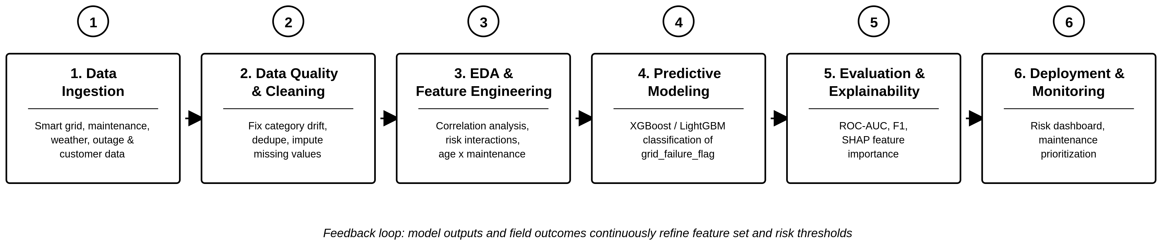

Solution Summary
Initial EDA on 50,500 asset records (32 features) confirms the target grid_failure_flag is well-balanced (43.0% failure rate), making it suitable for standard classification techniques. The strongest correlates of failure identified so far:
Feature | Correlation w/ Failure | Direction
equipment_health_score | -0.293 | Lower health -> higher failure risk
storm_risk_index | +0.259 | Higher storm risk -> higher failure risk
maintenance_overdue_days | +0.195 | More overdue days -> higher failure risk
inspection_score | -0.194 | Lower inspection score -> higher failure risk
voltage_fluctuation_pct | +0.189 | More fluctuation -> higher failure risk
oil_quality_score | -0.182 | Poorer oil quality -> higher failure risk
load_utilization_pct | +0.146 | Higher load -> higher failure risk

These findings directly inform feature engineering: composite risk scores combining equipment health with maintenance overdue days, and weather-load interaction terms, are expected to improve predictive power beyond individual features. Tree-based ensemble models (XGBoost/LightGBM) are proposed as primary candidates given their strength with mixed-type, interacting tabular features, with SHAP analysis used to produce maintenance-team-friendly explanations of each risk score.

5. Proposed Timeline
Week | Phase | Key Activities
1 | Data Understanding & Business Framing | Finalize objectives, confirm data dictionary, stakeholder alignment
2 | Data Cleaning & Quality Resolution | Fix category drift, dedupe, missing-value treatment, validation
3 | Exploratory Data Analysis | Univariate/bivariate analysis, correlation study, statistical testing
4 | Feature Engineering | Interaction features, risk scores, encoding, train/test split
5-6 | Model Development | Baseline + tree-based models, hyperparameter tuning, cross-validation
7 | Evaluation & Explainability | ROC-AUC/F1/Recall, SHAP analysis, threshold tuning for business cost
8 | Dashboard, Reporting & Final Presentation | Risk dashboard, business recommendations, documentation, delivery

6. Expected Deliverables / Outputs
Deliverable | Description
Data Quality & EDA Report | Documented cleaning steps, statistical findings, and visual insights
Predictive ML Model | Trained classifier predicting grid_failure_flag with documented performance metrics
Feature Importance / Explainability Report | SHAP-based ranking of failure drivers for engineering teams
Risk Dashboard / Visualization | Asset-level failure-risk view by region, asset type, and age
Business Recommendations Document | Prioritized, actionable steps for maintenance and operations teams
Final Presentation & Technical Documentation | Stakeholder-ready summary and reproducible technical writeup

