Vaibhav Shekhar Dave

Large Scale Parallel Data Processing

HW-2 Report

Git repo:

<https://github.ccs.neu.edu/vaibhavdave5/parallelDataProcessing/tree/master/SocialTraingle>

**Implementation:**

**Psuedo Code:**

1) Reduce-side Join with Max filter

Let the data set be key value pair for(userID, followerID) represenated by each row.

---------------------------------------------------------------------------------------------------------

Map1 for finding Single Path

**if**(userID) < ***maxFilter*** && follower <***maxFilter***){

{

emit( userID, “userid” - “follower”- “from”)

emit( followerID, “userid” - “follower”- “to”)

}

----------------------------------------------------------------------------------------------------------

Reducer1 for Path2 – Partitioned by keys

Collect all to-s and from in two different lists namely to and from.

As the key is same we the follower info for a particular user in from list

and the information about whom a particular user follows in to List.

**for** (Text fromEdge : from) {

**for** (Text toEdge : to) {

// from is a->b and toEdge is b->c

// So we want to emit a->c

context.write(**new** Text(toEdge.toString().split("-")[0]) , // a

**new** Text(fromEdge.toString().split("-")[1])); // c

}

}

---------------------------------------------------------------------------------------------------------

Map 2.1 – reiterates through the database to make a to List

**if**(userID) < ***maxFilter*** && follower <***maxFilter***){

for each record emit (follower+”-”+userID, “to”)

}

-----------------------------------------------------------------------------------------------------------

Map 2.2 – iterates through the reduce1 output to make a Path2List List

Let the output of reduce1 br in the format (a,b)

for each row

emit(a+”-”+b, from)

Final Reducer: Partitioned by keys

Takes input from output of Map2.1 and Map2.2

For every row

Calculate number of Tos and number of froms

So To.count > 0

There is path between that means we have completed the traingle

and add the number of fromCounts to the main count (global variable).

---------------------------------------------------------------------------------------------------------

2) Map-Side Join:

Map 1: Let the data set be key value pair for(userID, followerID) represenated by each row.

Setup() -

Iterate through all rows and make a HashMap <userId, List<FollwerID>>

For max filter

**if**(userID > *max* || followerID > *max*) {

// do nothing

}

else{

map.add(userID, List.add(FollowerID));

}

Map

Read each row from input: (userID, followerID)

**if**(userID > *max* || followerID > *max*) {

// do nothing

}

for each userid1 in row find userid1.followers(from map)

for each userid2 in userid1.followers find userid2.followers(from map)

if(userid2.followers.contains(userID)){  
 count++

}

Configuration :

Small Cluster (4 nodes) :

REP-join, MAX = 20000 – Number of triangles 1315197755 time = 58 min

RS-join, MAX = 10000 – Number of triangles 7234833 time = 15 min

Large Cluster (7 nodes) :

REP-join, MAX = 20000 – Number of triangles 1315197755 time = 33 min

RS-join, MAX = 10000 – Number of triangles 7234833 time = 8 min

Output from Twitter Replicated Join:

<https://github.ccs.neu.edu/vaibhavdave5/parallelDataProcessing/tree/d2dcb9748b38515cc183d80d00b00bfa47ca60f5/SocialTraingle/MR-Demo/output>

Output from RS Join:

<https://github.ccs.neu.edu/vaibhavdave5/parallelDataProcessing/tree/d375f9319bb62890a3ee8785998a37d38881022d/SocialTraingle/MR-Demo/output-Triangle>

Logs

Twitter Rep Join – Large Cluster

https://s3.amazonaws.com/aws-logs-577453344208-us-east-1/elasticmapreduce/j-2UTY17W9WITC2/hadoop-mapreduce/history/2019/02/10/000000/job_1549838415613_0001-1549838663252-hadoop-TwitterRepJoin-1549840651485-20-0-SUCCEEDED-default-1549838710824.jhist.gz

RSJoin job 1 - Large Cluster

https://s3.amazonaws.com/aws-logs-577453344208-us-east-1/elasticmapreduce/j-2UTY17W9WITC2/hadoop-mapreduce/history/2019/02/10/000000/job_1549838415613_0002-1549841029486-hadoop-RSJoin-1549841186902-20-11-SUCCEEDED-default-1549841035875.jhist.gz

RS-Join Complete - Large Cluster

https://s3.console.aws.amazon.com/s3/object/aws-logs-577453344208-us-east-1/elasticmapreduce/j-2UTY17W9WITC2/hadoop-mapreduce/history/2019/02/10/000000/job_1549838415613_0003-1549841188946-hadoop-RSJoin%252BComplete%252BTriangle-1549841504069-47-11-SUCCEEDED-default-1549841195587.jhist.gz?region=us-east-1&tab=overview

Twitter Rep join

https://s3.amazonaws.com/aws-logs-577453344208-us-east-1/elasticmapreduce/j-2OSS0JC20J2YS/hadoop-mapreduce/history/2019/02/10/000000/job_1549811928896_0011-1549818237189-hadoop-TwitterRepJoin-1549821689429-20-0-SUCCEEDED-default-1549818243398.jhist.gz

RS Join 1

https://s3.amazonaws.com/aws-logs-577453344208-us-east-1/elasticmapreduce/j-2OSS0JC20J2YS/hadoop-mapreduce/history/2019/02/10/000000/job_1549811928896_0002-1549812171266-hadoop-RSJoin-1549812429287-20-5-SUCCEEDED-default-1549812179685.jhist.gz

RS join Complete:

<https://s3.amazonaws.com/aws-logs-577453344208-us-east-1/elasticmapreduce/j-2OSS0JC20J2YS/hadoop-mapreduce/history/2019/02/10/000000/job_1549811928896_0003-1549812432231-hadoop-RSJoin%2BComplete%2BTriangle-1549813064651-44-5-SUCCEEDED-default-1549812438345.jhist.gz>

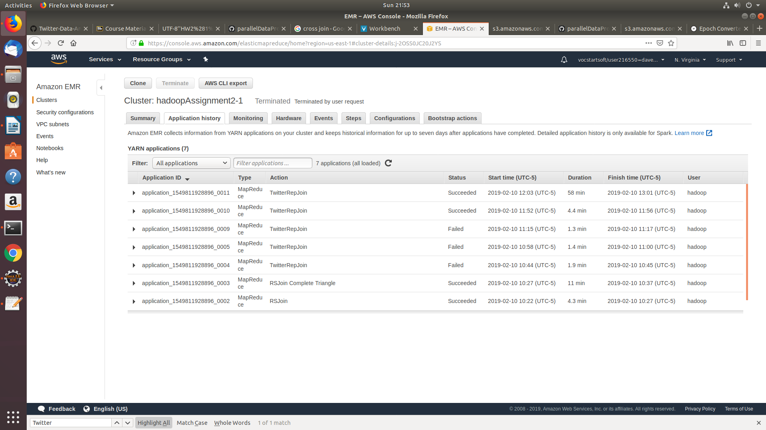

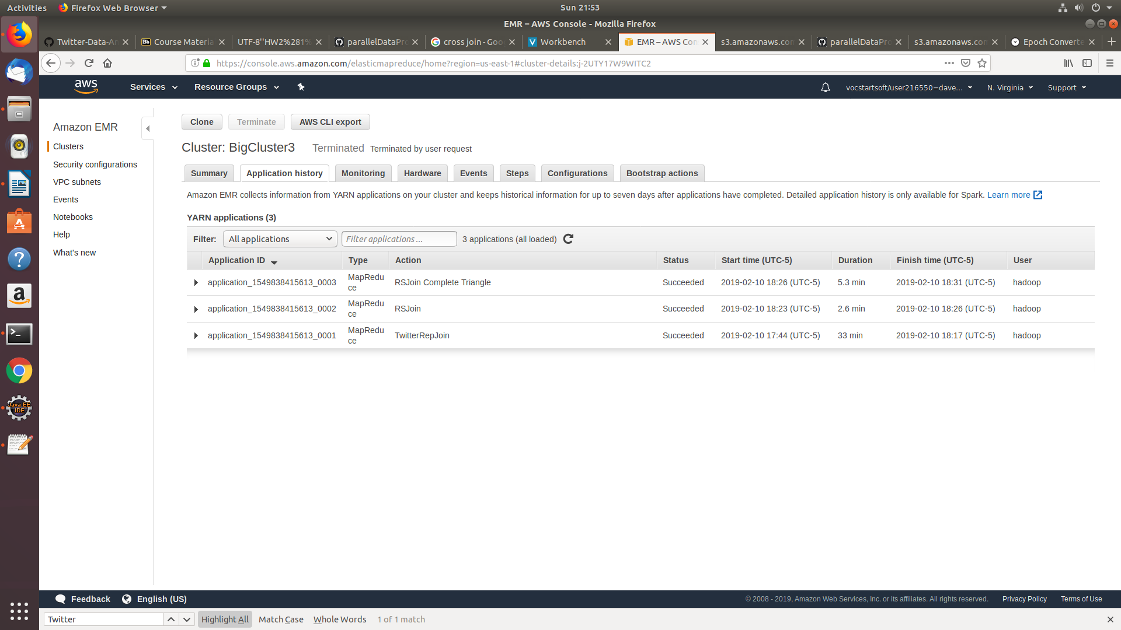

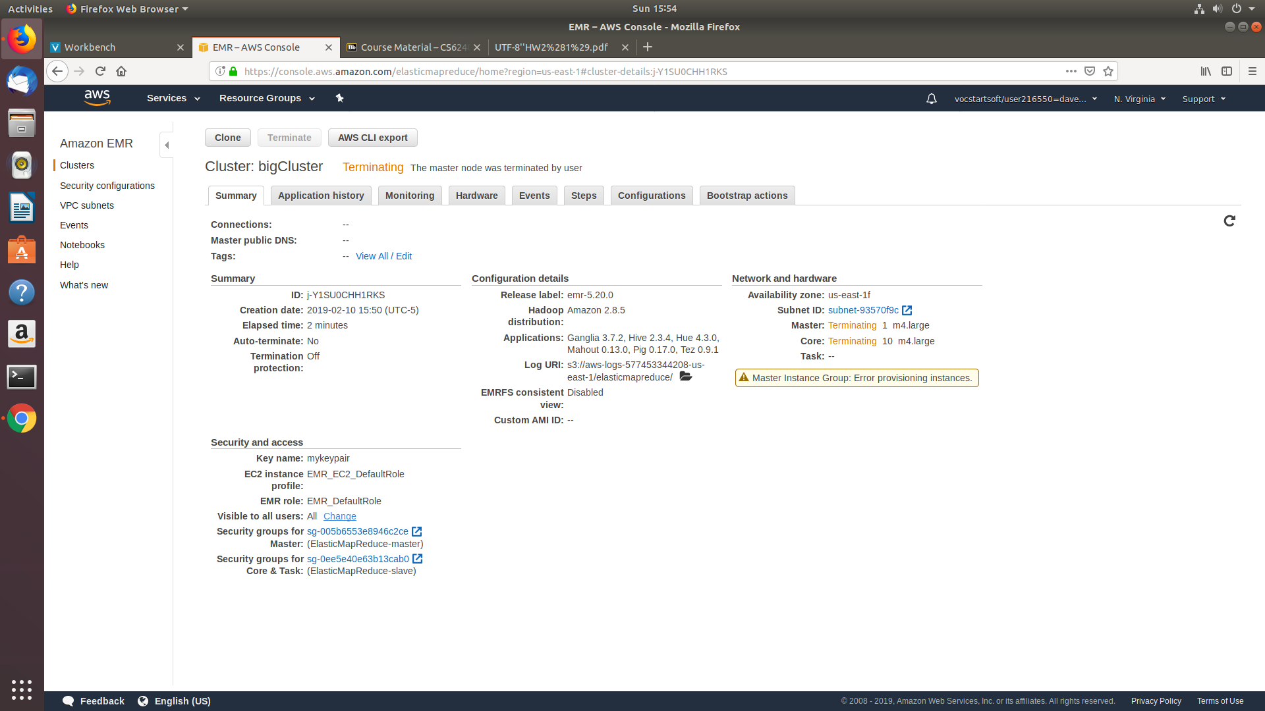

**Tried using 11 clusters but I got this error so my small cluster has 4 clusters and large has 7 clusters.**

**Analysis:**

Show the MapReduce pseudo-code for the program you used to determine the cardinality (and maybe data volume) of Path2. If you did not use a program, show the steps of the analysis you performed to estimate the number?

1. Psuedo Code

Mapper

Let each row of the record be (userid , followerID)

Emit(userid, from)

Emit(followid, to)

Reducer

Count the number of from c

Count the number of to d

Mul = c*d

Total count(global var) =+ mul

Implementation:

<https://github.ccs.neu.edu/vaibhavdave5/parallelDataProcessing/blob/master/SocialTraingle/MR-Demo/src/main/java/wc/Path2JoinRSCardinality.java>

2) Show the table with all 12 cardinality and all 12 volume estimates for the two join steps and RS-join vs. Rep-join. If you merge the two steps into one for one or both join types, state so clearly in the report. Then you only have to report the corresponding input/shuffle/file cache/output numbers for the merged program

|  |  |  |  |  |  |  |
| --- | --- | --- | --- | --- | --- | --- |
|  | RS Join input | RS join Shuffle | RS join Output | Rep Join input | Rep join File Cache | Rep join Output |
| Step 1 | Full input of Edges.csv  1319496574 bytes | 1356928  Bytes  88571  records | 1302114799  Bytes  4387766  records | 1319496574  bytes | 9130999808  bytes | 1315197755  bytes |
| Step 2 | 4387766  records  1302114799  Bytes | 26397 records  23200210944 | **201519176792**  **Records**  **Ran on whole edges.csv** | Merged step 1 and 2 | Merged step 1 and 2 | Merged step 1 and 2 |

1. For cardinality of Path2 I have the following code and output

Output: <https://github.ccs.neu.edu/vaibhavdave5/parallelDataProcessing/blob/915bb51456220b3d589d923521becd5b172cf214/SocialTraingle/MR-Demo/output/part-r-00000>

Code:

<https://github.ccs.neu.edu/vaibhavdave5/parallelDataProcessing/blob/915bb51456220b3d589d923521becd5b172cf214/SocialTraingle/MR-Demo/src/main/java/wc/Path2JoinRSCardinality.java>