Retail Sales Data Analytics & AI-Based Demand Forecasting
AICTE | IBM SkillsBuild — Data Analytics with AI Internship Program 2026
Organization: BharatCares | Duration: 17th August – 30th September 2026

1. Introduction
Retail businesses generate large volumes of transactional data every day. When analyzed effectively, this data can reveal sales trends, customer behavior patterns, and future demand — enabling smarter business decisions. This project applies data analytics and artificial intelligence (AI) techniques to a retail sales dataset to extract insights, forecast future sales, and segment customers by purchasing behavior.

2. Objectives
- Clean and preprocess raw retail transaction data.
- Perform Exploratory Data Analysis (EDA) to identify sales trends across time, category, and region.
- Build an AI/ML regression model to forecast sales demand.
- Apply unsupervised learning (KMeans clustering) to segment customers.
- Derive actionable business insights from the analysis.

3. Dataset Description
A retail transactions dataset (2,000+ records) was used, containing fields such as Order ID, Date, Product Category, Region, Payment Mode, Customer Age, Unit Price, Quantity, Discount Percentage, and Sales value. The dataset includes realistic seasonal sales patterns and category-driven demand signals, along with minor data quality issues (missing values, duplicates) that were addressed during preprocessing.

4. Methodology

4.1 Data Cleaning
Duplicate records were removed based on Order ID. Missing values in Customer Age and Discount Percentage were imputed using median and mean values respectively. Date fields were parsed to extract Month and Weekday features for time-based analysis.

4.2 Exploratory Data Analysis
EDA was performed to understand sales distribution across time, product category, and region, and to examine relationships between numeric variables using a correlation heatmap.

4.3 AI Model 1 — Sales Demand Forecasting
A Random Forest Regressor was trained to predict sales value using category, region, payment mode, customer age, unit price, quantity, discount, and month as input features. The dataset was split 80/20 into training and test sets.

4.4 AI Model 2 — Customer Segmentation
KMeans clustering (k=3) was applied on aggregated customer purchase metrics (total spend, average order value, order count) after standard scaling, to identify distinct customer segments for targeted marketing.

5. Exploratory Data Analysis — Results
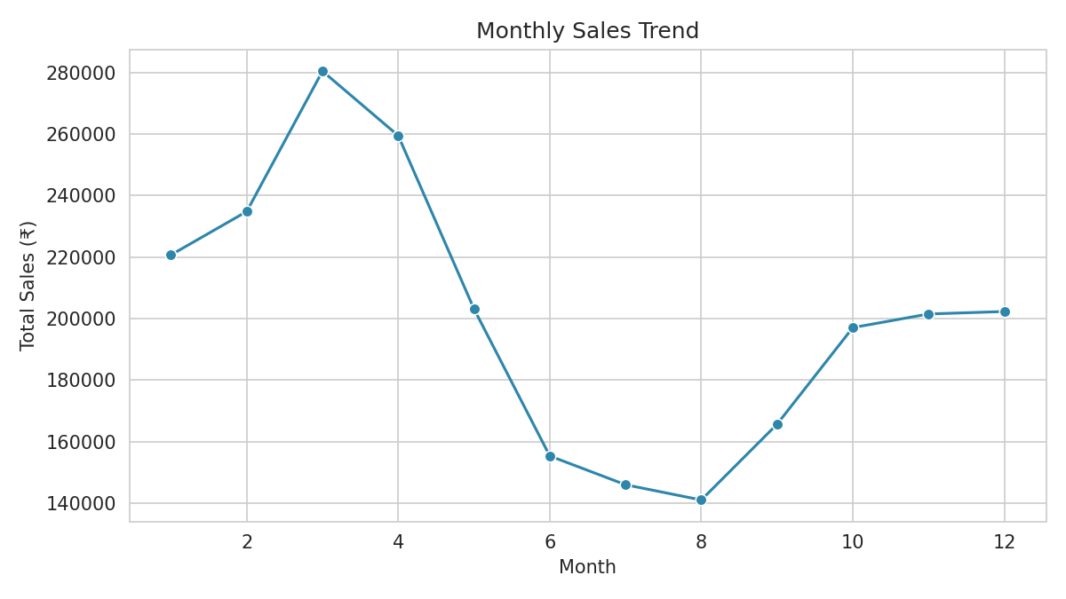
Figure 1: Monthly sales trend showing a strong seasonal peak in Oct–Dec.
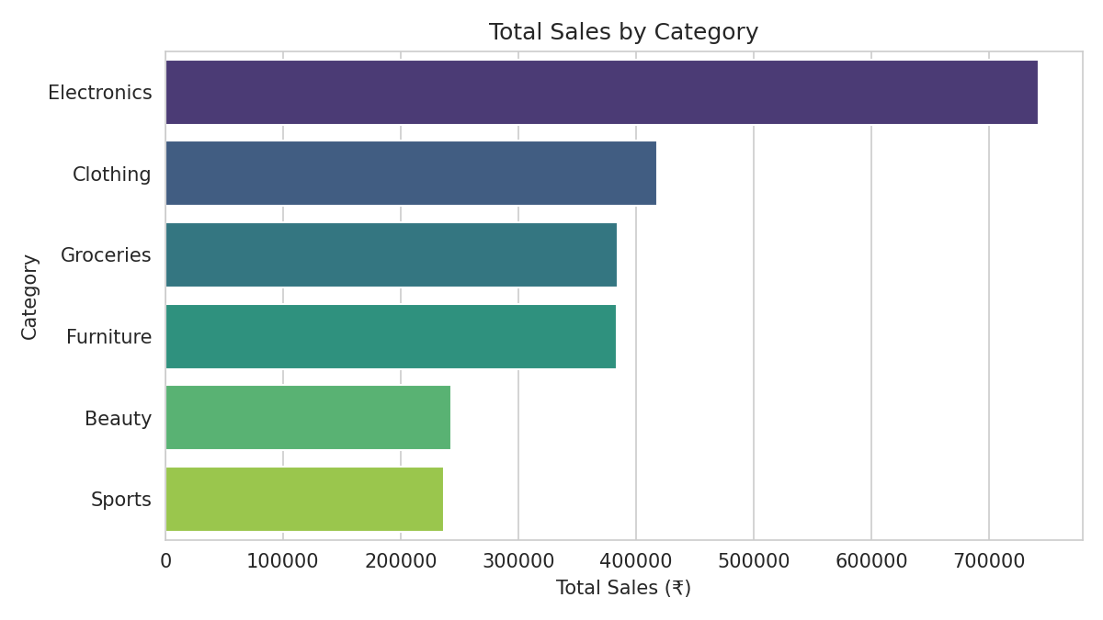
Figure 2: Electronics and Furniture generate the highest total sales.
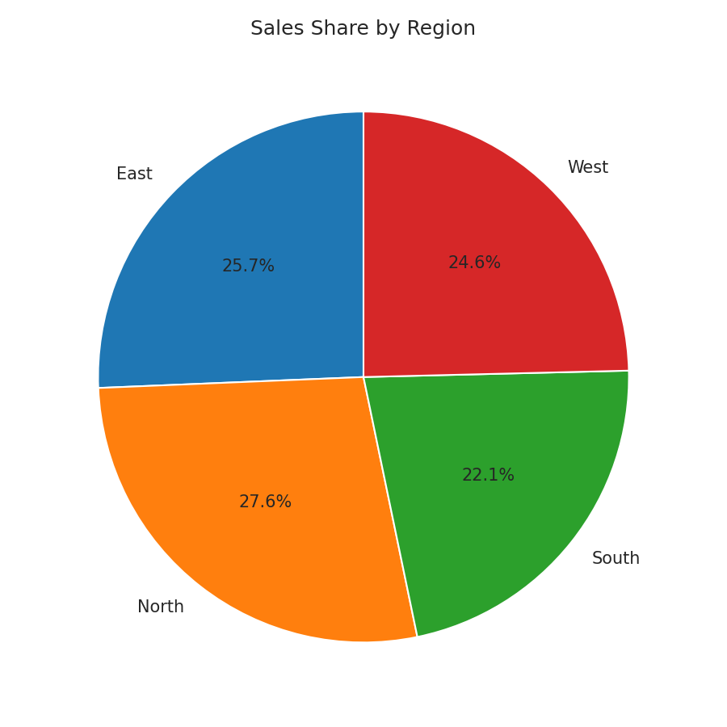
Figure 3: Regional distribution of total sales.
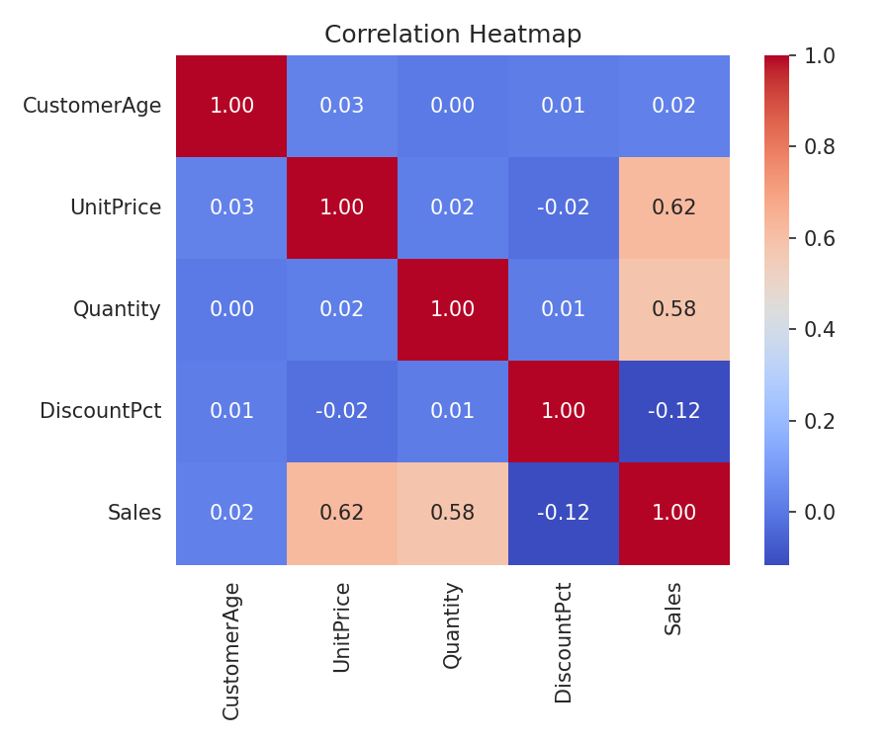
Figure 4: Correlation heatmap of numeric features.

6. AI Model Results

6.1 Forecasting Model Performance
Metric | Value
Mean Absolute Error (MAE) | 141.20
Root Mean Squared Error (RMSE) | 215.25
R² Score | 0.958

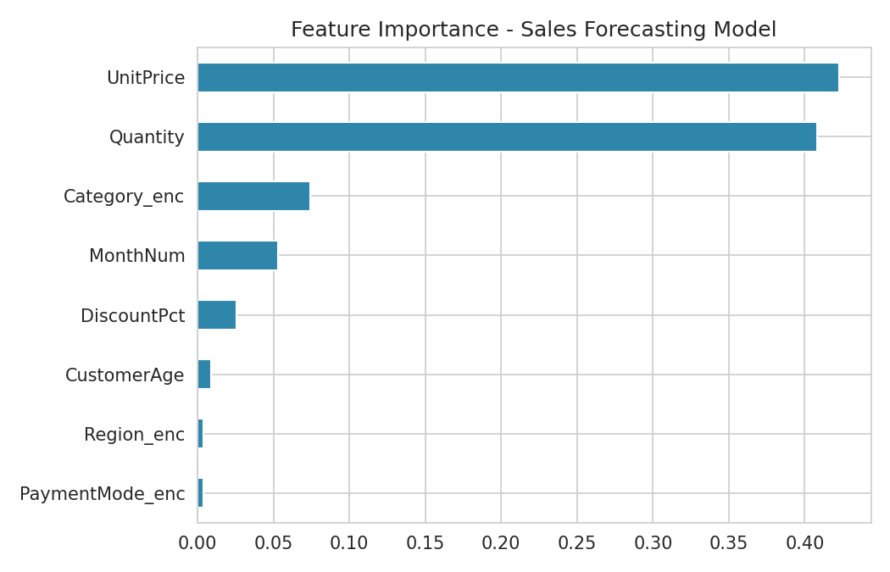
Figure 5: Feature importance — Unit Price and Quantity are the strongest predictors of sales.
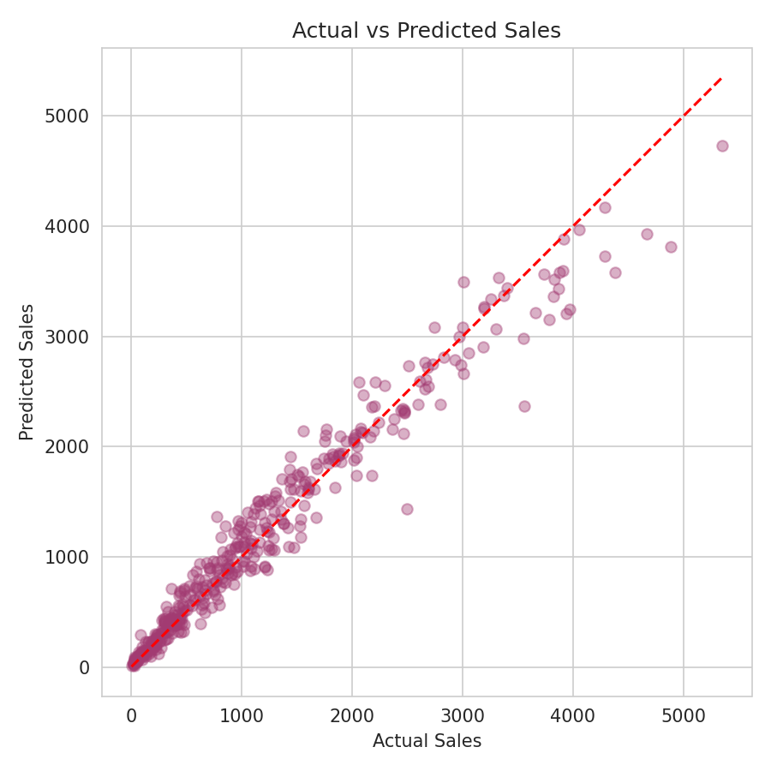
Figure 6: Actual vs Predicted sales values (R² = 0.958).

6.2 Customer Segmentation
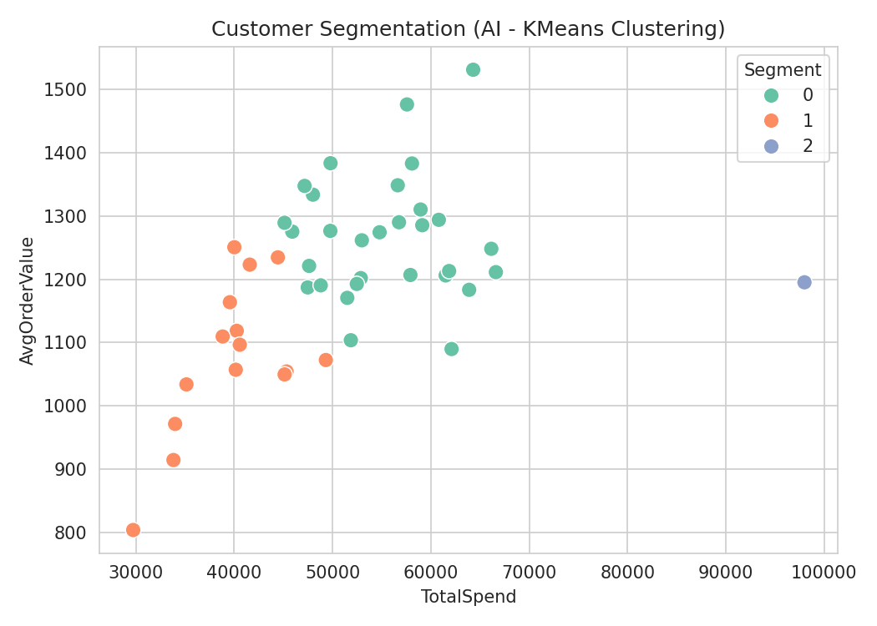
Figure 7: Three customer segments identified based on spend and order behavior.

7. Key Insights
- Sales peak strongly in October–December, indicating a festive/seasonal demand surge.
- Electronics and Furniture are the top revenue-generating categories.
- Unit Price and Quantity are the strongest predictors of total sales value.
- Three distinct customer segments were identified — low, medium, and high-value customers.
- The forecasting model achieved a strong R² score of 0.958, indicating high predictive accuracy.

8. Business Recommendations
- Increase inventory and staffing ahead of Q4 (Oct–Dec) to meet seasonal demand.
- Design loyalty programs targeted at high-value customer segments.
- Focus marketing spend on Electronics and Furniture categories, which drive the most revenue.
- Use the forecasting model to plan monthly procurement and reduce stockouts/overstock.

9. Conclusion
This project successfully demonstrates a complete data analytics and AI pipeline — from raw data cleaning to actionable business insights. The AI-based forecasting model achieved high accuracy in predicting sales, and the customer segmentation model provides a foundation for targeted marketing strategies. This work highlights how AI-driven analytics can support data-informed decision-making in the retail sector.

10. Tools & Technologies Used
- Python 3 — Programming language
- pandas, NumPy — Data manipulation
- Matplotlib, Seaborn — Data visualization
- Scikit-learn — Machine learning (Random Forest, KMeans)

