In the function module ZFI_PAYMEDIUM_DMEE_20 we need to update table
The code has been uploaded as text file in git hub with same name
ZFI_BATCH_SIGN
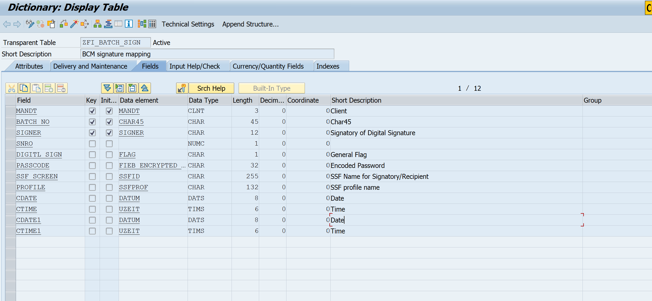
Sample Data
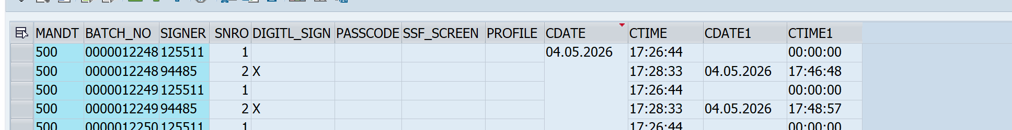

Approver need to be fetched from table
ZFI_BNK_RULE
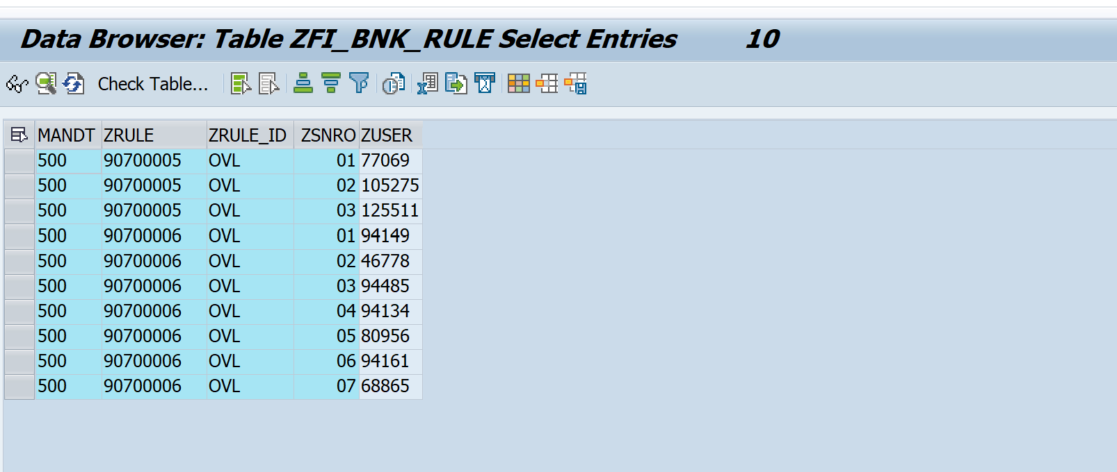
SNRO 1 – Rule 90700005 users
SNRO 2 Rule 90700006 users
Batch no logic is changes to
Part | Field | Len | Positions
Paying company code | ZBUKR | 4 | 1–4
Bank country | BANKS | 3 | 5–7
Run date | LAUFD | 8 | 8–15
Run id | LAUFI | 6 | 16–21
Proposal flag | XVORL | 1 | 22
TemSe key field | DTKEY | 16 | 23–38
Sequence number | LFDNR | 3 | 39–41
For your sample row it produces:
OVL IN 20260623 00001 HB_01 001
└ZBUKR┘└BANKS┘└─LAUFD─┘└LAUFI┘^└──DTKEY───┘└LFDNR┘
XVORL(blank)
If you are unable to find these fields in the function module do let me know I will guide or map the fields which you are getting I will try to get others

