Observations related to YRGR109:

- Do not delete entries whose diff = 0. For entries whose diff NE 0, make the line red.

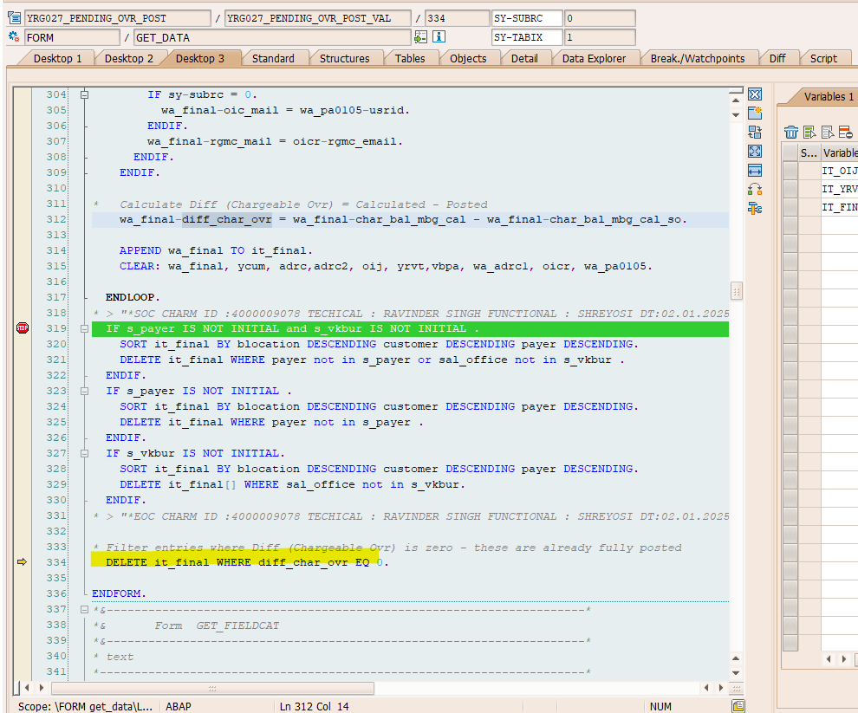

- Source should be YRGR109 instead of GR102.

- Change Subject: “Ovr Posting Pending_10551_01.05.2026 to 31.05.2026”

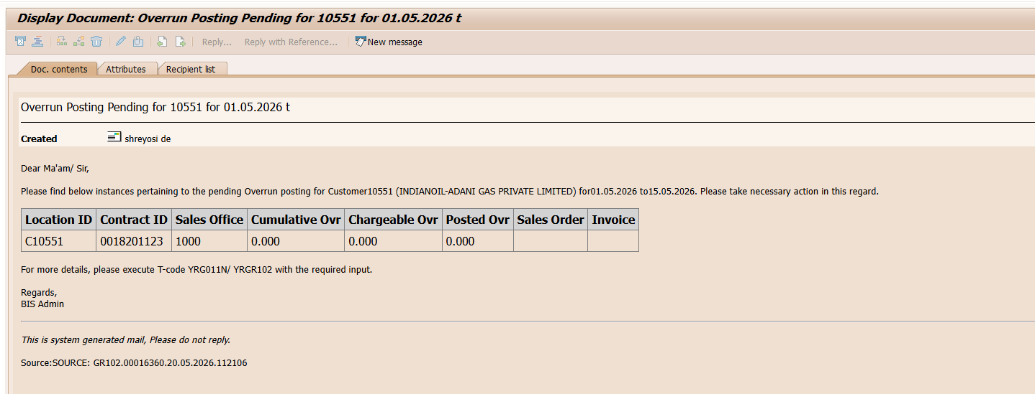

- Modify the table as available in the email body of YRGR102.
- Give space in the highlighted area.

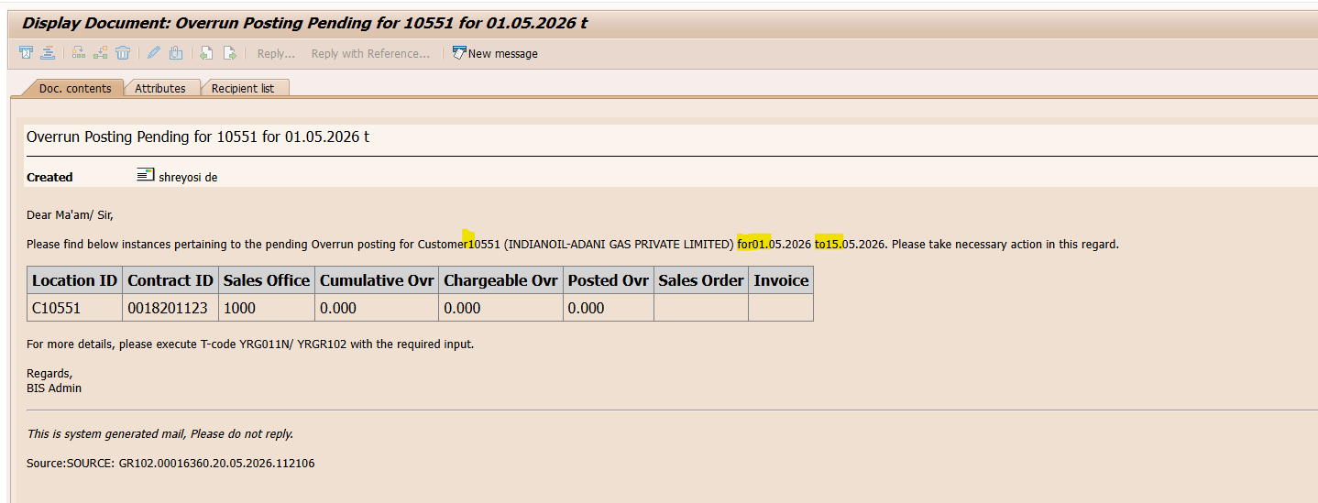

- In the highlighted area, use T-code YRGR109.

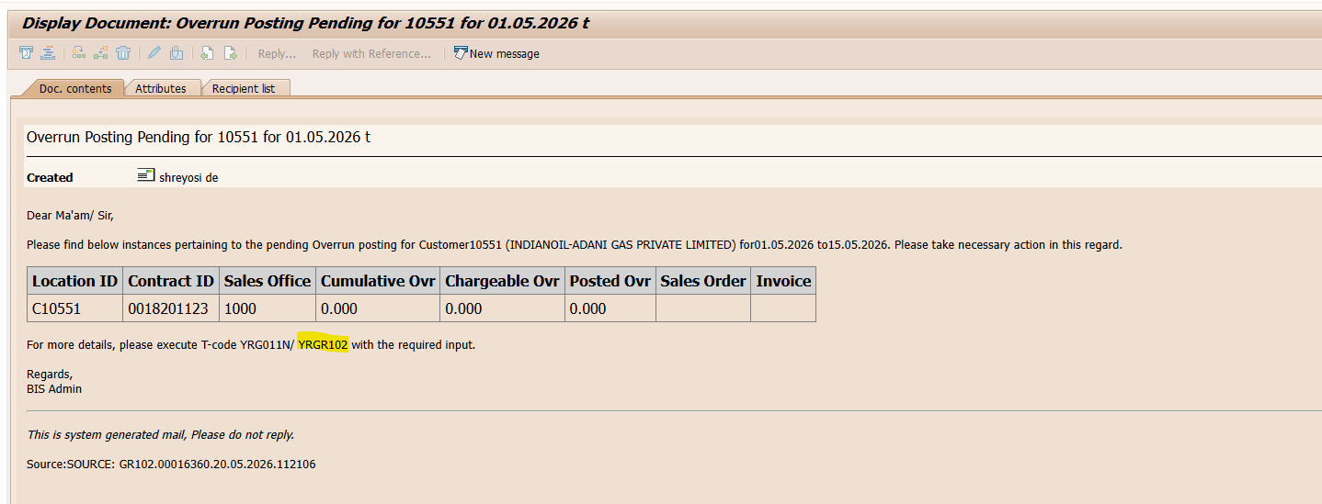

- Word ‘Source’ is coming twice.

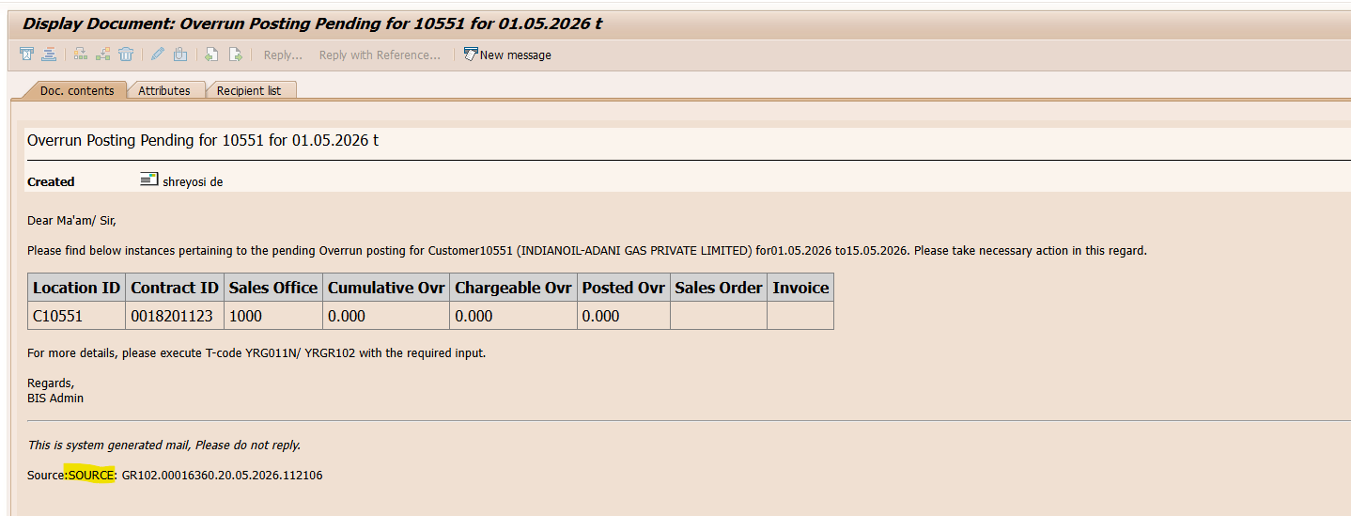

- Find the user who has carried out the last change in the past three months. (same code implemented in YRGR102). The last change user for each contract ID needs to be identified. Reference : YRGR102

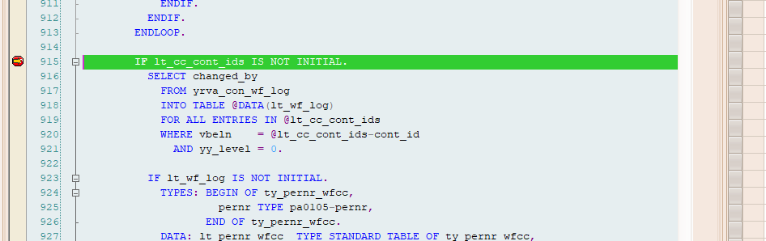

- Coding for CC to reporting officer is pending. Reference YRGR102.

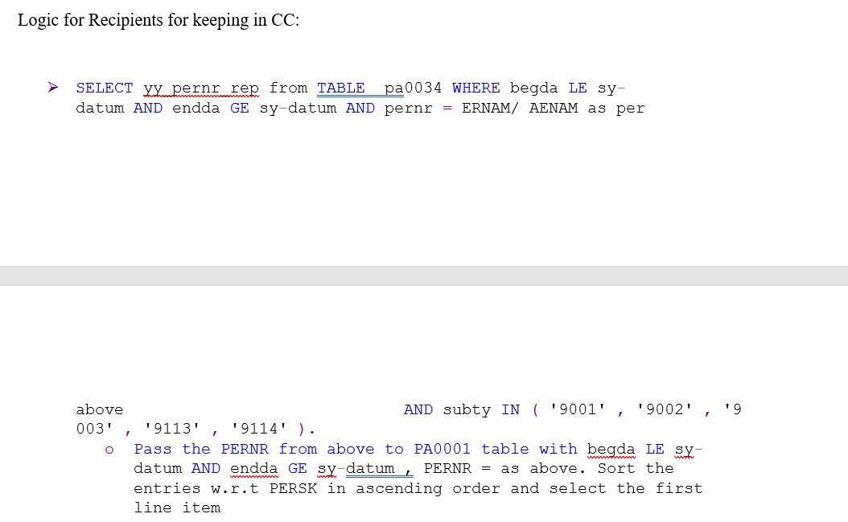

With Thanks,
Shreyosi De

From: Shreyosi De (श्रेयसी डे)
Sent: 20 May 2026 10:53

