- Old Arithmetic type conflict
s_quant TYPE i.
ls_bseg-amt = amt TYPE i.
ls_bseg-wrbtr = wrbtr TYPE wrbtr. (Data Type- CURR, Length- 23, Decimal- 2)
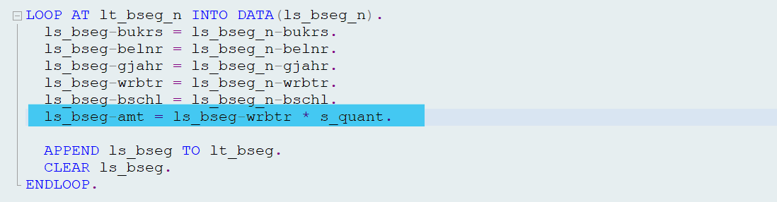

- “Select … for (former) cluster table … without ORDER BY” is not resolved using pseudo code as wrong pseudo code used.
Pseudo Code to be used = “#EC CI_NOORDER
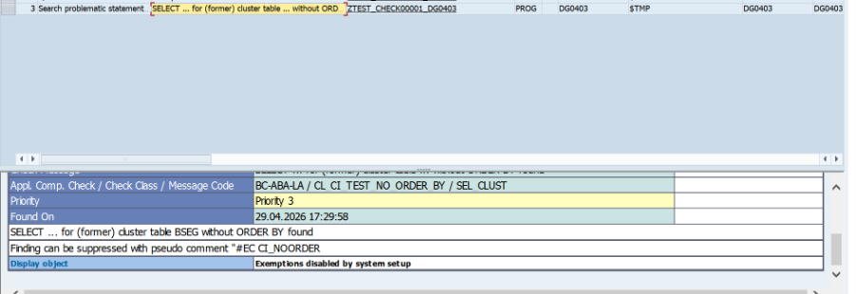

- Applied a pseudo comment to suppress the DB operation warning, but it incorrectly removed the SELECT field list and statement header, leaving only JOIN and WHERE clauses, which broke the query
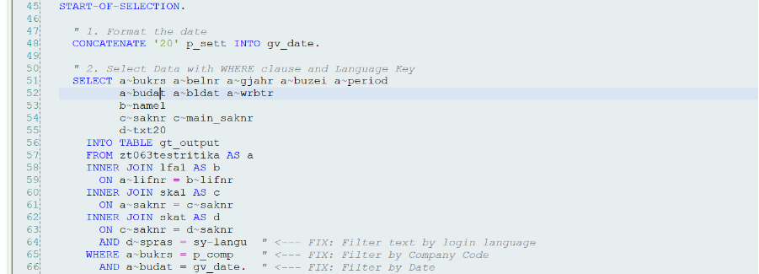
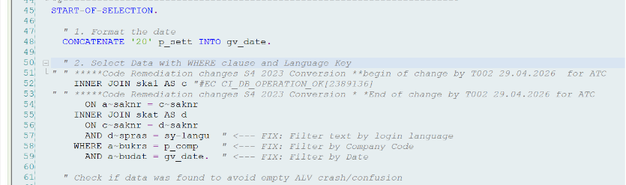

- Functionality not available: equivalent function on roadmap - (TRAN - MCHB) It added the Pseudo Comment, but issue did not solve.
CODE snippet à macro_fill_fieldcat 'CHARG'
'MCHB'
c_out.
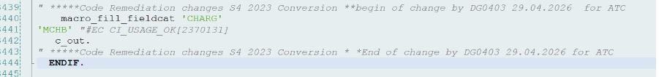
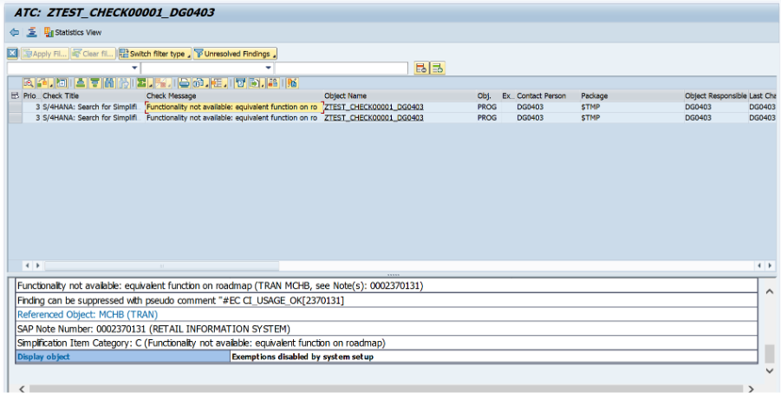
7. Syntax error in select query. Table fields were eliminated and not included in query.
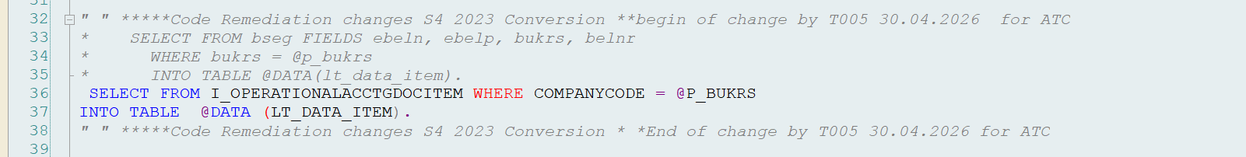
8. Syntax Error in SORT statement. Sort applied on the table is incorrect.
Wrong query ----> SORT lt_data_head. By

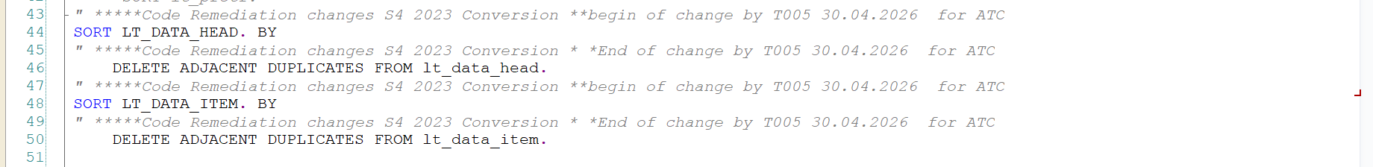
9. “Order by Primary Key” is not working with views.
solution : order by key fieldname(s) of view
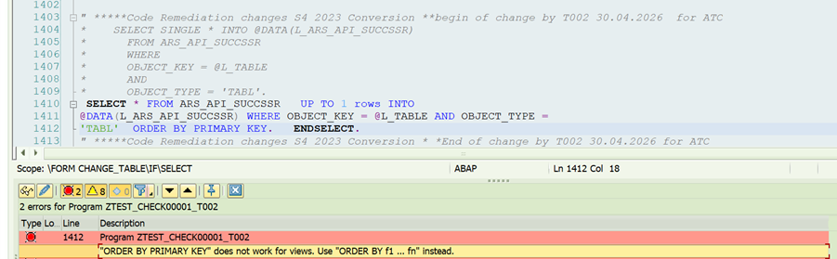
10. did not applied pseudo code "#EC CI_NO_TRANSFORM
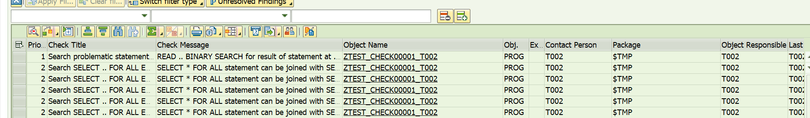
11. “LOOP AT itab. EXIT/RETURN/LEAVE ... for result of statement at line” issues are not resolved.
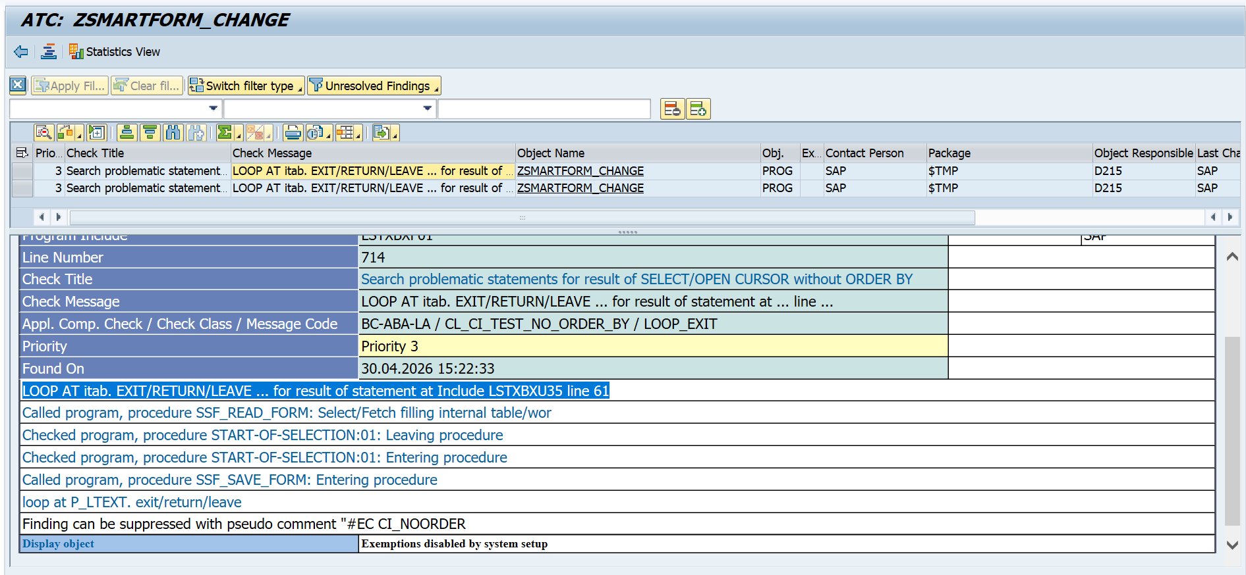

12. Resolving “LOOP AT itab. AT ... ENDAT. for result of statement at ... line ...” and “LOOP AT itab. ON CHANGE OF ... ENDON. for result of statement at ... line ...” issues. Both issue are in same loop and same table. So for solving the issue it applies Sort on the table used in loop. But as two issues are there for same table, It is Sorting the same table two times at a place.
