GeM Vendor Auto-Creation – Inputs Required
Program ZGEM_CREATE_VENDOR (S/4HANA, Business Partner via CVI). Vendor creation currently fails on the items below. Please provide the values / confirm the settings.
A. Values needed to update the program
# | What we need | Why / current error | Your input
1 | Reconciliation G/L account (AKONT) for GeM vendors in company code OVL | Program uses 190101 – fails: "G/L account 190101 does not exist in company code OVL". Confirm it is created in OVL (SKB1). | 190101 (Exist in OVL)
2 | Type of Industry value (field J_1KFTIND) | Fails: "Type of Industry J_1KFTIND is not filled" – mandatory for GeM vendors. | Blank used till now
B. Configuration to be set by Functional / Basis (no code change possible)
# | Setting | Where | Action
3 | CVI "Same Number" for direction BP → Vendor, grouping GEMV | SPRO → Master Data Synchronization → CVI → Business Partner Settings → Settings for Vendor Integration → Field Assignment → Number Assignment → Define Number Assignment for Direction BP to Vendor | Tick "Same Number" for GEMV (fixes "Enter the external supplier number")
4 | BP number range 21 (grouping GEMV) must be INTERNAL | BUCF (Number Ranges & Groupings for Business Partner) | Confirm range 21 is internal so the BP gets a number that CVI copies to the vendor
C. Please confirm these values (carried over from ONGC/OVL) are correct for this system
Field | Current value | OK? / Correct value | Field | Current value | OK? / Correct value
Company code (BUKRS) | OVL | OK | Payment method (ZWELS) | 9 SBI / 8 other | OK
Recon account (AKONT) | 190101 (see #1) | Ok | Withholding tax type | I0 | Ok
Sort key (ZUAWA) | 000 | Ok | Purch. org (EKORG) | PMAT / PSRV | Ok
Planning group (FDGRV) | DL | Ok | Industry key (BRSCH) | VOTH / Z031-Z034 | Ok
Payment terms (ZTERM) | 0001 | Ok | Supplier BP role | FLVN00 | OK
Note: Items 3 and 4 are Customizing only. Without the "Same Number" flag (item 3), the external GEMV vendor cannot take the Business Partner number, so vendor creation cannot complete regardless of program changes.
Point A. 1. GL is currently working for CoCode OVL
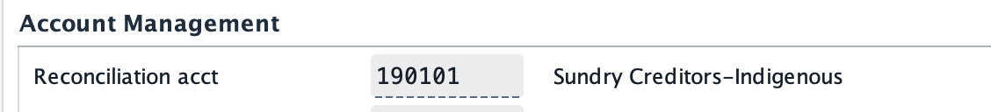

- 2 Type of industry is currently mandatory, but it’s a free text. ( though entries are maintained in Config)
As last solution you may default ‘GEM’ there
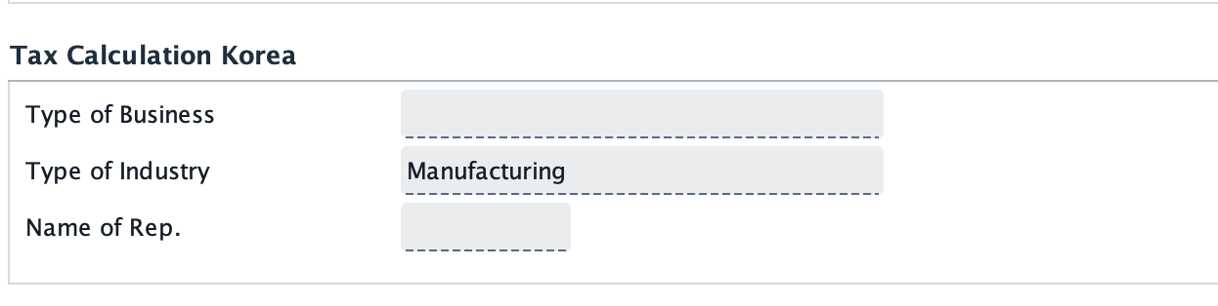

- 3. I have created a fresh, without assigning External Vendor Code, and it creates BP same as Vendor code
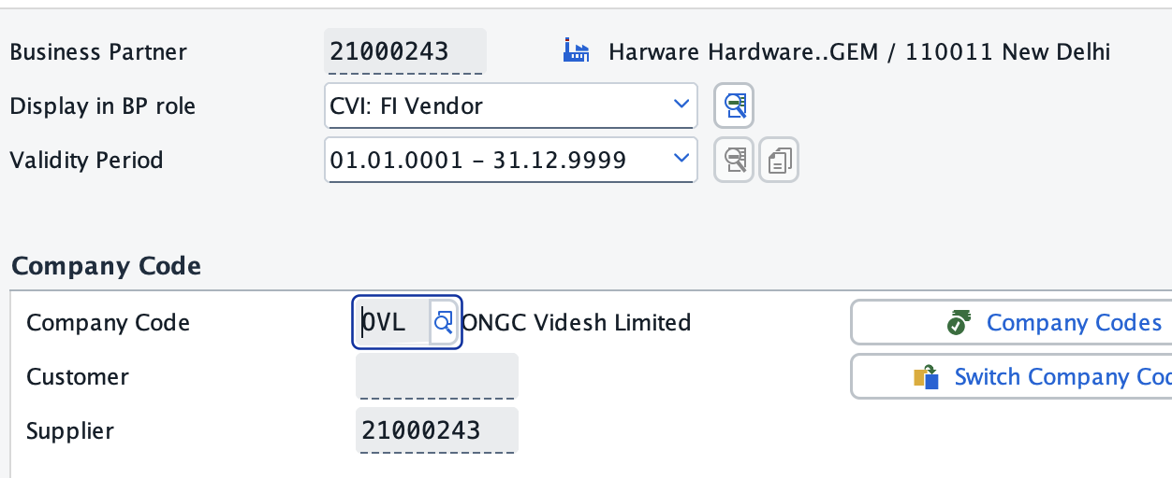

b. 4 same as above

