ATC Issues –

2.Not remediating error - EXPORT issue
This can be resolved from psuedo code "#EC CI_FLDEXT_OK[2215424
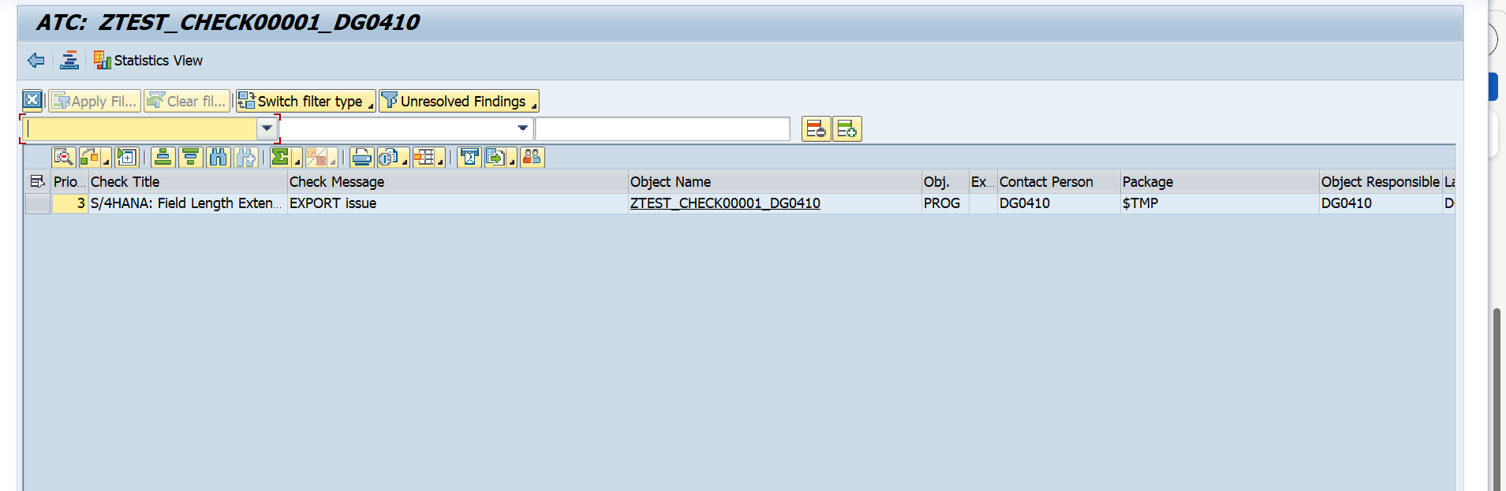

4. ZUTILITY_MOVE_HELPER: WRITE in LOOP for result of statement at ... line ...

Not resolving this issue. No changes.
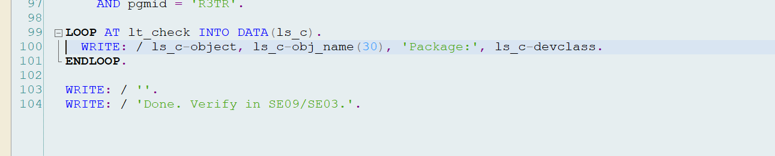
- Not Generating program for "ZUTIL_TR_BULK_UNLOCK" ATC for Select Single. but in some programs Select Single were resolved.
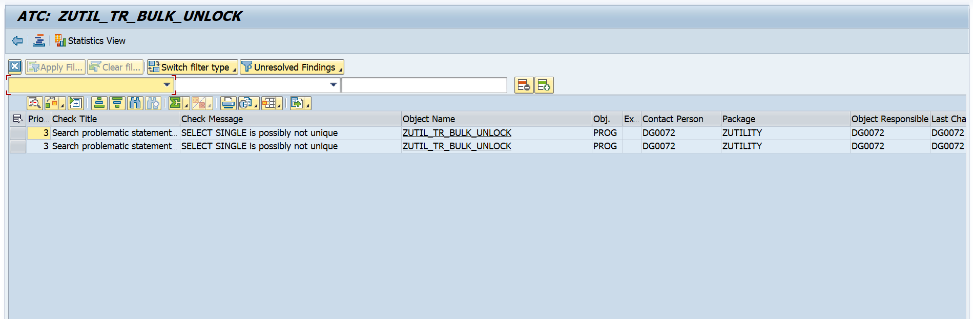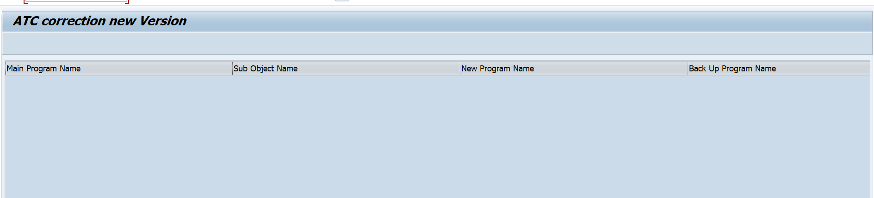
- did not added endselect after order by primary key. Endselect. needed
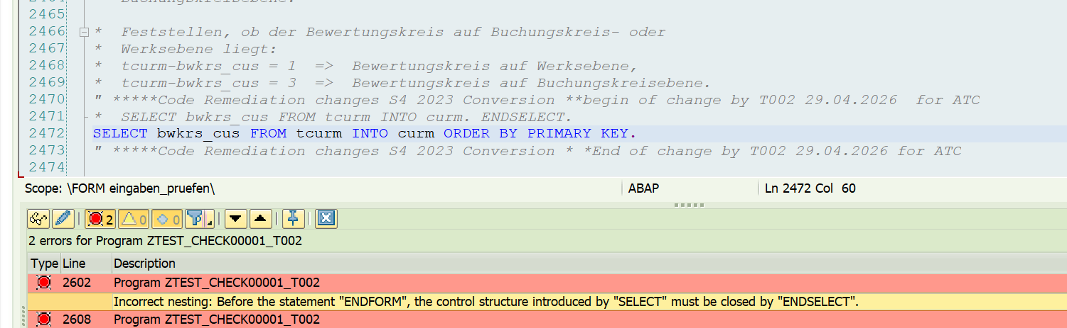

7. Applied pseudo commnet but change the original select Query completely (even change the select fields) 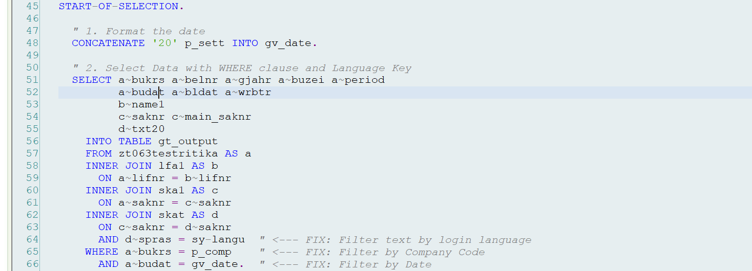
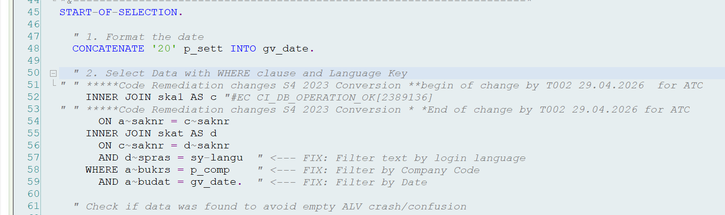
8. Program 'ZUSEERCMD', ‘ZUSEERCMD_NEW’: Not resolving write issue and write in loop .... issue. Adding pseudo at wrong statements.
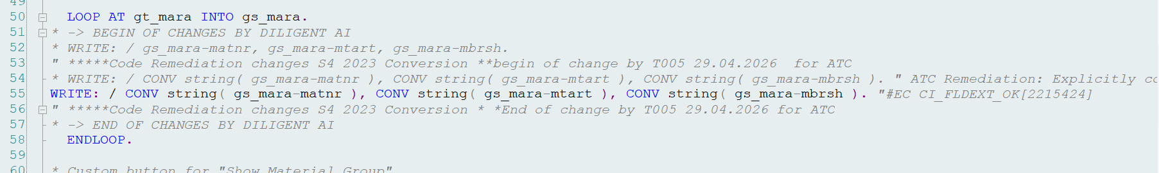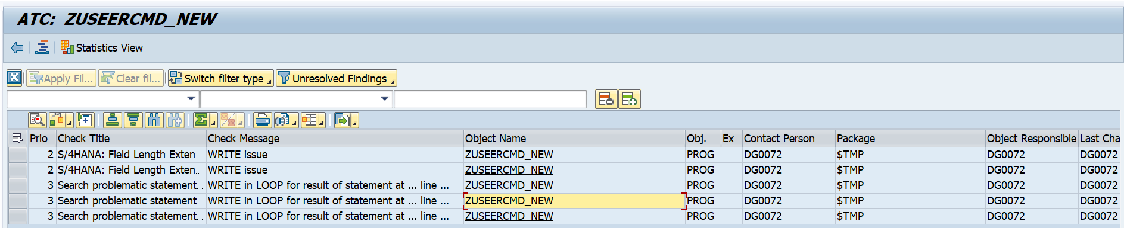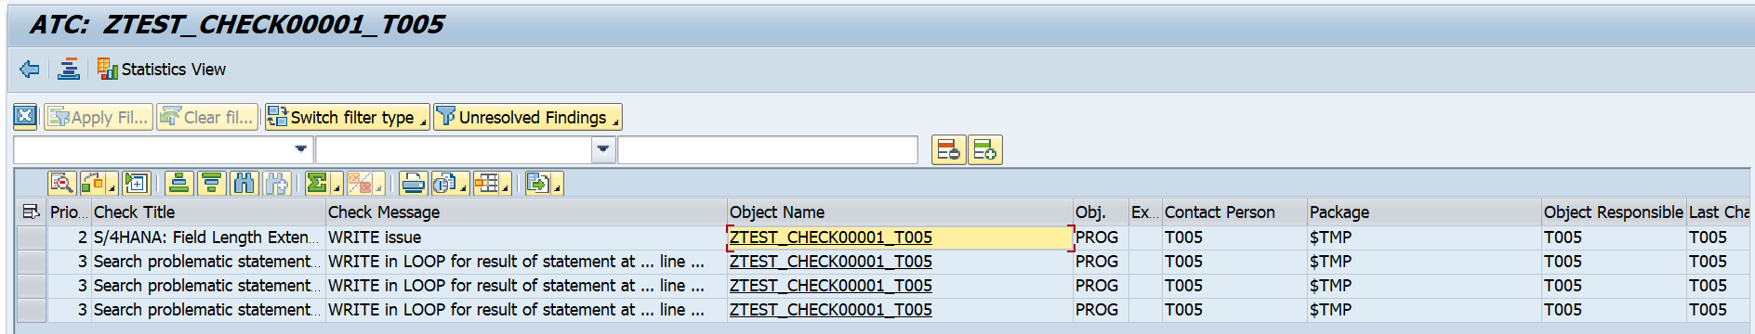
9. Functionality not available: equivalent function on roadmap - It added the Psuedo Comment but issue did not solved.
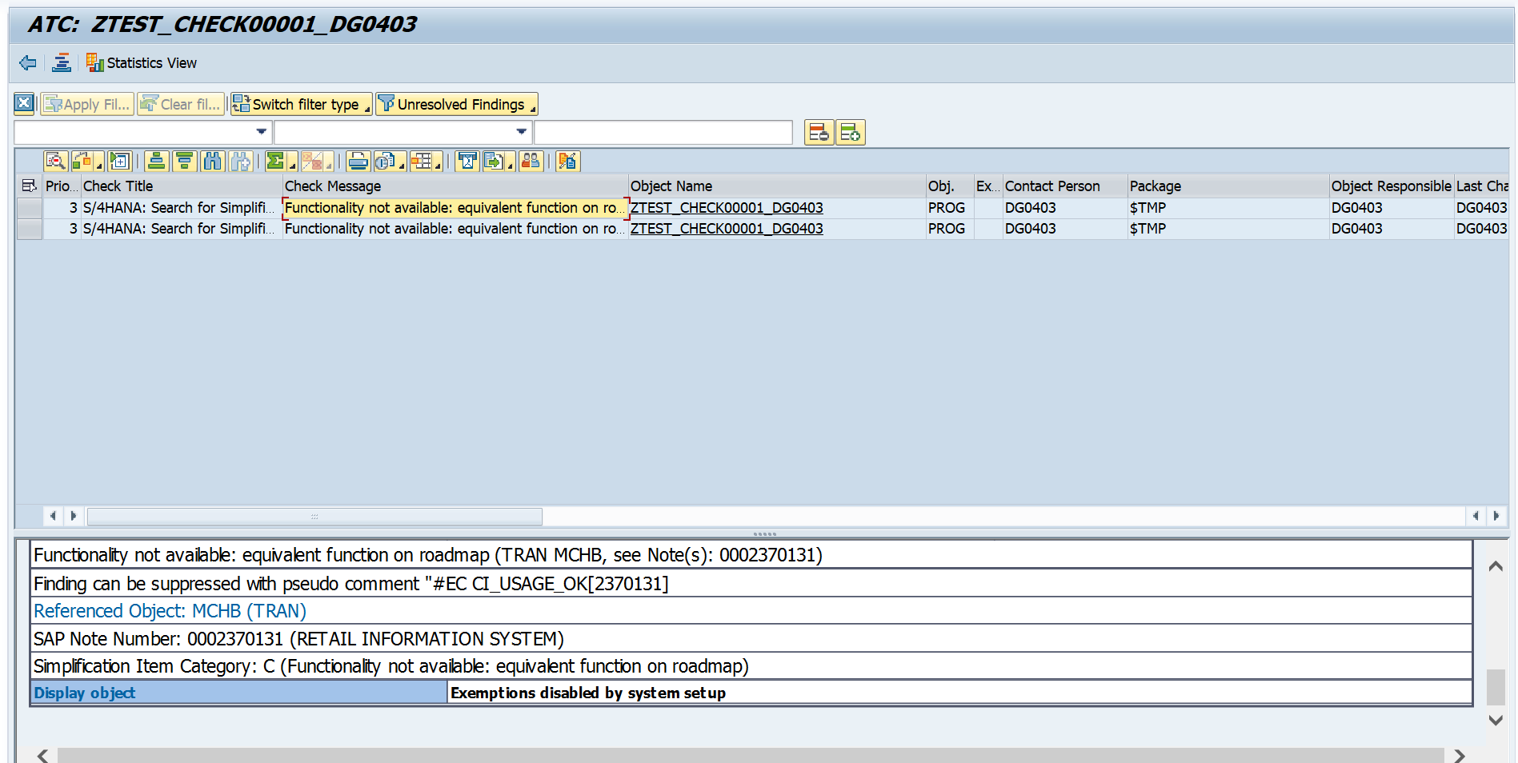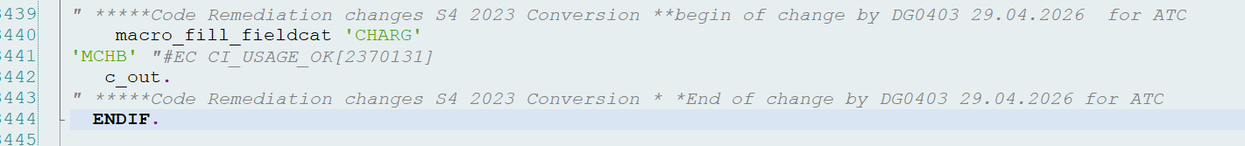
10. In some programs write issue are not resolving. Applying pseudo for write issue but still issue persist in some programs, write statement is written in loop, needed Sort on internal table.
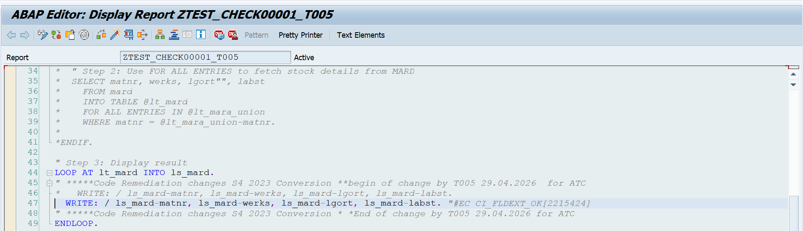
11. Gives syntax error as - space after DATA (
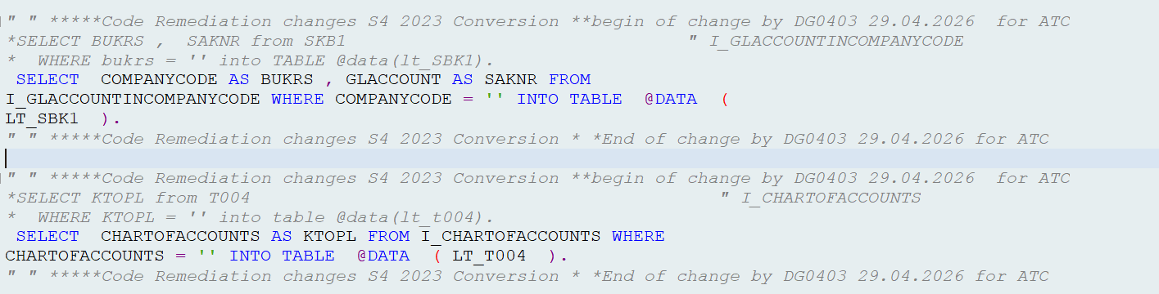
14. PROG - ZTEST_BSEG
Synatx error space in data declaration and no commas in select query 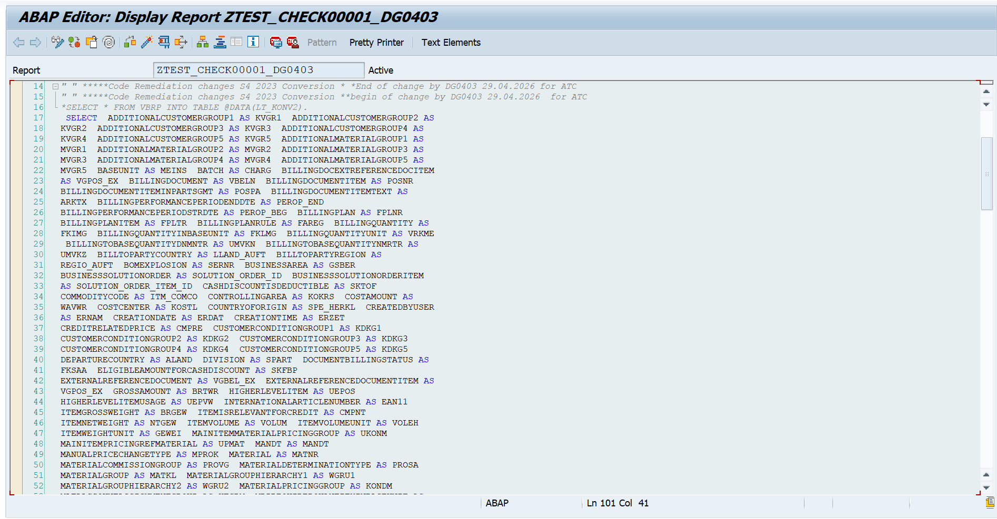
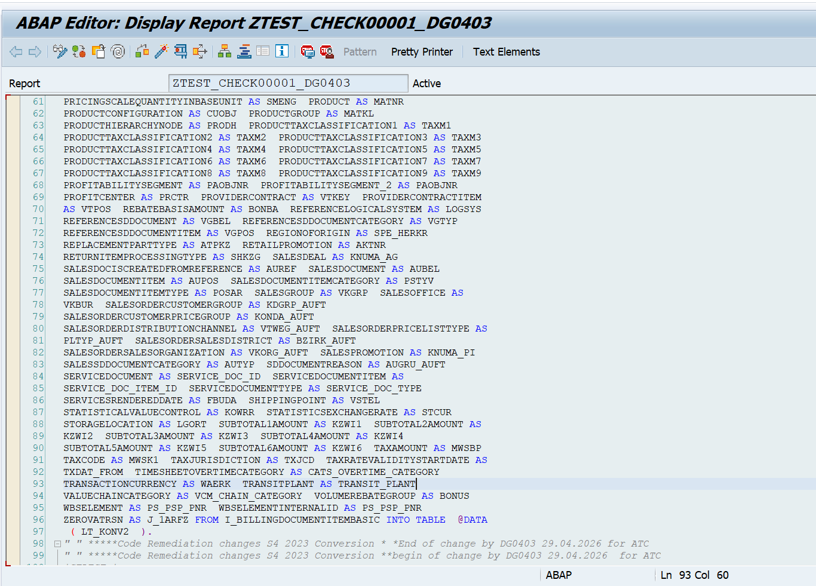
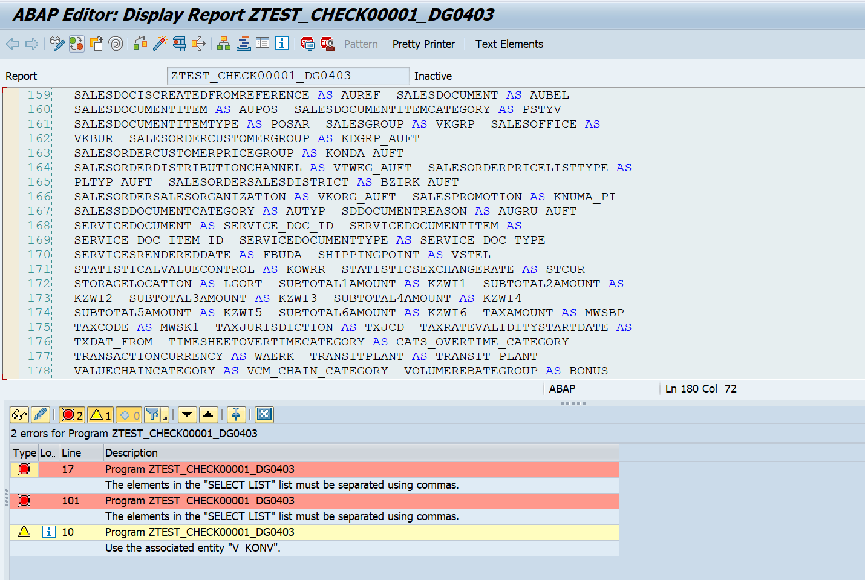
Did not solved by PSUEDO
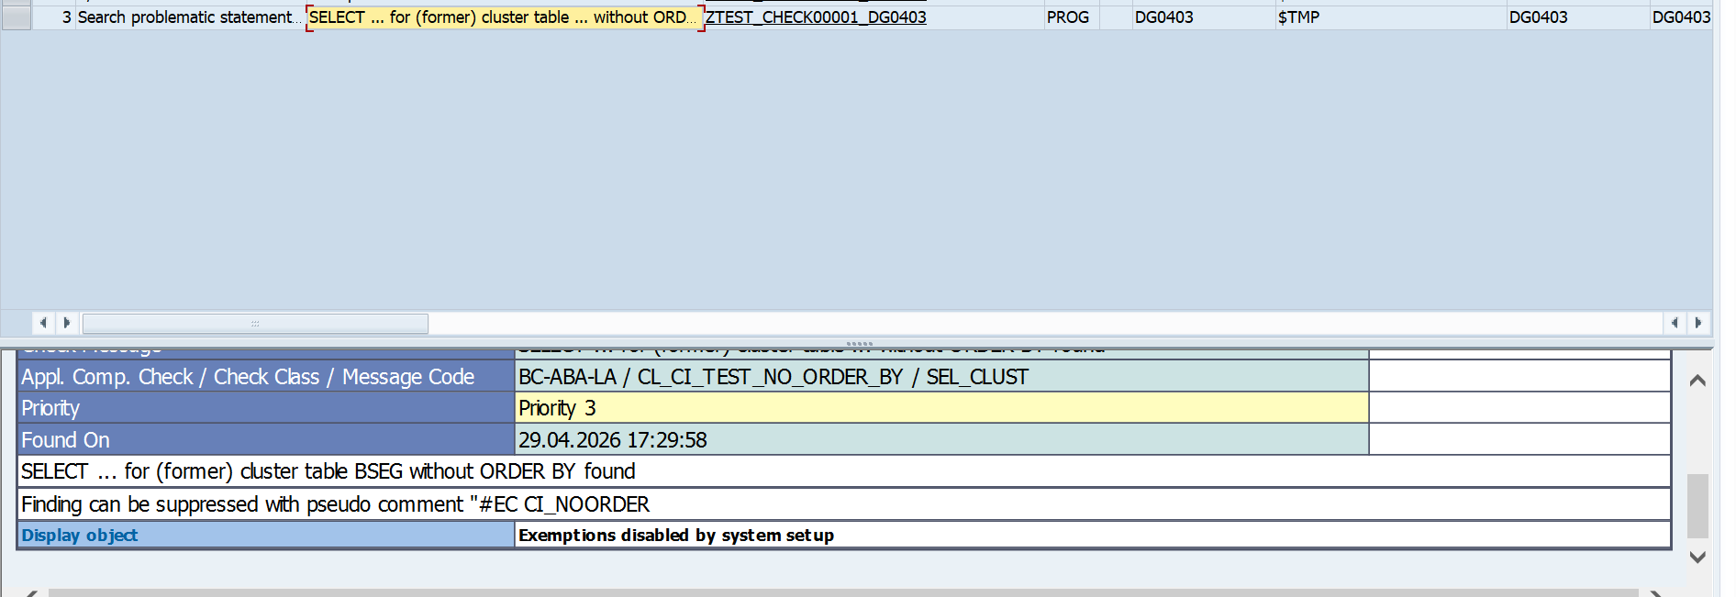

17. -Inline Declaration incorrect. Syntax error.
-Also Resolved Priority 1 issue but in same query one more issue was there in same query that was not resolved.
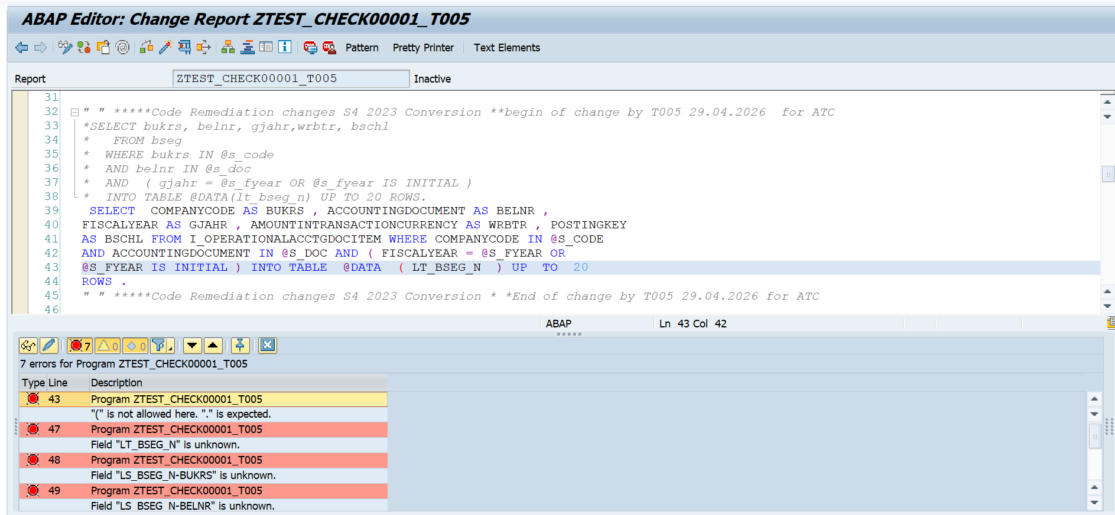
18. Old Arithmetic type conflict ------> not resolving

