Please check YRGR102 in QAR for the variant: email

- As seen emails should have been triggered to 50669 for the below highlighted contracts. However, the entries are getting skipped.

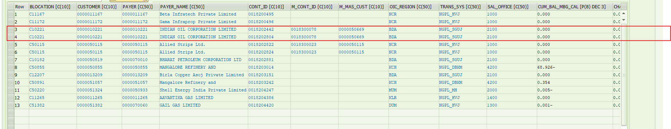

Kindly check.

- Also, make modification in the below code

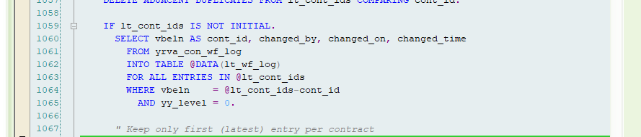

Here select the entries that have been changed within 3 months from the current date. This is to be done for both YRGR102 & YRGR109

- YRGR102: The below code piece should work when the email checkbox is checked.

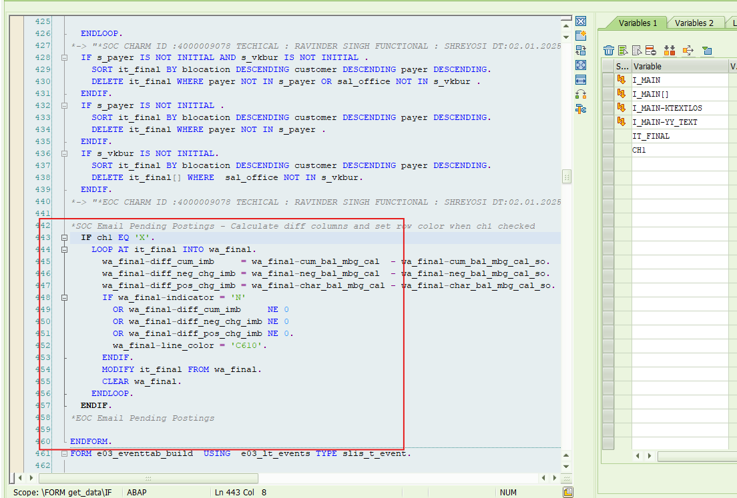

- Add ‘Ngmc@gail.co.in’ in CC.
- In the email body, add the below line in the highlighted area

Note to ZO: You are requested not to modify any imbalance clauses with retrospective effect, as the same may impact already posted imbalances. Further, it may please be ensured that any imbalance shifting, wherever applicable, is completed prior to closure of the corresponding fortnight.

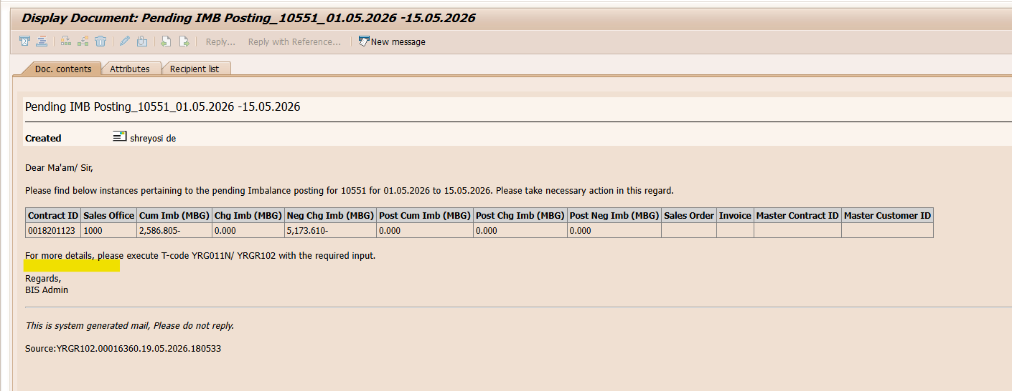

- In the table of email body, add location ID (first column) <LOCID>, already available in report (do it for YRGR109, as well)

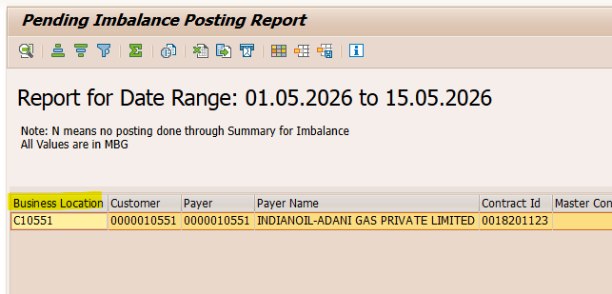

- In the email body, add customer name <KNA1-NAME1>. (add name in YRGR109 too)

Modified line ‘Please find below instances pertaining to the pending Imbalance posting for Customer 10551 (KNA1-NAME1) for 01.05.2026 to 15.05.2026. Please take necessary action in this regard.’

