The following changes are to be made to the allocation program:
- On the allocation ALV screen, a column for ONGC Material is to be placed after GAIL Material
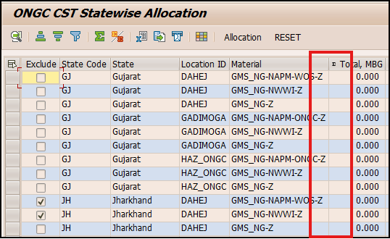

- The logic for exclusion in ALV is to be changed. Material is also to be passed in the code below. This code is appearing thrice between line numbers 1109 to 1149.
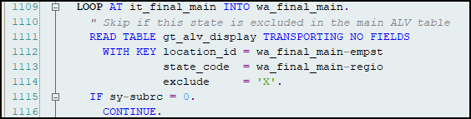

- Round Up of SCM values: The allocated volumes in SCM are to be rounded-up to the next higher number at the second place after decimal.
  - For example, 100.123456 should be rounded-up to 100.13. 250.000001 should be rounded up to 250.01 etc.
  - To do this, remove line numbers 1257 and 1258 as these are no longer needed here.
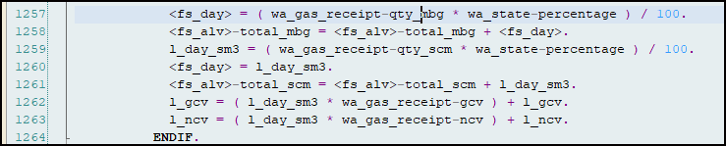

  - After line number 1259, multiply l_day_sm3 by 100, apply CEIL function and then divide the result by 100. Use this value in subsequent lines.
  - At line number 1268 and 1269 round off the GCV and NCV values to three places after decimal.
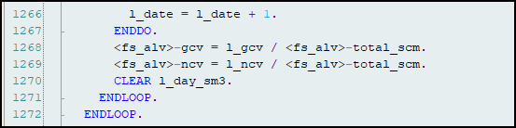

  - After line number 1269, calculate the Total MBG by passing <fs_alv>-GCV to the FM YRX_QTY_UOM_TO_QTY_UOM. Round off the Total MBG till 3 places after decimal.
  - After the allocation has been done, make an internal table and extract data from the ALV where Total SCM IS NOT 0 and Exclude IS NOT X.
  - Sort the internal table as per IT_ASALES. After sorting, check if Gujarat is appearing in any row. If so, pick all rows of Gujarat and take them to the top.
  - Now pick one Location ID-GAIL Material-ONGC Material combination and sum up its allocated quantities for one day (for example Day 01). For the same combination, get the receipt quantity for that day (Day 01).
  - Find the difference between the receipt and allocated quantities as DIFFERENCE = RECEIPT – ALLOCATION.
  - Add this difference to the allocated quantity for Day 01 for the combination Location ID-GAIL Material-ONGC Material-State Code appearing in the first row of the sorted internal table.
  - If the difference cannot be adjusted fully in the first row, move on to the next one.
  - After the quantities have been calculated in this fashion, recalculate the Total Sm3, Average GCV, Average NCV and Total MBG values.
  - Continue steps h to l for all the other days.

