- YRVT_CONT_DCQ — full structure (SE11): key fields, field names for contract, gas day, DCQ_QTY/MAX_QTY/MIN_QTY, CREON, TIME, and how "latest" entries are versioned.
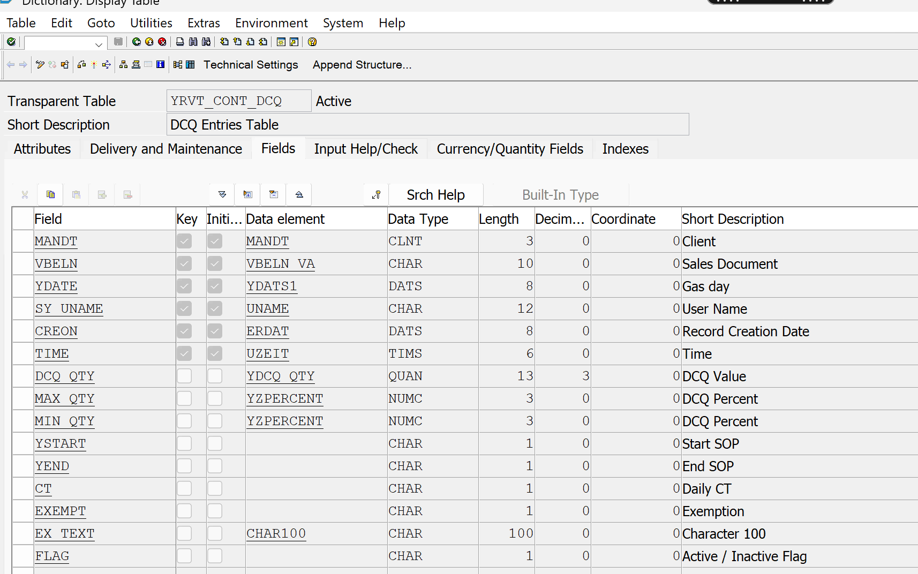

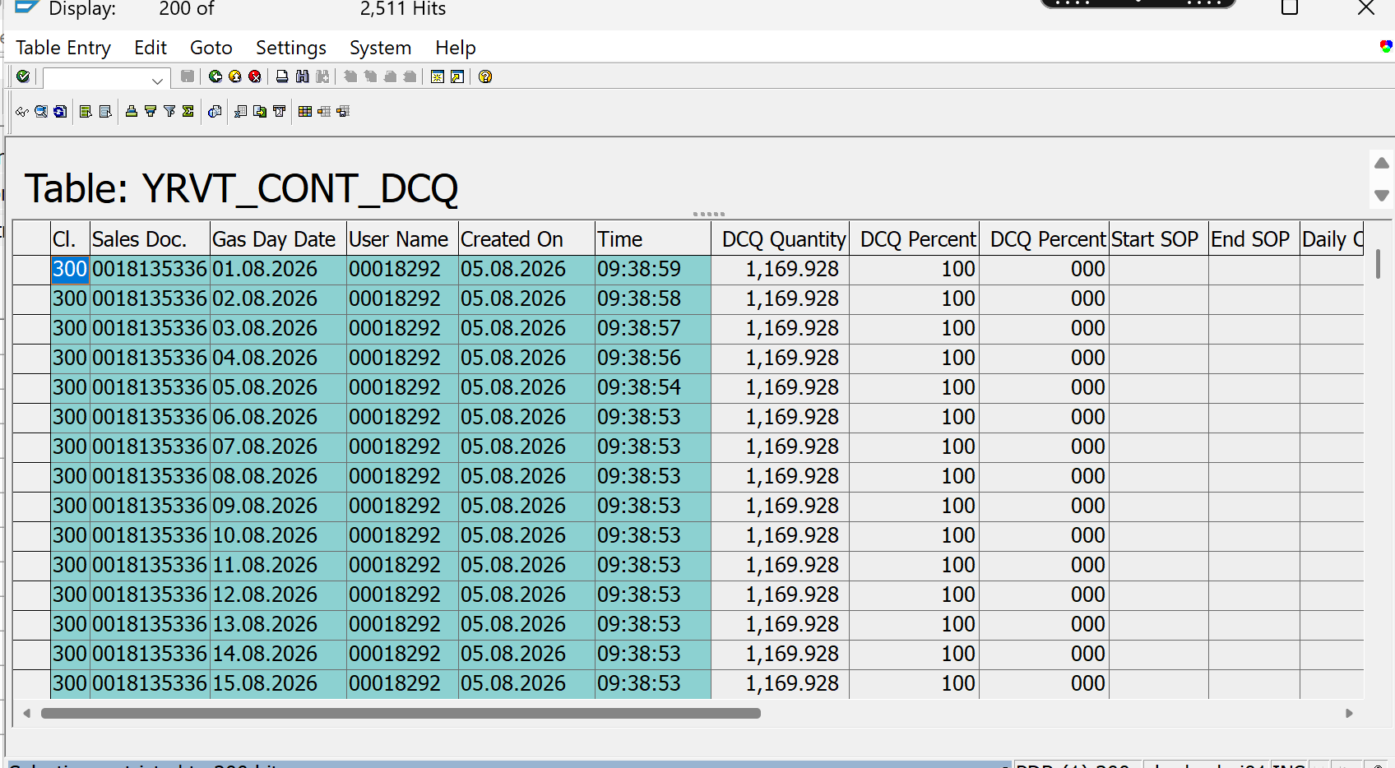
- KNA1-YYGAID — data element, length, and sample values (confirm it stores the BSARK value exactly).
- Sample T176/T176T entries for CGD — a few BSARK + VTEXT rows so I can pin down the GA-ID-in-VTEXT matching rule precisely.
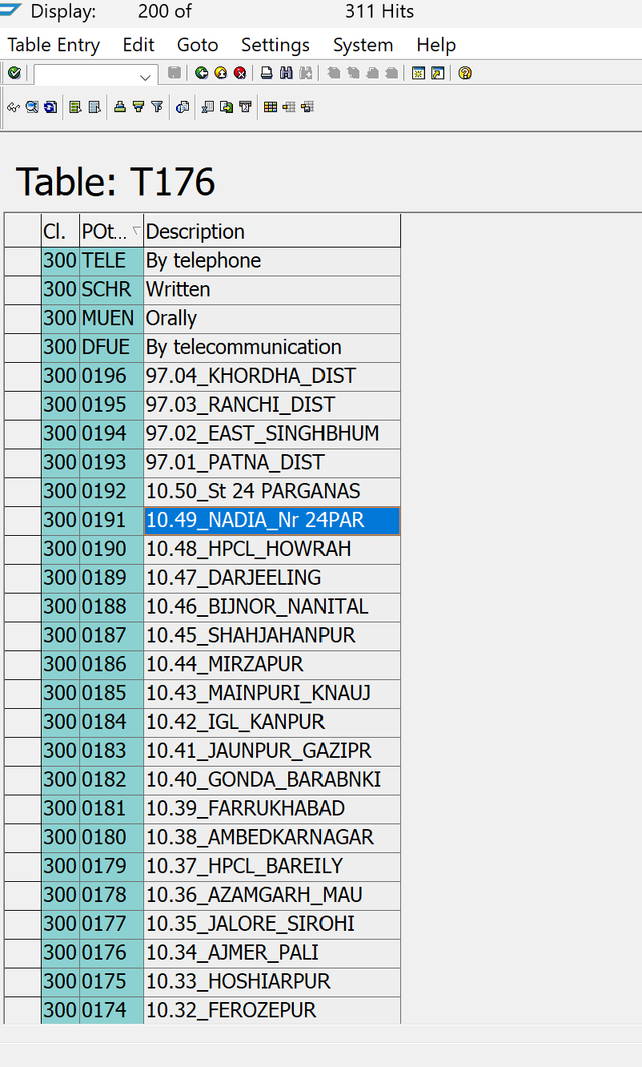
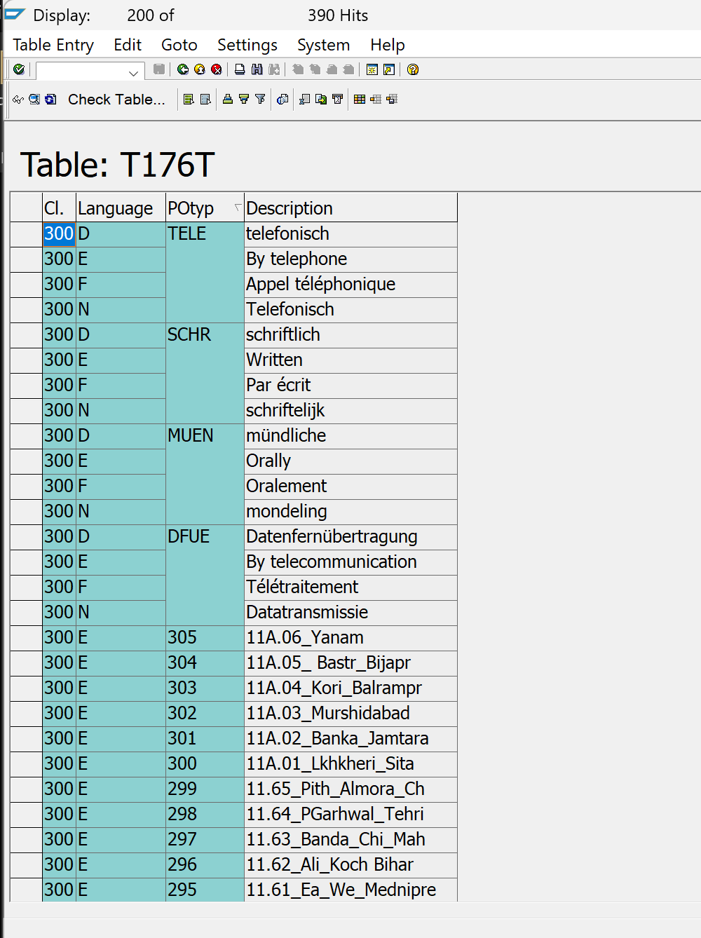

- AUGRU = 'CGD POOL' — AUGRU is 3 characters in standard SAP (order reason)… "CGD POOL" won't fit. Is this actually the AUGRU code vs its description text, or a different field? Need the real code/value.
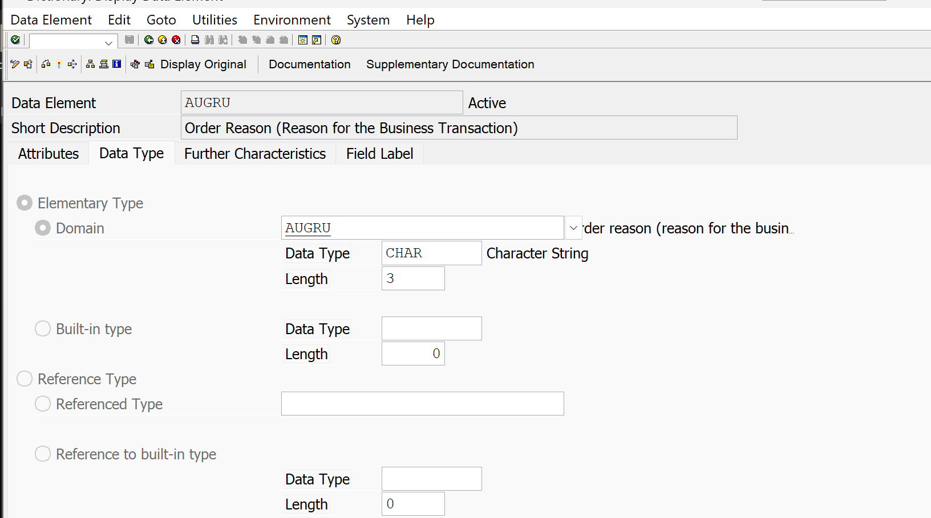
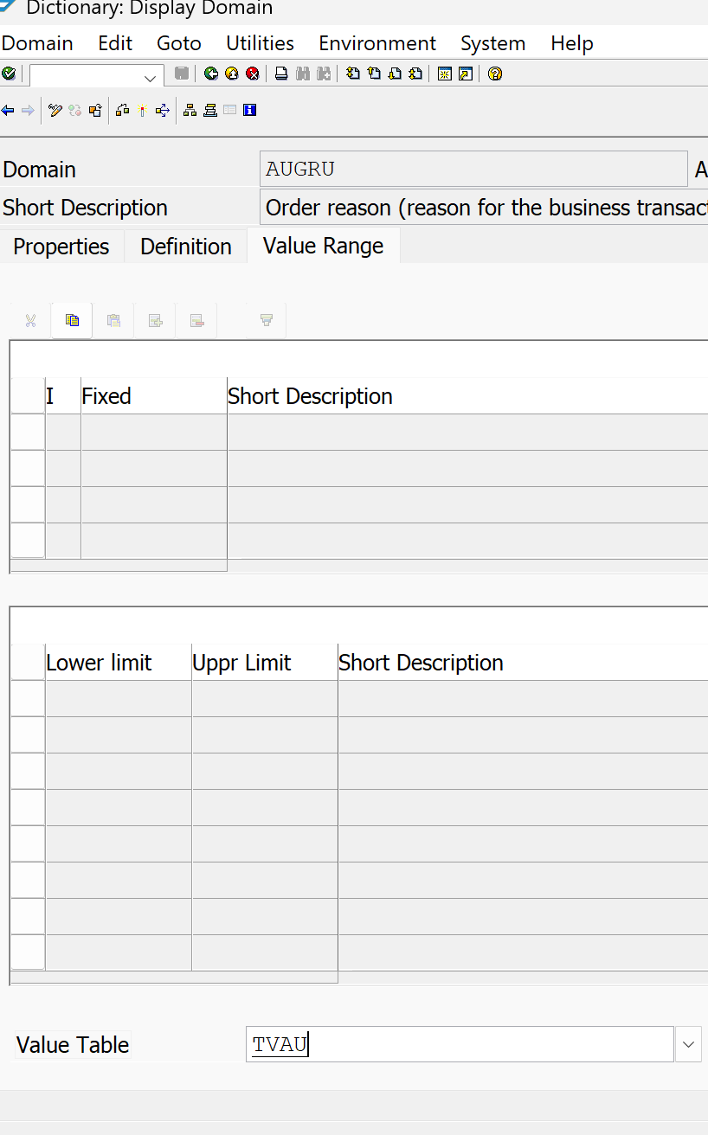

- YRXR001 — source/selection screen: exactly how to call its "Excel Sheet Upload" (SUBMIT with which parameters? Is there a reusable FM/routine?) and its expected file format; also YRXR006 source to see the reference call pattern. Neither is in this repo (YRGG015 is).
File with name - YRXR001_1 and YRXR001_2 there in git hub
- OIJNOMI — which fields identify the CGD contract and gas day (e.g. NOMTYPE/DOCIND/CONTRACT_NO/NOMDATE) in your system's usage, plus confirmation DELIND is the deletion flag used.
Table strutre available in git hub with name OIJNOMI

- Fortnight (FN) definition — is there a table/FM defining gas fortnights (1st–15th / 16th–month-end?), or is it derived by rule? Needed for the "single FN" validations in Upload and Download.
This we have done in other program also check git hub GMS program
- Stage-2 upload file format — the doc embeds the Stage-1 template only. I need the confirmed-qty excel layout (Customer | Gas Day | Confirmed Qty | …? highlighted cells? one row per customer per day or matrix like Stage 1?).
Matrix like stage 1

- Data elements/domains conventions — should new table fields reuse existing data elements (MENGE, KUNNR, VBELN, BSARK etc.) and should the quantity fields carry a UoM reference field? Also: do the 7 tables need table-maintenance generators (SM30) and are they to go in a specific package/transport layer?

Reuse old fields as many as possible

- T-code(s) — should I create transaction codes for the new program(s), and any authorization object requirements?
Will be created later
- One program or two? The doc's screen mock implies a single program with two sections ("GA ID wise Demanded Nomination" and "Contract wise Scheduled Nomination") each with radio buttons. Confirm one combined selection screen vs. two separate programs.
One program

