Format No/ Rev: TS-ABAP-00
Release: 1.0  Author: Ayush Sethi | Development No
 | Technical Specification
 | OVL – Project S/4 HANA Migration
 | History
 | Version V01 | Status | Date 30/06/2016
 | 01 | Initial
Storage location of this design document: \\...
Storage location of the corresponding specification document: \\...

Content
0 Overview 4
1 Organization 4
1.1 Project Team / Development Team 4
1.2 Project Plan 4
1.3 Further References 4
2 Glossary 4
3 Rough Design 4
3.1 Architecture and Behavior 4
A.1.1 Assumptions 4
A.1.2 Involved Systems 4
3.2 Interfaces and Integration 4
3.3 User Interfaces 5
3.4 Customizing 5
3.5 Archiving 5
4 Detailed design 5
A.1.3 Function 1 6
A.1.3.1 Detailed Data Model 6
5 Verification of constraints 8
5.1 Data volumes 20
5.2 Performance 20
5.3 Data protection 20
5.4 Data security 20
5.5 Internationalisation/Localisation aspects 20
5.6 Portability 20
5.7 Compatibility to previous versions 20
5.8 Legal Aspects 20
6 Test Programs/Test Environment 21
7 Appendix 21
7.1 Related Documents 21
7.2 Overview of Modifications 21
7.3 Restrictions 21
7.4 Alternative Design Ideas 21
7.5 Open Issues 21

Overview
It has been decided to implement a Proxy to change the password and send SMS to the corresponding user.

Organization

Project Team / Development Team
Name | Project Role(s) / Comments
 | [Team Lead - Functional]
Mr. Vaibhav Maheshwari | [Team Lead - Technical]
Mr. Ayush Sethi | [Lead Consultant - Technical]

Project Plan
Not Applicable

Further References

Functional Specification No.
Technical Specification No.
Transport Request No. | OCDK900505, OCDK900188, OCDK900513, OCDK900517
Function Module Name | Not Applicable
Function Group Name | Not Applicable
Layout Name | Not Applicable
Transaction Code

Glossary
Created a Report to fetch and update the status of all the invalid workitems to completed.

Rough Design

Architecture and Behavior

Assumptions

Involved Systems

Interfaces and Integration

User Interfaces

Customizing

Archiving

Detailed design

ABAP |  | JAVA | C/C++
DDIC elements |  | Packages, components | Functions
Function modules |  | Classes | Data types
Workflow elements |  | Interfaces | Classes
Dynpros |  | Exceptions | Attributes
Transactions |  | Servlets, Java Server Pages | Exceptions
… |  | Enterprise Java Beans | …

Use the below section in case new objects are created
S No. | ABAP | Description
1 | Tables
1.1 | ZPS_BASIN | Basin master
2 | Proxies
2.1 | Not Applicable | Not Applicable
3 | Search Helps
3.1 | ZPS_H_BASIN | Search Help for Basin Master data
4 | Transaction Codes
4.1 | ZOPSBASIN01 | Create Basin
4.2 | ZOPSBASIN02 | Change Basin
4.3 | ZOPSBASIN03 | Display Basin
 | Components of the system
 | …

Function

Detailed Data Model

Tables

ZPS_BASIN

This Table is created to maintain the Basin Master.

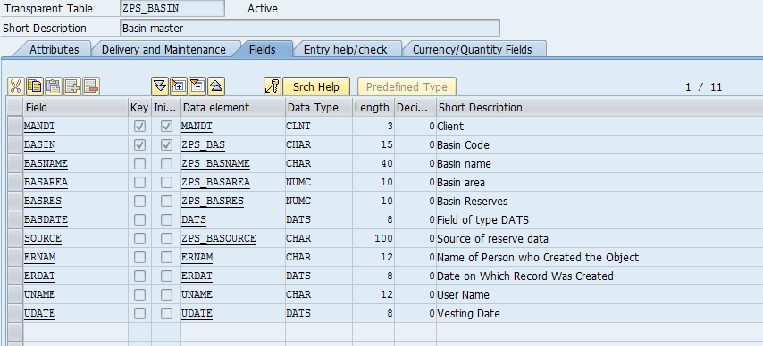

Transaction Codes

A.1.3.1.2.1 ZOPSBASIN01
This Transaction Code is used to Create Basin Master.

Whenever you open this transaction and fill the required fields along with that of other fields, the data will be updated in the table ZPS_BASIN for the particular Basin Code.

Depending upon the Particular Basin Code, you can change the data of that Basin.
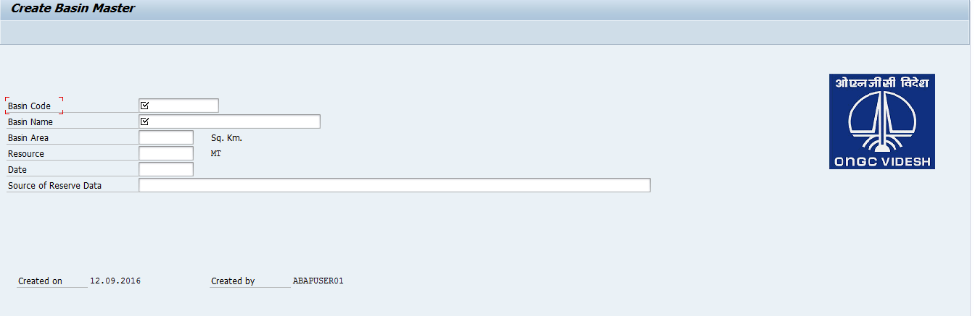

A.1.3.1.2.2 ZOPSBASIN02
This Transaction Code is used to Change Basin Master.

When Basin has been created successfully you can change the Basin details for the particular Basin Code through this Transaction. It will query the table ZPS_BASIN to check whether the record has been created or not. If it will find the records then the changes are made accordingly and otherwise it will give an error. Once the Data has been changed successfully it will update the table ZPS_BASIN.

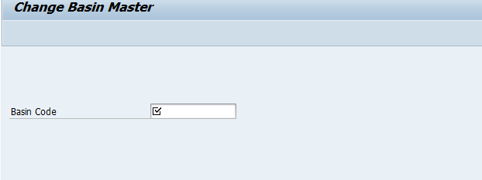

After entering the Basin Code, you can Change Basin Master Data.
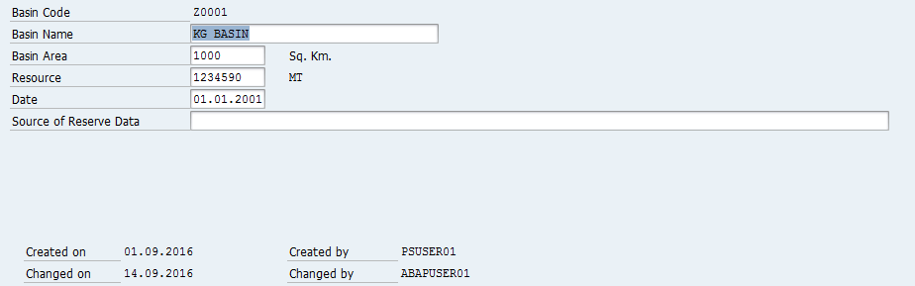

A.1.3.1.2.3 ZOPSBASIN03
This Transaction Code is used to Display Basin Master.

When Basin has been created successfully, you can Display the Basin details for the particular Basin Code through this Transaction. It will query the table ZPS_BASIN to check whether the record has been created or not. If it will find the record then it will Display the details accordingly and otherwise it will give an error.

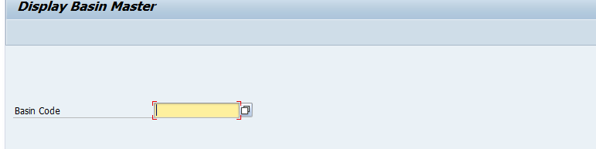

After entering the Basin Code, you can Display Basin Master Data.

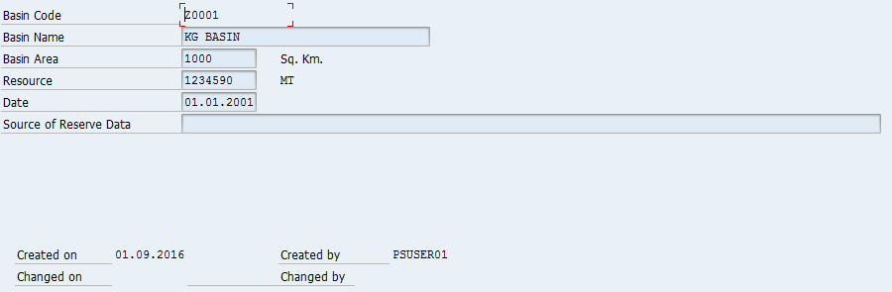

Unit Testing

Verification of constraints

Data volumes

Performance

Data protection

Data security

Internationalisation/Localisation aspects

Portability

Compatibility to previous versions

Legal Aspects

Test Programs/Test Environment

Appendix

Related Documents

Overview of Modifications

Restrictions

Alternative Design Ideas

Open Issues

