A1

Step1: Install Vmware Workstation for launcing the virtual machines. Launch the first Virtual machine that is Ubuntu.

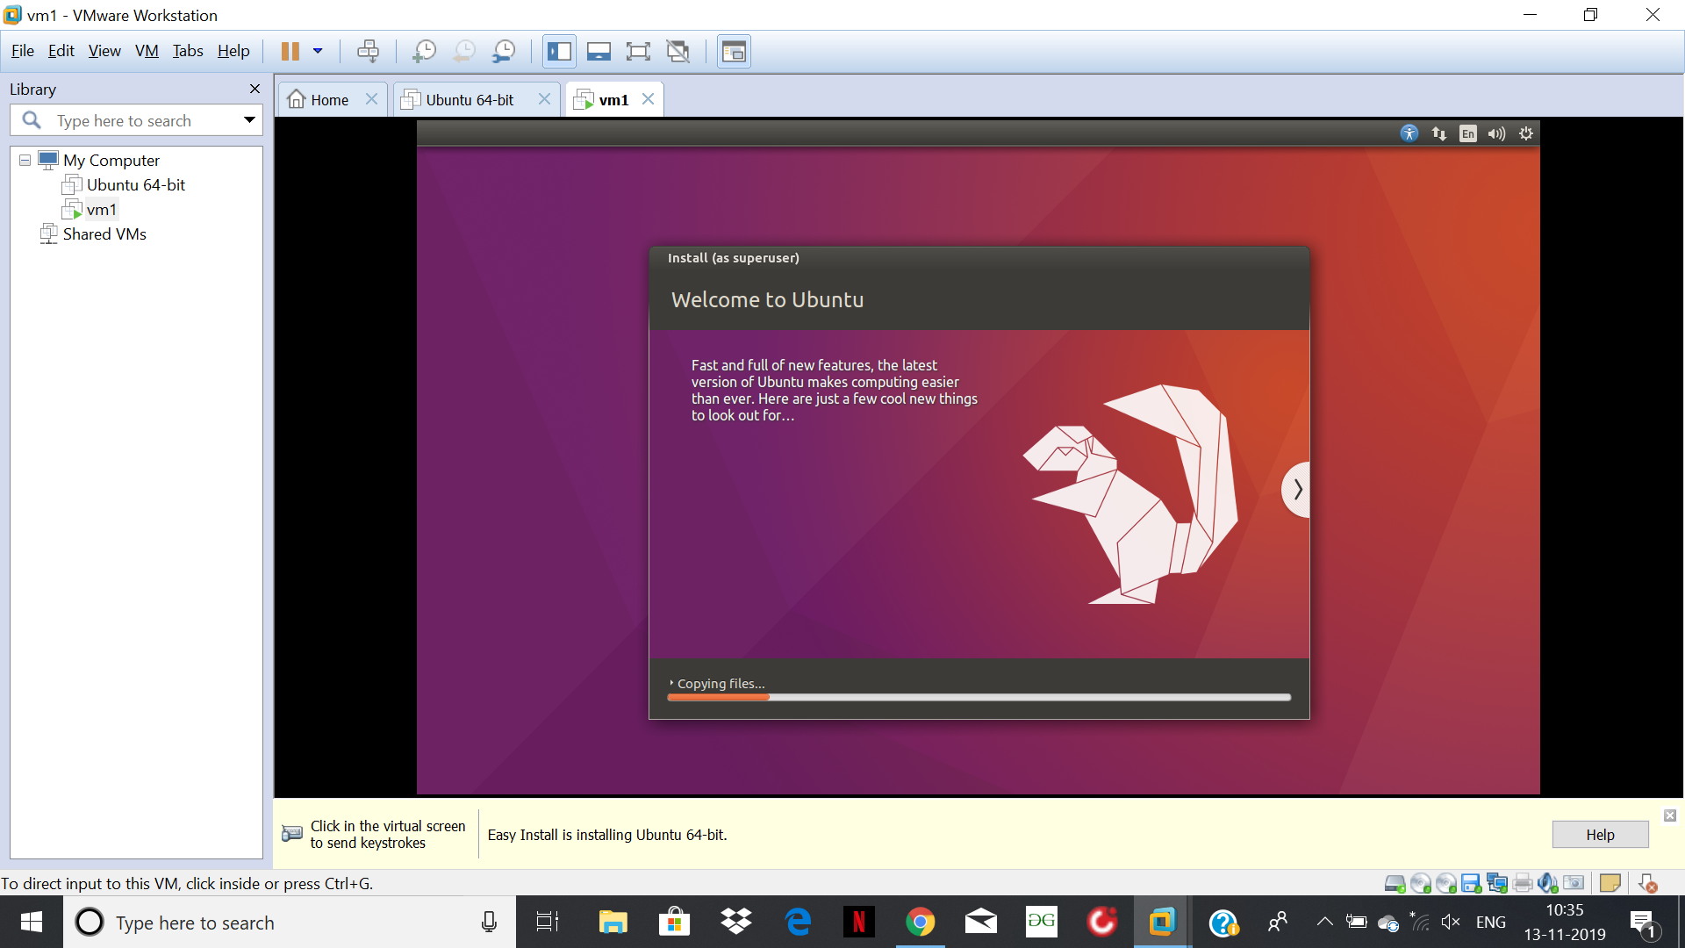

Step2: Go to terminal and update it for downloading all the packages.

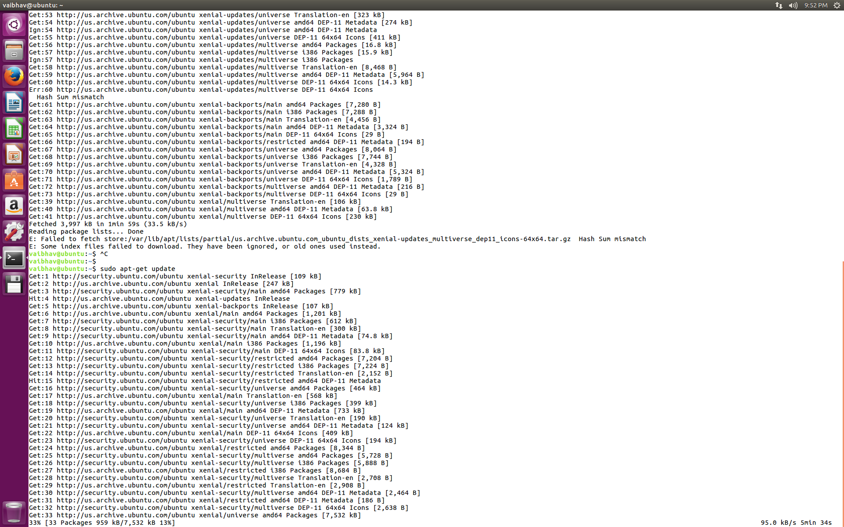

Step3: Run the command to download and install Wireshark in Ubuntu virtual machine 1.

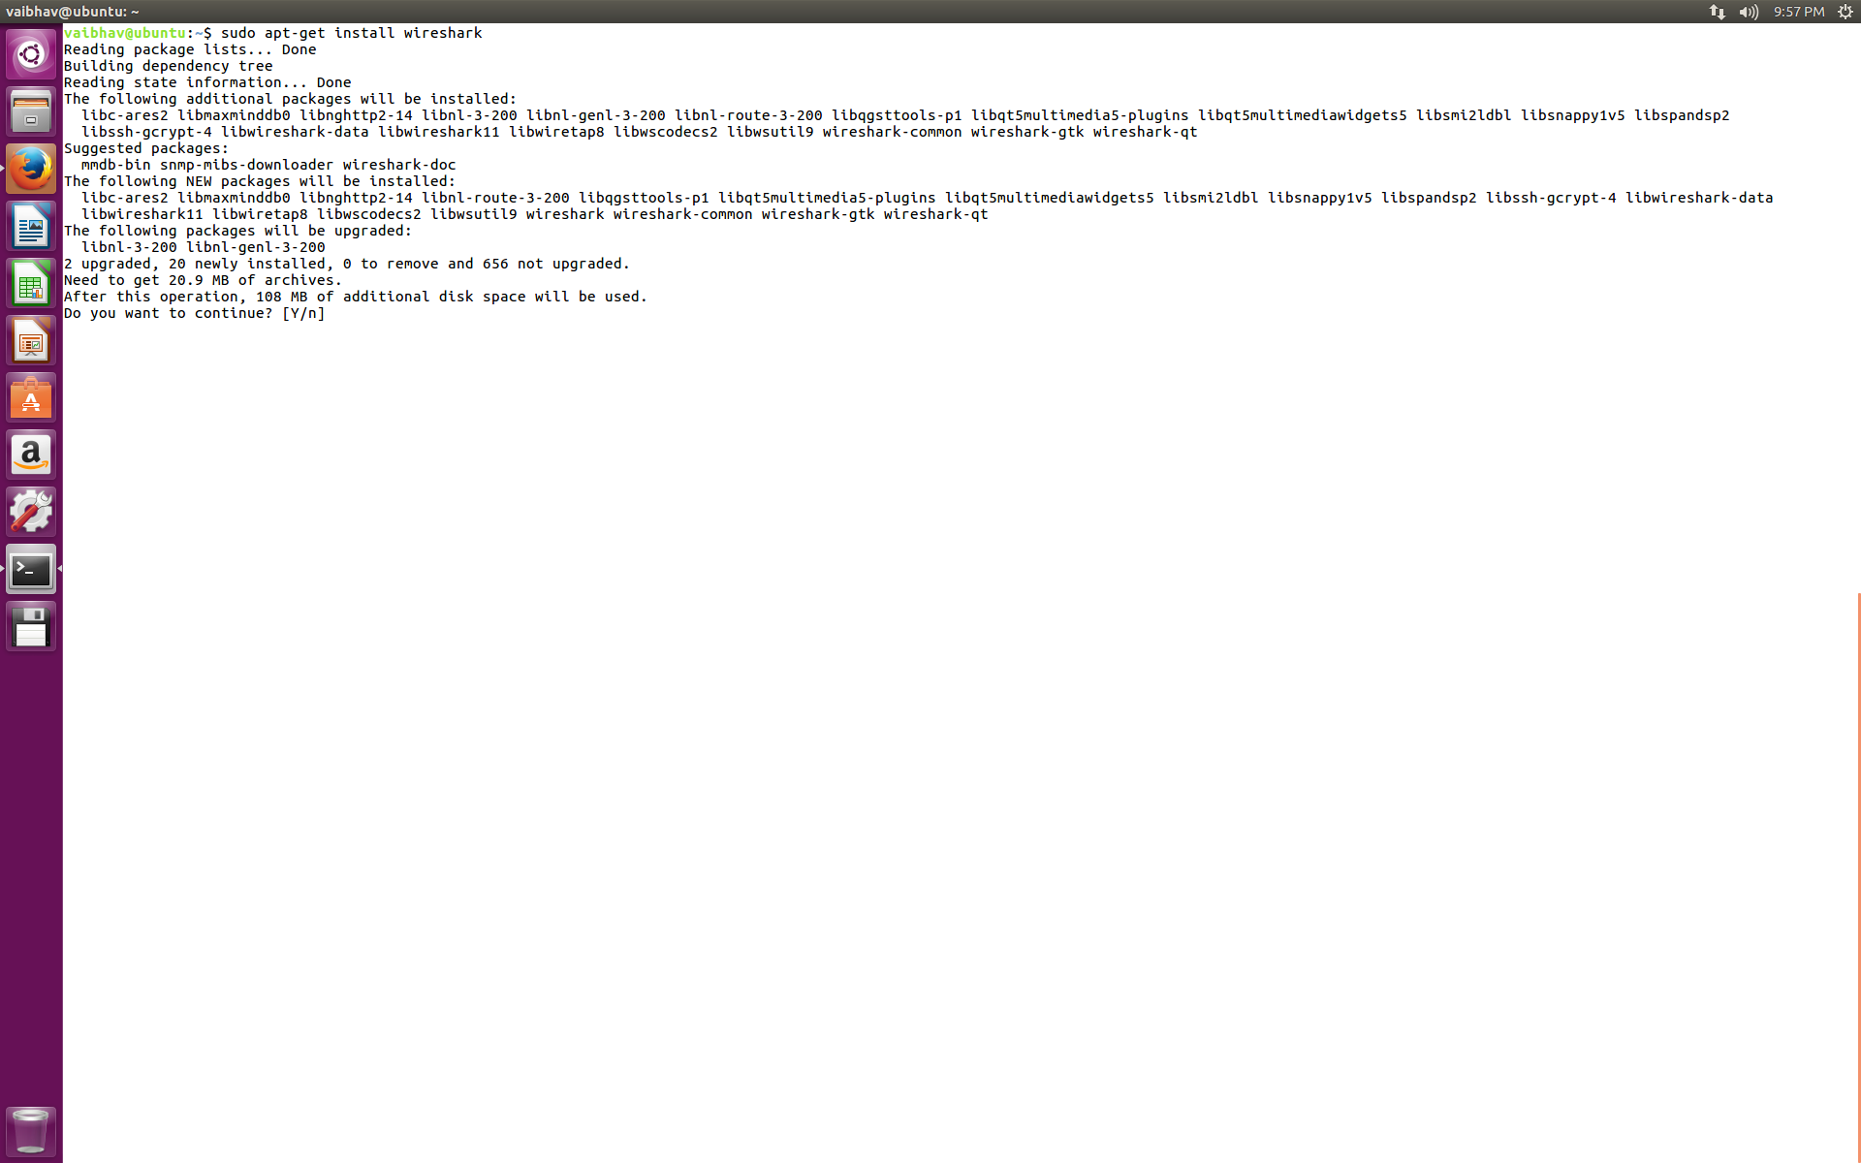

Step4: Wireshark is installed. Open Wireshark.

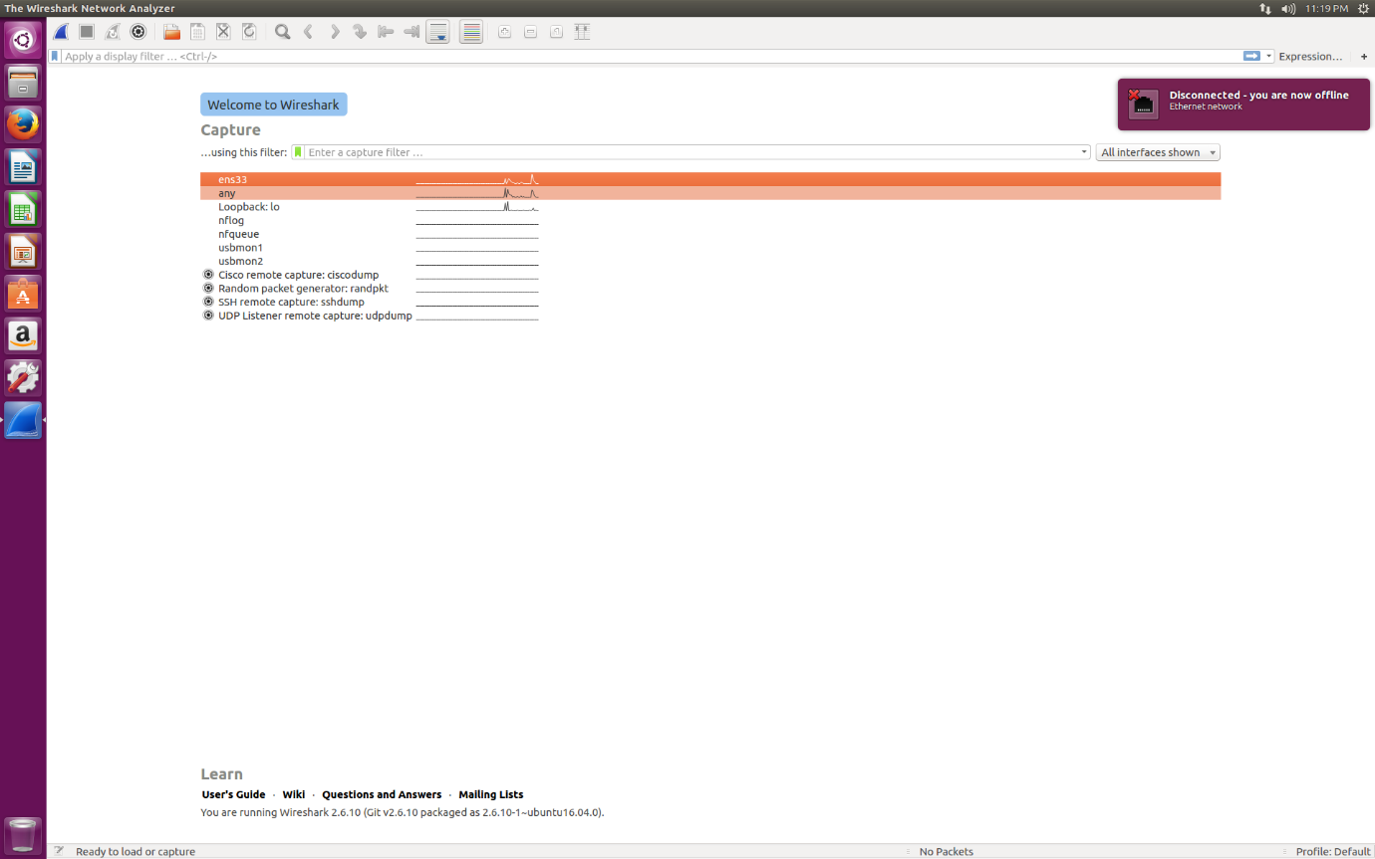

Step5: Capture the packets Using wireshark in Vm1.

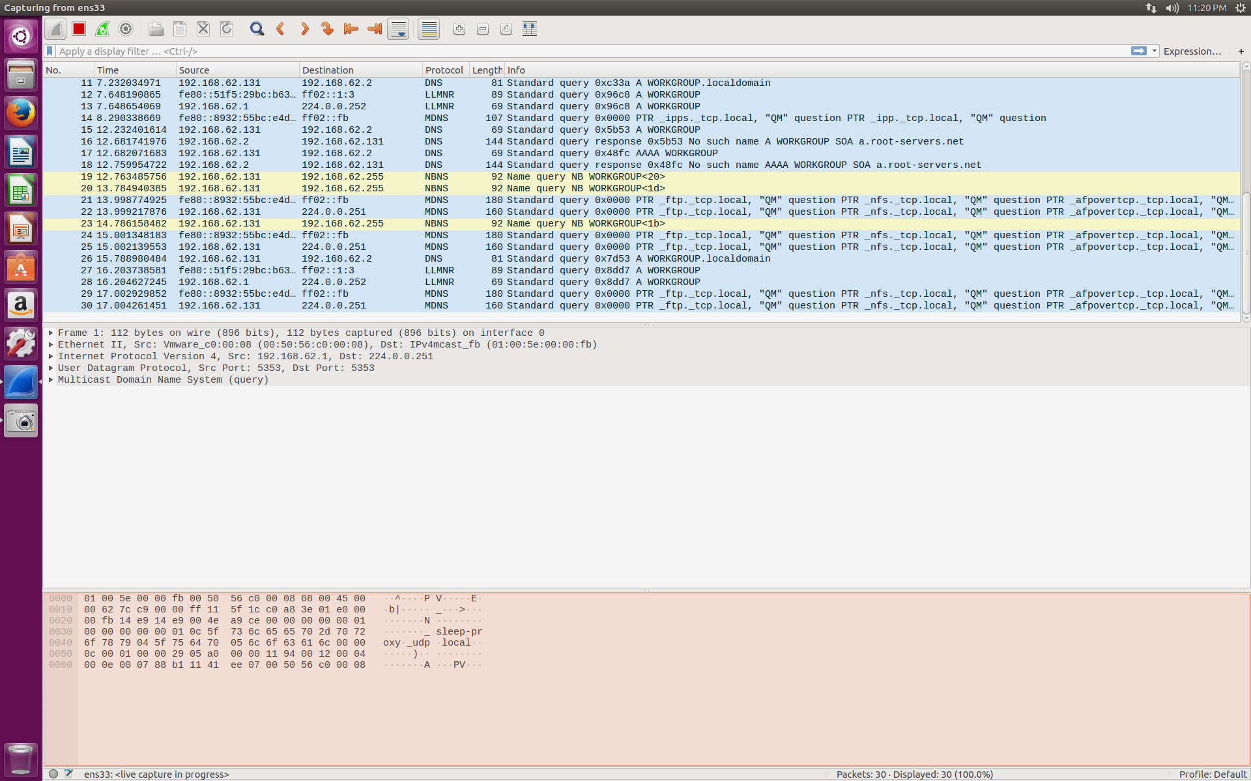

Step 6: Install virtual machine 2.

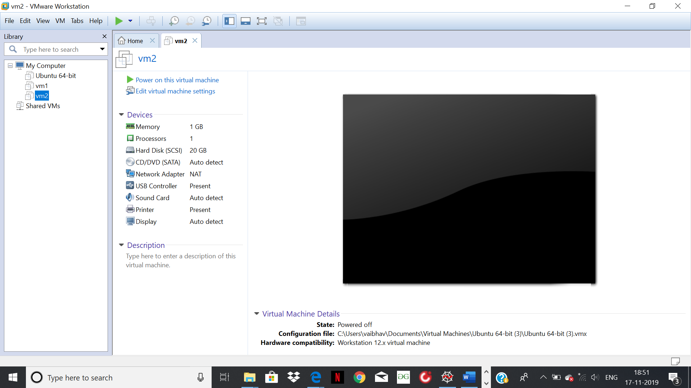

Step 7: Run the command sudo-apt get update to download all the packages and dependencies.



Step 8: Install Wireshark in virtual machine2.

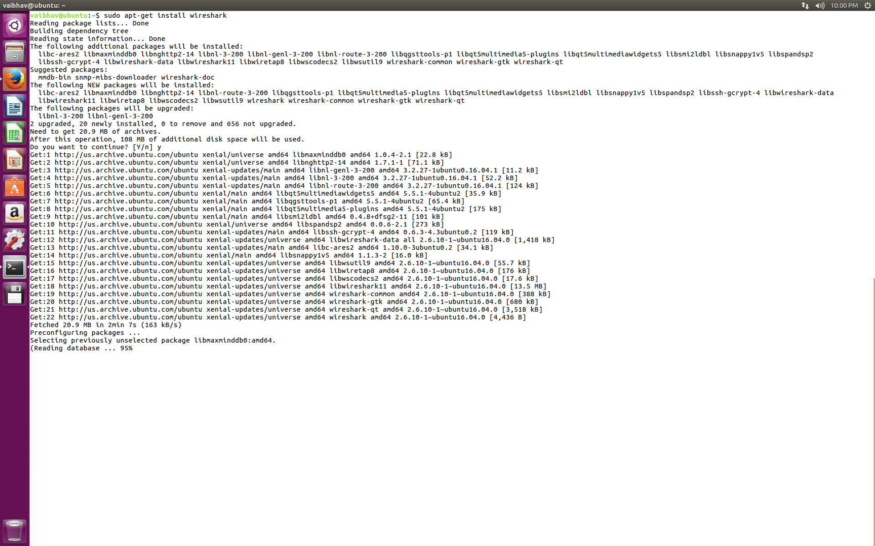

Step 9: Capture the packets in virtual machine2 using wireshark.

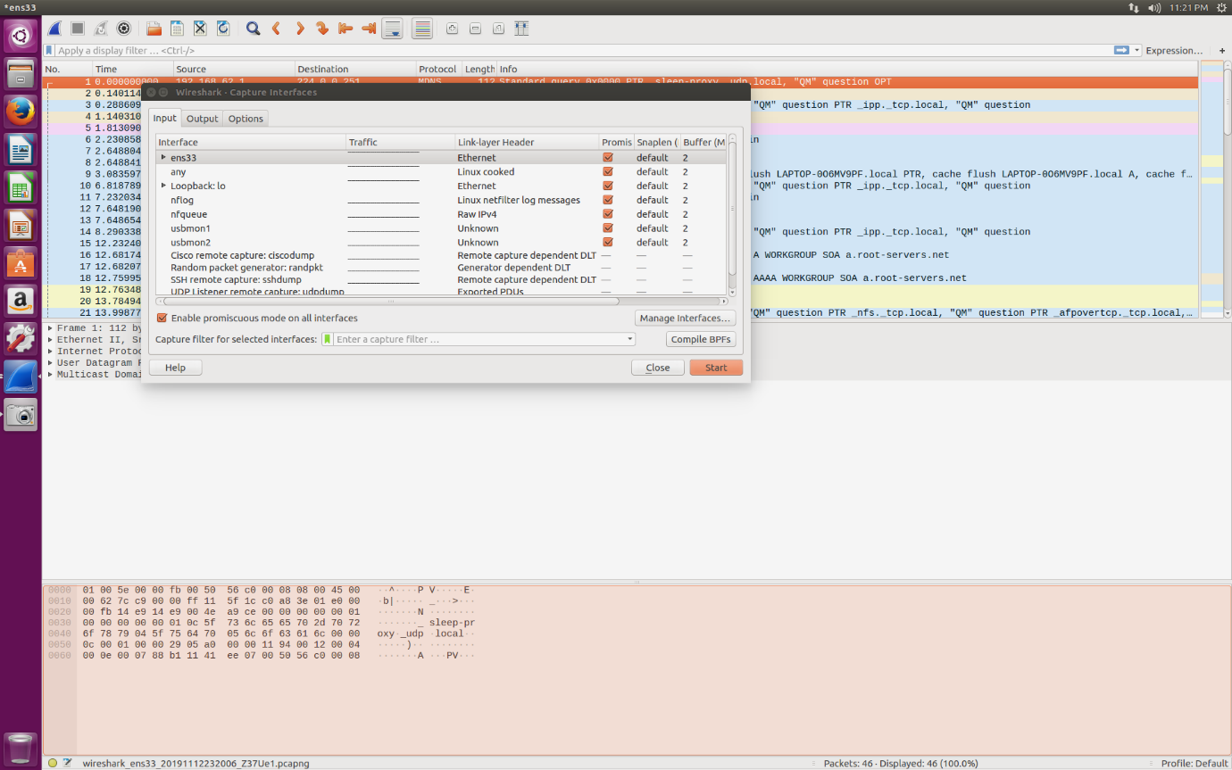

Step 10: Install tcp-dump in Vm1.

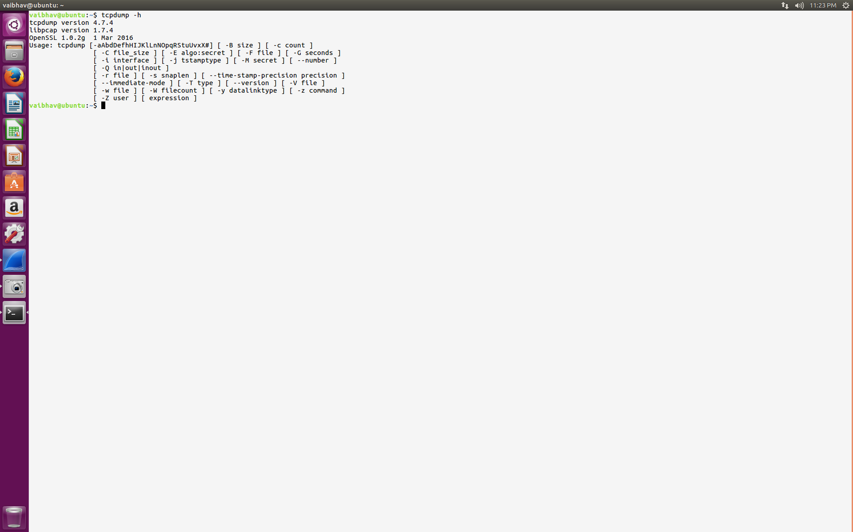

Step 11: Install tcpdump in Vm2.

