A5: Perform practical 2 and practical 3 in EC2 as well.

Step 1: Launch two virtual machines in EC2 of AWS.

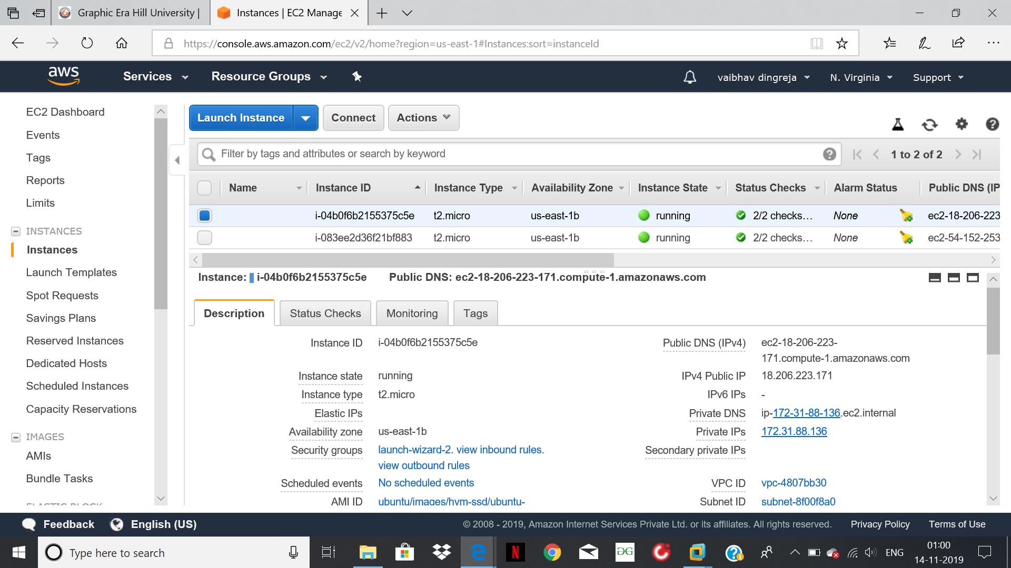

Step 2: Capture the packets using Wireshark.

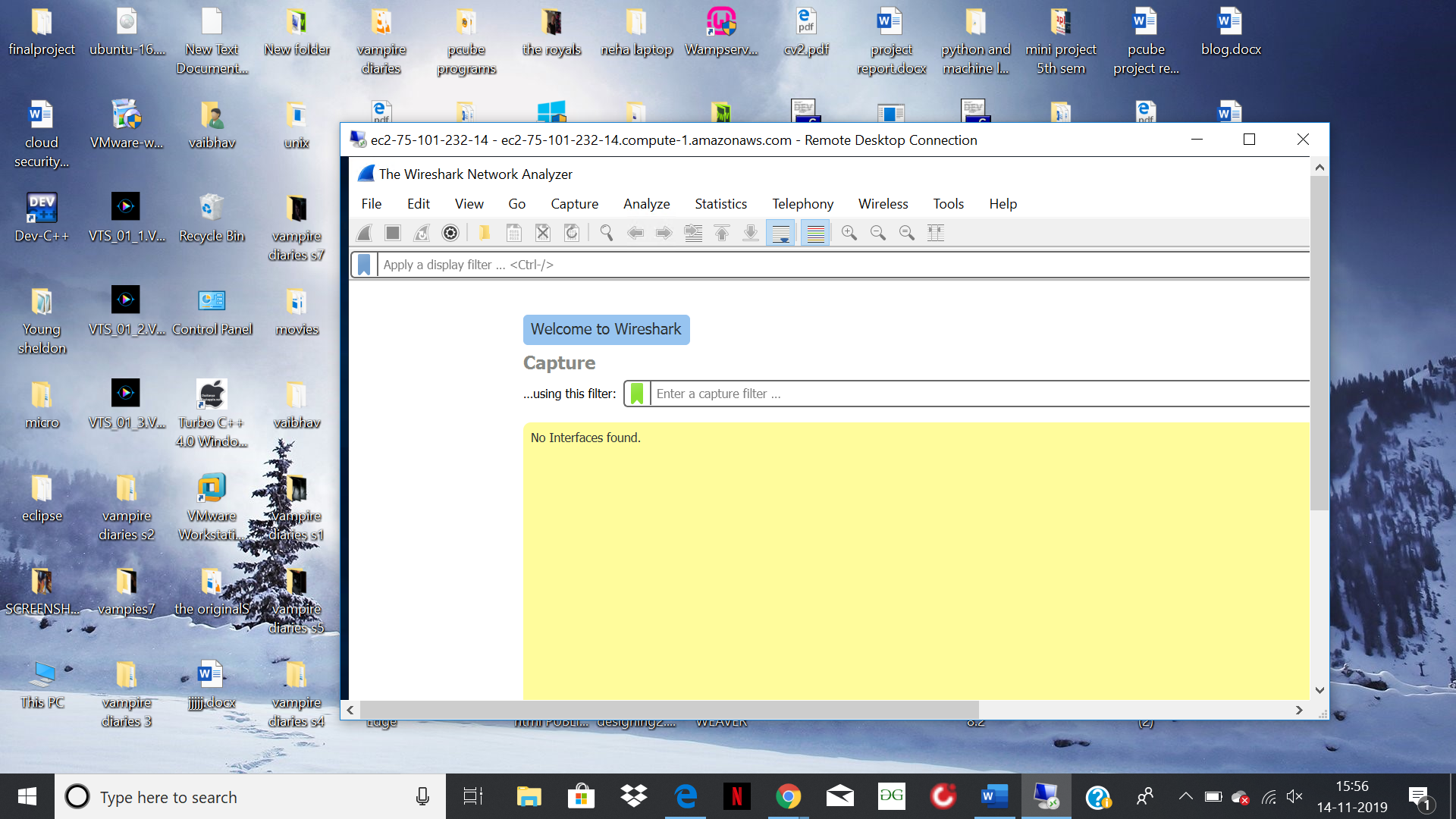

Step 3: Capture the packets from VM1.

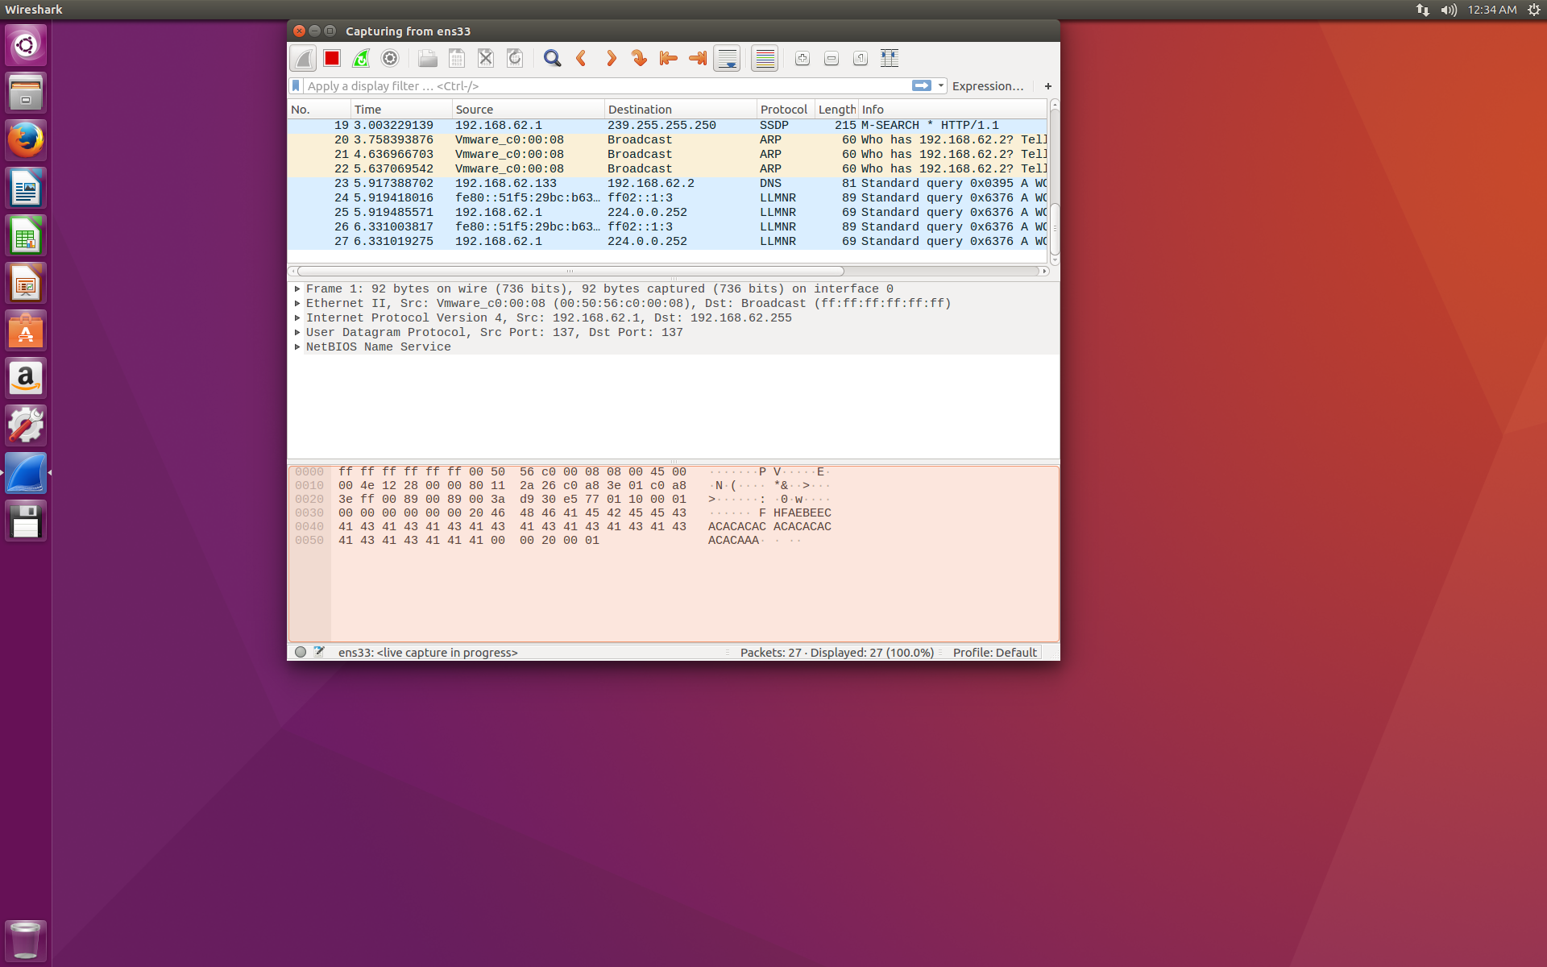

Step 4: Start virtual machine 2 and download wireshark in it.

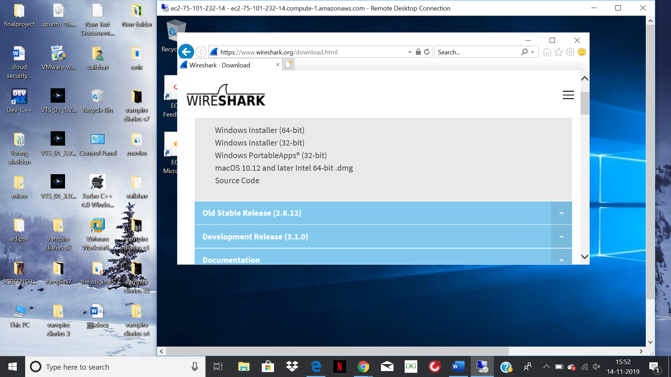

Step 5: Capture the packets of Virtual machine 2.

