Logistics Data Analyst Internship
Week 3 Report
Advanced Data Analysis and Visualization in Logistics
Project: Last-Mile Delivery Optimization for an E-commerce Company

Name: Vaibhav Nandlal Gangurde Date: October 2026

1. Introduction
This report analyses the cleaned last-mile delivery dataset prepared in Week 2 (3,000 orders) using Python. The goal is to understand how delivery time and cost behave, which factors cause delays, and where operational bottlenecks exist. The analysis uses pandas for calculations and matplotlib and seaborn for visualization. All results in this report were produced by the script week3_eda_visualization.py.

1.1 Dataset Structure and Key Variables
Variable | Role in the analysis
Delivery_Time_min | Main performance metric; promised delivery time is 60 minutes
Distance_km, load_kg | Shipment characteristics that drive time and cost
Shipping_Cost | Transportation cost per delivery (Rs)
Traffic, Weather, hour, is_peak_hour | Operating conditions that may cause delay
Vehicle_Type, Agent_Rating | Resource attributes
is_late | 1 if delivery time is above 60 minutes, otherwise 0

2. Exploratory Data Analysis (EDA)
EDA starts with numeric summaries: central tendency (mean, median), spread (standard deviation), shape (skewness) and relationships (correlation).
# ---- Step 1: Exploratory Data Analysis ----
num = ["Distance_km", "Delivery_Time_min", "Shipping_Cost", "load_kg", "Agent_Rating"]
print(df[num].describe().round(2))
print("Skewness:\n", df[num].skew().round(2))
corr = df[num].corr().round(2)
print(corr)
print("Late-delivery rate: %.1f%%" % (df["is_late"].mean() * 100))

Variable | Mean | Median | Std Dev | Min | Max
Distance_km | 13.1 | 13.0 | 6.9 | 1.0 | 25.0
Delivery_Time_min | 56.2 | 55.8 | 19.8 | 7.6 | 108.3
Shipping_Cost | 108.6 | 108.7 | 42.6 | 9.2 | 200.6
load_kg | 20.8 | 20.8 | 11.4 | 1.0 | 40.0

Delivery time has a mean of 56.2 minutes and a median of 55.8 minutes. The two are almost equal and the skewness is 0.05, so the distribution is nearly symmetrical. The standard deviation of 19.8 minutes shows that individual deliveries vary a lot around the average. 42.1% of all deliveries exceeded the promised 60 minutes, which is far above the 18% problem level described in Week 1 and confirms a serious service gap in this dataset.

2.1 Correlations
Pair | Correlation | Interpretation
Distance vs Delivery Time | 0.85 | Strong positive: longer distance, longer time
Distance vs Shipping Cost | 0.97 | Very strong positive: distance is the main cost driver
Load vs Shipping Cost | 0.12 | Weak positive: weight adds a little cost
Agent Rating vs Delivery Time | -0.01 | No relationship in this data

3. Visualizations and Interpretation
Six charts were created. Each chart type was selected to match the question being asked. The code that generates all charts is shown first.
# ---- Step 2: Visualizations ----
# 1. Histogram: distribution of delivery time
plt.figure(figsize=(7, 4))
sns.histplot(df["Delivery_Time_min"], bins=30, kde=True, color="#2E75B6")
plt.axvline(60, color="red", linestyle="--", label="Promised time (60 min)")
plt.title("Distribution of Delivery Time"); plt.xlabel("Delivery time (min)"); plt.legend()
plt.tight_layout(); plt.savefig("charts/1_delivery_time_hist.png", dpi=150); plt.close()

# 2. Box plot: delivery time by traffic level
plt.figure(figsize=(7, 4))
sns.boxplot(data=df, x="Traffic", y="Delivery_Time_min", order=["Low", "Medium", "High"], palette="Blues")
plt.title("Delivery Time by Traffic Level"); plt.ylabel("Delivery time (min)")
plt.tight_layout(); plt.savefig("charts/2_traffic_boxplot.png", dpi=150); plt.close()

# 3. Scatter + regression line: distance vs delivery time
plt.figure(figsize=(7, 4))
sns.regplot(data=df.sample(800, random_state=1), x="Distance_km", y="Delivery_Time_min",
scatter_kws={"alpha": 0.4, "s": 15}, line_kws={"color": "red"})
plt.title("Distance vs Delivery Time"); plt.xlabel("Distance (km)"); plt.ylabel("Delivery time (min)")
plt.tight_layout(); plt.savefig("charts/3_distance_scatter.png", dpi=150); plt.close()

# 4. Line chart: average delivery time by hour of day (finds peak-hour bottlenecks)
hourly = df.groupby("hour")["Delivery_Time_min"].mean()
plt.figure(figsize=(7, 4))
plt.plot(hourly.index, hourly.values, marker="o", color="#1F3864")
plt.title("Average Delivery Time by Hour of Day"); plt.xlabel("Hour"); plt.ylabel("Minutes")
plt.tight_layout(); plt.savefig("charts/4_hourly_trend.png", dpi=150); plt.close()

# 5. Heatmap: correlation matrix
plt.figure(figsize=(6, 4.5))
sns.heatmap(corr, annot=True, cmap="Blues", vmin=-1, vmax=1)
plt.title("Correlation Heatmap"); plt.tight_layout()
plt.savefig("charts/5_correlation_heatmap.png", dpi=150); plt.close()

# 6. Bar chart: late-delivery rate by weather and vehicle
late = df.groupby(["Weather", "Vehicle_Type"])["is_late"].mean().mul(100).reset_index()
plt.figure(figsize=(7, 4))
sns.barplot(data=late, x="Weather", y="is_late", hue="Vehicle_Type", palette="Blues")
plt.title("Late-Delivery Rate by Weather and Vehicle"); plt.ylabel("Late deliveries (%)")
plt.tight_layout(); plt.savefig("charts/6_late_rate_weather.png", dpi=150); plt.close()

3.1 Histogram: Distribution of Delivery Time
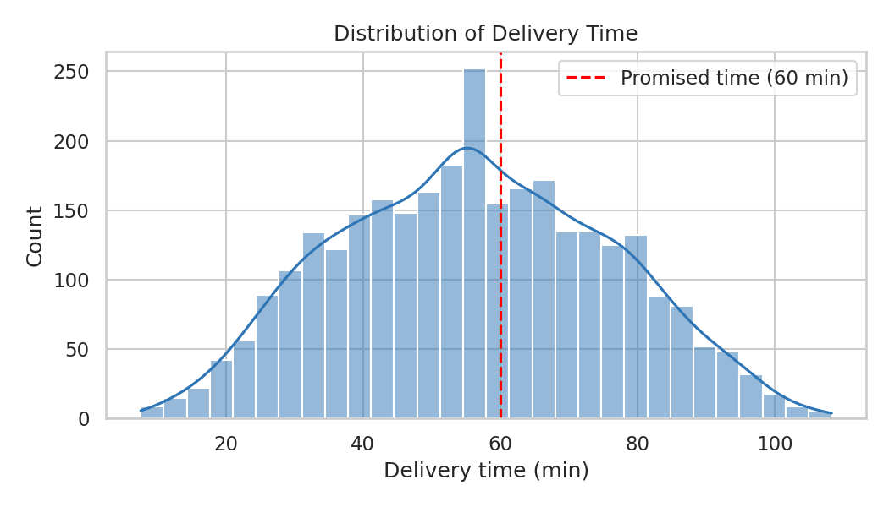
Figure 1: Distribution of delivery time with the 60-minute promise
Why a histogram: it shows the shape and spread of a single continuous variable. The red line marks the 60-minute promise, so everything to its right is a late delivery. A large part of the distribution lies beyond this line, which visually confirms the high late rate.

3.2 Box Plot: Delivery Time by Traffic Level
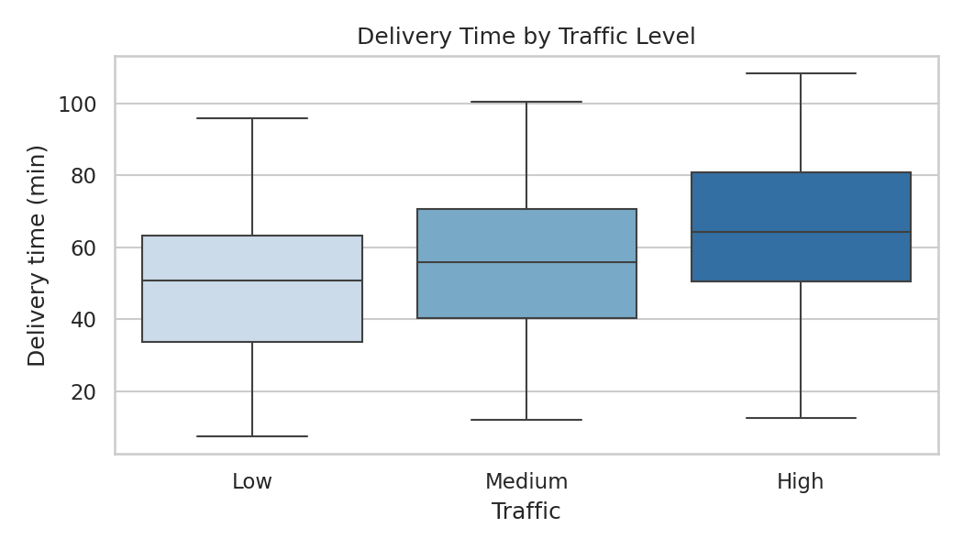
Figure 2: Delivery time by traffic level
Why a box plot: it compares the median and spread of a number across categories. Average delivery time is 49.1 min in low traffic, 55.8 min in medium traffic and 65.4 min in high traffic, so high traffic adds about 16 minutes compared with low traffic.

3.3 Scatter Plot with Regression Line: Distance vs Delivery Time
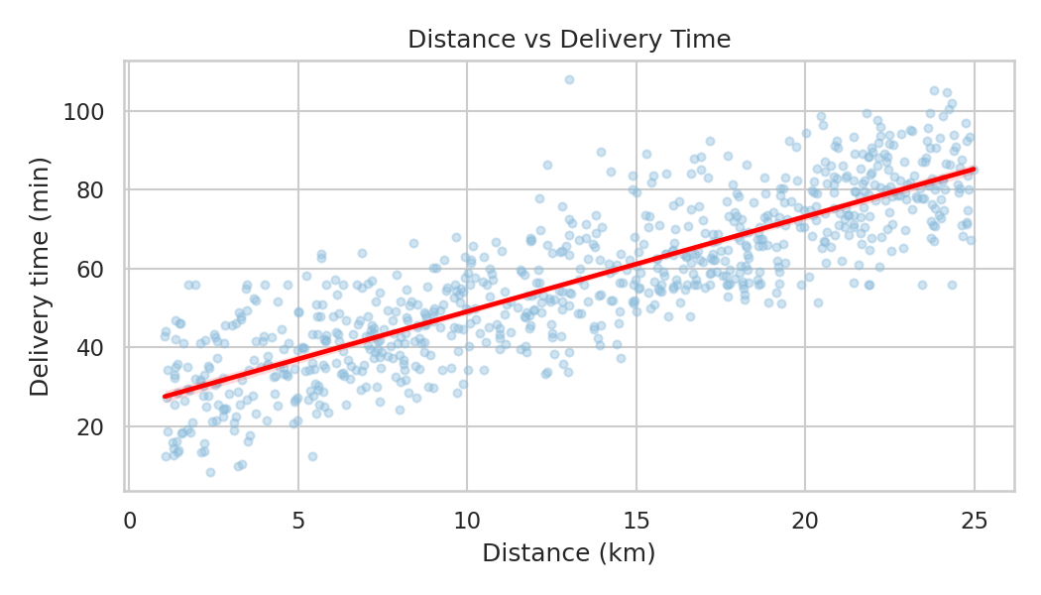
Figure 3: Distance vs delivery time
Why a scatter plot: it shows the relationship between two continuous variables. The points follow a clear upward line (correlation 0.85), so distance is the biggest single driver of time. This also tells us that a regression model will work well in Week 4.

3.4 Line Chart: Average Delivery Time by Hour
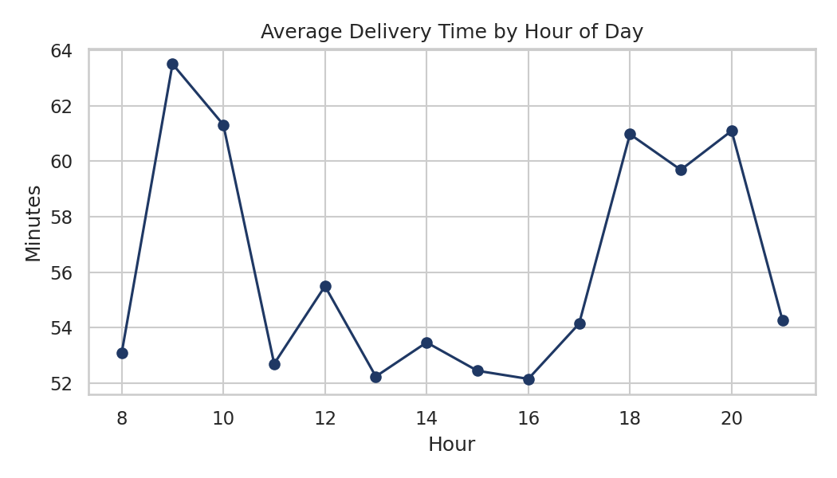
Figure 4: Average delivery time by hour of day
Why a line chart: it shows a trend over an ordered variable (time). Two clear peaks appear, in the morning (9-10) and evening (18-20) rush hours. The slowest hour is 9 AM with 63.5 minutes, while the fastest is 4 PM with 52.1 minutes. Peak-hour orders take 61.3 minutes on average versus 53.4 minutes at other times, and 49.9% of peak-hour orders are late versus 37.7%.

3.5 Heatmap: Correlation Matrix
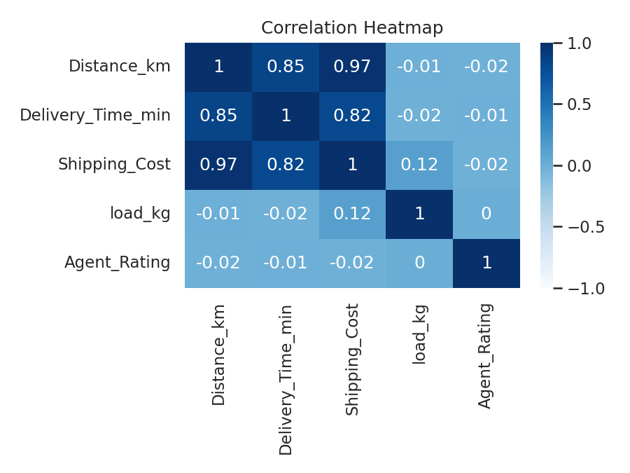
Figure 5: Correlation heatmap of numeric variables
Why a heatmap: it compresses many pairwise relationships into one picture. Distance is strongly linked with both time and cost, while load and agent rating have almost no relationship with delivery time. This helps in selecting important variables for modelling.

3.6 Bar Chart: Late-Delivery Rate by Weather and Vehicle
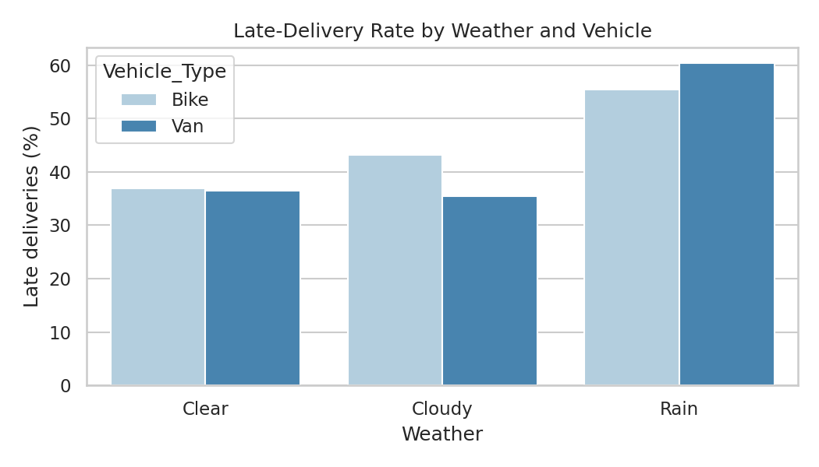
Figure 6: Late-delivery rate by weather and vehicle type
Why a grouped bar chart: it compares a rate across two categorical variables. Rain raises the late rate to 56.8%, compared with 36.8% in clear weather. Vans (40.7%) and bikes (42.6%) are similar, so vehicle type is not the main cause of lateness.

4. Analytical Insights

4.1 Operational Efficiency
- On-time performance: Only 57.9% of deliveries meet the 60-minute promise.
- Agents: Agent rating has no effect on delivery time, so the delays are caused by conditions and planning, not by individual agent performance.

4.2 Cost Drivers
- Distance: Distance has a 0.97 correlation with cost. Reducing kilometres travelled is the most effective way to reduce cost per delivery.
- Vehicle type: Average cost is almost identical for bikes (Rs 108.5) and vans (Rs 108.8) in this data, so allocating vans only where load requires it can save resources.

4.3 Bottlenecks
- Peak hours: 9-10 AM and 6-8 PM deliveries are about 7.9 minutes slower.
- Weather: Rain increases the late rate by 20 percentage points.
- Combined effect: The combination of high traffic and rain gives a 71% late rate, compared with only 24.9% in low traffic and clear weather.

5. Recommendations
- Build routes that minimize total distance, for example by grouping nearby addresses into zones (Week 4).
- Use realistic promised times that depend on distance, traffic and weather instead of one fixed 60 minutes.
- Add extra riders or stagger dispatch during 9-10 AM and 6-8 PM, and move non-urgent orders to quieter hours.
- Create a rain protocol: more buffer time, early warnings to customers and priority for short routes.
- Track KPIs by traffic, weather and hour on a dashboard so that managers see bottlenecks as they happen.

6. Conclusion
The exploratory analysis and six visualizations show that delivery time and cost are driven mainly by distance, while traffic, rush hours and rain create the main bottlenecks. Agent rating and vehicle type had little effect. These findings guide the Week 4 predictive model and optimization strategies. Note: the dataset is simulated, so exact numbers will differ on real company data, but the analysis method stays the same.

