Logistics Data Analyst Internship
Week 4 Report
Predictive Modeling and Optimization in Logistics Systems
Project: Last-Mile Delivery Optimization for an E-commerce Company

Name: Vaibhav Nandlal Gangurde Date: October 2026

1. Problem Definition
Customers are promised a delivery time, but 42% of deliveries in the analysed data arrive later than 60 minutes. If the company could predict the delivery time of each order before dispatch, it could give realistic promises, flag risky orders early and plan routes and vehicles better. The prediction problem is therefore defined as:
- Problem: Predict Delivery_Time_min (in minutes) for a new order using information known at dispatch time.
- Type: Supervised regression (target is a continuous number).
- Business goal: Reduce late deliveries and cost per delivery by using the predictions for flagging, routing and vehicle allocation.

1.1 Dataset, Features and Target
The dataset is the cleaned simulated delivery data from Weeks 2 and 3 (3,000 orders), structured like the public Amazon Delivery Dataset. Only information available before the delivery starts is used, so that the model can really be used in practice.
Feature | Description
Distance_km | Distance from hub to customer
Traffic, Weather | Categorical conditions, one-hot encoded
Vehicle_Type | Bike or Van, one-hot encoded
hour, is_peak_hour | Hour of dispatch and rush-hour flag
load_kg | Parcel weight
Target: Delivery_Time_min | Delivery time to be predicted (minutes)

After one-hot encoding there are 9 input columns. The data was split 80/20 into 2400 training and 600 test orders.
# ---- Step 1: Data preparation ----
features = ["Distance_km", "Traffic", "Weather", "Vehicle_Type", "hour", "is_peak_hour", "load_kg"]
X = pd.get_dummies(df[features], drop_first=True)
y = df["Delivery_Time_min"]
X_train, X_test, y_train, y_test = train_test_split(X, y, test_size=0.2, random_state=42)

2. Model Selection and Implementation
Four regression models of increasing complexity were compared:
- Linear Regression: A simple, fast and fully explainable baseline. Delivery time is expected to grow roughly in proportion to distance, so it should work well.
- Decision Tree: Easy to explain with rules (for example, if distance is above X and traffic is high), but a single tree can overfit.
- Random Forest: An ensemble of many trees that reduces overfitting and handles non-linear patterns and interactions.
- Gradient Boosting: Builds trees one after another, each correcting the errors of the previous one; usually very accurate on tabular data.
# ---- Step 2: Train and compare models ----
models = {
"Linear Regression": LinearRegression(),
"Decision Tree": DecisionTreeRegressor(max_depth=6, random_state=42),
"Random Forest": RandomForestRegressor(n_estimators=200, random_state=42, n_jobs=-1),
"Gradient Boosting": GradientBoostingRegressor(random_state=42),
}
rows = []
for name, m in models.items():
m.fit(X_train, y_train)
pred = m.predict(X_test)
cv = cross_val_score(m, X, y, cv=5, scoring="r2").mean() # 5-fold cross-validation
rows.append({"Model": name,
"MAE": mean_absolute_error(y_test, pred),
"RMSE": np.sqrt(mean_squared_error(y_test, pred)),
"R2": r2_score(y_test, pred),
"CV_R2": cv})
results = pd.DataFrame(rows).round(3)
print(results)

3. Evaluation and Validation

3.1 Metrics Used
- MAE (Mean Absolute Error): Average absolute error in minutes. Easy for managers to understand.
- RMSE (Root Mean Squared Error): Square root of the average squared error. Penalizes large mistakes more strongly.
- R-squared (R2): Share of variation in delivery time explained by the model (1.0 is perfect).
- 5-fold Cross-Validation (CV R2): Average R2 over 5 train/validation splits, which checks that the result is stable and not due to a lucky split.

3.2 Model Comparison
Model | MAE (min) | RMSE (min) | R2 | CV R2 (5-fold)
Linear Regression | 4.79 | 6.30 | 0.899 | 0.892
Decision Tree | 5.87 | 7.51 | 0.856 | 0.844
Random Forest | 5.33 | 6.92 | 0.878 | 0.859
Gradient Boosting | 5.06 | 6.58 | 0.890 | 0.882

All four models explain between 86% and 90% of the variation in delivery time. Linear Regression performed best (MAE 4.79 min) and Gradient Boosting was a close second (MAE 5.06 min). This is reasonable, because in this simulated data delivery time grows almost linearly with distance and condition delays are additive. On real data with complex interactions (for example, rain combined with specific roads), tree-based ensembles usually gain an advantage, which is why Gradient Boosting was selected for tuning and deployment-style analysis: it is almost as accurate and can capture non-linear effects when they exist.

3.3 Hyperparameter Tuning
GridSearchCV tested 12 combinations of n_estimators, max_depth and learning_rate for Gradient Boosting using 5-fold cross-validation and MAE as the score.
# ---- Step 3: Hyperparameter tuning ----
grid = GridSearchCV(
GradientBoostingRegressor(random_state=42),
param_grid={"n_estimators": [100, 200], "max_depth": [2, 3, 4], "learning_rate": [0.05, 0.1]},
cv=5, scoring="neg_mean_absolute_error", n_jobs=-1)
grid.fit(X_train, y_train)
best = grid.best_estimator_
pred = best.predict(X_test)
print("Best params:", grid.best_params_)
print("Tuned MAE: %.2f | RMSE: %.2f | R2: %.3f" % (
mean_absolute_error(y_test, pred), np.sqrt(mean_squared_error(y_test, pred)), r2_score(y_test, pred)))

Result | Value
Best parameters | learning_rate = 0.1, max_depth = 2, n_estimators = 200
Tuned MAE | 4.99 minutes
Tuned RMSE | 6.52 minutes
Tuned R2 | 0.892

The tuned model predicts delivery time with an average error of about 4.99 minutes, which is small compared with the 60-minute promise and good enough for planning decisions.
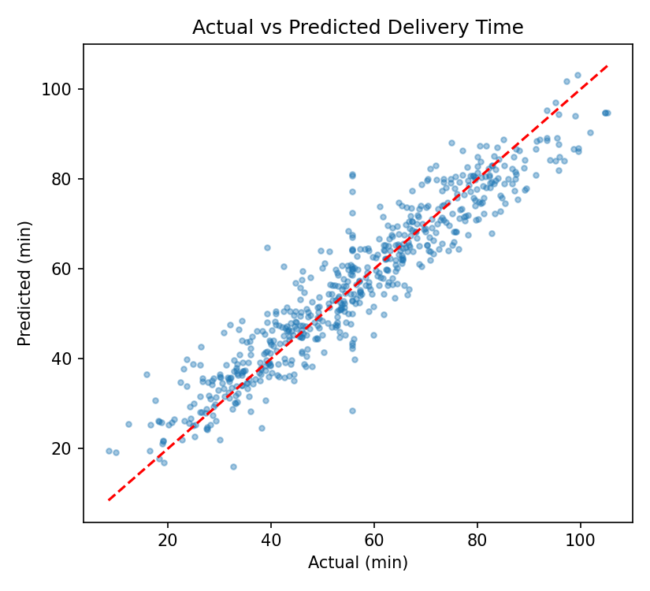
Figure 1: Actual vs predicted delivery time (test set). Points close to the red line are accurate predictions.
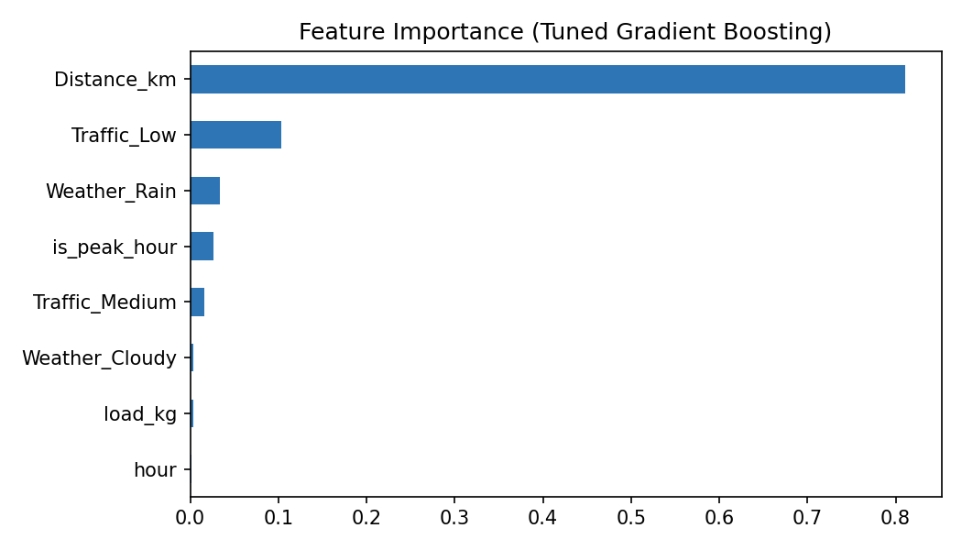
Figure 2: Feature importance of the tuned model
Feature importance shows that distance explains most of the prediction (81%), followed by low traffic (10%), rain (3.4%) and peak hour (2.7%). This agrees with the Week 3 analysis and gives the business confidence in the model.

4. Optimization Strategies
A prediction is only useful if it leads to a better decision. Three optimization strategies were built on the model insights.
# ---- Step 4: Optimization using model insights ----
# 4a. Late-risk flagging: predicted time above promised 60 min
test = df.loc[X_test.index].copy()
test["pred_time"] = pred
test["risk_late"] = test["pred_time"] > 60
res["flagged_pct"] = round(float(test["risk_late"].mean() * 100), 1)
res["flag_precision"] = round(float((test.loc[test.risk_late, "Delivery_Time_min"] > 60).mean() * 100), 1)
res["flag_recall"] = round(float(test.loc[test.Delivery_Time_min > 60, "risk_late"].mean() * 100), 1)

# 4b. Zone-based vehicle allocation: cluster drop points into 8 zones (one rider per zone)
coords = df[["drop_latitude", "drop_longitude"]].values
df["zone"] = KMeans(n_clusters=8, random_state=42, n_init=10).fit_predict(coords)

def route_length(points): # total distance of visiting points in order
return np.sqrt((np.diff(points, axis=0) ** 2).sum(axis=1)).sum() * 111 # degrees -> km

def nearest_neighbour(points): # greedy route: always go to the closest next stop
left, order = list(range(1, len(points))), [0]
while left:
nxt = min(left, key=lambda i: np.linalg.norm(points[order[-1]] - points[i]))
order.append(nxt); left.remove(nxt)
return points[order]

before = after = 0
for z in range(8):
pts = df[df.zone == z].head(40)[["drop_latitude", "drop_longitude"]].values # 40 stops per route
before += route_length(pts) # current: stops visited in order received
after += route_length(nearest_neighbour(pts))
print("Route distance before: %.0f km | after: %.0f km | saving: %.1f%%" % (
before, after, (1 - after / before) * 100))

4.1 Late-Risk Flagging
Orders whose predicted time is above 60 minutes are flagged before dispatch. On the test set, 43.2% of orders were flagged. Of the flagged orders, 88.8% were truly late (precision), and 91.6% of all truly late orders were caught (recall). Dispatchers can give flagged orders a more experienced agent, a shorter route, an earlier slot or a more honest delivery promise to the customer.

4.2 Zone-Based Vehicle Allocation and Route Planning
Delivery points were grouped into 8 zones using K-Means clustering on latitude and longitude, with one rider or vehicle per zone. Inside each zone, the stops were ordered with a nearest-neighbour heuristic (always go to the closest unvisited stop). For 8 routes of 40 stops each, the total distance fell from 1429 km (stops visited in the order received) to 437 km, a saving of 69.4%.
Important note: this saving is large because the baseline visits stops in random order. Compared with an already reasonable manual route, real savings are usually much smaller (roughly 10 to 30 percent). In practice, the nearest-neighbour step can be replaced by Google OR-Tools, which solves the Vehicle Routing Problem with capacity and time-window constraints.

4.3 Peak-Hour Resource Planning and Cost Minimization
Peak-hour orders (1070 of 3,000) take about 7.9 minutes longer than other orders. Moving non-urgent orders out of the peak windows, adding temporary riders at 9-10 AM and 6-8 PM, and using the model to predict next-day volume would reduce delays at the busiest hours. Because cost grows with distance, shorter zone-based routes also reduce fuel and driver cost per delivery directly.

5. Recommendations
- Use the tuned model to show customers a realistic estimated delivery time at checkout.
- Flag orders predicted to exceed the promise and send them to the best available agent or slot.
- Divide the city into clustered zones and optimize routes inside each zone with an OR-Tools VRP solver.
- Staff the rush hours and rainy days more heavily, using the model to forecast demand.
- Retrain the model every month with new data and monitor MAE so that performance does not drift.

6. Limitations
- The data is simulated, so real-world accuracy will differ and must be checked on actual company data.
- Real delivery time also depends on factors not in the data, such as road closures, customer availability and parking.
- The routing heuristic does not use road-network distances or capacity limits; a full VRP solver is needed for production.

7. Conclusion
A complete predictive and optimization workflow was developed: problem definition, feature preparation, comparison of four models, cross-validation, hyperparameter tuning and evaluation. The final model predicts delivery time with an MAE of about 4.99 minutes and R2 of 0.892. Its insights support late-risk flagging, zone-based vehicle allocation, shorter routes and better peak-hour planning. Together, the four weeks show how a data-driven approach converts raw logistics records into faster deliveries, lower cost and better customer satisfaction.

References
- scikit-learn documentation: LinearRegression, DecisionTreeRegressor, RandomForestRegressor, GradientBoostingRegressor, GridSearchCV.
- Google OR-Tools: Vehicle Routing documentation (developers.google.com/optimization/routing).
- Kaggle: Amazon Delivery Dataset (kaggle.com).

