|  |  |  |  |  |  |
| --- | --- | --- | --- | --- | --- |
| **S.N** | **Input** | | | **Output** | |
| **BILLS** | **TIP%** | **Number Of People** | **TIP(Per Person $)** | **Total(Per Person $)** |
| 1. | 500 | 10 | 2 | 25 | 275 |
| 2. | 800 | 10 | 2 | 40 | 440 |
| 3. | 1000 | 10 | 2 | 50 | 550 |
| 4. | 1000 | 15 | 4 | 37.5 | 287.5 |
| 5. | 900 | 20 | 5 | 36 | 216 |
| 6. | 700 | 20 | 6 | 23.333333333333332 | 140 |
| 7. | 400 | 15 | 3 | 20 | 153.33333333333334 |
| 8. | 600 | 15 | 4 | 22.5 | 172.5 |

Successful Test Cases ::

1.Test Case

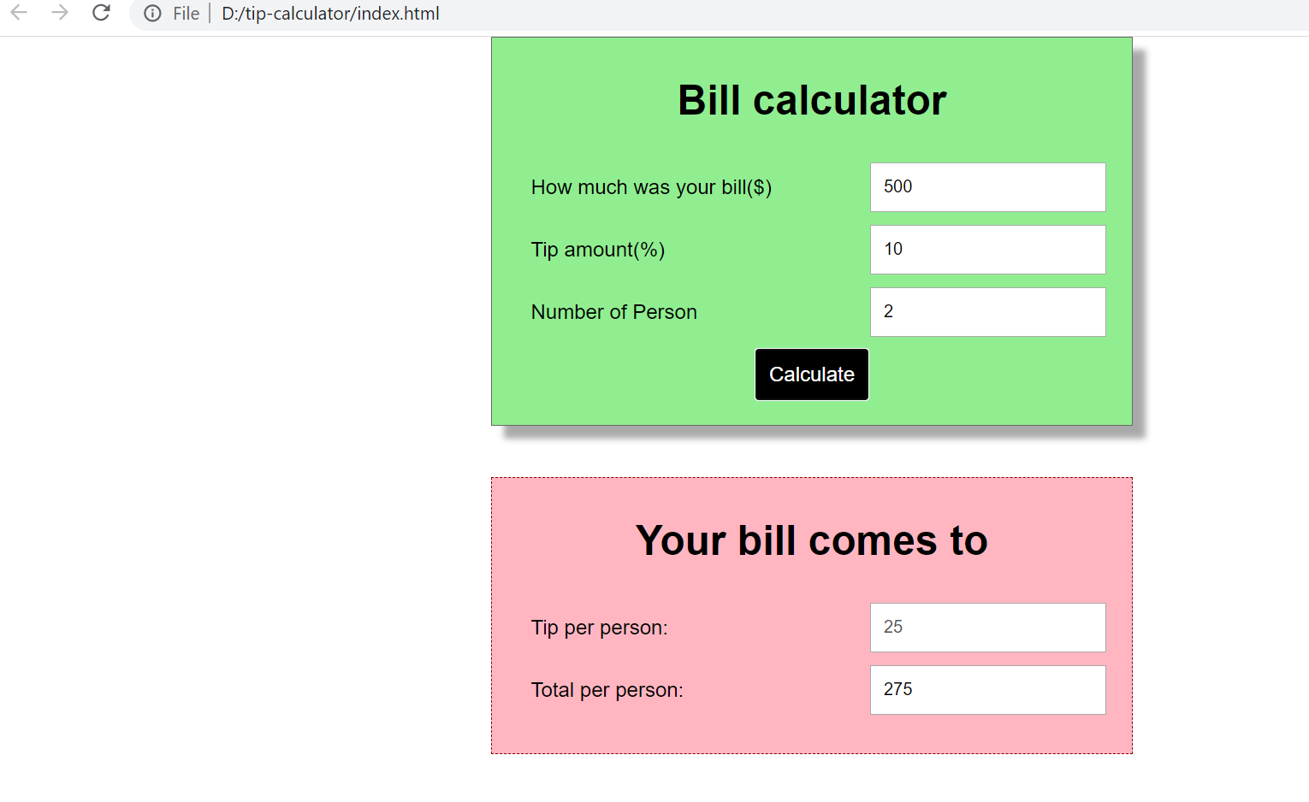 2.

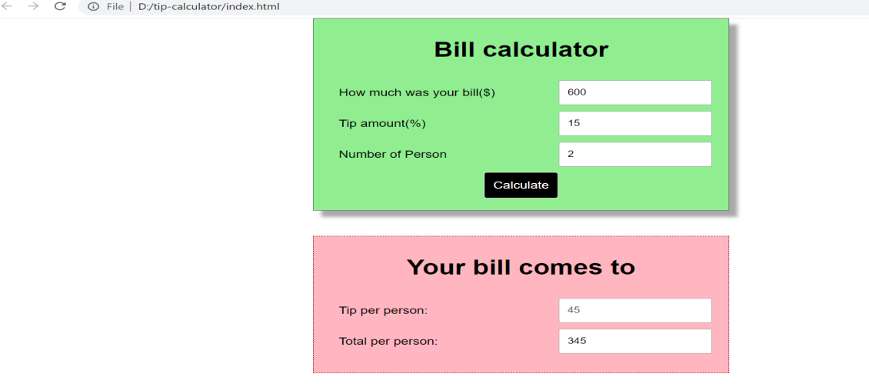

3.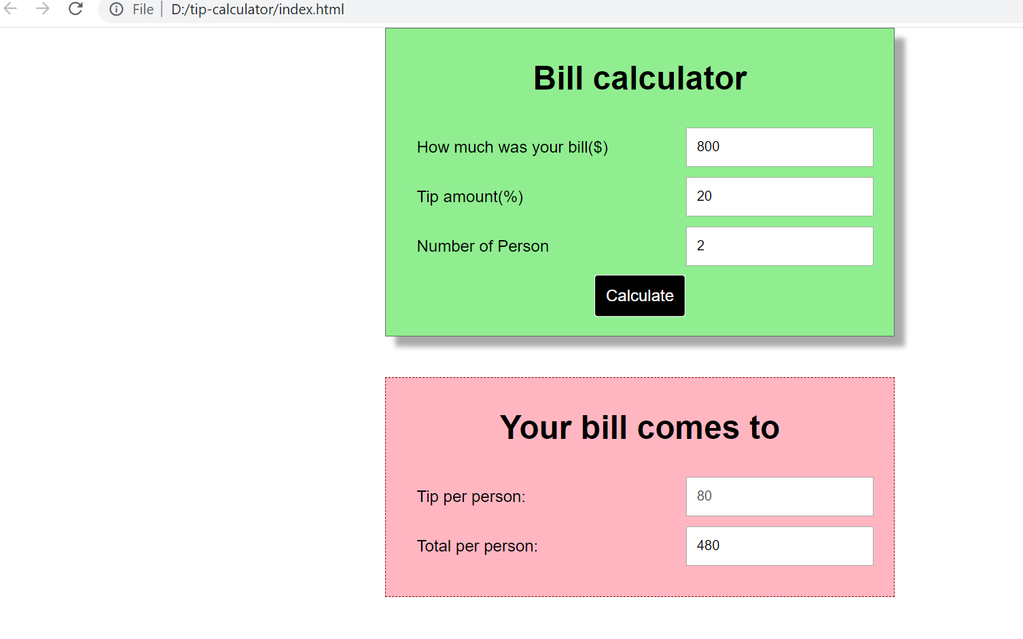

4.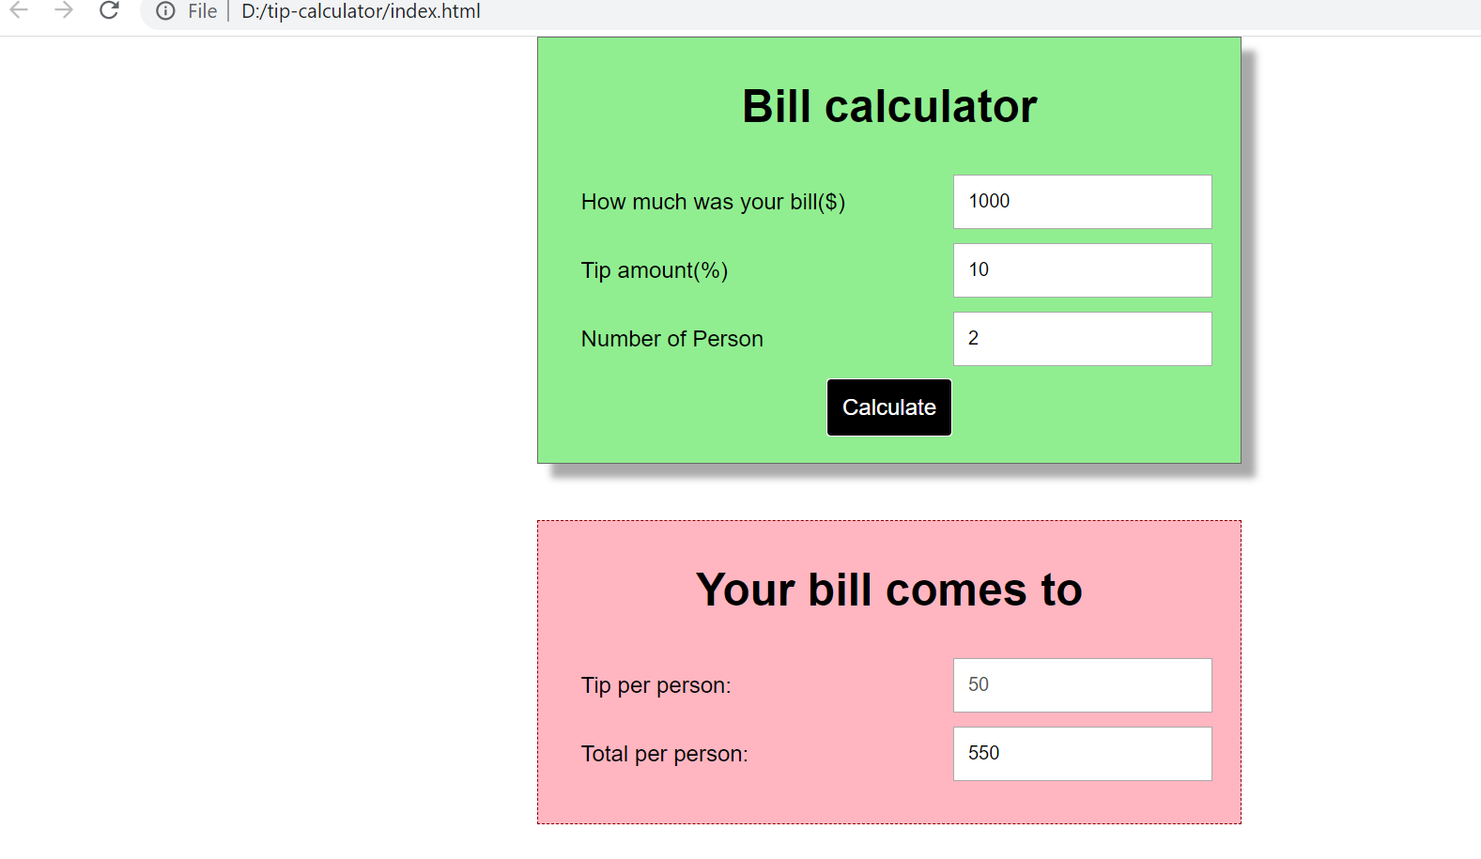

5.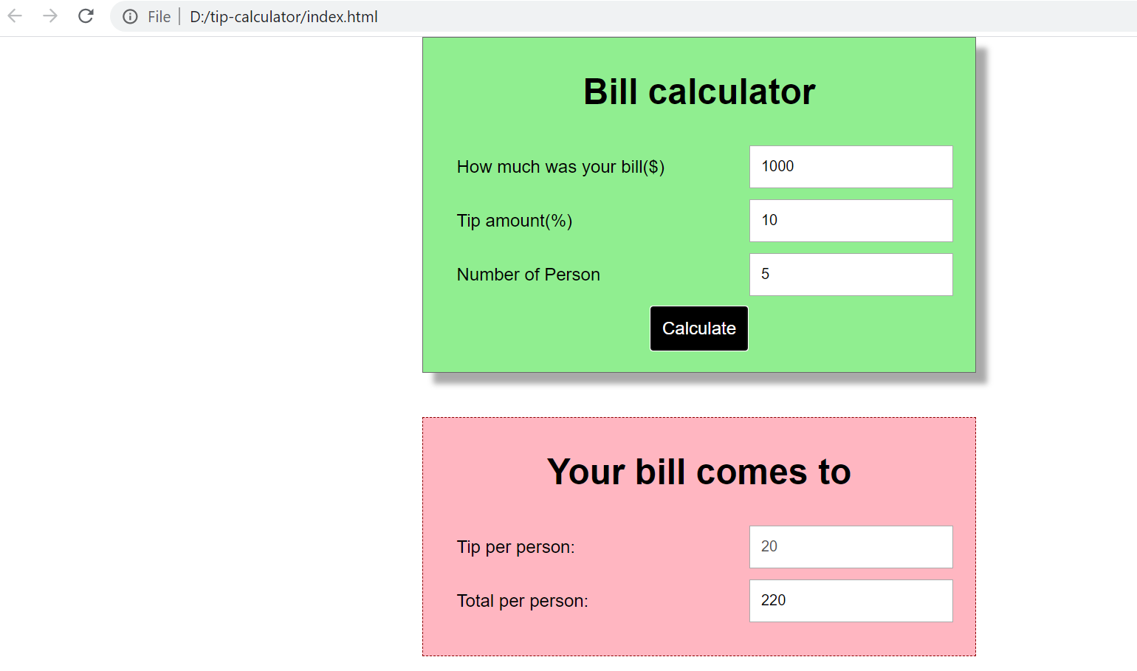

Failure Test cases ::

1.Test Case- User is not allowed to leave any field empty, All the data field are to be filled before calculate.

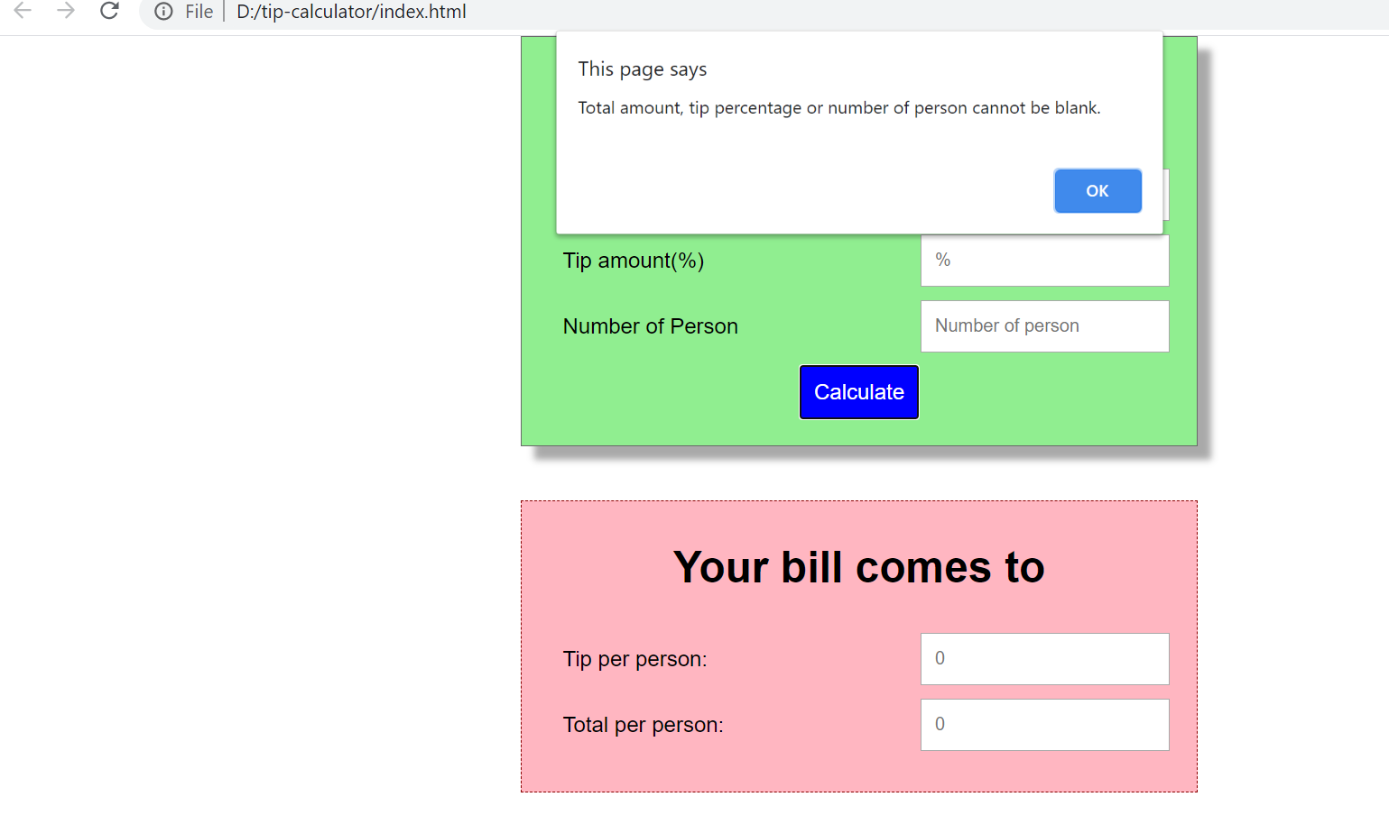

2.