Storage Keywords
Monday, March 3, 2025
7:02 PM

- Device (/dev/vda) → A raw disk (like a physical hard drive or virtual disk).
- Partition (/dev/vda1) → A section of the disk that is prepared for use. A disk can have multiple partitions (vda1, vda2, etc.).
- Filesystem → A structure (like XFS, ext4, NTFS) that organizes data inside a partition. Formatting a partition (mkfs.xfs /dev/vda1) creates a filesystem.
- Mount Point (/mnt/data) → A directory where the filesystem is attached so you can access files. Mounting (mount /dev/vda1 /mnt/data) makes the filesystem usable.

Physical Storage Partitions
Sunday, December 15, 2024
12:52 AM

Command and Files

lsblk
/dev/sda
fdisk
cfdisk

Windows uses NTFS filesystems.
Ubuntu uses EXT4 filesystems.

The ‘lsblk' command, short for “list block devices,” is a powerful tool that provides detailed information about block devices such as hard drives, solid-state drives, and other storage-related devices.

When you run this command, the 'type' with named 'part' is the partition.

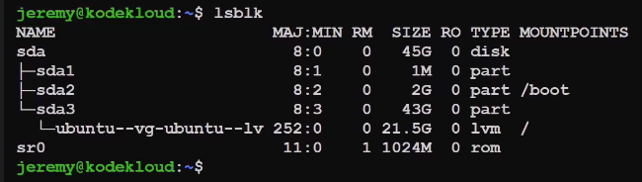

sda is a disk with 3 partitions - sda1, sda2 and sda3

This disk naming starts like sda( 1st disk), sdb(2nd disk), sdc(3rd disks) and so on…

sad1 can be found by running:
ls /dev/sda1

ls /dev/sda = It points to entire disk

sudo fdisk --list /dev/sda = This command will list all the partitions of the sda.

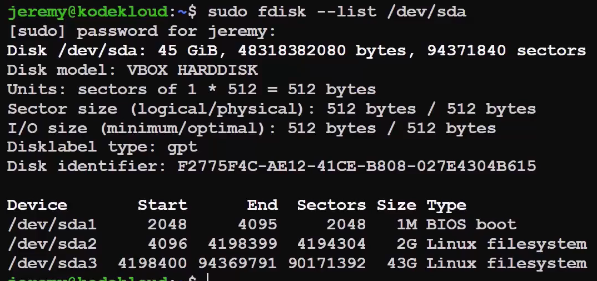

fixed disk (fdisk)

What are Sectors?
A sector is a fixed-size unit of storage on a hard disk drive or other storage medium.

How to partition a disk?

cfdisk stands for curses-based fdisk.
cfdisk command is used to create, delete, and modify partitions on a disk device.
It displays or manipulates the disk partition table by providing a text-based “graphical” interface.

- sudo cfdisk /dev/sdb

- Choose the partition table format - mbr(master boot record) or dos(both are equivalent)
, gpt( good partition table)

- Click on new and select the partition size.

Partitioned are numbered on the order in which they are created and not on the positioned on the storage devices.

- You can also choose the Type of partition - Linux Filesystem, Linux swap etc.
  - Linux Filesystem - To store personal or OS Data
  - EFI - For boot partition
- Click on 'Write' button to partition.

Can we use a block device without mounting it in linux

Yes, you can use a block device without mounting it in Linux, but the extent of what you can do is limited.

Why Mount?
Mounting a block device essentially makes its filesystem accessible within the Linux file system hierarchy.

Direct Access to Block Devices
While mounting provides a convenient and user-friendly way to access a block device, you can directly interact with it at a lower level.

So, there's a block device /dev/nbd0. How can I access it with and without mounting?

Accessing /dev/nbd0: With and Without Mounting

Accessing with Mounting

1. Identify the Filesystem:

Use file command to determine the filesystem type:

file /dev/nbd0

2. Create a Mount Point:

Choose a directory to mount the device, e.g., /mnt/nbd0:

mkdir /mnt/nbd0

3. Mount the Device:

Use the mount command, specifying the device, mount point, and filesystem type:

sudo mount -t <filesystem_type> /dev/nbd0 /mnt/nbd0

Replace <filesystem_type> with the actual filesystem type (e.g., ext4, xfs, ntfs).

4. Access the Filesystem:
Navigate to the mount point and use standard file system operations:

cd /mnt/nbd0
ls

🛠 Example in Linux

If you have:

/dev/sda1 mounted as /boot
/dev/sda2 mounted as /
/dev/sda3 mounted as /home

It would roughly compare to:

C: for system files (like / in Linux)
D: for user files (like /home in Linux)
E: for extra storage (like /mnt/storage in Linux)

Configure and Manage Swap Space
Sunday, December 15, 2024
1:15 AM

command and files

swapon
mkswap
swapoff

Swap space is a reserved area on a Linux computer's hard disk that extends the system's physical RAM (random access memory)

How it works
When a Linux system runs out of RAM, the operating system (OS) moves inactive processes into swap space to make room for active processes. This allows processes to continue running and prevents memory errors

swapon --show - This will display the swap space if we have any.

To format a partition to be used as swap, we run this 2 commands:
  - sudo mkswap /dev/vdb3
  - sudo swapon /dev/vdb3

Run swapon --show to check.

If we have a swap space, is it possible that it won't be list by 'swapon --show' command because we haven't formatted it yet?

If we reboot the system, this swap space will again be not available to be used as swap space.

To stop using a partition as swap space, run

sudo swapoff <partition-name>
sudo swapoff /dev/vdb3

Instead of partitions we can also use simple files as swap. To do this, we have to fill file with 0s( Binary zeroes). We can also use 'dd' utility.

sudo dd if=/dev/zero of=/swap bs=1M count=128

if=/dev/zero - This is used to generate infinite number of zeroes in a file. 'if' stands for input file.

of=/swap - This will copy the content to /swap. 'of' stands for output file.

We should only allow root user to read and write to this file as it can view the other data.

sudo chmod 600 /swap

This will write 128 blocks of 1 MB each. It means 128 MB of swap space can be created.

To use this /swap file as swap, run
sudo mkswap /swap

KK Lab 1
Monday, February 24, 2025
2:15 AM

KK Lab

Format the 21MB partition as swap. Next, make it active, and tell Linux to start using it as swap memory.

mkswap /dev/vdb2
swapon /dev/vdb2

Create three primary partitions on /dev/vdb.

First should have 10MB, second should have 21MB and the third should have 15MB.

Follow the below given steps:

fdisk /dev/vdb
If the user is not root, you need to use the command with sudo.

Now, enter below given responses:

Command (m for help): n
Select (default p): <just-leave-it-default-and-press-enter>
Partition number (1-4, default 1): <just-leave-it-default-and-press-enter>
First sector (2048-2097151, default 2048): <just-leave-it-default-and-press-enter>
Last sector, +sectors or +size{K,M,G,T,P} (2048-2097151, default 2097151): +10M
Command (m for help): w
You can follow these same steps for all three partitions.

Further, you can verify the created partitions using the below command:

lsblk

similarly use fdisk for deleting also.

Resize the /dev/vdb3 partition (which you created earlier) to 21MB.

Use
cfdisk /dev/vdb

Create and Configure Filesystems
Sunday, December 15, 2024
3:41 PM

Commands and Files
mkfs
xfs_admin

A filesystem (FS) is an organized collection of data and methods used to store, retrieve, and manage information on a storage device. In computing, it is the structure and logic that defines how files are named, stored, organized, and accessed by the operating system and applications.

Redhat uses xfs filesystems and ubuntu uses ext4 filesystems.

The mkfs command stands for “make file system” and is utilized to create a file system, which organizes a hierarchy of directories, subdirectories, and files, on a formatted storage device. This can be a partition on a hard disk drive (HDD), a USB drive, or other storage media.

To make a partition /dev/sdb1 as filesystem, run
sudo mkfs.xfs /dev/sdb1

-L option is used to label the partition
-i option is used to specify the size of inode

inode (index node)

An inode is a data structure that contains metadata about a file and they change when a file is accessed or modified.

A metadata includes several type of information such as filetype, size, owner's name, last access, link count(soft link or hard link) etc.

This inodes does not store the file name in the metadata.

This metadata takes 128 bytes space for each file.

Inode is assigned with unique numeric value identifier.

ls -i lists the files and their inode number.

https://www.youtube.com/watch?v=BJ13GsC0_os

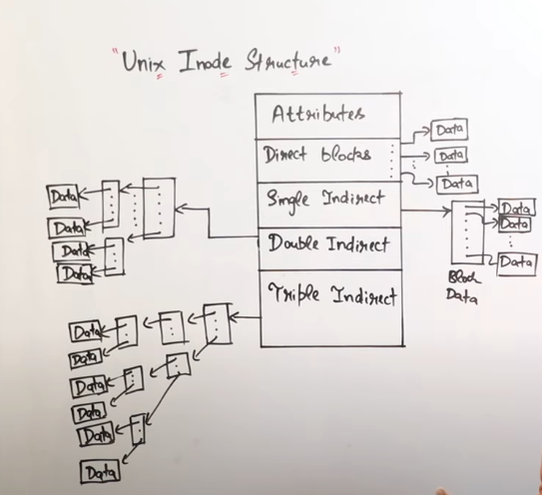

If we run out of inodes, no more files or directories can be created even though you have enough space.

xfs_admin command is sued to make changes to filesystems that are already made such as changing the labels.
In ubuntu, we use mkfs.ext4 or mke2fs( in older versions)

Shows Mounted Filesystems

df -T

Configure Systems to Mount Filesystems at or During Boot
Sunday, December 15, 2024
4:13 PM

Commands and Files

mount
umount
/mnt/
/etc/fstab

Configure Systems to Mount Filesystems at Boot

To make a filesystem accessible we have to mount it. Mounting means attaching our filesystems to one of our directories, making the files on that device accessible within your file system,

Command to lists /mnt/

The /mnt directory in Linux is used as a mount point for temporarily mounted filesystems.

To mount a filesystem /dev/vdb1, run the following command

sudo mount /dev/vdb1 /mnt/

We can also use - "lsblk" command after that to confirm

To unmount, run
sudo umount /mnt/

Note - It's umount and not 'unmount'

Is it possible that multiple filesystesm are mounted to /mnt ?
No, only one filesystem can be mounted to /mnt at a time.

If you mount a filesystem to /boot. This filesystem will automatically mounts this filesystems. It does according to instructions in a file.

/etc/fstab contains rule where specific file systems are detected then automatically mounted in the user's desired order every time the system boots.

fstab stands for filesystem table.

Table structure

The table itself is a 6 column structure, where each column designates a specific parameter and must be set up in the correct order. The columns of the table are as follows from left to right:

  - Device: usually the given name or UUID of the mounted device (sda1/sda2/etc). e.g. /dev/vda2
  - Mount Point: designates the directory where the device is/will be mounted. e.g. /boot
  - File System Type: shows the type of filesystem in use. e.g. xfs
  - Options: lists any active mount options. If using multiple options they must be separated by commas.
  - Backup Operation: (the first digit) this is a binary system where
    - 1 = dump utility backup of a partition.
    - 0 = no backup. This is an outdated backup method and should NOT be used.
  - File System Check Order: (second digit) Here we can see three possible outcomes.
    - 0 means that fsck will not check the filesystem.
    - Numbers higher than this represent the check order. The root filesystem should be set to 1 and other partitions set to 2.

  - After editing the /etc/fstab file, run the command- sudo systemctl daemon-reload. Although daemon behind this process will take care but it's better to run above command. If you now, reboot your system using - sudo systemctl reboot, then you see the entries after running lsblk.

fstab entry for a swap space

/dev/vdb3 none swap defaults 0 0
Mount point of a swap space should be none.
0 0 - Swap is not meant to be for backup and checked for errors.
Reboot your system to see the swap space by running the 'swapon --show' command.

Importance of uuid

Suppose we have 2 SSDs - sda and sdb. If our static cable changed in motherboard then this sequence may change i.e. sda name will show for sdb and vice versa. Mounting a wrong name with wrong device may lead to error. So, It’s better to have an UUID.

The Linux kernel can automatically find and map volumes to a storage device using UUIDs, which saves time and avoids breaking the Linux system.

To check the UUID of a device, run
sudo blkid /dev/vdb1

fsck
fsck (File System Consistency Check) is a tool used to check and repair filesystem errors on Linux.
sudo fsck /dev/sda1
Runs a check on /dev/sda1 and fixes issues if found.

Dump vs Backup

/etc/fstab

In the /etc/fstab file, each entry consists of six fields:

- <file system> – The device name, UUID, or label of the filesystem (e.g., /dev/sda1 or UUID=xyz).
- <mount point> – The directory where the filesystem will be mounted (e.g., /mnt/data or /home).
- <type> – The filesystem type (e.g., ext4, xfs, swap, nfs).
- <options> – Mount options like defaults, ro (read-only), rw (read-write), noexec, nofail, etc.
- <dump> – A backup indicator (0 = no dump, 1 = include in backups, usually for root /).
- <pass> – Filesystem check order during boot (0 = no check, 1 = first to check, 2 = other filesystems).

KK Lab 2
Monday, February 24, 2025
10:20 PM

What file do we need to edit to tell the Linux OS which filesystems it should automatically mount when it boots up?

We will need to edit /etc/fstab file to tell the Linux OS which filesystems it should automatically mount when it boots up.

Create an xfs filesystem with the label "DataDisk" on /dev/vdb.

mkfs.xfs -L "DataDisk" /dev/vdb

Verify:
- sudo blkid | grep vdb
- lsblk -f

Create an ext4 filesystem with 2048 inodes on /dev/vdc

mke2fs - create an ext2/ext3/ext4 file system

-I inode-size
-N number-of-inodes

mke2fs -N 2048 /dev/vdc

OR

mkfs.ext4 -N 2048 /dev/vdc

Configure the system to automatically use /dev/vdb as swap when it boots up.

Edit /etc/fstab file:

vi /etc/fstab
If the user is not root, you need to use the command with sudo.

Add this line in it:

/dev/vdb none swap defaults 0 0

Save and exit.

Change the label for /dev/vdb filesystem to SwapFS

Execute below given command:

xfs_admin -L "SwapFS" /dev/vdb
If the user is not root, you need to use the command with sudo.

Filesystem and Mount Options
Sunday, December 15, 2024
11:38 PM

command and files
lsblk
findmnt
/etc/fstab

Filesystem and Mount Options

lsblk - Gives information about which block device is mounted where.

findmnt - lists the all-mounted file system on the system.

findmnt searches for the mounted file in /etc/fstab, /etc/mtab, or /proc/self/mountinf locations. By default, it shows all mounted file systems on the system.

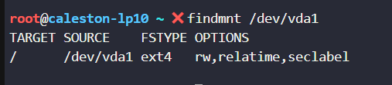

findmnt -t xfs,ext4
This is used to give real mount points which are generally xfs or ext4.

sudo mount -o ro /dev/vdb2 /mnt
This will mount /dev/vdb2 to /mnt with ro( read only) option. So, you'll not be able to create a file by running command like:
sudo touch /mnt/test

Other Options

noexec - It will not launch any program on the filesystem.
nosuid - It will not allow the program to run with root privileges without needing sudo command

The /proc directory is NOT a real file system but a virtual file system that is created dynamically by Linux to provide access to certain types of hardware information and information about the running processes. It is mapped to /proc and mounted at boot time.

Note - If a filesystem is already mounted with read-only (ro), you can change its options without unmounting using remount.
sudo mount -o remount,rw,noexec,nosuid /dev/vdb2 /mnt

remount → Updates mount options

Filesystem can also be mount automatically at boot time.

You have to make entries like this in /etc/fstab

/dev/vdb1 /mybackup xfs ro,noexec 0 2

KK Lab 3
Monday, February 24, 2025
11:24 PM

Mount /dev/vdb1 back into the /mnt/ directory. But this time, use these mount options: ro,noexec,nosuid.

/dev/vdb1 is currently mounted with the rooption, so it's read-only. Remount it with the rw option so it becomes read-write.

mount -o remount,rw /dev/vdb1 /mnt

or

unmount and remount using different options

Edit /etc/fstab so that the ext4 filesystem on /dev/vdb1 is automatically mounted into /mnt at boot time.
But also make sure that this filesystem is mounted as read-only. Otherwise said, use these two mount options: defaults and ro.

vi /etc/fstab

/dev/vdb1 /mnt ext4 defaults,ro 0 2

NFS
Monday, December 16, 2024
3:14 PM

Commands and Files
/etc/exports
exportfs

Using Remote Filesystems

Protocol is a language. This protocol or language is used so that a client and server can communicate with each other.

NFS is a common protocol which stands for Network File Systems. Network File Sharing (NFS) is a protocol that allows you to share directories and files with other Linux clients over a network.

There are two parts to setup NFS:

- Setting up NFS server
- Setting up NFS Clients

Setting up NFS server

- First we need to install the NFS Kernel—this is the server component that enables a machine to expose directories as NFS shares.

sudo apt install nfs-kernel-server

- Second, we need to inform the NFS Server, what filesystems or directories we want to share. For this, we need to edit the /etc/export file.

vim /etc/exports

Syntax:

<Filesystem or Directory we want to share> hostname1 or IP or IP Range(rw,sync,no_subtree_check) hostname2(ro,sync,no_subtree_check) ….

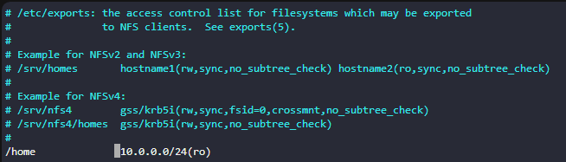

- rw = Client can read or write to this shared filesystem or directory
- ro = Client can Read only the shared filesystems or directories
- sync = Synchronous writes of data i.e. NFS ensures that data written by a client is actually saved on a storage device before reporting the operation as successful.
- async = Client can issue multiple write requests and NFS can report the operation as successful before the data written by a client is saved. This is faster but if system reboots in the middle, data can be lost.

subtree_check Performs subtree checking, which involves checking parent directories of an exported subdirectory whenever a file is accessed.

no_subtree_check(default) Turns off subtree checking (opposite of subtree_check). This is the default name because subdirectory name can be changed which can cause issue in the 'subtree-check' option.

all_squash Maps all user IDs and group IDs to the anonymous user on the client
no_all_squash Maps remote user and group IDs to similar IDs on the client (by default)

root_squash Maps remote root user on NFS Client to the anonymous user on the client (by default ). All read/write request on NFS client will be mapped to a user called 'nobody' on the server.

no_root_squash Maps remote root user on NFS Client to the root user on NFS share we mount or It allows remote user on NFS client to also have a root privilege on remote NFS share we mount.

squash meaning "suppress"

man exports - To get more information about /etc/exports

- To apply the changes to NFS server, we run:
sudo exportfs -r

-r means "re-export" or It can be treated as doing refresh based on the '/etc/export' file.

- Restart the NFS server: systemctl restart nfs-server

- To see the current exported NFS shares, run:
sudo exportfs -v

-v means "verbose"

You will find some default options that automatically get assigned.

we can also add wildcards to /etc/exports

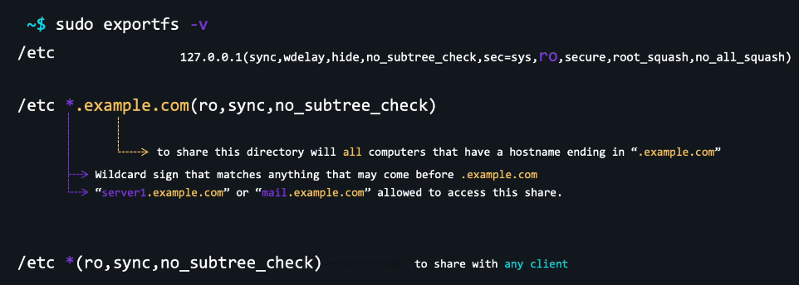

NFS Client

Install all the utilities required for NFS

sudo apt install nfs-common

We can mount the file shared by NFS server using:

sudo mount IP_or_hostname_of_server:/path/to/remote/directory /path/to/local/directory

e.g. To mount an NFS Share (/etc) by the NFS server (127.0.0.1)

sudo mount 127.0.0.1:/etc /mnt

To unmount

sudo umount /mnt

So, mounting and unmounting is similar to normal mounting and unmounting, it's just you have to specify the NFS server IP or hostaname.

If you mount to NFS server on boot

you just have to edit /etc/fstaab

Here, filetype will be nfs instead of xfs or ext4
and filesystem will have NFS server IP or hostname

127.0.0.1:/etc /mnt nfs defaults 0 0

NBD
Tuesday, December 17, 2024
12:46 PM

/dev/sda or /dev/vda point to disk ( or first disk because of 'a' in 'sda'

/dev/sda1 points to first partition on the first disk

/dev/sda and /dev/sda1 are block special files that reference block devices.

NBD or Network Block Devices points to block devices but of a remote computer.

So, we can have a network block device like /dev/nbd0 which points to disk on remote computer.

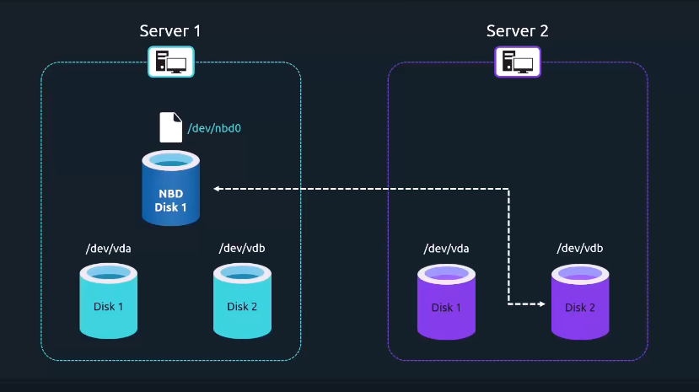

In this we will have two components:

NBD Server - It contains the real block device that will be shared through the network.

NBD client - Here, we will attach the remote block device we want to add to our system.

Configuring NBD Server

- We need to install - sudo apt install nbd-server
- Open default configuration file - sudo vim /etc/nbd-server/config

By default, nbd daemon will run under the user 'nbd'

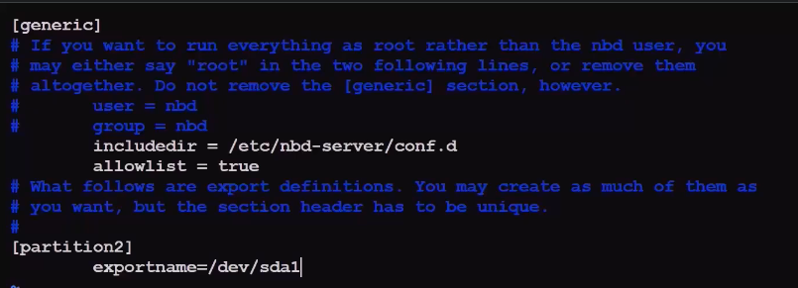

Here,

partition2 = It is the name of the export. It can be any name.
exportname= It is the name of the NBD we want to share

user = nbd
group = nbd

above two lines are default. To run everything as root. you need to comment it out.

#user = nbd
#group = nbd

allowlist = true

This will allow nbd clients to list all the files what a Block Device can share with us.

SAVE the file.

RESTART the nbd daemon -

sudo systemctl restart nbd-server.service

Configuring NBD Client

- sudo apt install nbd-client
- Next we need to load a kernel modules. The kernel module extends the kernal functionality so that it becomes able to handle remote network block devices.

sudo modprobe nbd

this only loads it for the current boot.

Each time we restart our operating system, we would need to manually load the module again.

In Ubuntu or Debian, we can edit the file

sudo vim /etc/modules-load.d/modules.conf

and type "nbd" and save the file.

- Attach nbd

sudo nbd-client <IP-address-of-system-hosting-nbd OR hostname> -N <name of export>

e.g. sudo nbd 127.0.0.1 -N partition2

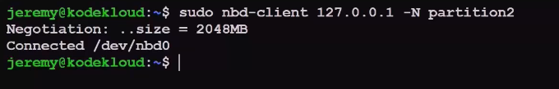

- This file '/dev/nb0' is a special block device file will be associated with remote block device.

- We can mount this block device '/dev/nbd0' into the '/mnt' directory.

sudo mount /dev/nbd0 /mnt

ls /mnt will list all the content of /dev/sda1

To detatch, we can unmount it using.

sudo umount /mnt

You can confirm this by running the 'lsblk' command. There will be blank under the MOUNTPOINTS row in nb0 column.

To detatch this network block device,

sudo nbd -client -d /dev/nbd0

Now if you list block device again, lsblk,

there will be 0 size available for nbd0.

We can also list the exports available on NBD server.

sudo nbd-client -l <IP address of system hosting NBD server>

KK Lab 4
Tuesday, February 25, 2025
12:07 AM

An NFS server is already running and active in the system. Configure the existing NFS server to share the /home directory in read-only mode. Allow access to any client within the CIDR range 10.0.0.0/24.

Open the NFS server configuration file: vi /etc/exports
Add the following line: /home 10.0.0.0/24(ro)
Save the file and exit the text editor.
Once you edit /etc/exports file, export it using exportfs -r.

Restart the NFS server:
systemctl restart nfs-server

Now, the "/home" directory is shared in read-only mode for clients in the specified CIDR range.
Note: You need to use sudo with the commands if the user is not root.

For this step, manually mount the NFS share with the following properties:

The IP of the NFS server is 127.0.0.1.
The remote directory you should mount from 127.0.0.1 is /home.
Mount this share in the local directory /mnt.

mount 127.0.0.1:/home /mnt

Verify:

findmnt

In the previous step, we have manually mounted NFS share. For this step, configure the system to automatically mount an NFS share when it boots up:

The share is on the server with the IP address 127.0.0.1.
The remote directory you should mount from the NFS server is /home
Mount it in the local directory /mnt
Use defaults in the mount options

To automatically mount the NFS share at system startup, add an entry to the "/etc/fstab" file. Edit the file with a text editor such as nano or vim:
vi /etc/fstab
Note: You need to use sudo with the command if the user is not root.

Add the following line to the end of the file:
127.0.0.1:/home /mnt nfs defaults 0 0
Save the file and exit the text editor.

Type will be nfs

Can a single entry in "/etc/exports" be used to share the same file directory with two different IPs by specifying them?

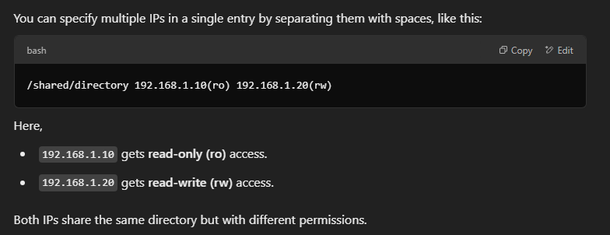

LVM Storage
Sunday, February 16, 2025
9:18 PM

Command and Files

PV > VG > LV

pvcreate
pvs

vgcreate
vgextend
vgs
vgreduce

lvcreate
lvs
lvresize
lvdisplay
lvresize
lvremove
lvm
lvmdiskscan

LVM (Logical Volume Manager) is a storage virtualization technology that provides a flexible way to manage disk space by abstracting physical storage devices into logical volumes, allowing administrators to dynamically create, resize, and move storage volumes across multiple physical disks without needing to worry about their exact physical location, offering greater flexibility compared to traditional partitioning methods.

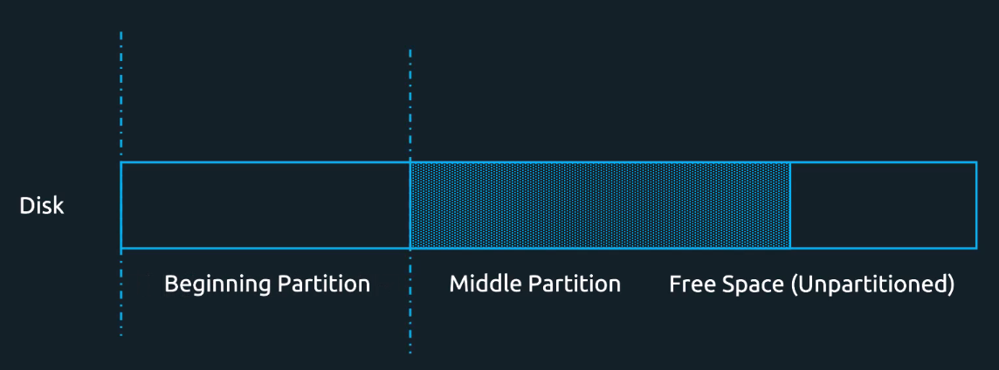

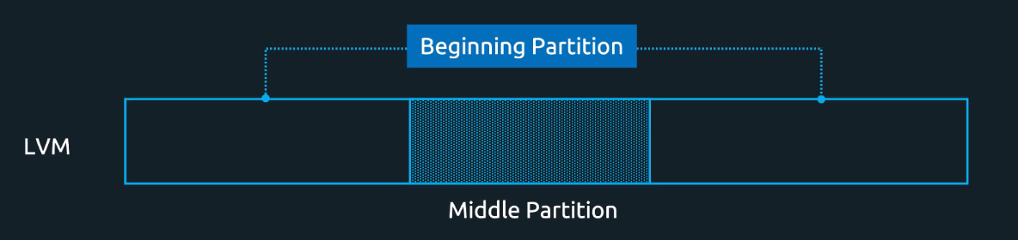

Keywords

PV, VG, LV, PE

Physical Devices – are the physical devices used to store data. They may be disk partitions, whole disks, RAID arrays or SAN disks. These are generally the /dev/sda, /dev/sdb etc.

PV (Physical Volume):
Physical devices can not be used for LVM directly. They have to be converted into Physical Volumes(PVs). So, the first step is to convert the physical device into physical volume.

VG (Volume Group):
are the storage pool made from one or more PV. VG is used to create Logical Volumes(LVs). It is not necessary to use the entire VG to create LVs

LV (Logical Volume):
are created from the free physical extents in a volume group. Think of physical extent as the smallest unit of space for storing data (similar to a data block in the hard disk). LVs are collection of logical extents which are mapped to physical extents.

PE (Physical Extent):
The smallest unit of storage within a VG, used to allocate space to LVs.

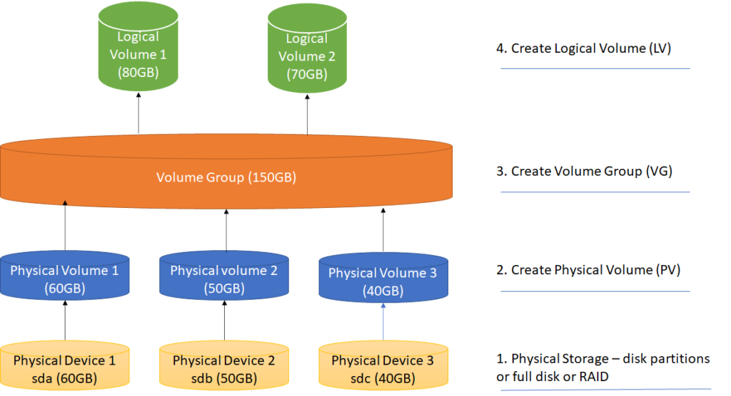

Example

Suppose there are three disks of 1 terabyte (TB) capacity each. Each of these physical disks is a physical volume (PV), designated PV 1, PV 2, and PV 3.

The total or aggregate available physical storage is 3 TB.

All three disks are added to Volume Group 1. Two logical volumes (LVs) are created from the volume group: LV1 and LV2. Each LV has a capacity of 1.5 TB. Other LV combinations with different capacities can also be created, such as the following:

3 LVs of capacities 1 TB, 500 gigabytes (GB), 1.5 TB.
4 LVs of capacities 500 GB, 500 GB, 1 TB, and 1 TB.
5 LVs of capacities 500 GB, 500 GB, 500 GB, 500 GB, 1 TB.
In this way, LVM adds flexibility to storage needs without increasing the complexity of storage management.

Installing LVM

sudo yum install -y lvm2

sudo systemctl enable lvm2-lvmetad
sudo systemctl start lvm2-lvmetad

Verify using-
lvm version

sudo lvmdiskscan - The lvmdiskscan command lists block devices that can be used as physical volumes (PVs) in Logical Volume Management (LVM).

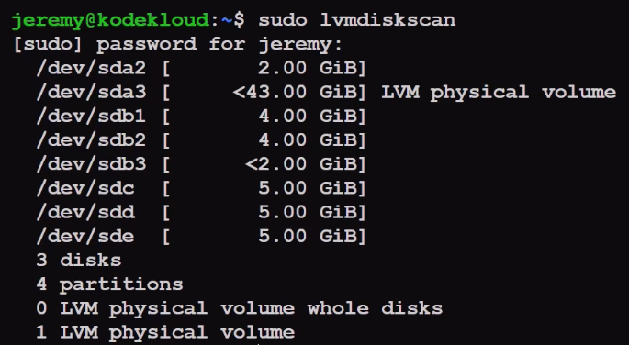

- Add two disks to LVM to create PV - For this you need to paas the Block Device Files that points to this disks and partitions.

sudo pvcreate /dev/sdc /dev/sdd

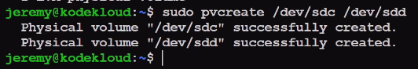

- sudo pvs - To show what PV are currently attached to LVM.

Psize - It shows the total size of the PV.

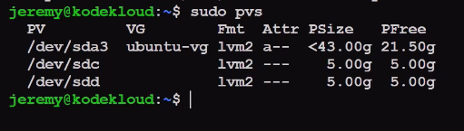

- Create a VG from PVs

sudo vgcreate <name of VG> <PVs>

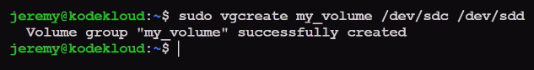

We can add more PVs to the VG and thus make its capacity indefinite. Use command-

sudo vgextend <VG name> <PV to attach>

To check available VGs
sudo vgs

To remove a PV from the VG
sudo vgreduce VG <PV name>

We can also remove from PVM using
pvremove <PV>

- Create LV which is like a partition in LVM.

lvcreate --size 2G --name <LV name> <VG name>

List LVs
sudo lvs

To resize an LV so that it can use all the free spze available in a VG
sudo lvresize --extents 100%VG <VG Name>/<LV>

We can shrink or enlarge LV to any custom size using --size.

Partitions can be found at places like /dev/sda1, LV can be found at

/dev/<name of volume-group><name-of-logical-volume>

To get more information about the LV run -

sudo lvdisplay

Now we can create an ext4 filesystem using
sudo mkfs.ext4 /dev/VG-name/partition name

To resize an LV with a filesystem on it , we can not use this command
sudo lvresize --size 3G <volume>/<partition>

This will only reszie the LV and not the partition

Use this command to resize both LV and
sudo lvresize --resizefs --size 3G <volume>/<partition>

some file systems can be enlarged, but they can't be shrink.

Destroy/Remove the Logical Volume called smalldata.
sudo lvremove volume1/smalldata

Lab
Monday, February 17, 2025
8:40 PM

How can we list PVs bein used in VG.

Resize the Logical Volume called smalldata to 752 MB.
This logical volume resides on the volume group called volume1.

lvresize --size 752M volume1/smalldata

Install lvm on this system.

apt install lvm2 -y

Imagine that our volume group volume1 is running out of free space. It currently uses /dev/vdb to store data. Add /dev/vdc to this volume group so that we gain more usable storage space.

When using vgcreate, it automatically initializes the device as a physical volume (PV) before adding it to the volume group (VG).

Monitor Storage Performance
Sunday, February 16, 2025
11:00 PM

Command and Files

iostat -n, where n=1,2,3….second
sar -u
pidstat
dmstat

For monitoring storage, we have following tools-

sysstat package
Sysstat is a useful utility that includes a number of programs for monitoring system resources, performance, and use.

sudo apt install sysstat

CPU Usage
To view current CPU stats, use the sar command with the -u option.
$ sar -u

Disk or Device Usage

iostat

To find disc statistics, use the iostat command. It displays the current data transfer rate, the total number of blocks read and written to disc, and the average block rate.

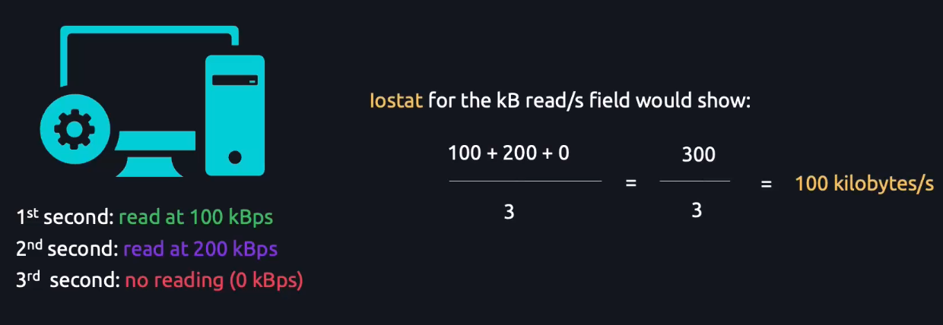

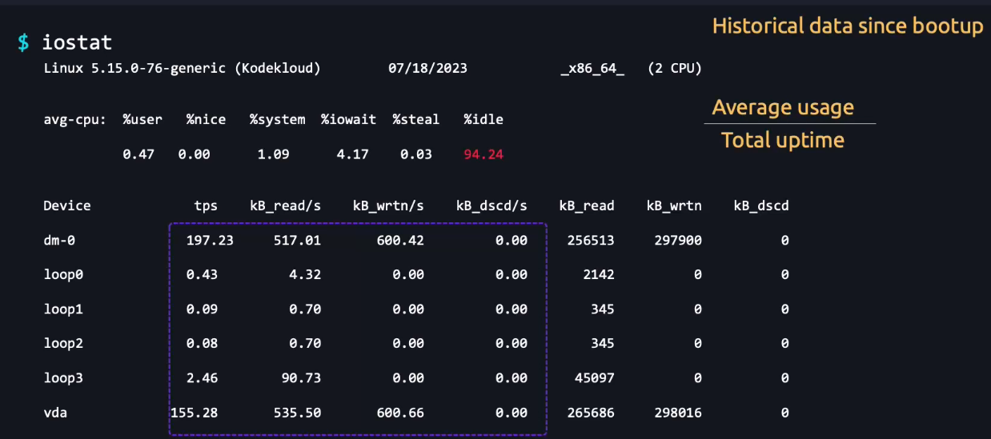

tps(transfer per second) - Read or write something
kB_read/s - kilo Byte read per second
kB_wrtn/s - kilo byte written per second
kB-dscd/s -

These 4 are calculated as - average usage/Total uptime

kB_read - It is total kilobytes read

How to predict using above.

High tps - That device is being used very often.
High kB_read/s and kB_wrtn/s High Large volumes of data being transferred.

Viewing the Current Process
$ pidstat -d

Exercise

dd if=/dev/zero of=DELETEME bs=1 count=1000000 oflag=dsync &
[1] 1411

if - Input File
/dev/zero - File to generate infinite number of zeroes
of - output file
DELETEME - We write to a file called 'DELETEME'
bs =1 - It tells dd to write data 1 byte at a time
count - It tells dd to write 1000000 times
oflag=dsync - Forces direct disk writes, bypassing cache for accurate speed measurement. It makes the process to not to use cache so that this process can take time.
& - This makes the command to run in the bg

To monitor this process

iostat 1
This command will display how the iostat commands are being used every 1 sec.
To refresh every n sec, run iostat n

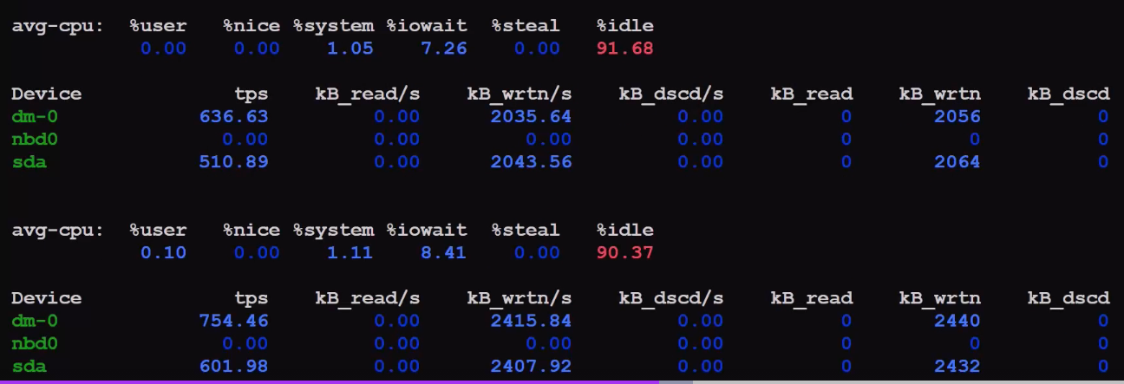

From above, it seems that something is being written to dm-0 and sda

Run

pidstat -d

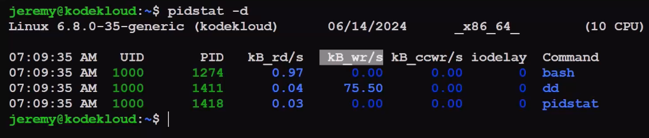

dd command is showing the largest value in the kB-wr/s

To refresh the command every n sec
pidstat -d n

We can get the idea which process (PID) is running what.

dm-0 - dm stands for Device Mapper. This was created by LVM. We can get the more information about this using -

sudo dmsetup info /dev/dm-0

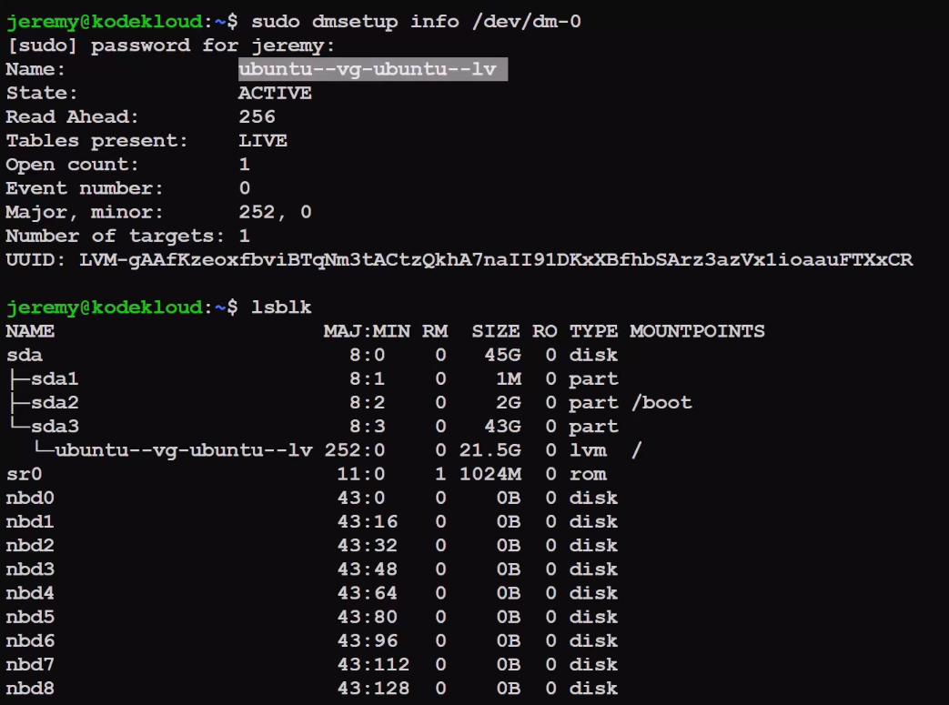

We can see that this dm-0 is an LV created under the sda3.

That's why we were getting high value for sda!!!!

We also check the PID using the command

ps 1411

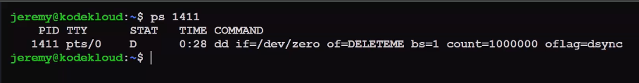

We can gracefully stop this process using kill 1411
kill -9 1411 - To kill a process forcefully.

iostat -d - To get info of device utilization only.
iostat -h - To get info in human readble form

For pidstat,
pidstat -d --human

-h option doesn't work with pidstat

To check for individual partition

iostat -p ALL - To check all the device with the partitions also.

OR

iostat -p sda

Advanced FS Permissions
Monday, February 17, 2025
1:11 AM

Command and Files

setfacl
getfacl
chattr

Think of a scenario in which a particular user is not a member of a group created by you but still, you want to give some read or write access, ACLs can help you in this.

setfacl: Used to set ACL entries.

sudo setfacl --modify user:<username>:<permission> <filename>

sudo setfacl --modify user:jermy:rw file3

User Jermy has read and write access to file3.

A '+' sign will appear if it's ACLs
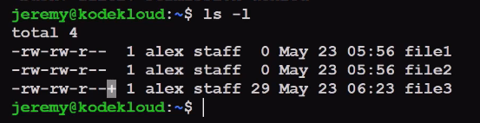

getfacl: Used to retrieve and display ACL entries.
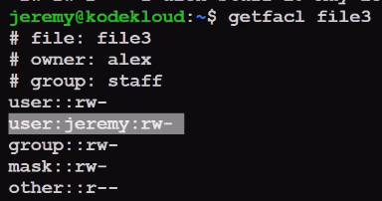

Mask

The mask entry indicates the maximum permissions allowed for users (other than the owner) and for groups. The mask is a quick way to change permissions on all the users and groups.

Since, we have modified the mask to 'r'. So, the effective permission now jermey has is 'read only' and not 'read and write'.

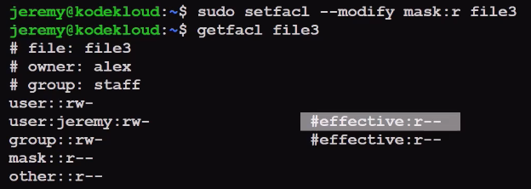

To deny a permission

Put blank in place of permission.
sudo setfacl --modify user:jermy: file3

OR

sudo setfacl --modify user:jermy:---file3

ACLs for group
sudo setfacl --modify group:sudo:rw file3

To remove an ACL
sudo setfacl --remove user:jermy file3
sudo setfacl --remove group:sudo file3

Remove all ACLs
sudo setfacl --remove-all file3

To add ACL to a directory (dir1) and all its subdirectory
sudo --recursive -m user:jermy:rwx dir1/

We can also use
sudo --recursive --remove user:jermy dir1/
sudo --recursive --remove group:sudo dir1/

chattr

With this you can only add data and can't delete the old data.
sudo chattr +a newfile

To remove chattr
sudo chattr -a newfile

Immutable Attribute(i)

With this, you can't edit, delete the filename
sudo chattr +i newfile

To remove
sudo chattr -i newfile

We can check chattr and immutable using ls attr <filename>
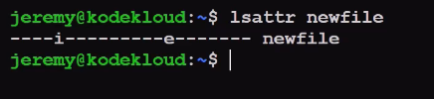

RAID - Create
Monday, February 17, 2025
8:44 PM

Create a level 1 RAID array, at /dev/md0, with two devices: /dev/vdb and /dev/vdc.

mdadm is already installed in your system which is used for creating, managing, and monitoring RAID devices using the md driver.

mdadm --create /dev/md0 --level=1 --raid-devices=2 /dev/vdb /dev/vdc

Enter y and press Enter if asked for the confirmation.

Note: You need to use sudo with the command in case of a non-root user.

Which one of these is also called a mirrored array?
Disks grouped in level 1 RAID is also called a mirrored array.

RAID

What command can you use to view a summary status of your RAID arrays?
The /proc/mdstat file contains the summary status of the RAID arrays, so you can use the cat /proc/mdstat command to view a summary status of your RAID arrays.

RAID

Lec-114: What is RAID? RAID 0, RAID 1, RAID 4, RAID 5, RAID 6, Nested RAID 10 Explained

Redundant Array of Independent Disk OR
Redundant Array of Inexpensive Disk

RAID (Redundant Arrays of Independent Disks) is a technique that makes use of a combination of multiple disks for storing the data instead of using a single disk for increased performance, data redundancy, or to protect data in the case of a drive failure.

How RAID Works?

RAID splits your data across multiple drives (similar to dividing the book into pieces). Depending on the RAID configuration, it may also create duplicates (like making extra copies). If one drive fails, the remaining drives can help reconstruct the lost data.

RAID Levels

RAID-0 (Stripping)

RAID-0 improves system performance by splitting data into smaller “blocks” and spreading them across multiple disks. This process is called “striping.” It enhances data access speed by enabling parallel read/write operations but provides no redundancy or fault tolerance.

A set of blocks distributed across the disks forms a “stripe.” For instance, “0, 1, 2, 3” is one stripe.
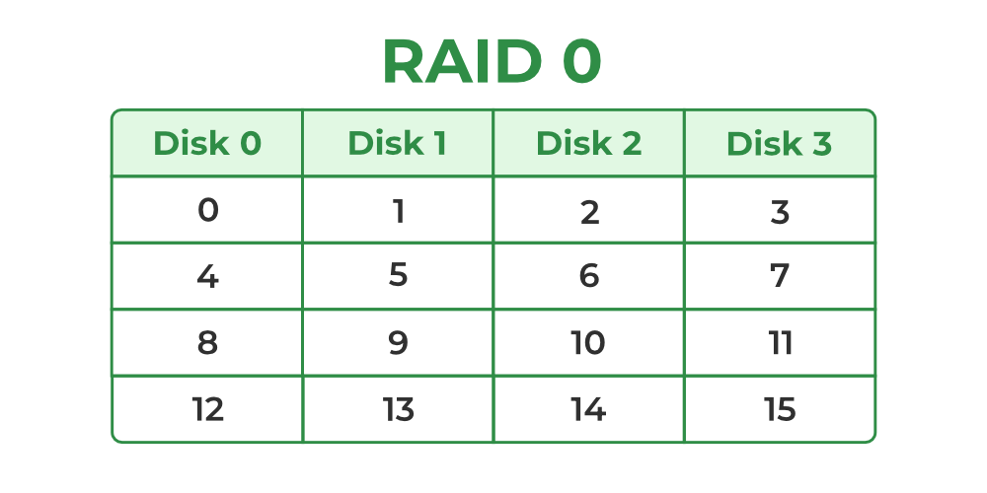

RAID-1 (Mirroring)

RAID-1 enhances reliability by creating an identical copy (mirror) of each data block on separate disks. This ensures that even if one disk fails, the data remains accessible from its duplicate. While this configuration is highly reliable, it requires significant storage overhead.

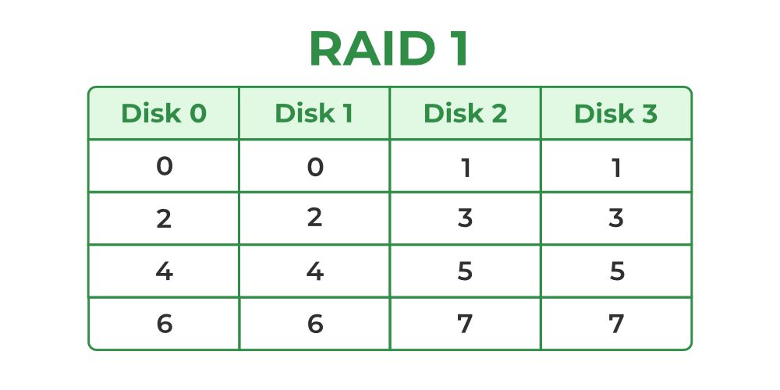
Block 0 is stored on Disk 0 and its duplicate on Disk 1.
Block 1 is stored on Disk 2 and its duplicate on Disk 3.

RAID 1+0

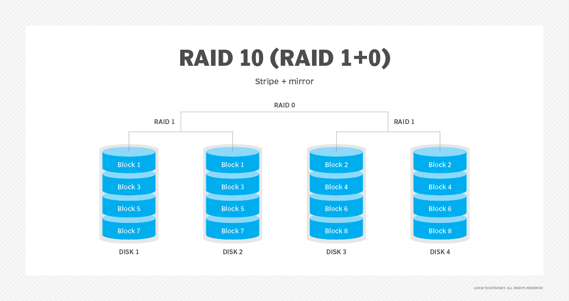

RAID 1+0 mirrors two drives together and then creates a striped set with the pair. RAID 0+1 creates two stripe sets and then mirrors them.

RAID 3 (Byte-Level Stripping with Dedicated Parity)

RAID-3 enhances fault tolerance by employing byte-level striping across multiple drives and storing parity information on a dedicated parity drive. The dedicated parity drive allows for the reconstruction of lost data if a single drive fails.

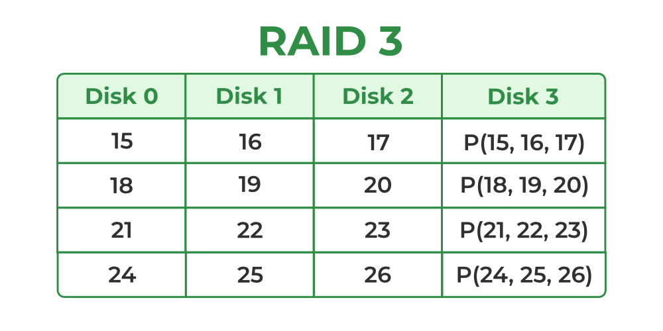
Here Disk 3 contains the Parity bits for Disk 0, Disk 1, and Disk 2.

Suppose, '15' is lost from the Disk 0 and we calculated the Parity by P(15+16+17= 48).
We can recover this 15 by -

data lost = P - Disk1 - Disk2
data lost = 48 - 16 - 17
data lost = 15

But if two disk fail, we can't recover.

RAID-5 (Block-Level Stripping with Distributed Parity)

RAID-5 builds on RAID-4 by distributing parity information across all disks instead of storing it on a dedicated parity drive. This distributed parity significantly improves write performance, especially for random write operations, while maintaining fault tolerance for single disk failures.

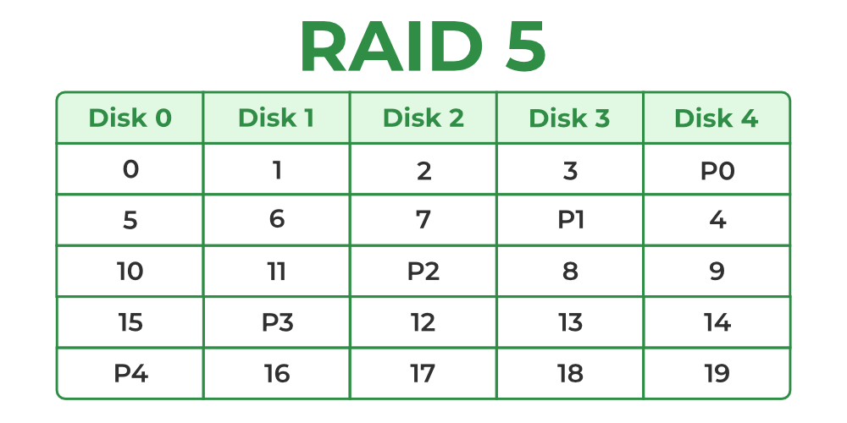

Storage Tips
Monday, March 3, 2025
6:34 PM

Use fdisk for partitioning - create and delete.
Use cfdisk for editing partitioning.
man -k

All about Linux
Monday, February 17, 2025
1:07 AM

🔥 In Linux, almost everything is treated as a file, and most operations involve:

Reading and Writing – Every process interacts with files, whether it's reading configurations, writing logs, or handling data.
Logging – Most actions generate logs, which are stored in specific files (e.g., /var/log/).
Commands Accessing Files – Many commands retrieve data from system files and present them in a user-friendly format.

Lab
Thursday, March 6, 2025
11:32 AM

Which one of these is also called a mirrored array?

level 1 RAID

What command can you use to view a summary status of your RAID arrays?

The /proc/mdstat file contains the summary status of the RAID arrays, so you can use the cat /proc/mdstat command to view a summary status of your RAID arrays.

Create a level 1 RAID array, at /dev/md0, with two devices: /dev/vdb and /dev/vdc.

mdadm is already installed in your system which is used for creating, managing, and monitoring RAID devices using the md driver.

mdadm --create /dev/md0 --level=1 --raid-devices=2 /dev/vdb /dev/vdc

In your home directory, you will find a file named specialfile. Add an ACL permission to this file so that the user called john can read and write to it.

setfacl --modify user:john:rw specialfile

From the file called specialfile, remove the ACL permissions for the user called john.
setfacl --remove user:john specialfile

To the file called specialfile, add an ACL permission for the group called mail. The mail group should get permissions to read and execute this file.

setfacl --modify group:mail:rx specialfile

In your home directory, you will find a directory called collection. Use the setfacl command recursively, so that ACL entries are modified on the directory itself but also all the files and subdirectories it may contain. The ACL permissions should allow the user called john to read, write and execute all entries within this directory.

setfacl --recursive --modify user:john:rwx collection/

