Programming in C and C++ (CST-501)
Assignment 1 (Basics of printf)
Sol 1.
#include <stdio.h>
int main(){
printf("*********\n*\t*\n*\t*\n*\t*\n*\t*\n*\t*\n*\t*\n*\t*\n*\t*\n*********");
return 0;
}
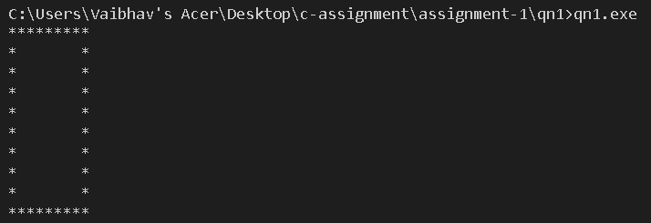

Sol 2.
#include <stdio.h>
int main(){
printf("Vaibhav Gupta | 25583009 | Advanced Instrumentation & Artificial Intelligence");
}
gcc -E qn2.c > qn2.i – The qn2.i file include the extended version as it stends the include file and all macros replaced and all comments removed.
gcc -S qn2.c – It will generate the assembly file from my C code.
gcc -c qn2.c – Binary file generated from the assembly file.
a.out – Final linked executable file
qn2.exe – Final executable file that will provides the output.

Sol 3.

Sol 4.
#include <stdio.h>
int main(){
printf("Hello World");
printf("\n");
printf("\"Hello World\"");
printf("\n");
printf("This is \\n a line");
printf("\n");
printf("How\tare\tyou");
printf("\n");
printf("Hello\n\tWorld!");
printf("\n");
printf("\?\?!");
printf("\n");
printf("Good/\\Day!");
printf("\n");
printf("For printing \\n we use \\\\n");
printf("\n");
printf("\"He\"llo wo\"rld");
printf("\n");
return 0;
}
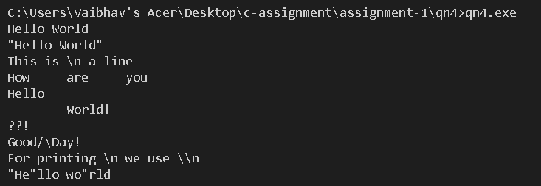

Sol 5.
#include <stdio.h>
int main(){
if(printf("\"Hello World\"")){
}
return 0;
}

