Q-1) Write a C program to compute the area, circumference, and diameter of a circle. Use PI as a macro in your program and also include the standard header file that provides the value of PI. Ensure both methods of using PI are implemented correctly and clearly in the code.
Sol :-
#include <stdio.h>
#include <math.h>
#define PI 3.14159

int main(){
float radius;
printf("Enter the value of the radius :\n");
scanf("%f", &radius);
float diameter = 2 * radius;
float circumference = 2 * PI * radius;
float area = PI * radius * radius;
printf("The value of radius is: %f\nThe value of diameter is: %f\nThe value of circumference is: %f \nThe value of area is: %f\n",radius,diameter,circumference,area);
printf("------------------------------------\n");
printf("The values of area and circumference using the header file:\n");
printf("------------------------------------\n");
diameter = 2 * radius;
circumference = M_PI * 2 * radius;
area = M_PI * radius * radius;
printf("The value of radius is: %f\nThe value of diameter is: %f\nThe value of circumference is: %f\nThe value of area is: %f\n",radius,diameter,circumference,area);
return 0;
}
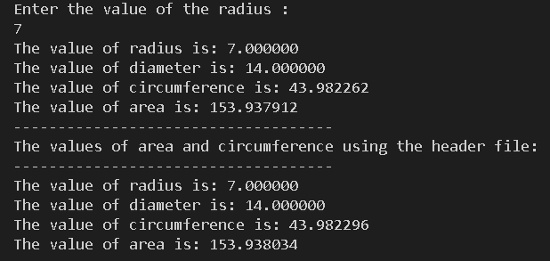
Q-2) Write a C program to take input for principal (P) and time (t), then compute the final amount (A) using the below formula. [For example: If you enter P: 100000, t: 6, the A is 170778.56].
Sol:
#include <stdio.h>
#include <math.h>
int main(){
double A;
float P, t;
printf("Enter the principal amount: \n");
scanf("%f", &P);
printf("Enter the time: \n");
scanf("%f", &t);
A = P * pow(1 + (9.0 / 500),5*t);
printf("The value of amount is : %lf", A);
return 0;
}

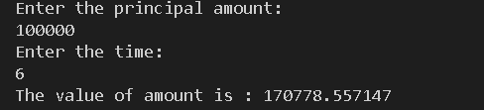
Q-3) You are developing an application for embedded systems with limited memory. To optimize your program and ensure it fits within memory constraints, you need to find out how much memory different data types like integers, floating-point numbers, and characters occupy on the target machine. Write a C program that helps you inspect the memory size (in bytes) required to store different primitive data types on the system where the program runs.
Sol.
#include <stdio.h>

int main(){
int a;
float b;
char c;
double d;
printf("The size of int data type is : %d\n", sizeof(a));
printf("The size of float data type is : %d\n", sizeof(b));
printf("The size of char data type is : %d\n", sizeof(c));
printf("The size of double data type is : %d", sizeof(d));
return 0;
}
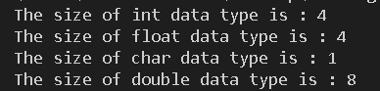
Q-4) Write a program to convert a small letter char to a capital letter char and vice-versa - a -> A, b -> B , B -> b……….
Sol.
#include <stdio.h>
#include <stdbool.h>
#include <ctype.h>

int main(){
char a;
printf("Enter the character :\n");
scanf("%c", &a);
bool lower = islower(a);
bool upper = isupper(a);

char b;
b = a + (lower * -32) + (upper * 32);
printf("The original input character from the user is: %c\n", a);
printf("The converted character is : %c\n", b);
return 0;
}
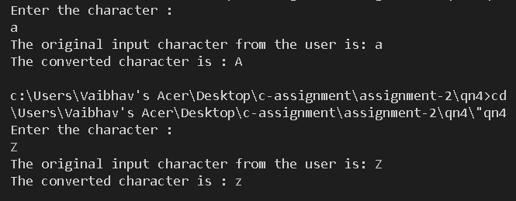

Q-5) Declare a float type variable e= 2.718281828 and print the following using variable e.
Sol.
#include <stdio.h>
#include <math.h>

int main(){
float e = 2.718281828;
printf("%.0f\n", e);
printf("%.0f.\n",round(e));
printf("%.1f\n",e);
printf("%.2f\n",e);
printf("%.6f\n",e);
printf("%.6f\n",e);
printf("%.7f\n",e);
return 0;
}
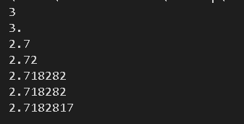
Q-6) Write a C program to print formatted output using different variables. Let's say a=1, b=12, c=123, d=1234, f=12345. Print the values of a to f such that it looks like as shown in a. Similarly take different character type variables and print these variables as shown in b.
Sol.
#include <stdio.h>
#include <string.h>
int main(){
int a = 1;
int b = 12;
int c = 123;
int d = 1234;
int e = 12345;

printf("%05d\n", a);
printf("%05d\n", b);
printf("%05d\n", c);
printf("%05d\n", d);
printf("%05d\n", e);
char a1[] = "a";
char a2[] = "ab";
char a3[] = "abc";
char a4[] = "abcd";
char a5[] = "abcde";
printf("-------------------------------\n");
printf("%5s\n", a1);
printf("%5s\n", a2);
printf("%5s\n", a3);
printf("%5s\n", a4);
printf("%5s\n", a5);
}
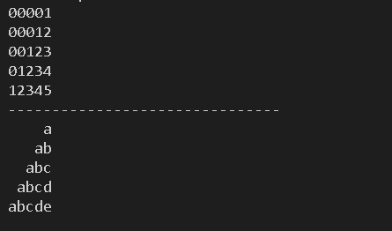
Q-7) Take an integer number of seconds as input, print the equivalent time in hours, minutes, and seconds as output. The recommended output format is: 7322 seconds is equivalent to 2 hours, 2 minutes, and 2 seconds.
Sol.
#include <stdio.h>

int main(){
int s;
printf("Enter the number of seconds :\n");
scanf("%d", &s);
int hour = s / 3600;
int minute = (s % 3600) / 60;
int seconds = s % 60;

printf("%d seconds is equivalent to %d hours, %d minutes and %d seconds.\n", s, hour, minute, seconds);
return 0;
}
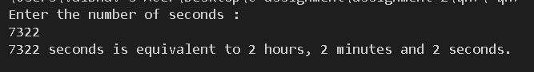
Q-8) Write a C program to reverse a 3-digit number without using a loop.
Sol.
#include <stdio.h>

int main(){
int a;
printf("Enter a 3-digit number:\n");
scanf("%d", &a);
int t, h, o;
t = a / 100;
h = (a % 100) / 10;
o = a % 10;
int reverse = 100 * o + 10 * h + t;
printf("The reverse number is %d", reverse);
return 0;
}
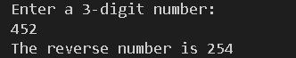

Q-9) Write a C program to print the corresponding Celsius to Fahrenheit. Print as floating point, 3 numbers after decimal point. [10 marks] Formula: F = (9/5 * C) + 32
Sol.
#include <stdio.h>

int main(){
float celsius;
printf("Enter the temperature in celsius :\n");
scanf("%f", &celsius);
float fahrenheit;
fahrenheit = ((float) 9 / 5) * celsius + 32;
printf("Your input temperature in celsius scale is %f\nYour temperature in fahrenheit scale is %.3f", celsius, fahrenheit);
return 0;
}
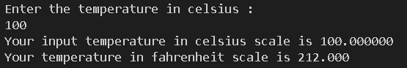
Q-10) Take the input x, y coordinate of a point, calculate and print the squared distance of the point from the origin.
Sol.
#include <stdio.h>
#include <math.h>

int main(){
float x;
float y;
printf("Give the x and y coordinate of a point : \n");
scanf("%f %f", &x, &y);
float dist;
dist = sqrt(pow(x, 2) + pow(y, 2));
printf("The distance of that point from the origin is %f", dist);
return 0;
}
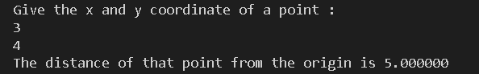
Q-11) Write a program to swap two numbers without using a third variable.
Sol.
#include <stdio.h>
int main(){
int a, b;
printf("Enter the two number a and b: \n");
scanf("%d %d", &a, &b);
printf("The original numbers before swapping is a = %d & b = %d\n", a, b);
b = b + a;
a = b - a;
b = b - a;
printf("The numbers after performing swapping is a = %d & b = %d\n", a, b);
return 0;
}
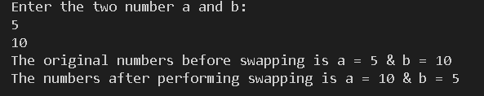
Q-12) Write a C program to take a 3-digit number as input and print whether the number is an Armstrong number or not. (An Armstrong number is a number for which the sum of the cubes of its digits equals the number itself, e.g., 153 = 1³ + 5³ + 3³)
Sol.
#include <stdio.h>
#include <math.h>
int main(){
int a;
printf("Enter a 3 digit number: \n");
scanf("%d", &a);
int h, t, o;
h = a / 100;
t = (a % 100) / 10;
o = a % 10;
if((pow(h,3)+pow(t,3)+ pow(o,3)) == a){
printf("The number is an Armstrong number\n");
} else {
printf("The number is not an armstrong number\n");
}
return 0;
}
