**Andorid Development Environment Setup**

1. Go to below URL to download android SDK

<http://developer.android.com/sdk/index.html>

1. Do not download Eclipse bundled with ADT as it will download entire new eclipse with ADT plugin and SDK bundled in it. We need to setup Andorid SDK and ADT independently

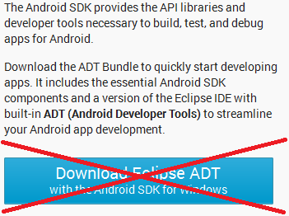

1. Click on “**GET THE SDK FOR EXISTING IDE”.** Click on the “Download the stand-alone Android SDK Tools for Windows” button.

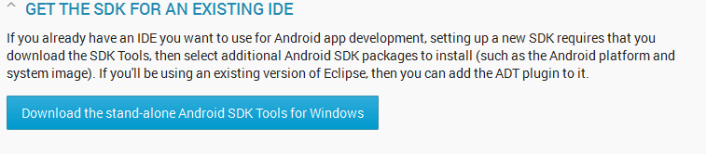

1. Accept the license agreement by click on checkbox “I have read and agree with the above terms and conditions”. Click on the “Download the stand-alone Android SDK Tools for Windows” button. It will download Andorid SDK.
2. We are using r23.0.2 version of Andorid SDK.
3. Execute Andorid SDK installer installer_r23.0.2-windows.exe

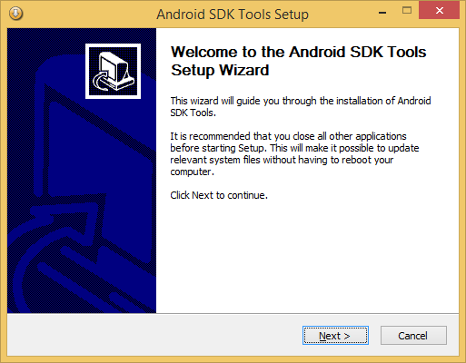

1. Click Next

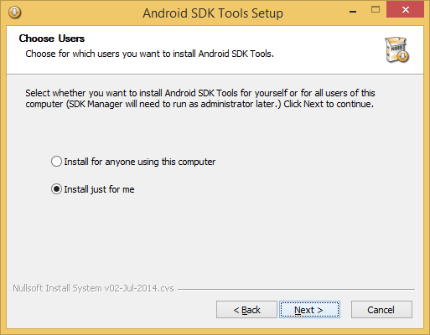

1. Click Next and install the Andorid SDK
2. Click on finish and it will start Andorid SDK Manager. This will help you download API support for past versions of Andorid.

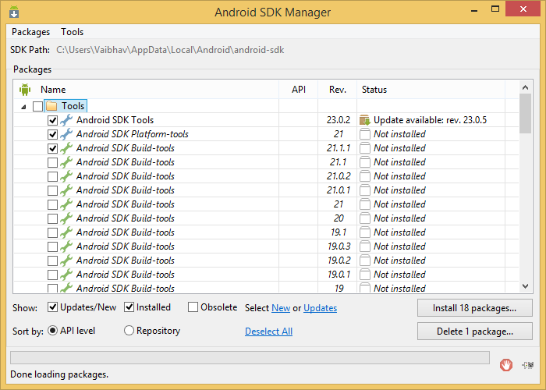

1. Keep the setting as is and select few other options if you want to install support for other version of Andorid also. Click on Install 18 package to install packages. Accept License and click Install.
2. The installation may take time depending upon the Internet speed. For me it took 2 hours.
3. You can also install other versions later also by starting Andorid SDK Manager.