Exercises Of Array
Program-1:
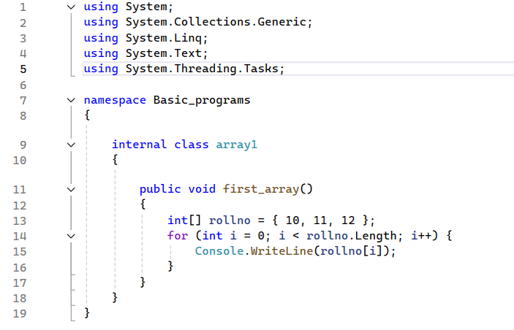program-2:
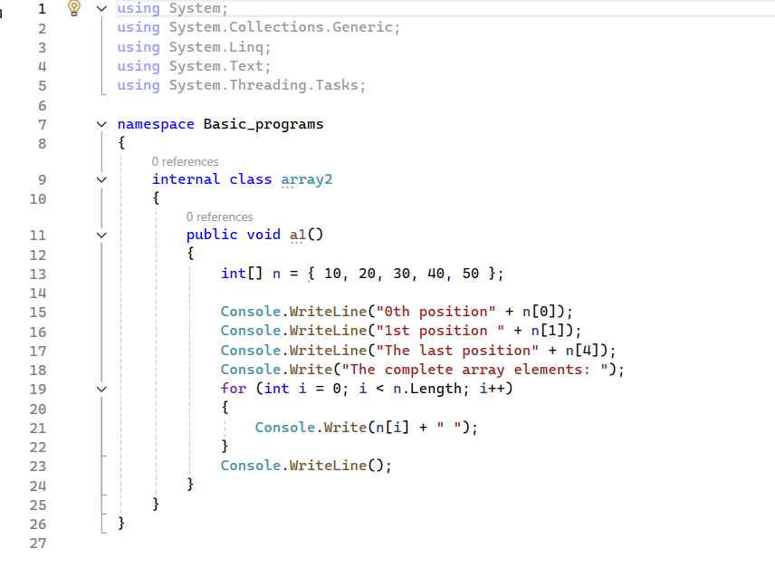
Program-3:
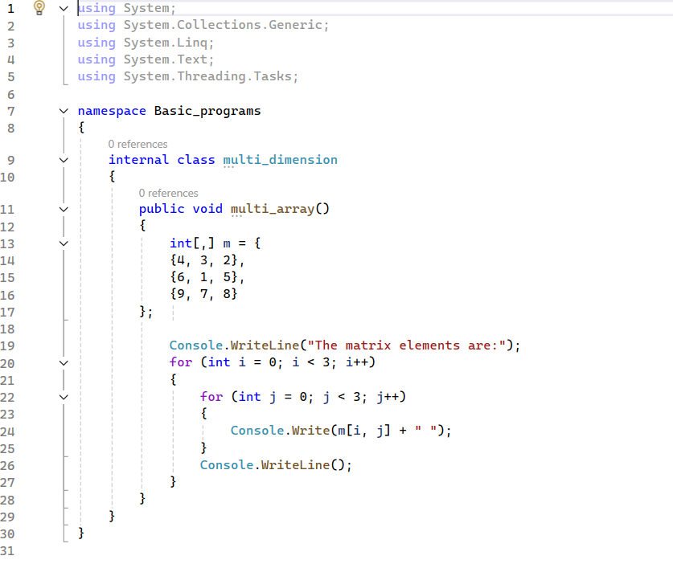proram-4:
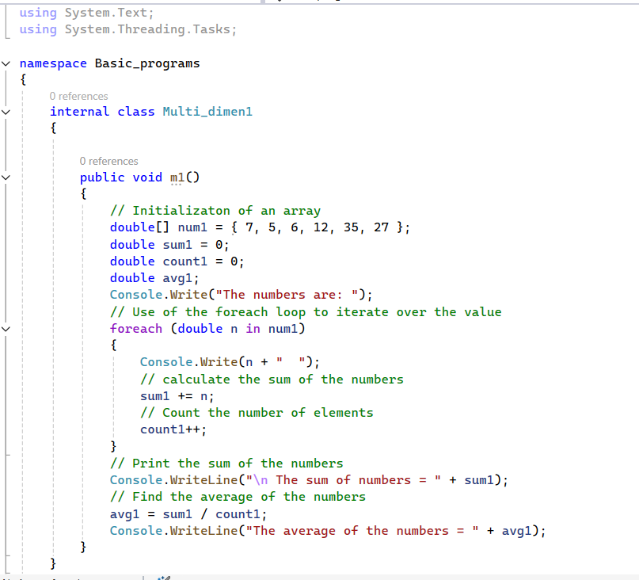

Program-5:
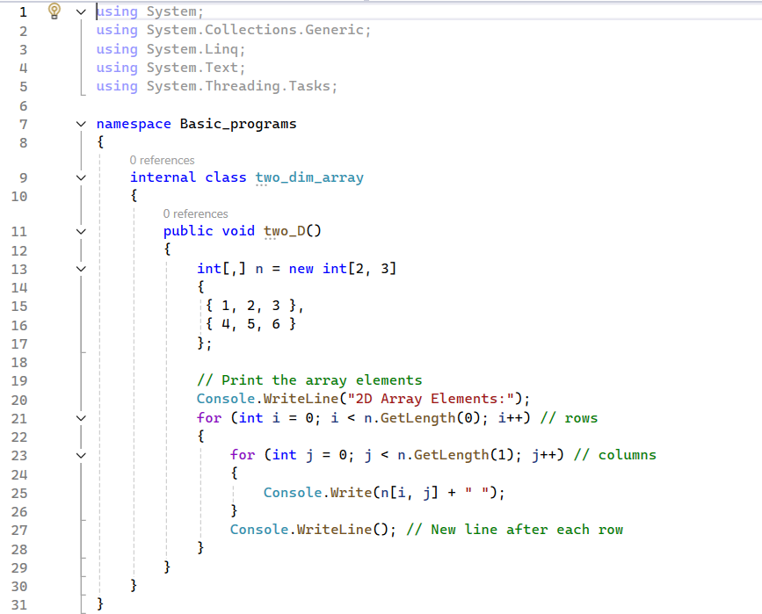program-6:Command line argument(Write code in your Program.cs file
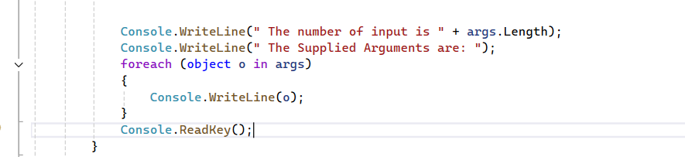
How to run

1. | Create a C# program that asks the user for 5 integers to store them in an array of integers and display them in reverse order.
2. | Create a program in C# that serves to search an array of integer values.
3. | Write a program in C# that asks the user for 10 integers to store them in an array of integers and show only even integers.
4. | Create a C# program that asks the user for 10 real numbers and shows the arithmetic mean of the positive and negative numbers.
5. | Create a C# program to create array of different vowel and print it.  char[] vowels = new [] { 'a', 'e', 'i', 'o', 'u' };  foreach (char vowel in vowels)  {  System.Console.Write(vowel);  }

