Lab exercise-2:
Write a C# Sharp program to swap two numbers.
Write a C# Sharp program to print on screen the output of adding, subtracting, multiplying and dividing two numbers entered by the user.
Write a C# Sharp program that takes four numbers as input to calculate and print the average.
Write a C# Sharp program that takes an age as input and prints something like "You look older than 20".
Write a C# program to create a new string from a given string where the first and last characters change their positions.
Write a C# Sharp program that prints the multiplication table of a number as input.
Write a C# program to print odd numbers from 1 to 99. Prints one number per line.

Program-1
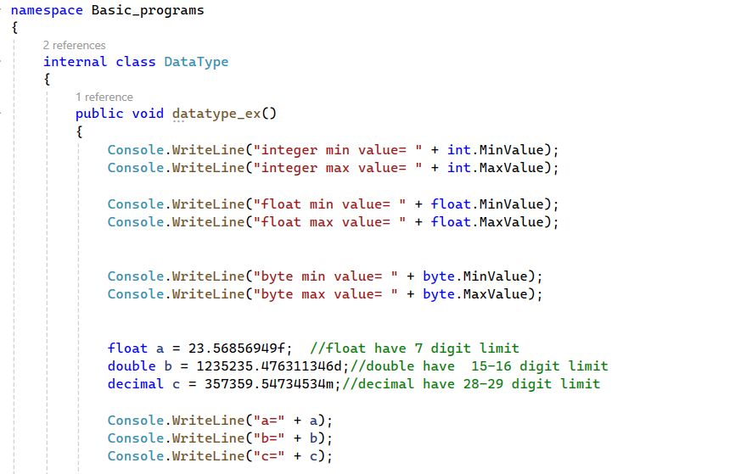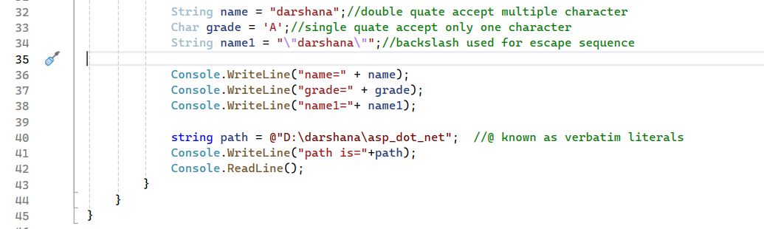

Progarm-2
