Example of A Binary Max Heap
- Suppose below is the given Binary Heap that follows all the properties of Binary Max Heap.
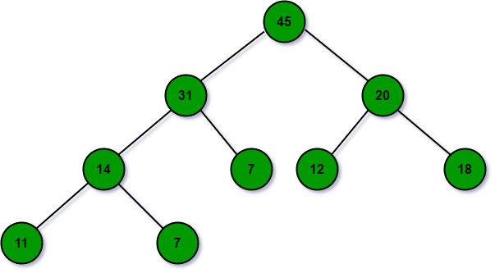
- Now a node with value 32 need to be inserted in the above heap: To insert an element, attach the new element to any leaf. For Example A node with priority 32 can be added to the leaf of the node 7. But this violates the heap property. To maintain the heap property, shift up the new node 32.
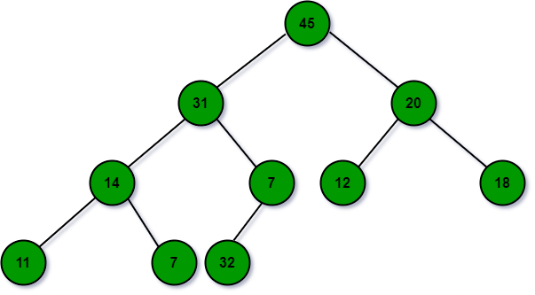
- Shift Up Operation get node with 32 at the correct position: Swap the incorrectly placed node with its parent until the heap property is satisfied. For Example: As node 7 is less than node 32 so, swap node 7 and node 32. Then, swap node 31 and node 32.
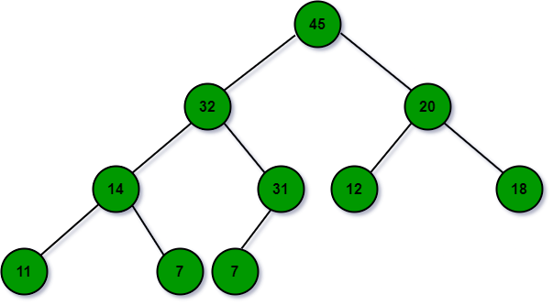
- Extract Max: The maximum value is stored at the root of the tree. But the root of the tree cannot be directly removed. First, it is replaced with any one of the leaves and then removed. For Example: To remove Node 45, it is first replaced with node 7. But this violates the heap property, so move the replaced node down. For that, use shift-down operation.
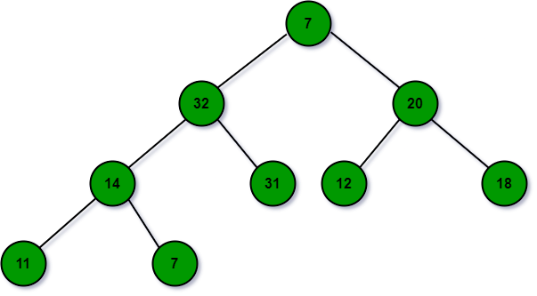
- Shift Down Operation: Swap the incorrectly placed node with a larger child until the heap property is satisfied. For Example Node 7 is swapped with node 32 then, last it is swapped with node 31.
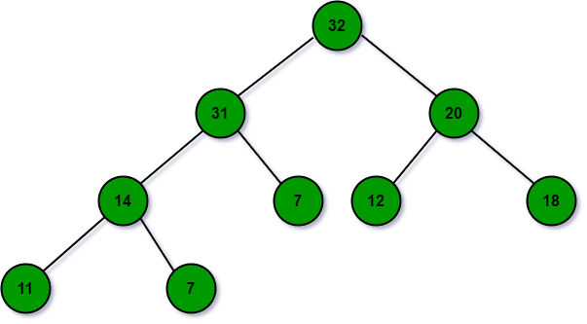
- Change Priority: Let the changed element shift up or down depending on whether its priority decreased or increased. For Example: Change the priority of nodes 11 to 35, due to this change the node has to shift up the node in order to maintain the heap property.
- Remove: To remove an element, change its priority to a value larger than the current maximum, then shift it up, and then extract it using extract max. Find the current maximum using get Max.
- Get Max: The max value is stored at the root of the tree. To get max, just return the value at the root of the tree.

Array Representation of Binary Heap
Since the heap is maintained in form of a complete binary tree, because of this fact the heap can be represented in the form of an array. To keep the tree complete and shallow, while inserting a new element insert it in the leftmost vacant position in the last level i.e., at the end of our array. Similarly, while extracting maximum replace the root with the last leaf at the last level i.e., the last element of the array.
Below is the illustration of the same:
