Explanation:
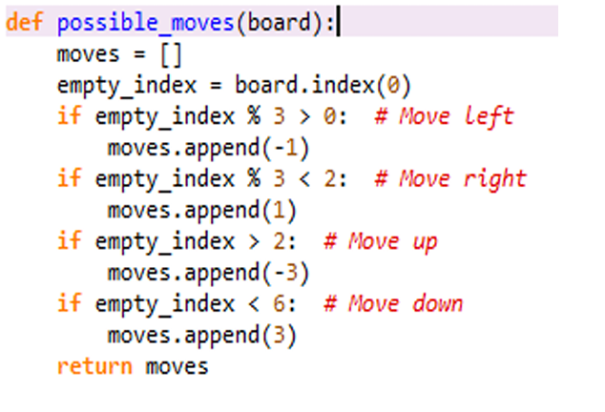

board = [1,2,3,
4,0,5,
6,7,8]

Empty_index = 4

if empty_index % 3 > 0:
moves.append(-1)

Index = 4

4 % 3 = 1

1 > 0
moves.append(-1)

[-1, 1, -3, 3]
Aaaaaaaaaaaaaaaaaaaaaaaaaaaaaaaaaaaaaaaaaaaaend

board = [0,1,2,
3,4,5,
6,7,8]

Index = 0
[1, 3]
board = [1,2,3,
4,5,6,
7,8,0]

Index = 8
Possible moves:
- Left ✔
- Up ✔
- Right ✖
- Down ✖
[-1, -3]

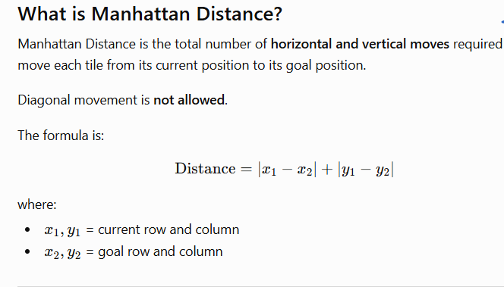

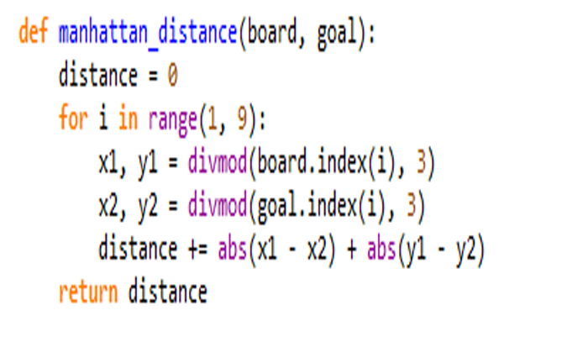

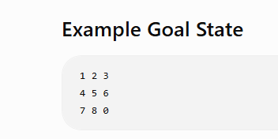

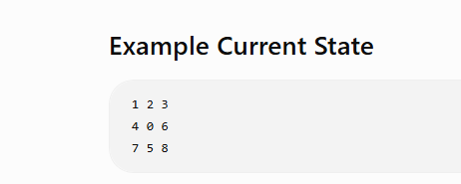
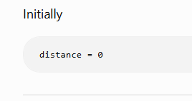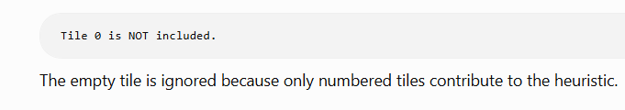

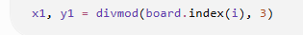
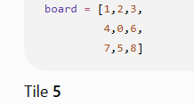
board.index(5)
returns
7

divmod(index,3)
divmod(7,3)
(2,1)
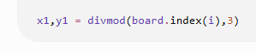
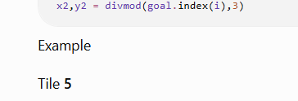
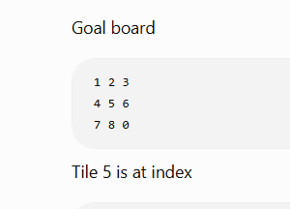
divmod(4,3)
