Machine learning is a branch of Artificial Intelligence that focuses on developing models and algorithms that let computers learn from data without being explicitly programmed for every task. In simple words, ML teaches systems to think and understand like humans by learning from the data.

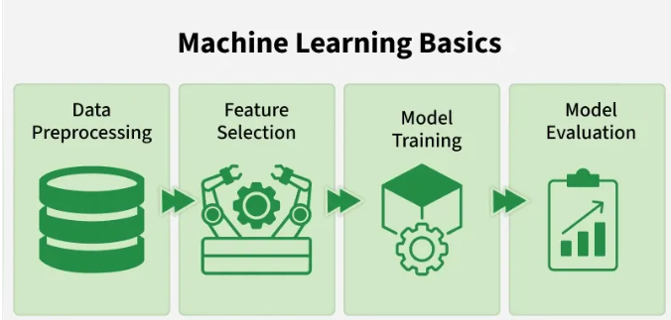

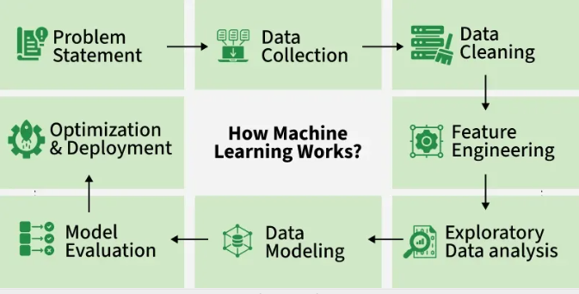

Machine Learning is mainly divided into three core types:
- Supervised Learning: Trains models on labeled data to predict or classify new, unseen data.
- Unsupervised Learning: Finds patterns or groups in unlabeled data, like clustering or dimensionality reduction.
- Reinforcement Learning: Learns through trial and error to maximize rewards, ideal for decision-making tasks.

Module 1: Machine Learning Pipeline

Deep Learning vs. Machine Learning
Deep learning is a specialized, advanced subset of machine learning inspired by the human brain. While traditional machine learning algorithms usually require humans to manually curate and extract the key features of the data, deep learning uses multi-layered artificial neural networks to automatically extract features and learn end-to-end.
How Machine Learning Works
As its name indicates, machine learning works by creating computer-based statistical models that are refined for a given purpose by evaluating training data, rather than by the classical approach where programmers develop a static algorithm that attempts to solve a problem. As data sets are put through the ML model, the resulting output is judged on accuracy, allowing data scientists to adjust the model through a series of established variables, called hyperparameters, and algorithmically adjusted variables, called learning parameters.
Because the algorithm adjusts as it evaluates training data, the process of exposure and calculation around new data trains the algorithm to become better at what it does. The algorithm is the computational part of the project, while the term “model” is a trained algorithm that can be used for real-word use cases.
The scope, resources, and goals of machine learning projects will determine the most appropriate path, but most involve a series of steps.
1. Gather and compile data
Training ML models requires a lot of high-quality data. Finding it is sometimes difficult, and labeling it, if necessary, can be very resource intensive. After identifying potential data sources, evaluate them to determine overall quality and alignment with the project’s existing data integration/repository resources. Those sources form the training foundation of a machine learning project.
2. Select an appropriate algorithm to yield the desired model
Depending on whether the project plans to use supervised, unsupervised, or semi-supervised learning, data scientists can select the most appropriate algorithms. For example, a simpler project with a labeled data set can use a decision tree, while clustering—dividing data samples into groups of similar objects—requires more compute resources as the algorithm works unsupervised to determine the best path to a goal.
3. Refine and prepare data for analysis
Chances are that incoming data won’t be ready to go. Data preparation cleans up data sets to ensure that all records can be easily ingested during training. Preparation includes a range of transformation tasks, such as establishing date and time formats, joining or separating columns as needed, and setting other format parameters, such as acceptable significant digits in real number data. Other key tasks include cleaning out duplicate records, also called data deduplication, and identifying and possibly removing outliers.
4. Educate the model through training
Once the desired final model has been selected, the training process begins. In training, a curated data set, either labeled or unlabeled, is fed to the algorithm. In initial runs, outcomes may not be great, but data scientists will tweak as needed to refine performance and increase accuracy. Then the algorithm is shown data again, usually in larger quantities to tune it more precisely. The more data the algorithm sees, the better the final model should become at delivering the desired results.
5. Assess model performance and accuracy
After the model has been trained to sufficient accuracy, it’s time to give it previously unseen data to test how it performs. Often, the data used for testing is a subset of the training data set aside for use after initial training.
6. Fine-tune and enhance model parameters
The model now is most likely close to deployment. Runs with test data sets should produce highly accurate results. Enhancements happen through additional training with specific data—often unique to a company’s operations—to supplement the generalized data used in the original training.
7. Launch the model
With results optimized, the model is now ready to tackle previously unseen data in normal production use. When the model is live, project teams will collect data on how the model performs in real-world scenarios. This can be done by monitoring key performance metrics, such as accuracy, the overall correctness of the model’s predictions, and recall, the ratio of correctly predicted positive observations. Also consider how the model’s predictions are affecting business outcomes on the ground—is it generating value, whether in increased sales of blouses or better diagnostics?
Conducting regular audits and reviews of the model’s performance can help identify issues or distortions that may have arisen post-deployment and are essential to ensure that the model performs effectively and meets the desired objectives.
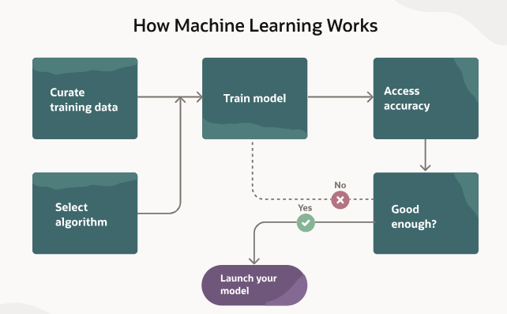

Machine Learning Algorithms
Algorithms are the computational part of a machine learning project. Once trained, algorithms produce models with a statistical probability of answering a question or achieving a goal. That goal might be finding certain features in images, such as “identify all the cats,” or it might be to spot anomalies in data that could indicate fraud, spam, or a maintenance issue with a machine. Still other algorithms might attempt to make predictions, such as which clothing items a buyer might also like based on what’s currently in a shopping cart.
Some of the most common algorithms used in machine learning are as follows:
- Neural networks: The human brain works by creating networks of nodes that perform functions as varied as processing images from our eyes, storing memories, and controlling our muscles. Computer-based neural networks are modeled after this brain architecture, creating layers of nodes that weigh the relationships between data they’ve analyzed and data in adjacent nodes. Working as a network, these nodes can determine features of data, such as elements within a picture.
- Linear regression: Linear regression algorithms take data points and build a mathematical equation for a line that best supports predicted outcomes. This is sometimes known as the “line of best fit.” Linear regression works by tweaking variables in the equation to minimize the errors in predictions. An example of linear regression is seen in pediatric care, where different data points can predict a child’s height and weight based on historical data. Similarly, BMI is linear regression that attempts to correlate height and weight to overall body fat. Because the algorithm uses a simple line for its predictions, error rates can be high. For instance, a BMI of 30 indicates obesity. That’s often true for the general public but definitely not for strength athletes such as NFL linebackers.
- Logistic regression: Best used for binary outcomes, logistic regression is like linear regression but with special considerations at the boundaries of possible data ranges. An example of logistic regression includes pass/fail analysis on the likelihood of converting a potential customer into a paying one. Logistic regression is often used in medical diagnoses—for instance, plasma glucose concentrations over a certain range are used as a strong indicator of diabetes. Logistic regression also can be used to predict whether an email is spam or not, or if a credit card transaction is fraudulent.
- Clustering: Clustering is a form of unsupervised learning that exposes an algorithm to unlabeled data sets in which data may fall into distinct groups, or clusters. As the algorithm evaluates training data, it searches for patterns and overlapping details between the data and creates groups. Say the algorithm is looking at the nutritional value of a wide variety of fruits. It might find that citrus fruits form one group, berries form another, and melons form a third. This allows for easier understanding of what makes each cluster unique. Clustering is particularly useful for any sort of categorization project, such as market segmentation.
- Decision trees: Decision trees use supervised learning and basic if-then progressions to make predictions. Depending on the complexity of the project, decision trees can be ideal as resource-light algorithms that produce straightforward results. For example, if a college wanted to determine which students could skip freshman English, it might use a decision tree that first asked if the student had taken four years of English in high school and, if so, whether the student had at least a 3.6 GPA in those classes. Another path might simply ask if the student had scored better than a certain threshold on the reading, writing, and language SAT sections.
- Random forests: On their own, decision trees come with limitations due to their inherent rigid workflows and requirement that all evaluation questions be answered. In our decision tree example above, the college might require that both conditions be true, even though meeting just one might be sufficient. And there could be other factors to consider, such as how well a student performed on an admissions essay. If all three factors were required, the college would have a problem of requiring an “overfit” to the decision tree. Students who fared well on all three criteria would highly likely be fine without taking English 101. However, others who also would be fine still will be required to take the class. Random forests bring together collections of decision trees that cumulatively weigh outcomes to present a broader perspective. With random forests, projects can still use the core mechanics of decision trees while considering nuanced relationships between relevant data points. So, our college might split these three criteria into separate decision trees and then use weights to decide who can skip English 101 based on finding, perhaps, that doing well in high school English is the most predictive indicator and that performance on the essay is the least.

