How Simulated Annealing Works in AI
Imagine you are blindfolded in a bumpy mountain range, and your goal is to find the lowest valley (the global minimum).
A simple approach (called "Hill Climbing" or "Gradient Descent") is to just keep stepping downwards. The problem? You might reach the bottom of a shallow valley (a local minimum) and get stuck, thinking you've reached the absolute bottom because every step from there goes up.
Simulated Annealing prevents you from getting stuck by allowing you to occasionally take a step up the mountain, especially early on.
Simulated Annealing prevents you from getting stuck by allowing you to occasionally take a step up the mountain, especially early on.
Here is the step-by-step process:
- Start Hot: You begin at a random location with a high "Temperature."
- Explore: You pick a random neighboring spot.
- Evaluate: * If the neighbor is lower (a better solution), you move there.
  - If the neighbor is higher (a worse solution), you might still move there.

A Real-World Example: The Traveling Salesperson
Imagine a delivery driver needs to visit 50 cities and return home, and they want to find the shortest possible route. Checking every single combination would take a supercomputer millions of years.
Instead, an AI uses Simulated Annealing:
- It generates a random route to start.
- It randomly swaps two cities in the route.
- If the new route is shorter, it keeps it.
- If the new route is longer, it will sometimes keep it anyway (based on the current "Temperature"). This prevents the AI from getting stuck with a "pretty good" route when a vastly better one requires temporarily mixing things up.
- As the algorithm runs, the "Temperature" drops. The AI stops accepting longer routes and fine-tunes the current route until it locks into a highly optimized path.

Imagine a short route visiting four cities before returning home.
- Current Route: Miami → Atlanta → Chicago → Dallas → Miami
The AI decides to randomly swap the positions of Atlanta and Dallas.
- New Route: Miami → Dallas → Chicago → Atlanta → Miami

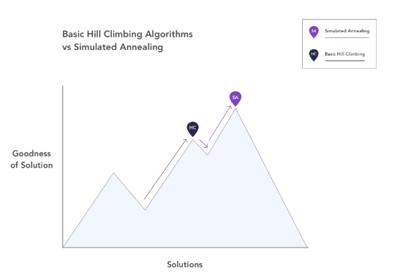

This plot represents the general basic behavior of simple hill climbing algorithms compared against the behavior of simulated annealing. We see that hill climbing results in the algorithm getting stuck at a local optimum because it cannot move downhill. On the other hand, simulated annealing has the ability to go downhill and escape that local optimum, eventually climbing up again to reach the global optimum. So what about simulated annealing allows this behavior?

