Develop Python Code to Solve below given puzzles (games) using heuristic tecnniques.
1. Treasure Hunt on a Grid
A robot starts at position S and must reach the treasure T in a 2D grid.
The robot can move:
- Up
- Down
- Left
- Right
Some cells contain obstacles (#).
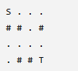
Discover a heuristic that estimates the remaining distance to the treasure.
h(n) = |xgoal − x| + |ygoal − y|
Reasoning:
- Horizontal distance
- Vertical distance
- Robot cannot move diagonally

2. 8-Puzzle
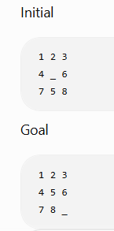
Expected Heuristics
Manhattan Distance of every tile
Total Manhattan Distance
3. Robot Vacuum Cleaner
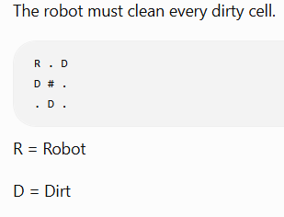

Task
The goal is all dirt removed.
Students must invent a heuristic.

Hint
Possible ideas:
- Number of dirty cells
- Distance to nearest dirt
- Sum of all distances
- Maximum distance
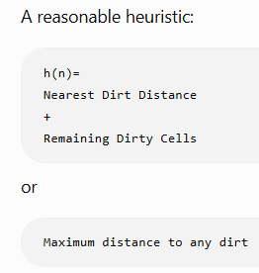

4. Delivery Robot
The robot must deliver packages to three houses.
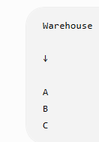
Packages can be delivered in any order
Students must think:
- Current position
- Remaining houses
- Best remaining travel estimate
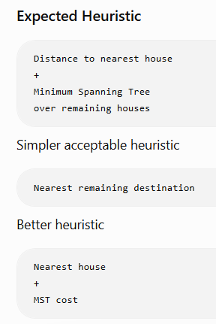

Solution
Students should discover that
Simply counting remaining houses is weak.
5. Maze Escape with Keys
