Knowledge Representation and Reasoning (KR&R) enables computers to understand, organize, and apply real-world information effectively using rules for accurate decision-making.
Knowledge, Representation, and Reasoning
Knowledge:
Refers to the information and facts about the world that a system needs to perform tasks effectively.
This includes data, rules, concepts, relationships, and general understanding of the domain or problem.
Example: Knowing that "water boils at 100°C" or "a car has four wheels."
Representation:
Involves structuring and organizing knowledge in a way that computers can store, process, and use.
Common methods include logical statements, graphs, semantic networks, ontologies, or frames.
Example: Representing a family tree with nodes (individuals) and edges(relationships).

Reasoning:
The process of drawing conclusions, making inferences, or solving problems using the represented knowledge.
This could involve deduction (logical reasoning), induction (generalization), or abduction (hypothesis generation).
Example: Given "All humans are mortal" and “Ram is human," reasoning
concludes, “Ram is mortal."

Components of KR&R:

Ontologies (Organized Knowledge) Provide a structured framework of knowledge, defining a set of concepts and categories that represent a subject.
Example: "A cat is an animal, and animals are living things."
Rules: Govern the logical framework within which AI systems operate to derive reasoned conclusions.
Example: "If it rains, take an umbrella."
Semantics: Offer a deeper understanding of data through meaningful interpretation and association.
Example: Knowing that "Apple" can mean a fruit or a company based on the sentence: "I ate an apple" vs. "Apple released a new iPhone."
What is Knowledge?
Knowledge is when someone (like John) understands and is sure about a fact
or idea (like "Mary will come to the party").
Propositions:
A proposition is a statement that can be either true or false, like "The sky is blue" or "Water boils at 100°C."
Knowing vs. Believing:
Knowing means being sure that something is true.
Believing means thinking something is true, but you might not be completely certain or correct.

What is Representation?
Representation is the use of one thing (like a symbol, image, or word) to stand for something else, making it easier to understand, use, or communicate.
Examples:
A drawing of a burger represents a fast-food restaurant.
The number "7" or Roman numeral "VII" represents the concept of the number seven.
Symbols and Propositions:
Symbols (like words, numbers, or drawings) are used to stand for ideas, objects, or facts.
Propositions are the ideas or facts that symbols represent.
Example: The sentence "The sky is blue" is a proposition because it represents the idea or fact that the sky has a blue color.

Knowledge-Based Systems
In AI, we build knowledge-based systems containing a Knowledge Base (KB) of symbolic representations.
These representations represent facts, beliefs, and goals, shaping the system’s actions and reasoning.
In Simple Terms: Knowledge Representation enables AI systems to be interpretable, purposeful, and functionally aligned with human understanding and
reasoning processes.

Example: A Smart Home AI System Knowledge Base (KB) contains symbolic representations:
Facts: "If the temperature is below 18°C, turn on the heater."
Beliefs: "People like a warm living room."
Goals: "Maintain a comfortable room temperature."

How it Shapes Actions and Reasoning:
The system checks the current temperature.
Based on its knowledge, it decides to turn on the heater automatically to meet the goal of a warm living room.

Knowledge-Based Systems
A knowledge-based system uses a Knowledge Base (KB) containing symbolic structures to represent beliefs and facts.
Unlike procedural systems, it separates knowledge representation from execution.
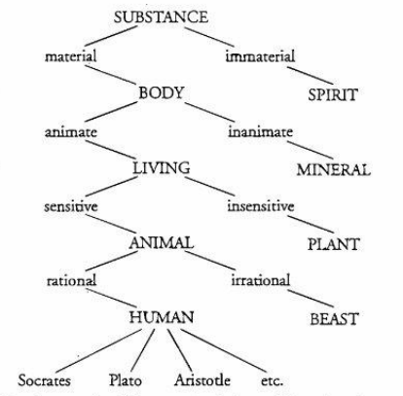
Subject and Predicate
Breaks sentences into two parts: Subject (what you're talking about) and Predicate (what you're saying about it).
Aristotle’s Syllogism: Combines subjects and predicates logically.
Example:
1. All trailer trucks are 18-wheelers.
2. Some Peterbilt is a trailer truck.
3. Therefore, some Peterbilt is an 18-wheeler.
Predicate Logic (More Detailed Form)
Represents relationships and internal structure using variables and
quantifiers (∀\forall: for all, ∃\exists: there exists).
Example:
Sentence: Every trailer truck has 18 wheels.
Logic:
(∀x)(trailerTruck(x)⇒numberOfWheels(x,18))

Meaning: For every xx, if xx is a trailer truck, then xx has 18 wheels.

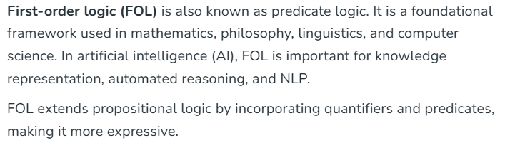
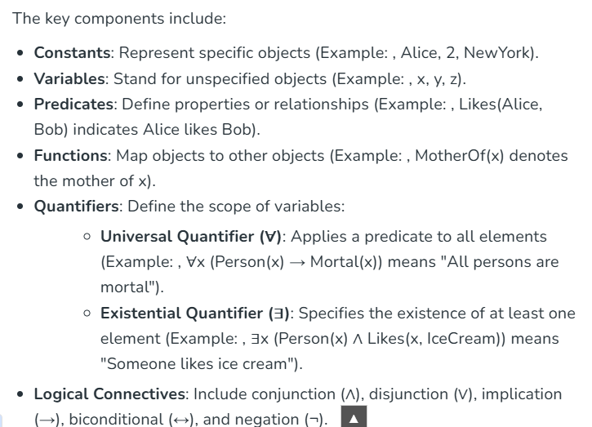
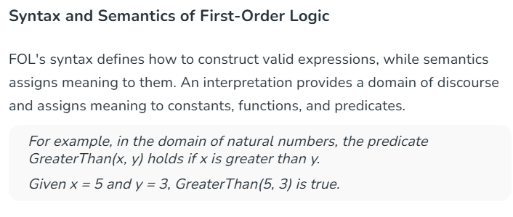
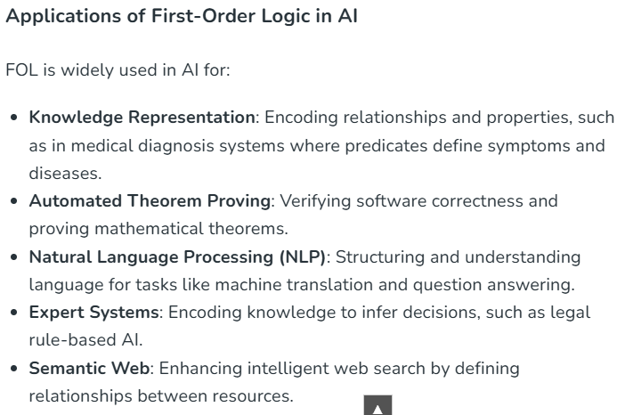

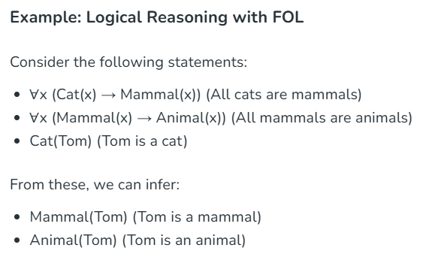

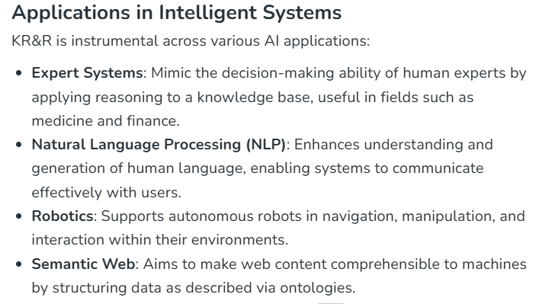

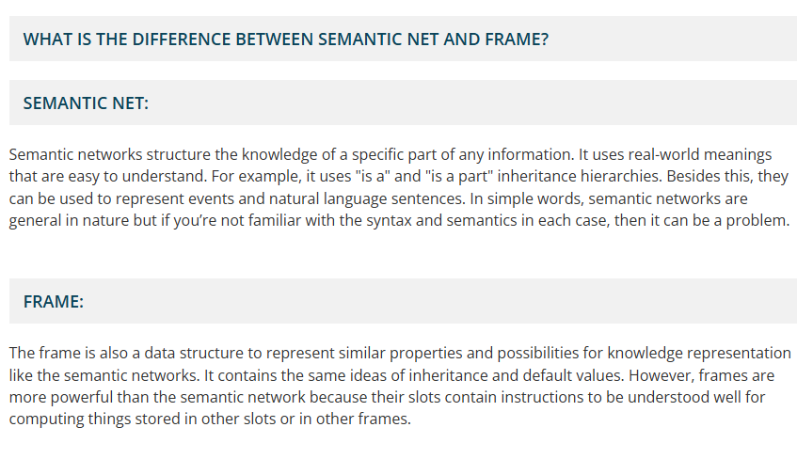
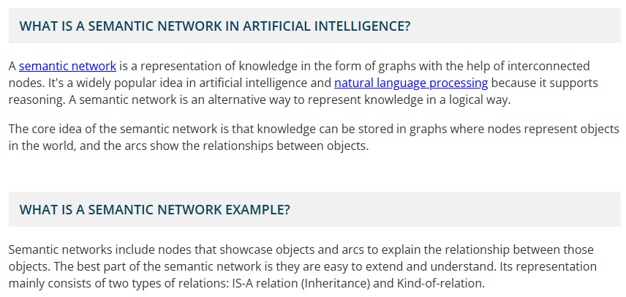
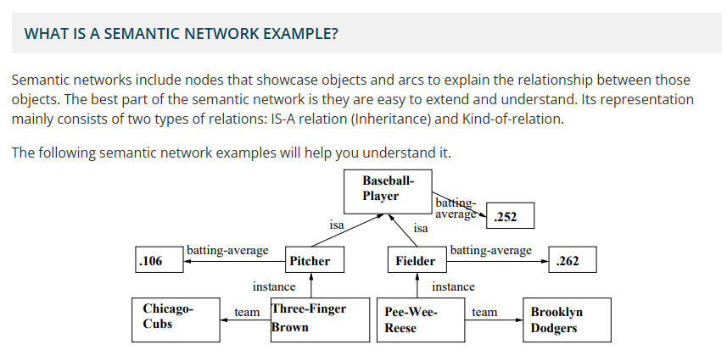
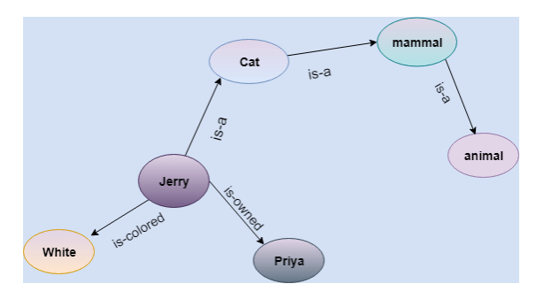
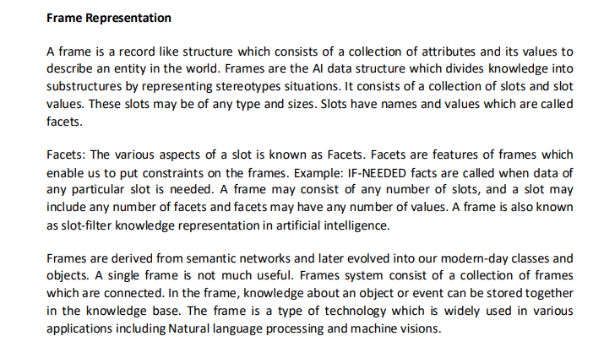

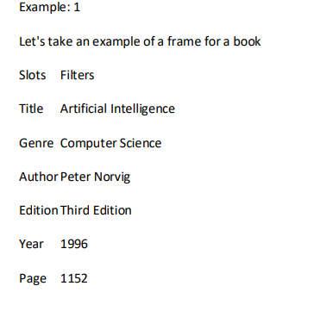
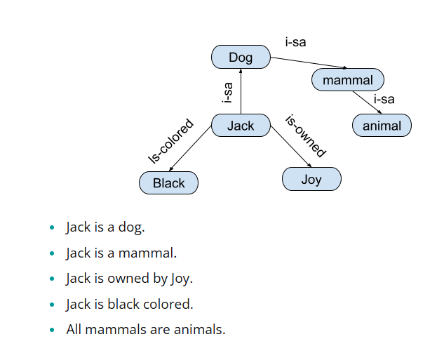
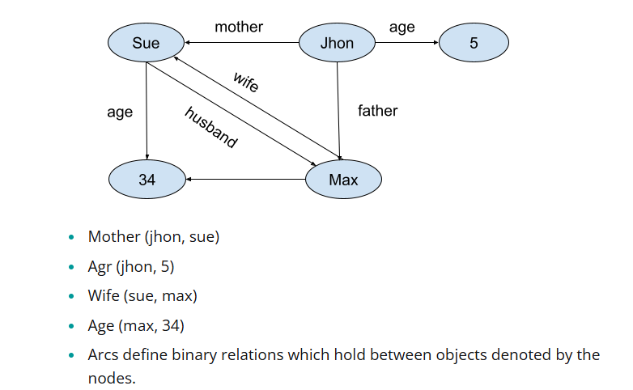
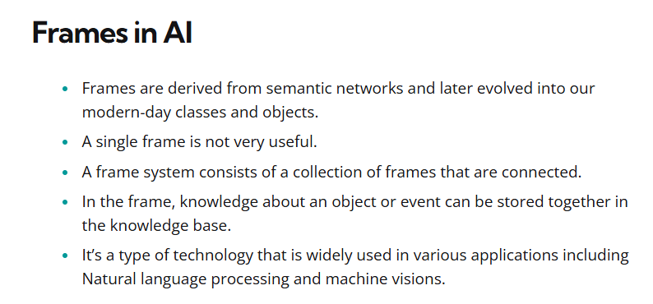
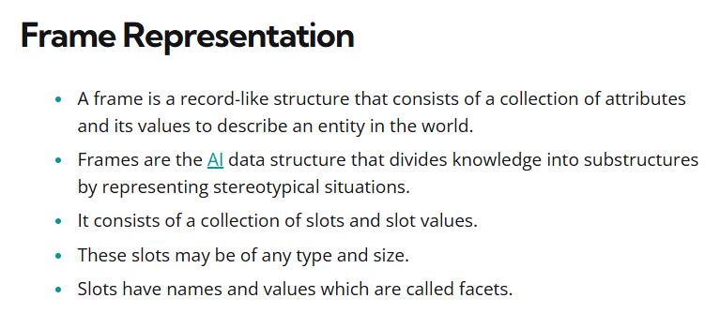
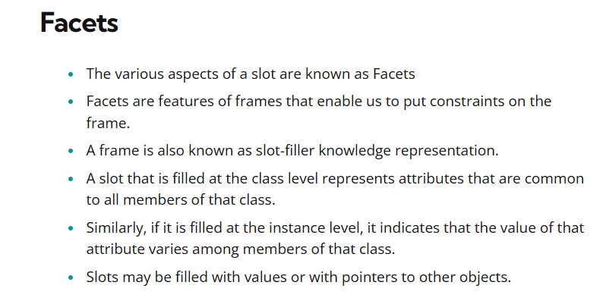

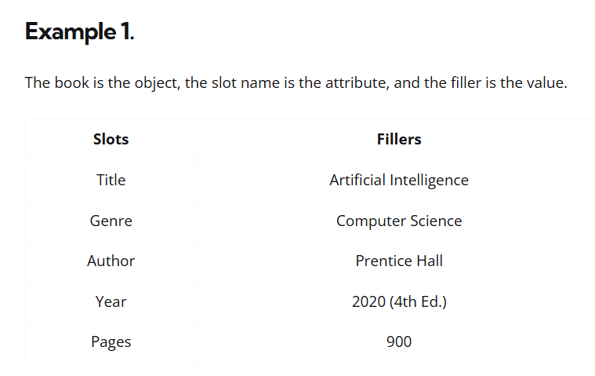
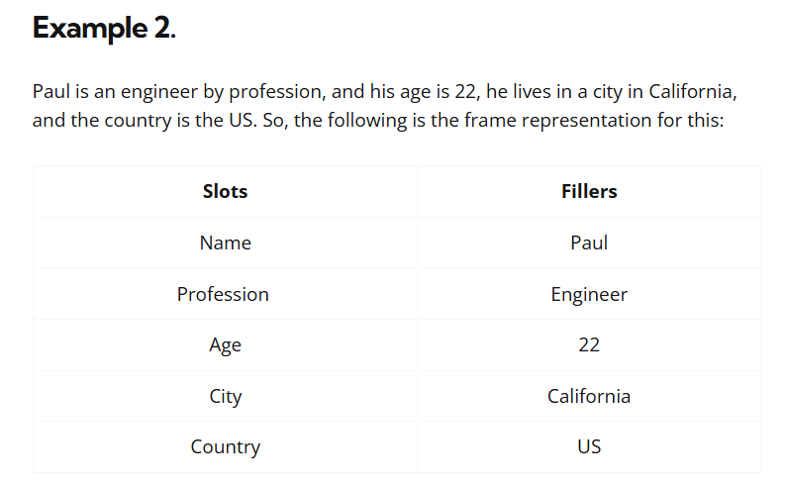

In mathematical logic, a second-order predicate is a predicate that takes a first-order predicate as an argument
