Exercise 1
NOTE: Use COLAB as editor for performing those programs

Perform following Programs, write & Run the codes and analyze output. Make separate file for each program.

1. print("Hello, World!")

2. if 5 > 2:
print("Five is greater than two!")

3. 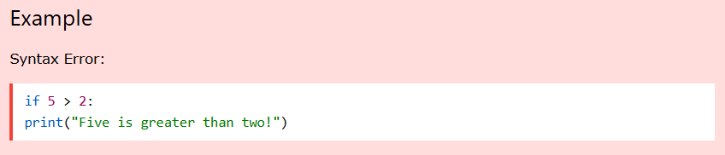
4. 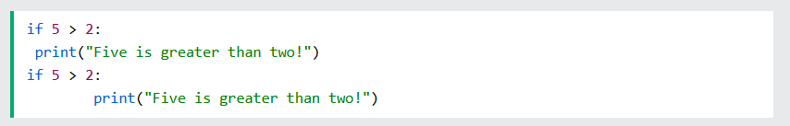
6. 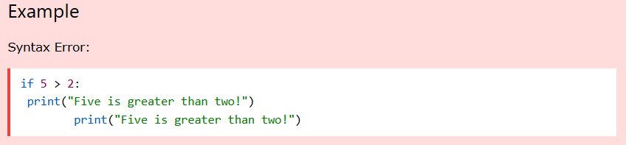
7. 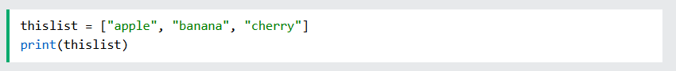
8. 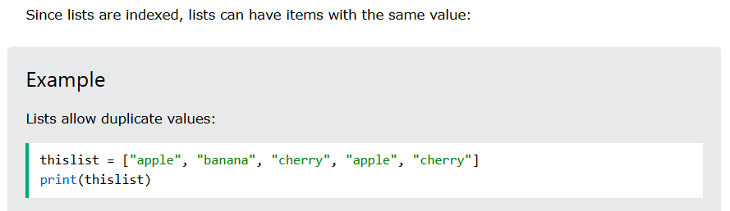
9. 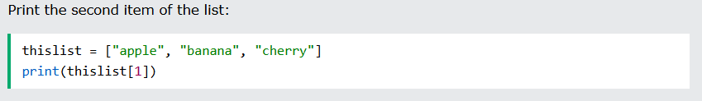
10. 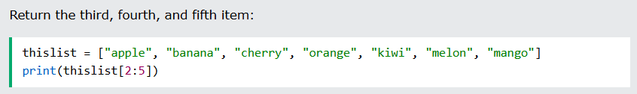
11. 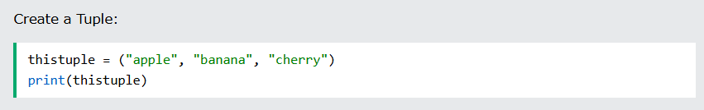
12. 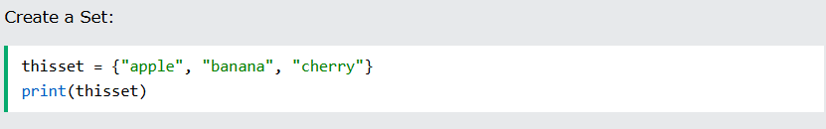
13. 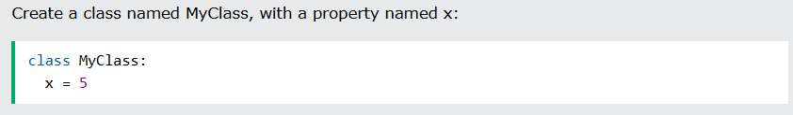

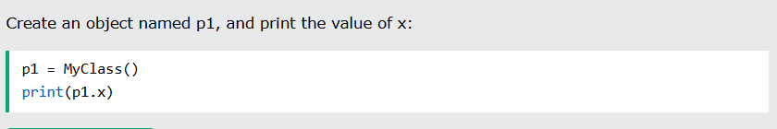
14. 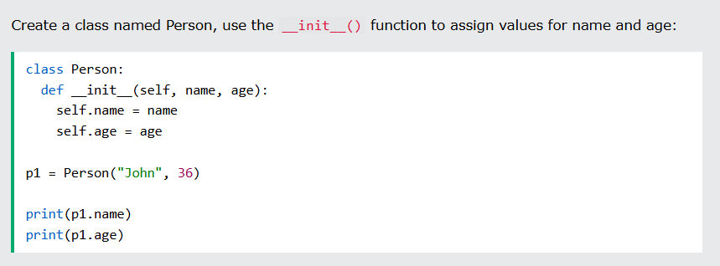
15. 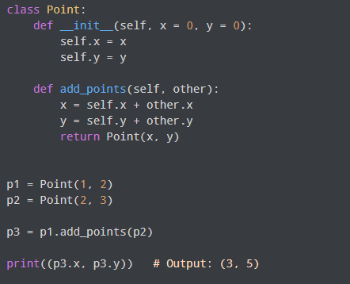
16.
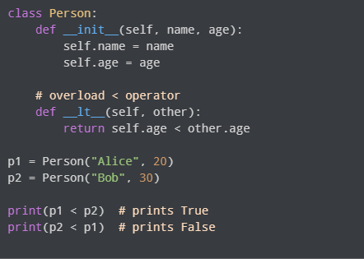
17. 