“VISION VOICE: SMART ASSISTANT FOR VISUALLY IMPAIRED”


A Major Project Report submitted in partial fulfilment of the requirements for the
award of the degree of

BACHELOR OF TECHNOLOGY
in
COMPUTER SCIENCE AND ENGINEERING
(ARTIFICIAL INTELLIGENCE AND MACHINE LEARNING)
Submitted by

PANDRAJULA SAI PAVAN 21R11A6685
TOGITI VAIBHAVI 21R11A6694
NUNSAVATH MALLESH 21R11A6682
Under the esteemed guidance of
Mrs. P. SWATHI
Assistant Professor - CSE (AI&ML) Department

DEPARTMENT OF COMPUTER SCIENCE AND ENGINEERING
(ARTIFICIAL INTELLIGENCE AND MACHINE LEARNING)
Geethanjali College of Engineering and Technology
Cheeryal(V), Keesara (M), Medchal(D), Telangana – 501301
MAY – 2025

CERTIFICATE

This is to certify that the Major Project Report entitled VISION VOICE: SMART ASSISTANT FOR VISUALLY IMPAIRED is a bonafide work done and submitted by
PANDRAJULA SAI PAVAN 21R11A6685
TOGITI VAIBHAVI 21R11A6694
NUNSAVATH MALLESH 21R11A6682
During the academic year 2024 - 2025, in partial fulfilment of requirement for the award of a Bachelor of Technology degree in CSE (Artificial Intelligence & Machine Learning) from Geethanjali College of Engineering and Technology (Accredited by NAAC with ‘A+’ Grade, Approved by AICTE and affiliated to JNTUH), is a bonafide record of work carried out by them under my guidance and supervision.

Certified further that to my best of the knowledge, the work in this report has not been submitted to any other institution for the award of any degree or diploma.

Project Guide Project Coordinator

Head of the Department External Examiner
Dr. G. Bindu Madhavi CSE(AI&ML)

DECLARATION

The following is a declaration that the Major Project report, "VISION VOICE: SMART ASSISTANT FOR VISUALLY IMPAIRED " is an original work completed and submitted to the CSE (AI&ML) Department of Geethanjali College of Engineering & Technology, which is affiliated with Jawaharlal Nehru Technological University Hyderabad. It serves as a record of legitimate project work completed by us under the supervision of P. Swathi, Assistant Professor, Department of CSE (AI&ML). We further affirm that none of the work included in this project has been applied for, in whole or in part, towards the award of any other degree or diploma.

PANDRAJULA SAI PAVAN TOGITI VAIBHAVI
(21R11A6685) (21R11A6694)

NUNSAVATH MALLESH
(21R11A6682)

ACKNOWLEDGEMENT

We would like to extend our sincere gratitude to our distinguished Chairman, Sri. G. R. Ravinder Reddy, whose steadfast support has been indispensable to the successful completion of our Major Project. We also express our heartfelt gratitude to our esteemed Vice Chairman, Sri. K. Harish Chandra Reddy, for his valuable support and encouragement throughout this journey. Our sincere appreciation goes to our respected Director, Dr. S. Udaya Kumar, GCET, whose guidance and insights have been instrumental in shaping our project. We are immensely grateful to our esteemed Principal, Dr. K. Sagar, GCET, for his unwavering support and direction during this entire process. Additionally, we extend our gratitude to Dr. V. Madhusudan Rao, Professor and Dean, School of Computer Science and Informatics, for his continuous support and motivation.

We are immensely grateful to Dr. G. Bindu Madhavi, Head of the Department, CSE (AI & ML), for her expertise, encouragement, and invaluable support, which have been instrumental in shaping our project's direction and outcomes. We extend our sincere appreciation to Mr. Shaik Akbar, Project Coordinator, CSE (AI & ML), for his steadfast support and guidance throughout this journey. We also express our heartfelt gratitude to our Project Guide,Mrs. P. Swathi, Assistant Professor, CSE (AI&ML) Department, for their insightful suggestions, continuous support, and invaluable mentorship, which have greatly contributed to the successful completion of our project.

Lastly, we would like to express our heartfelt gratitude to our friends and family for their unwavering support, understanding, and encouragement throughout this endeavor. Their patience and belief in us have been a constant source of motivation, and we are immensely grateful for their presence in our lives.

PANDRAJULA SAI PAVAN 21R11A6685
TOGITI VAIBHAVI 21R11A6694
NUNSAVATH MALLESH 21R11A6682
ABSTRACT

Vision-Voice: Smart Assistant for Visually Impaired is an innovative mobile and web-based application aimed at enhancing the independence and safety of visually impaired individuals. This multi-functional tool offers a variety of features tailored to assist users in different environments. For indoor navigation, users scan QR codes placed on doors or walls, allowing the app to provide detailed room information via Text-to-Speech (TTS). This ensures seamless movement inside buildings. For outdoor navigation, the app integrates with Google Maps. Users simply speak their destination, and the app initiates navigation while providing real-time directions through TTS, allowing hands-free navigation.

In emergency situations, the app includes an SOS alert system that sends the user’s current Google Maps location and a distress message to a predefined contact at the press of a button. Additionally, the web app integrates a YOLO-based object detection system, which identifies nearby objects and verbally alerts the user, ensuring they can avoid obstacles and walk safely. Another key feature is a barcode-scanning system that assists users in supermarkets. By scanning a product’s barcode, the app retrieves the item's details from a food database and informs the user through TTS, aiding in making informed purchase decisions.

This project combines cutting-edge AI technologies, like object detection and machine learning, with accessibility features, making daily tasks safer and more manageable for the visually impaired. Vision-Voice aims to be a comprehensive and easy-to-use assistant, providing reliable navigation, object recognition, and emergency support in both indoor and outdoor settings.

Keywords: Visually impaired, indoor navigation, outdoor navigation, QR code scanning, Google Maps, SOS alert, object detection, YOLO, barcode scanning, accessibility, Text-to-Speech, smart assistant.

TABLE OF CONTENTS

Abstract............................................................................................................................i
Table of Contents............................................................................................................ii
List of Figures.................................................................................................................iv
List of Abbreviations......................................................................................................v
1. INTRODUCTION................................................................................................1
1.1 Motivation….........................................................................................................1
1.2 Problem Statement…............................................................................................2
1.3 Project objectives..................................................................................................3
1.4 Existing Systems ..................................................................................................4
1.5 Limitations of Existing Systems...........................................................................5
1.6 Proposed System...................................................................................................6
1.7 Advantages of Proposed System...........................................................................7
2. AIM AND OBJECTIVES ................................................................................9
2.1 AIM of Proposed System......................................................................................9
2.2 Objectives of Proposed System............................................................................10
3. LITERATURE SURVEY..................................................................................12
3.1 Introduction………………...................................................................................12
3.2 Existing work........................................................................................................13
3.3 Limitations…………………................................................................................14
4. SOFTWARE/HARDWARE REQUIREMENTS.......................................15
4.1 Functional Requirements.......................................................................................15
4.2 Non-Functional Requirements...............................................................................17
4.3 Software Specifications.........................................................................................18
4.4 Hardware Requirements.........................................................................................21
5. SOFTWARE DESIGN.........................................................................................24
5.1 Process Cycle.........................................................................................................24
5.2 User Flow Diagram................................................................................................25
5.3 ER Diagram............................................................................................................26
5.4 Modules Description………...…………………...………………..……….…….27
6. SYSTEM IMPLEMENTATION……………………………………………28
6.1 Indoor Navigation Implementation........................................................................28
6.2 Outdoor Navigation and Google Maps Integration................................................29
6.3 Object Detection and TTS Feedback......................................................................35
6.4 SOS Alert System and Barcode Scanning..............................................................31
7. TRAINING AND TESTING.............................................................................32
7.1 Testing.....................................................................................................................32
7.2 Evaluation...............................................................................................................33
8. USER INTERFACE INTEGRATION...........................................................34
8.1 Design Principles....................................................................................................34
8.2 Key Features...........................................................................................................35
9. SAMPLE CODE.....................................................................................................37
10. OUTPUT SCREENS..........................................................................................43
11. CONCLUSION.....................................................................................................49
12. FUTURE SCOPE................................................................................................50
13. BIBLIOGRAPHY...............................................................................................51

LIST OF FIGURES

Fig. 5.1 Architecture Diagram………………………………………………..….24
Fig 5.2: User Flow Diagram…………………………………………………..…..25
Fig 5.3: E-R Diagram………………………………………………..…………….26
Fig 10.1.1 Home Screen Layout………………………………………...…………43
Fig 10.2.1 Home Screen……………………………………………………………43
Fig 10.2.2 Message Screen…………………………………………………………44
Fig 10.3.1 Home Screen……………………………………………………………44
Fig 10.3.2 Room Details Screen……………………………………………………45
Fig 10.4.1 Home Screen…………………………………………………………….45
Fig 10.4.2 TTS Screen……………………………………………………………...46
Fig 10.4.3 Navigation Screen……………………………………………………....46
Fig 10.5.1 Home Screen…………………………………………………………….47
Fig 10.5.2 Emergency Message Screen……………………………………...……..47
Fig 10.6.1 Object Detection Screen……………………………………...………....48

LIST OF ABBREVIATIONS

TTS - Text-to-Speech.
QR - Quick Response.
YOLO - You Only Look Once.
API - Application Programming Interface.
GPS - Global Positioning System.
ML - Machine Learning.
CPU - Central Processing Unit.
GPU - Graphics Processing Unit.
ML Kit - Mobile Machine Learning Kit.
SOS- Save Our Souls.
QR- Quick Response (Code)
SMS- Short Message Service

1.INTRODUCTION

1.1 Motivation
The motivation behind the Vision-Voice: Smart Assistant for Visually Impaired project stems from the desire to empower visually impaired individuals with greater independence, safety, and ease in navigating their everyday lives. According to the World Health Organization, approximately 2.2 billion people globally experience some form of vision impairment or blindness. Many of these individuals face significant challenges when it comes to basic activities like navigating through public and private spaces, identifying objects in their surroundings, or even performing essential tasks such as shopping. The lack of accessible technological solutions that cater specifically to these needs creates a substantial barrier to their independence.
The idea for Vision-Voice arose from the recognition that technological advancements, particularly in artificial intelligence, machine learning, and mobile applications, have immense potential to bridge this gap. By combining these technologies, Vision-Voice aims to provide a comprehensive tool that addresses several critical challenges faced by visually impaired people—whether indoors, outdoors, or in specific contexts like shopping or emergency situations.
Indoor navigation remains a significant problem for many people with vision impairments, as traditional GPS systems are not always effective. Using QR codes for indoor navigation provides an affordable and straightforward solution, giving users quick access to information about their surroundings. Outdoor navigation, powered by Google Maps and voice commands, ensures that visually impaired individuals can move confidently and safely in public spaces.
The object detection feature, powered by the YOLO model, was developed to help visually impaired users avoid obstacles and navigate more freely, enhancing their confidence and mobility. Additionally, the shopping assistance feature—allowing users to identify items via barcode scanning and access information from a product database—was designed to help visually impaired individuals perform everyday tasks independently.
Overall, Vision-Voice is driven by the vision of creating a world where technology enables inclusivity and accessibility for all. The project aims to enhance the quality of life for visually impaired individuals, providing them with tools that make them feel more self-reliant and secure in various environments.

1.2 Problem Statement
The primary problem addressed by the Vision-Voice: Smart Assistant for Visually Impaired project is the lack of accessible and comprehensive technological solutions that support visually impaired individuals in navigating various environments and performing essential tasks independently. According to the World Health Organization, over 2.2 billion people globally experience some form of vision impairment or blindness. These individuals face significant challenges in several aspects of daily life, including indoor and outdoor navigation, identifying objects, ensuring personal safety, and performing routine tasks such as shopping.
Traditional navigation systems, like GPS, are not suitable for indoor environments, leaving visually impaired individuals dependent on others for guidance in unfamiliar spaces. Additionally, avoiding obstacles and detecting objects in the surrounding environment is a major issue, as current mobility aids like canes and guide dogs may not always provide timely or sufficient information. Outdoor navigation, while somewhat supported by GPS-based applications, lacks full integration with real-time feedback systems like text-to-speech, which could guide users more effectively.
Personal safety is another pressing concern, especially in emergency situations where visually impaired individuals may need to alert others and share their location. Moreover, shopping independently presents challenges, as visually impaired individuals cannot easily identify products, access relevant information (such as names or prices), or distinguish between similar items on store shelves.
The Vision-Voice project seeks to solve these issues by offering a multi-functional smart assistant that integrates indoor and outdoor navigation, real-time object detection, an emergency SOS feature, and shopping assistance via barcode scanning. This solution leverages artificial intelligence and voice technology to provide visually impaired individuals with greater independence, safety, and autonomy in their daily lives.

1.3 Project Objectives
The primary objective of the Vision-Voice: Smart Assistant for Visually Impaired project is to enhance the independence, mobility, and safety of visually impaired individuals through a comprehensive and user-friendly mobile application. This project aims to leverage cutting-edge technologies like artificial intelligence, computer vision, and voice interaction to create a multi-functional tool that addresses key challenges faced by those with visual impairments in their daily lives.
- Indoor Navigation Support: To provide a reliable and accessible solution for visually impaired individuals to navigate indoor spaces. By using QR code scanning technology, the app allows users to scan codes placed on doors or walls and access detailed room information through text-to-speech (TTS). This enables them to independently explore unfamiliar environments like offices, malls, or hospitals.
- Outdoor Navigation Assistance: To facilitate safe and efficient outdoor navigation using voice commands and Google Maps integration. By enabling voice-based input for destination selection and real-time directions through TTS, the app aims to guide visually impaired users during travel, providing step-by-step instructions that help them navigate confidently.
- Emergency SOS Feature: To improve personal safety by offering an emergency alert system. With a single button press, users can send their real-time location and an emergency message to pre-selected contacts, ensuring timely assistance in critical situations.
- Real-Time Object Detection: To enhance mobility by integrating a YOLO-based object detection system that scans the environment and informs users of nearby objects through TTS. This helps users avoid obstacles and navigate their surroundings more safely.
- Shopping Assistance: To empower visually impaired individuals in supermarkets by providing barcode scanning and product identification capabilities. By accessing a food database, the app delivers essential information about products, allowing users to make informed purchasing decisions.

1.4 Existing Systems:
In recent years, various technological solutions have been developed to assist visually impaired individuals in navigating their surroundings, detecting objects, and performing routine tasks. These existing works and methods provide valuable insights into the development of smart assistants like Vision-Voice. The literature on assistive technologies for the visually impaired spans several areas, including navigation systems, object recognition technologies, and personal safety tools.
- Indoor Navigation: Indoor navigation for the visually impaired has been a challenging problem due to the lack of GPS coverage inside buildings. Solutions like beacon-based systems and QR code navigation have been explored to address this issue. Beacon-based systems use Bluetooth technology to provide location-based guidance, but they require significant infrastructure changes. QR code-based solutions, similar to those used in Vision-Voice, are more cost-effective and user-friendly. Studies show that QR codes can provide specific room and location information when scanned by mobile devices, offering a feasible alternative for indoor navigation.
- Outdoor Navigation: Outdoor navigation systems for visually impaired individuals typically rely on GPS and speech-based interfaces. Many apps, such as Google Maps, already include features like turn-by-turn navigation and voice instructions. However, visually impaired users require additional assistance, such as real-time feedback and audio prompts to ensure safe and efficient navigation. Research has explored integrating GPS with speech recognition and text-to-speech (TTS) technologies to allow users to provide voice input and receive real-time directions.
- Object Detection: Object detection has been significantly improved with the rise of deep learning models like YOLO (You Only Look Once) and OpenCV for real-time image processing. These models allow for the accurate detection of objects in the environment, helping visually impaired individuals avoid obstacles. Existing systems like Aira and Seeing AI provide similar functionalities, allowing users to receive real-time information about objects in their surroundings using smartphone cameras or wearable devices. Vision-Voice builds on these advancements by integrating YOLO for object detection with TTS feedback.

- Shopping Assistance:For shopping, solutions like BeMyEyes and NaviLens provide support to visually impaired individuals by offering product identification through barcode or QR code scanning. These apps connect users to sighted volunteers or use databases to retrieve product information. Vision-Voice similarly integrates barcode scanning, enabling users to identify products and receive information via TTS, offering a more autonomous shopping experience.

1.5 Limitations of Existing Work
Despite the significant advancements in assistive technologies for visually impaired individuals, existing solutions still face several limitations. These limitations hinder their effectiveness, usability, and accessibility in real-world scenarios. Some key limitations of the current systems are outlined below:
- Indoor Navigation Challenges: Many existing indoor navigation solutions, such as beacon-based systems and Wi-Fi triangulation, require extensive infrastructure modifications. These solutions depend on the installation of beacons or other hardware across indoor environments, which is both costly and labor-intensive. Moreover, these systems are not universally available in public spaces like malls, hospitals, or offices. QR code-based solutions are more affordable but often rely on the correct placement of the codes, which might not always be consistent or accessible in real-world environments. This inconsistency can reduce the reliability of QR code systems for indoor navigation.
- Outdoor Navigation Limitations: While GPS-based apps like Google Maps provide navigation for visually impaired users, they are limited in their ability to offer detailed, real-time feedback tailored to the specific needs of the visually impaired. These apps often lack features that alert users to obstacles or sudden changes in terrain, such as curbs or steps, which are critical for safe mobility. Additionally, GPS systems are not always accurate in densely populated urban areas, which can lead to confusion for visually impaired users. Furthermore, in noisy outdoor environments, relying solely on voice feedback through TTS can be challenging, as external sounds may drown out navigation instructions.
- Object Detection Shortcomings: While deep learning models like YOLO and tools like OpenCV have made real-time object detection more feasible, the accuracy of these systems can be affected by factors such as poor lighting, fast-moving objects, or cluttered environments. Additionally, some existing object detection apps, like Seeing AI, only provide basic information about nearby objects without delivering detailed context or distance information. This can limit the user’s ability to effectively avoid obstacles or navigate complex environments.
- Limited Autonomy in Shopping Assistance: Current shopping assistance tools, such as BeMyEyes or NaviLens, often require the involvement of third-party volunteers or rely on barcode databases that may not always be up to date or comprehensive. These apps also lack features for visually impaired users to create shopping lists or track purchases, limiting the overall shopping experience and independence.

1.6 Proposed System
The Vision-Voice application is designed as an intelligent assistant for visually impaired individuals, providing them with essential tools for navigation, object detection, emergency assistance, and product identification. The proposed system overcomes the limitations of existing solutions by integrating multiple assistive technologies into a single, user-friendly application.
- Indoor Navigation Using QR Codes: For indoor navigation, the system utilizes QR codes placed at strategic locations such as doors and hallways. When a user scans a QR code using their smartphone camera, the system decodes the information stored within the QR code, which includes details about the room’s purpose and any relevant directions. This information is then converted into speech using Text-to-Speech (TTS) technology, allowing users to receive audio guidance about their location. This feature enables visually impaired individuals to navigate complex indoor environments such as schools, offices, hospitals and various places independently.
- Outdoor Navigation with Voice Commands and Google Maps: The outdoor navigation module leverages Google Maps and voice recognition technology to assist users in reaching their destinations. Users can input their destination through voice commands, eliminating the need for manual text input. The system processes the speech input, retrieves the location, and generates the most efficient route using Google Maps. As the user moves, real-time GPS tracking ensures continuous updates on their progress. The system provides step-by-step audio instructions through TTS, ensuring that the user can navigate safely without relying on visual cues.
- Object Detection with YOLO and OpenCV: To enhance spatial awareness, the system integrates YOLOv8 (You Only Look Once), a powerful object detection algorithm, alongside OpenCV for real-time image processing. The smartphone camera captures the user’s surroundings, and the system detects objects in the frame, such as furniture, doors, or obstacles in the path. The detected objects are announced via TTS, providing users with instant feedback about their environment. This feature ensures safer movement and prevents accidental collisions.
- SOS Emergency Alert System: For emergency situations, the system includes an SOS alert module that allows users to seek help with a single button press. When activated, the system retrieves the user’s GPS coordinates and automatically sends an emergency message along with a Google Maps location link to pre-designated contacts or emergency services. This quick-response mechanism ensures that visually impaired individuals can receive immediate assistance when needed.
- Product Identification with Barcode Scanning: The application also includes a barcode scanning feature to assist users while shopping. Using the smartphone camera, users can scan barcodes on products, and the system retrieves relevant details from a connected database. The product name and description are read aloud via TTS, helping users identify items without requiring visual confirmation. This feature enhances their independence in purchasing goods from supermarkets or retail stores.

1.7 Advantages of Proposed System
- Enhanced Indoor Navigation: One of the primary advantages of the system is its ability to facilitate indoor navigation using QR code scanning. Unlike traditional systems that rely on complex and costly infrastructure, this solution is cost-effective and easy to implement. Users can quickly scan QR codes placed at different locations, and the system will provide detailed audio descriptions, enabling independent movement inside buildings such as malls, offices, and hospitals.
- Voice-Assisted Outdoor Navigation: The system utilizes Google Maps and voice recognition to provide seamless outdoor navigation. Instead of manually entering destinations, users can simply speak their desired location, and the system will generate the most efficient route. Real-time GPS tracking ensures accurate guidance, while Text-to-Speech (TTS) technology provides spoken navigation instructions, making it highly accessible for visually impaired individuals.
- Real-Time Object Detection for Safer Navigation: With YOLOv8 and OpenCV, the system can detect objects in real time and inform users about obstacles in their path. This reduces the risk of accidents and injuries by ensuring that users are aware of their surroundings. Unlike traditional white cane or guide dog-based navigation, this solution provides a digital layer of safety without requiring additional external assistance.
- Quick and Reliable Emergency Assistance: The SOS alert feature allows users to seek help with just one button press. The system automatically sends an emergency message along with the user’s GPS location to pre-selected contacts or emergency services. This ensures a quick response in urgent situations, improving safety for visually impaired individuals when traveling alone.
- Independent Shopping Experience with Barcode Scanning: The barcode scanning feature enables users to identify products in supermarkets or retail stores without assistance. By scanning a barcode, the system retrieves product details from a connected database and reads the information aloud using TTS. This helps visually impaired individuals shop independently, enhancing their confidence and autonomy.
- Cost-Effective and Scalable Solution: Unlike expensive wearable devices or complex infrastructure-dependent solutions, Vision-Voice leverages widely available smartphone technology. By utilizing smartphone cameras, voice recognition, and AI-driven models, the system provides an affordable and scalable solution that can be deployed globally without significant investment in additional hardware.

2.AIM AND OBJECTIVES

2.1 AIM of Proposed System

The Vision-Voice application is designed to serve as an intelligent assistive system for visually impaired individuals, enabling them to navigate their surroundings safely and independently. The primary aim of the proposed system is to integrate advanced computer vision, speech processing, and navigation technologies to provide a seamless experience for users in both indoor and outdoor environments. By leveraging QR codes, Google Maps, YOLO-based object detection, an SOS alert system, and barcode scanning, the system ensures a comprehensive solution for visually impaired individuals, addressing their mobility and accessibility challenges.
One of the key objectives of the system is to provide accurate and real-time navigation assistance. The indoor navigation feature utilizes QR codes to help users identify rooms and locations within buildings, ensuring they can move freely without external help. Similarly, the outdoor navigation module is designed to work with voice commands and Google Maps, allowing users to input destinations through speech and receive real-time navigation instructions via Text-to-Speech (TTS). This eliminates the dependency on manual input and enhances accessibility.
Another crucial goal of the system is to improve spatial awareness and obstacle detection. The implementation of YOLOv8 and OpenCV enables real-time object detection, ensuring that users receive auditory notifications about objects in their path, thereby reducing the risk of accidents. Additionally, the SOS emergency alert system provides a reliable safety mechanism by sending real-time location updates to emergency contacts, ensuring that users can quickly seek assistance when needed.
Furthermore, the system aims to provide independence in daily activities, such as shopping, through barcode scanning. By retrieving and reading product details aloud, visually impaired individuals can make informed purchasing decisions without relying on others.

2.2 Objectives of Proposed System
- To Provide Seamless Indoor Navigation:One of the primary objectives of the proposed system is to enable visually impaired individuals to navigate indoor spaces safely and independently. By utilizing QR code-based navigation, the system ensures that users can scan QR codes placed at different locations, such as doors or hallways, and receive real-time Text-to-Speech (TTS) feedback regarding their location and surroundings. This eliminates reliance on external assistance and enhances autonomy in enclosed environments such as shopping malls, hospitals, schools, and offices.
- To Facilitate Voice-Assisted Outdoor Navigation:The system aims to integrate Google Maps and speech recognition to enable voice-assisted outdoor navigation. Instead of requiring users to manually input their destinations, the system processes spoken commands, retrieves the location, and generates an optimized route. The navigation instructions are conveyed through TTS technology, ensuring that users receive continuous and accurate guidance throughout their journey.
- To Enhance Obstacle Detection and Spatial Awareness: To improve mobility and prevent accidents, the proposed system incorporates YOLOv8 (You Only Look Once) and OpenCV for real-time object detection. By identifying objects and obstacles in the user’s path, the system provides immediate auditory feedback, allowing users to navigate their environment safely. This objective is crucial for minimizing the risk of collisions and enhancing overall situational awareness.
- To Ensure Emergency Assistance with an SOS Alert System: Safety is a fundamental aspect of the proposed system. The SOS alert module enables users to quickly send an emergency alert with their GPS location to pre-registered contacts. This ensures that users can receive immediate assistance in case of distress, accidents, or emergencies. The system aims to streamline emergency response times and provide a reliable safety net for visually impaired individuals when traveling alone.
- To Enable Independent Product Identification in Retail Environments: The proposed system includes a barcode scanning feature that allows users to scan product barcodes in supermarkets and retrieve relevant product details from a connected database. The information is read aloud using TTS, allowing visually impaired individuals to make informed purchasing decisions without external assistance. This objective enhances the user’s independence in shopping environments.
- To Develop a Cost-Effective and Scalable Solution: Another key objective is to ensure that the system remains affordable, scalable, and easily deployable. Unlike expensive assistive devices, this system is designed to work with standard smartphone cameras and processing capabilities, making it accessible to a larger population without requiring specialized hardware.

3. LITERATURE SURVEY

3.1 Introduction
Assistive technologies for visually impaired individuals have evolved significantly in recent years, leveraging advancements in computer vision, artificial intelligence, and speech processing. Traditional mobility aids such as white canes and guide dogs have been instrumental in assisting visually impaired individuals, but they come with limitations, including restricted range, dependency on physical contact, and the inability to provide detailed contextual information about the environment.
Early efforts in assistive technology primarily focused on ultrasonic sensor-based navigation systems, which provided obstacle detection through audio or haptic feedback. However, these systems often suffered from limited accuracy and range constraints, making them less effective in complex environments. The introduction of computer vision and deep learning-based approaches, such as YOLO (You Only Look Once) and OpenCV, has significantly improved real-time object detection capabilities, allowing users to receive immediate alerts about obstacles in their path.
Additionally, voice-assisted navigation systems utilizing Google Maps API and speech recognition have enabled users to navigate outdoor environments efficiently. These systems allow visually impaired individuals to provide voice commands and receive step-by-step navigation instructions via Text-to-Speech (TTS) technology. Similarly, QR code-based indoor navigation has been explored as a cost-effective solution for assisting users in navigating large indoor spaces by scanning QR codes to retrieve room-specific details.
Emergency response systems have also been a key area of research, leading to the development of SOS alert applications that use GPS tracking to send real-time location updates to emergency contacts. Furthermore, barcode scanning for product identification has been integrated into assistive applications, enabling users to recognize everyday products while shopping.

3.2 Existing Work

D. Suryawanshi et al. (2021): This study proposed a voice-based assistant using Raspberry Pi integrated with camera and speaker modules to help visually impaired individuals through object detection and voice response. The model was capable of identifying objects and providing voice-based alerts to guide users in indoor environments. However, the major limitation of the system was its reliance on non-portable hardware. Due to the size and power constraints of Raspberry Pi and peripheral modules, it hindered real-time mobility and wasn’t practical for users on the move.

G. M. Jaiswal & R. Jaiswal (2020): The researchers introduced an indoor navigation system using ultrasonic sensors to detect obstacles and assist blind individuals in maneuvering through indoor environments. Audio feedback was provided via earphones to inform the user about nearby obstacles. While this system offered a basic navigation aid, its functionality was restricted to closed indoor spaces. It did not incorporate visual object recognition or work effectively outdoors, limiting its usability in more dynamic real-life scenarios.

K. R. Kumar & V. V. Reddy (2019):This work focused on developing a reading assistant using Optical Character Recognition (OCR) and Text-to-Speech (TTS) conversion to help visually impaired users read printed documents. The assistant converted text from books or labels into audio output. Despite its innovation, the system’s limitation was inaccuracy when scanning non-standard fonts or under poor lighting conditions, making it less effective in many real-world use cases.

A. Sharma & M. Patel (2022): An Android-based mobile application was proposed to serve as a voice assistant for visually impaired users. It utilized voice commands for tasks like calling, time updates, and simple feedback using Google APIs. While accessible and cost-effective, it lacked key features such as real-time object detection and offline processing, heavily relying on stable internet access, which is not always guaranteed for users in rural or remote areas.

B. Verma et al. (2023): This research implemented an advanced object detection system using the YOLOv5 algorithm to aid visually impaired individuals in identifying everyday objects around them. The system showed high accuracy and responsiveness in identifying multiple object types in real time. However, the primary drawback was its demand for high computational resources, making it unsuitable for mid-range or older smartphones, which are more commonly owned by the intended users.

3.3 Limitations

- Dependence on Internet Connectivity: Several features like Google Maps navigation, speech recognition, and cloud-based data retrieval require a stable internet connection. In areas with poor connectivity, the functionality of the app may be limited.
- Limited Object Detection in Low Light Conditions: The accuracy of object detection using the smartphone camera decreases in low-light environments, which may hinder usability during nighttime or in poorly lit indoor spaces.
- Hardware Resource Constraints: Real-time features such as YOLO-based object detection and Google APIs can be resource-intensive, requiring smartphones with relatively high processing power and memory, which might not be accessible to all users.
- Indoor Navigation Precision: QR-code-based indoor navigation may face challenges such as improper QR code placement, damage, or obstruction, reducing the system’s effectiveness in accurately guiding users indoors.
- Battery Consumption: Continuous usage of camera, GPS, TTS, and internet services can lead to high battery consumption, which may be inconvenient for users relying on the app for extended periods.
- Speech Recognition Errors: In noisy environments or for users with speech impairments or strong accents, the accuracy of voice recognition can be compromised, affecting the interaction experience.
- Limited Language Support: While the app may use default Google services for voice input/output, it might not support all regional languages or dialects used by visually impaired users across different areas.

4. SOFTWARE REQUIREMENTS

4.1 Functional Requirements
The Vision-Voice: Smart Assistant for Visually Impaired project has several functional requirements that define the core features and capabilities necessary for the system to achieve its goals. These requirements ensure that the system meets the needs of visually impaired users by providing reliable, real-time support for navigation, object detection, shopping assistance, and emergency situations.
1. QR Code-based Indoor Navigation:
- The system must enable users to scan QR codes placed on walls or doors using the mobile device’s camera.Upon scanning, the system should decode the QR code and retrieve relevant room/location information.
- The app must then use the Text-to-Speech (TTS) engine to read out the location details to the user in real-time.QR codes should be scanned accurately within a reasonable distance and in various lighting conditions.
2. Outdoor Navigation with Voice Commands:
- The app must provide a button that, when pressed, activates the Google Speech Recognition system to accept voice input from the user. The app should capture the user’s destination and initiate outdoor navigation using Google Maps API.
- The system must provide turn-by-turn navigation instructions using the TTS engine, ensuring the user receives continuous verbal guidance. GPS tracking must be accurate, and the system should update directions in real-time based on the user’s movement.
3. Object Detection and Avoidance:
- The app must use the mobile camera and the YOLO object detection model to identify objects in real-time.Detected objects should be communicated to the user via TTS, alerting them to obstacles in their immediate vicinity.
- The object detection should work efficiently in diverse environments and lighting conditions.
4. Shopping Assistance via Barcode Scanning:
- The system should enable users to scan product barcodes using the mobile camera. Upon scanning, the app should retrieve product information from a connected database and read out the details (e.g., product name, price) using TTS.
- Barcode scanning must be accurate and able to retrieve information for a wide range of products.
5. Emergency SOS Alert:
- The system must include a dedicated SOS button that, when pressed, sends an emergency message containing the user’s real-time location via SMS to pre-configured contacts.
- The app should retrieve the user’s current location using the GPS module and ensure the message is delivered promptly.

4.2 Non-functional Requirements
The non-functional requirements for the Vision-Voice: Smart Assistant for Visually Impaired project define the system’s quality attributes, performance expectations, and overall usability. These requirements ensure that the system is not only functional but also efficient, reliable, and user-friendly for visually impaired individuals. Below are the key non-functional requirements of the project:
1. Performance:
- The system must provide real-time responses for critical functions such as object detection, QR code scanning, and voice-based navigation. Delays in processing could hinder user safety and navigation, so the system should ensure low latency (ideally less than 2 seconds) between user input and response.
- The object detection module must perform efficiently, processing camera input and identifying objects in real-time without significant lag.
2. Reliability:
- The system must be highly reliable, ensuring continuous and accurate operation under various conditions, including different lighting environments, indoor and outdoor settings, and varying network connectivity.
- The SOS alert system must consistently send emergency messages with the correct real-time location to pre-configured contacts, with a high success rate for message delivery.
3. Scalability:
- The system should be scalable, allowing integration with additional features or databases (e.g., expanding the product database for the shopping assistance feature). As new technologies emerge, the system should easily accommodate enhancements.
4. Usability:
- The app must have an intuitive user interface with minimal complexity to accommodate visually impaired users. All interactions should be voice-based or rely on accessible button interfaces.
- The app should be accessible and compatible with screen readers, ensuring compliance with WCAG (Web Content Accessibility Guidelines) standards.
- The system should ensure that feedback, including navigation instructions and object detection alerts, is clear, concise, and appropriately timed to enhance user safety and experience.
5. Security:
- User data, such as emergency contacts and location data, must be stored securely with encryption to ensure privacy and confidentiality.
- The system should comply with data privacy regulations, such as GDPR or relevant local laws, to protect user information.
6. Availability:
- The app should function in a variety of environments, even when offline or with limited connectivity. For features requiring internet access (e.g., Google Maps navigation), the system should provide a fallback mechanism or notify the user of the connectivity issues.

4.3 Software Requirements
The Vision-Voice: Smart Assistant for Visually Impaired project involves various software components for both the mobile and web application functionalities. Since you’ve used Flask for the web application, Android programming for the mobile app development, and Java as the primary language for building the app, the software requirements must include the necessary tools, libraries, frameworks, and dependencies for each component. Below is a detailed description of the software requirements for the project:
1. Development Environment:
- IDE for Android Development: Android Studio is the official integrated development environment (IDE) for Android development, providing the necessary tools for writing, testing, and debugging Java-based Android applications. It offers features such as a visual layout editor, real-time code editing, emulators, and performance monitoring tools.
- Java Development Kit (JDK): A minimum of JDK 8 or higher is required for building the Android app. The JDK provides essential tools like the Java compiler and runtime environment.
- IDE for Flask Web Development: For developing the Flask web application, an IDE like Visual Studio Code or PyCharm is highly recommended. These IDEs support Python development with integrated debugging, version control, and extension capabilities for Flask.
- Python (Version 3.7 or higher): Flask is a Python-based framework, so installing Python is essential. The system should have Python 3.7 or higher to ensure compatibility with Flask and its dependencies.
2. Frameworks and Libraries:
- Flask Framework: Flask is a lightweight Python web framework used to build the web application for the object detection feature in Vision-Voice. The necessary packages include:
- Flask (v2.x): Flask serves as the core web framework for routing, handling requests, and managing web components.
- Flask-CORS: Used to handle Cross-Origin Resource Sharing, essential for integrating web components with external services or APIs.
- Flask-SQLAlchemy: If a database is used in the web app for managing products or user-related data, Flask-SQLAlchemy simplifies interactions with relational databases like MySQL or SQLite.
3. YOLO (You Only Look Once) and OpenCV:
- YOLO (v3 or v4): YOLO is a pre-trained deep learning model for real-time object detection. The YOLO model is integrated with Flask to process images from the web app and identify objects in real-time.
- OpenCV (v4.x): OpenCV is used for camera access and image processing. It enables real-time video stream capture for object detection and passes data to the YOLO model for analysis.
- TensorFlow/PyTorch: Depending on the implementation of the YOLO model, either TensorFlow or PyTorch may be used for managing the deep learning aspects of object detection.
4. Android Application Libraries:
- Android SDK and Build Tools: The Android SDK is required for compiling and building Android apps. The project should use the latest stable version of the SDK to ensure compatibility with modern Android devices.
- Build Tools (Gradle): Gradle is the build automation system used by Android Studio. It manages project dependencies and compiles the Java code into APK (Android Package).
- Google Maps API: For outdoor navigation, the Google Maps API is integrated into the Android app.
- Google Maps SDK for Android: This SDK enables the app to display maps and provide navigation features based on user input. It allows for the integration of GPS-based location tracking and real-time routing.
- Google Places API: This API is used to help users search for and specify destination locations using voice commands.
5. Google Text-to-Speech (TTS) and Speech Recognition APIs:
- Google Text-to-Speech (TTS): Used to convert text-based navigation or object information into speech output. TTS is integrated into the Android app to enhance user interaction.
- Google Speech API: Speech recognition is used for capturing voice input from users. This API converts spoken commands into text, which is then processed for navigation or barcode scanning.
- ZXing (Zebra Crossing) Library: For barcode scanning in the shopping assistance feature, the app uses the ZXing (Zebra Crossing) library, a popular open-source library for barcode generation and scanning.
6. Database:
- SQLite/MySQL Database: For managing product information in the shopping assistance module or user data in the SOS module, a database is necessary. SQLite is lightweight and can be used for local data storage, while MySQL can be used if a cloud-based database is required for scalability.
- If using SQLAlchemy in Flask, the database schema can be managed using this ORM (Object-Relational Mapper).
7. Version Control:
- Git: Git is used for version control and collaboration. It allows developers to track changes in the project, manage branches, and collaborate effectively.
- GitHub/GitLab: GitHub or GitLab repositories can be used to host the code, manage issues, and implement CI/CD pipelines if needed.

4.4 Hardware Requirements:
The Vision-Voice: Smart Assistant for Visually Impaired project involves both mobile and web-based applications, as well as real-time functionalities such as QR code and barcode scanning, object detection, navigation, and speech processing. These features necessitate specific hardware components to ensure the system performs efficiently and reliably. Below is a detailed description of the hardware requirements necessary to support the functionalities of the project:
1. Mobile Device Requirements:
The mobile application is designed for visually impaired users and must run on smartphones. The device requirements ensure that the app can support features like camera access, voice recognition, and GPS tracking.
a. Smartphone (Android-based):
Since the mobile app is developed using Android programming and Java, the following hardware specifications are required:
- Operating System: Android version 7.0 (Nougat) or higher.
- Processor: A Quad-core or higher processor, such as the Snapdragon 450 or better, is recommended for smooth multitasking, fast QR and barcode scanning, and real-time object detection.
- RAM: A minimum of 2 GB of RAM is necessary for running the app without lag. However, for optimal performance, particularly for features like real-time object detection and navigation, 3 GB or more is preferred.
- Internal Storage: At least 16 GB of internal storage, but 32 GB or higher is recommended for storing app data, map caches, and product databases.
- Camera: The mobile device requires a rear camera with a minimum of 8 MP resolution for clear and accurate QR code, barcode, and object detection scanning. Higher resolution cameras (12 MP or more) are recommended for enhanced object detection accuracy.
- GPS Module: A built-in GPS receiver is essential for accurate location tracking and outdoor navigation. The GPS module should support A-GPS (Assisted GPS) for faster location acquisition.
- Microphone and Speaker: A high-quality microphone is needed for voice input (speech recognition) to capture user commands for navigation, while the speaker must be capable of clear audio output for text-to-speech (TTS) notifications and alerts.
- Battery: Given the continuous use of the camera, GPS, and TTS, a battery capacity of at least 3000 mAh is recommended to ensure long usage time without frequent charging interruptions.
b. Accessibility Features:
The mobile device should support built-in accessibility features such as screen readers, high contrast modes, and vibration feedback to enhance usability for visually impaired users. These features ensure that users can easily interact with the app’s touch interface and voice commands.
2. Laptop/Desktop for Development and Deployment:
The development environment, particularly for the web app built using Flask, and the machine learning model for object detection requires a computer with sufficient computational power.
- Processor: A multi-core processor, such as an Intel i5 or AMD Ryzen 5 (or higher), is required for running software development environments (Android Studio, Flask development) and for training or deploying object detection models using YOLO and OpenCV.
- RAM: A minimum of 8 GB of RAM is required for general development and local testing of the mobile and web applications. For more intensive tasks like model training or real-time object detection testing, 16 GB or more is recommended to handle heavy computations.
- Storage: 512 GB SSD is recommended for faster read/write operations, quick application builds, and running emulators. Additional storage may be needed if training large machine learning models.
- Graphics Card (Optional): If you plan to run object detection models like YOLO locally, a dedicated GPU (e.g., NVIDIA GTX 1650 or higher) is beneficial for faster processing of images and real-time object detection. A GPU is especially important for handling image frames at high speed when using frameworks like TensorFlow or PyTorch for object detection.
3. External Hardware Requirements:
- QR Codes and Barcodes: To support the QR code-based indoor navigation and barcode scanning for shopping assistance, physical QR codes must be printed and placed in strategic indoor locations, such as doorways or walls, in environments like offices, malls, or hospitals.Barcodes should be attached to products for easy identification in supermarkets. Existing barcodes on products can be leveraged.
- Network Connectivity: Wi-Fi/4G/5G Connectivity: Both the mobile and web applications require a stable internet connection for features like Google Maps navigation, speech recognition, and cloud-based data retrieval. A Wi-Fi or 4G/5G network is necessary for smooth real-time operations. The app should be capable of functioning on a 4G mobile network when outdoors for GPS and navigation tasks.
4. Camera (For Web App Object Detection): A webcam with at least 1080p resolution should be connected to the device running the Flask web app for effective object detection. If using an external camera for more flexible placement or higher-quality video, options like Logitech C920 (1080p) or better should be considered.

5. SOFTWARE DESIGN

5.1 Process Cycle
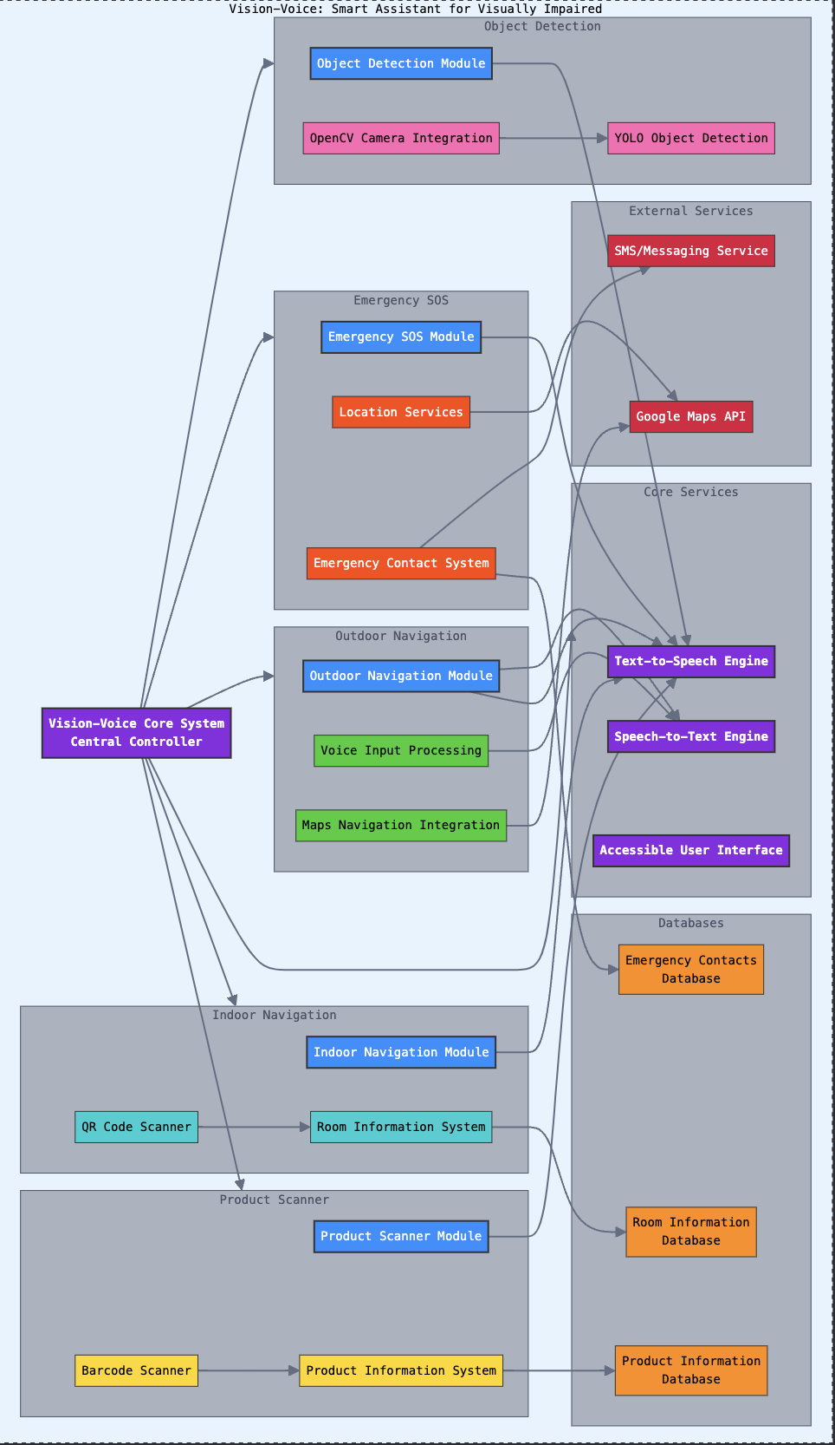
Fig 5.1: Architecture Diagram.

5.2 User Flow Diagram

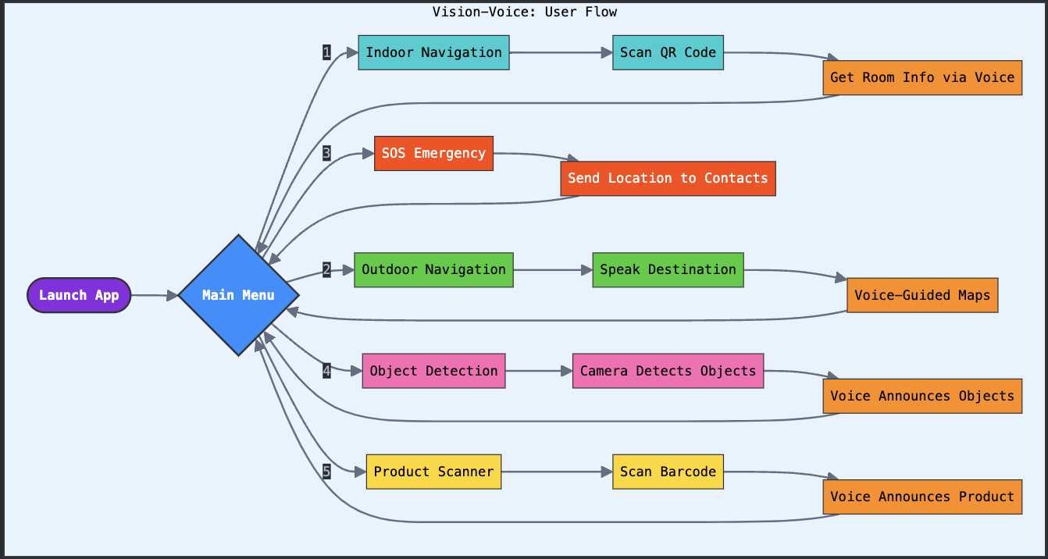
Fig 5.2: User Flow Diagram.

5.3 E-R Diagram

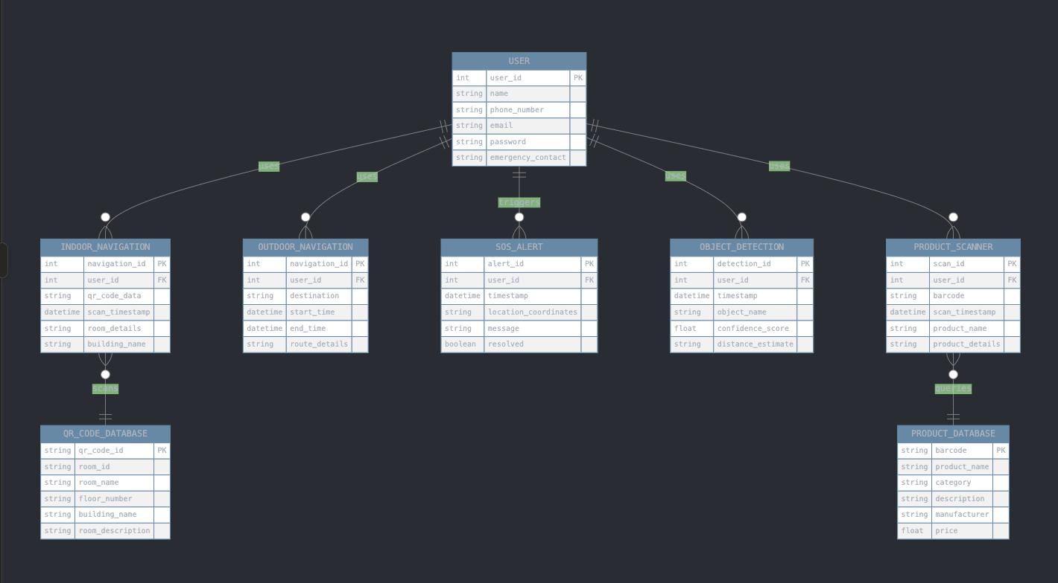
Fig 5.3: E-R Diagram.

5.4 Modules Description

The Vision-Voice application consists of several key modules, each designed to address specific needs of visually impaired individuals. These modules work together to enhance navigation, safety, and independence in both indoor and outdoor environments.
- Indoor Navigation Module: This module is responsible for helping users navigate indoor spaces using QR codes. QR codes are placed on doors or walls of rooms, containing specific information about the room, such as its function and directions. The user scans the QR code using their smartphone camera, and the app extracts the encoded data. This information is then relayed to the user through the Text-to-Speech (TTS) engine, enabling them to understand their current location and navigate within the building.
- Outdoor Navigation Module: The outdoor navigation module is integrated with Google Maps and voice recognition. It allows users to input their destination through voice commands. Once the user provides a location, the app interfaces with Google Maps to calculate the best route. Using GPS data, the app tracks the user’s location and provides real-time spoken directions through TTS, helping them reach their destination safely.
- SOS Alert Module: This module is designed to assist users during emergencies. By pressing a single button in the app, the SOS alert module captures the user’s current GPS location and sends an emergency message, along with a Google Maps link to the user’s location, to pre-selected contacts or emergency services. This feature ensures that help can be sought quickly and easily.
- Object Detection Module: Using YOLOv8 and OpenCV, the object detection module scans the user’s surroundings for obstacles or objects. It detects objects in real-time and communicates the object’s name and position to the user via TTS, ensuring safe navigation without collisions.
- Barcode Scanning Module: This module helps users identify products by scanning barcodes on items. The app accesses a product database, retrieves the product details, and reads the information aloud, helping visually impaired users shop independently.

6. SYSTEM IMPLEMENTATION

6.1 Indoor Navigation Implementation
The indoor navigation system in the Vision-Voice project is designed to assist visually impaired individuals in navigating indoor environments by leveraging QR code technology and a Text-to-Speech (TTS) system. The implementation begins by placing QR codes outside various rooms or areas within a building. These QR codes contain encoded information about the room’s identity, such as the room number, its purpose, and additional details like directions or landmarks.
When the user approaches a room, they use their smartphone to scan the QR code using the app’s built-in camera functionality. The app utilizes the phone’s camera to detect and read the QR code using an appropriate QR code scanning library (such as Google’s ML Kit or ZXing for Android). Once the QR code is detected, the system extracts the encoded data and processes it.
The extracted information is then passed to the TTS engine, which converts the textual data into speech. The TTS system (such as Google TTS or another integrated engine) reads aloud the room details to the user in real-time. This allows the user to identify where they are and receive specific information about the room or area they are about to enter.
The implementation is designed to ensure a seamless experience. It takes into account accessibility features such as voice prompts guiding the user to focus the camera correctly and error handling for cases when the QR code isn’t scanned properly. By utilizing this QR-based indoor navigation system, visually impaired individuals can independently navigate indoor spaces without needing assistance, greatly improving their mobility and autonomy. The combination of real-time QR detection and TTS output ensures a user-friendly and efficient indoor navigation experience tailored to the needs of visually impaired users.

6.2 Outdoor Navigation and Google Maps Integration
The outdoor navigation system in the Vision-Voice project provides visually impaired individuals with real-time, voice-guided navigation using the integration of voice commands, Google Maps, and Text-to-Speech (TTS) technology. The implementation begins with a simple, accessible interface that features a prominent button for starting the navigation process. Upon pressing the button, the system activates the Google TTS engine to prompt the user for a destination.
The user then speaks the name of their desired location, which is captured by the system using speech recognition technology, such as Google’s Speech-to-Text API. This voice input is converted into text and processed by the app. Once the system recognizes the location, it leverages the Google Maps API to generate a route from the user’s current location to the desired destination. This process involves querying Google Maps for accurate directions, accounting for the user’s starting point and any preferences (such as walking routes or public transport).
Once the route is generated, the app enters navigation mode, where Google Maps starts providing real-time directions to the user. During this process, the app continuously retrieves the user’s GPS coordinates to track their location on the map. Using the TTS engine, the app converts the visual map instructions into verbal instructions, guiding the user step-by-step with clear directions such as “Turn left in 100 meters” or “Continue straight for 200 meters.”
The system is designed to accommodate challenges faced by visually impaired users, such as frequent updates when they are approaching a turn or alerting them when they need to reroute if they deviate from the planned path. In case of deviation or poor GPS signal, the system recalculates the route and continues providing updated guidance using TTS.
Furthermore, the integration ensures that the app provides timely and precise navigation feedback, ensuring that the user can move through outdoor spaces confidently and safely. By converting Google Maps’ visual directions into spoken instructions, the Vision-Voice outdoor navigation system enables visually impaired users to travel independently without relying on external assistance. The seamless combination of voice recognition, Google Maps, and TTS ensures efficient and accessible outdoor navigation.

6.3 Object Detection and TTS Feedback
The object detection feature in the Vision-Voice project is designed to help visually impaired users navigate their surroundings safely by detecting nearby objects and providing real-time feedback via Text-to-Speech (TTS). This feature uses the YOLOv8 (You Only Look Once) object detection model integrated with OpenCV to process live video from the smartphone’s camera and identify objects in real-time.
The implementation begins by accessing the camera feed using OpenCV, which streams live video frames to the YOLOv8 model for object detection. YOLOv8 is a highly efficient and fast object detection algorithm that can detect multiple objects in a single pass through the image. The model, pre-trained on the COCO dataset, recognizes a wide range of everyday objects such as people, chairs, doors, and vehicles, which are relevant to visually impaired users for navigating through various environments.
Each frame from the camera feed is analyzed by YOLOv8, which detects objects and outputs bounding boxes, labels, and confidence scores for each object. The detected objects are then processed to determine their location relative to the user, such as whether they are to the left or right side of the frame. This spatial information is crucial for helping users understand where the objects are in relation to their movement.
Once the objects are detected, the system converts the visual information into spoken feedback. The TTS engine reads out the name of each detected object and provides spatial cues, such as “Chair on the left” or “Person ahead.” This real-time audio feedback allows users to adjust their movements and avoid obstacles, ensuring safe navigation.
This object detection system is designed to work efficiently even in dynamic environments, offering continuous updates as the user moves. The combination of YOLOv8 for high-speed object detection and TTS for auditory feedback provides a robust solution that enhances the user’s spatial awareness, enabling them to navigate their environment safely and independently.

6.4 SOS Alert System and Barcode Scanning
The SOS alert system and barcode scanning feature in the Vision-Voice project serve to enhance the safety and shopping experience for visually impaired users. The SOS alert system is a crucial feature designed to provide assistance in emergency situations, while the barcode scanning feature aids users in identifying products in environments like supermarkets.
The SOS alert system is implemented with a simple and accessible interface—a dedicated button within the app. When a user presses this button during an emergency, the app immediately retrieves the user’s current location using GPS. The system generates a Google Maps link to the user’s exact coordinates and sends this along with a pre-defined emergency message, such as “I am in an emergency,” to a designated contact or emergency services via SMS. The use of GPS ensures that the location data is accurate, while the automated message eliminates the need for manual input in a stressful situation. This feature is designed for rapid and reliable communication, ensuring that help can be dispatched quickly.
The barcode scanning feature assists visually impaired users in identifying products while shopping. This is particularly useful in supermarkets where users need to know the products they are selecting. The system uses the smartphone’s camera to scan barcodes on products, similar to how the QR code scanning is implemented for indoor navigation. The barcode data is then matched with a product database to retrieve relevant details, such as the product’s name, price, and description.
Once the product information is fetched, the app uses the Text-to-Speech (TTS) engine to read the product name and details aloud to the user, allowing them to make informed decisions while shopping. This feature enhances the independence of visually impaired individuals by eliminating the need for visual confirmation of product details, thereby offering a more autonomous shopping experience. Both the SOS alert and barcode scanning systems work seamlessly to improve the safety, convenience, and independence of visually impaired users in everyday scenarios.

7. TESTING AND EVALUATION

7.1 Testing
Testing is a critical phase in the development of the Vision-Voice application, ensuring that each module functions as intended and provides a seamless, reliable experience for visually impaired users. The testing process involved several stages, including unit testing, integration testing, and user acceptance testing (UAT), each focusing on different aspects of the system.
- Unit Testing: Each module in the application was tested individually to verify that the core functionalities worked as expected. For example, the indoor navigation module was tested for accurate QR code scanning and correct extraction of room details, while the outdoor navigation module was tested for voice command recognition and route generation using Google Maps. The SOS alert system was tested to ensure that the GPS coordinates were captured correctly and that the emergency message and location link were sent successfully.
- Integration Testing: After individual testing, the modules were integrated, and their interactions were tested to ensure seamless communication between them. For instance, the camera feed from the object detection module was integrated with the YOLOv8 model, and the detected objects were relayed to the Text-to-Speech (TTS) engine. Similarly, the barcode scanning module was tested to ensure that the camera, barcode recognition, database retrieval, and TTS feedback worked harmoniously.
- User Acceptance Testing (UAT): User testing was conducted with a group of visually impaired individuals to assess the application’s usability and effectiveness in real-world scenarios. Feedback from users was collected to identify any areas of improvement in the interface, voice prompts, and overall ease of use. Based on the feedback, further refinements were made to improve the app’s accessibility and user experience.

7.2 Evaluation
The evaluation of the Vision-Voice application focuses on assessing the system’s performance, usability, and effectiveness in real-world scenarios. The primary goal of the evaluation was to ensure that the application successfully meets the needs of visually impaired individuals, providing them with reliable navigation, object detection, and emergency assistance.
- Performance Evaluation: The system’s performance was evaluated by measuring the accuracy and responsiveness of key modules. For the indoor navigation module, the QR code scanning speed and the precision of room detail extraction were tested in various lighting conditions to ensure consistent performance. The outdoor navigation module was assessed for its ability to accurately recognize voice commands and provide real-time directions through Google Maps. The object detection module was evaluated by testing the YOLOv8 model’s accuracy in detecting obstacles and providing timely auditory feedback to the user. The system’s overall latency, particularly the time taken to process data and deliver Text-to-Speech (TTS) feedback, was closely monitored to ensure a smooth user experience.
- Usability Testing: The usability of the application was evaluated by conducting tests with visually impaired individuals. The interface was designed to be simple and accessible, with clear voice prompts guiding users through each step. Feedback from the users was gathered to assess how intuitive and easy the system was to use. Features such as the SOS alert system and barcode scanning module were also tested in real-world scenarios, with users reporting on their effectiveness and ease of access during emergencies and shopping.
- Effectiveness Assessment: The evaluation measured how effectively the application fulfilled its purpose. Metrics such as successful object avoidance, the accuracy of product identification in the supermarket, and the time taken to receive emergency help were used to determine the system’s overall success in enhancing independence for visually impaired users.

8. USER INTERFACE INTERACTION

8.1 Design Principles
- Accessibility and User-Centric Design: The primary objective of the system is to ensure that visually impaired users can easily interact with the application without requiring external assistance. The interface is designed with voice-based interaction, eliminating the need for complex touch-based navigation. The use of Text-to-Speech (TTS) technology ensures that users receive clear and comprehensible audio feedback.
- Real-Time Processing and Efficiency:Since the system involves object detection, navigation, and emergency alert mechanisms, real-time processing is critical. The implementation of YOLOv8 and OpenCV enables quick and accurate object recognition, ensuring that users receive immediate feedback about obstacles. Similarly, Google Maps API integration allows for smooth and responsive outdoor navigation, providing turn-by-turn directions in real time.
- Modularity and Maintainability: The system is built in a modular manner, with each functionality (indoor navigation, outdoor navigation, SOS alerts, object detection, and product recognition) operating as an independent module. This modular approach allows for ease of updates and enhancements, making it possible to integrate new features without disrupting the existing system.
- Scalability and Cost-Effectiveness: The Vision-Voice application is designed to be scalable, ensuring compatibility with low-end and high-end smartphones without requiring specialized hardware. By leveraging widely available smartphone cameras and cloud-based processing, the system remains cost-effective and accessible to a larger population.

8.2 Key Features
- Indoor Navigation via QR Code: One of the standout features of Vision-Voice is its indoor navigation system that utilizes QR codes placed at various locations such as room doors or hallways. When a visually impaired user scans a QR code, the system retrieves relevant information (such as room number, location description, or instructions) embedded in the code and reads it aloud using Text-to-Speech (TTS). This enables users to independently navigate indoor spaces like malls, offices, hospitals, or schools without needing external help. The feature is easy to implement in most environments and offers a highly effective way to orient visually impaired users.
- Outdoor Navigation with Voice Assistance: For outdoor navigation, Vision-Voice integrates Google Maps and speech recognition technology, allowing users to input their desired destinations using voice commands. The app generates turn-by-turn navigation instructions and provides continuous guidance through TTS. This feature ensures that users can navigate unfamiliar streets or areas independently, with real-time auditory feedback on their position, direction, and estimated time of arrival. It eliminates the need for manual input, which can be difficult for visually impaired individuals.
- SOS Alert System: The SOS alert system is a vital feature for ensuring user safety in emergencies. When activated, it sends an emergency message along with the real-time GPS location to pre-defined contacts, providing immediate assistance when needed. This ensures that users are not left stranded in emergency situations and can quickly notify others of their location, offering peace of mind to both users and their loved ones.
- Real-Time Object Detection: The real-time object detection feature of the app uses the YOLOv8 model to scan the user’s surroundings for potential obstacles or objects. The system processes the video feed from the device’s camera and identifies objects such as chairs, tables, or people, providing auditory feedback about their location. This helps users avoid collisions and navigate through crowded or cluttered environments, enhancing spatial awareness.
- Barcode Scanning for Product Identification: Vision-Voice includes a barcode scanning feature to assist users while shopping. By scanning the barcode of products in a supermarket, the app fetches product details from a connected database and reads out the name, price, and other important information. This helps visually impaired individuals make informed purchasing decisions without relying on store attendants, promoting independence in retail environments.
- Multi-Device Support: The system is designed to be compatible with a wide range of smartphones, making it accessible to a larger population. It utilizes the existing hardware resources (like the smartphone’s camera, GPS, and microphone) without requiring specialized or expensive devices, keeping the system cost-effective and widely deployable.
- Easy User Interface: The user interface (UI) is designed to be simple and intuitive, with minimal interaction required. Since visually impaired users will rely primarily on auditory feedback, the system is built to ensure voice-guided operation. Simple touch gestures or voice commands are all that is needed to activate various features.

9. SAMPLE CODE

Navigation Application.java

import android.content.Intent;
import android.net.Uri;
import android.os.Bundle;
import android.speech.RecognizerIntent;
import android.view.View;
import android.widget.Button;
import android.appcompat.app.AppCompatActivity;
import java.util.List;

public class MainActivity extends AppCompatActivity {
private static final int SPEECH_REQUEST_CODE = 100;

@Override
protected void onCreate(Bundle savedInstanceState) {
super.onCreate(savedInstanceState);
setContentView(R.layout.activity_main);

Button navigateButton = findViewById(R.id.navigate_button);
navigateButton.setOnClickListener(new View.OnClickListener() {
@Override
public void onClick(View v) {
startVoiceRecognition();
}
});
}

private void startVoiceRecognition() {
Intent intent = new Intent(RecognizerIntent.ACTION_RECOGNIZE_SPEECH);
intent.putExtra(RecognizerIntent.EXTRA_LANGUAGE_MODEL, RecognizerIntent.LANGUAGE_MODEL_FREE_FORM);
startActivityForResult(intent, SPEECH_REQUEST_CODE);
}

@Override
protected void onActivityResult(int requestCode, int resultCode, Intent data) {
super.onActivityResult(requestCode, resultCode, data);
if (requestCode == SPEECH_REQUEST_CODE && resultCode == RESULT_OK) {
List<String> results = data.getStringArrayListExtra(RecognizerIntent.EXTRA_RESULTS);
if (results != null && !results.isEmpty()) {
openGoogleMaps(results.get(0));
}
}
}

private void openGoogleMaps(String destination) {
Uri gmmIntentUri = Uri.parse("google.navigation:q=" + Uri.encode(destination));
Intent mapIntent = new Intent(Intent.ACTION_VIEW, gmmIntentUri);
mapIntent.setPackage("com.google.android.apps.maps");
startActivity(mapIntent);
}
}

SOS Alert.java

import android.Manifest;
import android.content.pm.PackageManager;
import android.os.Bundle;
import android.telephony.SmsManager;
import android.view.View;
import android.widget.Button;
import android.widget.Toast;
import androidx.appcompat.app.AppCompatActivity;
import androidx.core.app.ActivityCompat;
import androidx.core.content.ContextCompat;

public class MainActivity extends AppCompatActivity {
private static final int PERMISSION_REQUEST_SMS = 1;
private String emergencyNumber = "+911234567890";

@Override
protected void onCreate(Bundle savedInstanceState) {
super.onCreate(savedInstanceState);
setContentView(R.layout.activity_main);

Button sosButton = findViewById(R.id.sos_button);
sosButton.setOnClickListener(new View.OnClickListener() {
@Override
public void onClick(View v) {
sendSOS();
}
});
}

private void sendSOS() {
if (ContextCompat.checkSelfPermission(this, Manifest.permission.SEND_SMS) != PackageManager.PERMISSION_GRANTED) {
ActivityCompat.requestPermissions(this, new String[]{Manifest.permission.SEND_SMS}, PERMISSION_REQUEST_SMS);
} else {
SmsManager smsManager = SmsManager.getDefault();
smsManager.sendTextMessage(emergencyNumber, null, "Emergency! Please Help!", null, null);
Toast.makeText(this, "SOS Alert Sent!", Toast.LENGTH_SHORT).show();
}
}
}

QR Code App-Scanner.java

package com.example.qr navigation app;
import androidx.camera.lifecycle.ProcessCameraProvider;
import androidx.core.content.ContextCompat;
import com.google.common.util.concurrent.ListenableFuture;
import com.google.mlkit.vision.barcode.common.Barcode;
import com.google.mlkit.vision.barcode.BarcodeScanning;
import com.google.mlkit.vision.common.InputImage;
import java.util.concurrent.ExecutorService;
import java.util.concurrent.Executors;

public class QRCodeScannerActivity extends AppCompatActivity {

// Flag to prevent multiple scans
private boolean isScanned = false;
private ExecutorService cameraExecutor;

@Override
protected void onCreate(Bundle savedInstanceState) {
super.onCreate(savedInstanceState);
// Link to your layout file (make sure activity_qr_scanner.xml exists)
setContentView(R.layout.activity_qr_scanner);
// Initialize a background thread for analyzing camera frames
cameraExecutor = Executors.newSingleThreadExecutor();
// Start the camera
startCamera();
}

private void startCamera() {
// Get a CameraProvider instance
ListenableFuture<ProcessCameraProvider> cameraProviderFuture =
ProcessCameraProvider.getInstance(this);
cameraProviderFuture.addListener(() -> {
try {
ProcessCameraProvider cameraProvider = cameraProviderFuture.get();

// Set up the ImageAnalysis use case
ImageAnalysis imageAnalysis = new ImageAnalysis.Builder()
.setBackpressureStrategy(ImageAnalysis.STRATEGY_KEEP_ONLY_LATEST)
.build();

// Set an analyzer to process camera frames
imageAnalysis.setAnalyzer(cameraExecutor, image -> {
if (!isScanned) {
scanQRCode(image);
} else {
image.close();
}
});

// Bind the camera to the lifecycle with the default back camera
Camera camera = cameraProvider.bindToLifecycle(
this,
androidx.camera.core.CameraSelector.DEFAULT_BACK_CAMERA,
imageAnalysis
);
} catch (Exception e) {
Log.e("CameraX", "Camera binding failed", e);
}
}, ContextCompat.getMainExecutor(this));
}

@SuppressLint("UnsafeOptInUsageError")
private void scanQRCode(ImageProxy imageProxy) {
// Check if the image is valid
if (imageProxy.getImage() == null) {
imageProxy.close();
return;
}
InputImage image;
try {
// Convert the camera frame to an InputImage for ML Kit
image = InputImage.fromMediaImage(
imageProxy.getImage(),
imageProxy.getImageInfo().getRotationDegrees()
);
} catch (Exception e) {
imageProxy.close();
return;
}
}

Web-app.py
from flask import Flask, render_template, Response, jsonify
import cv2
import time
from ultralytics import YOLO
app = Flask(__name__)
VIDEO_URL = 'https://192.168.0.102:8080/video' # your IP Webcam stream
MODEL_PATH = 'yolov8n.pt' # your YOLOv8 weights
ALERT_COOLDOWN = 5 # seconds between alerts
ALERT_THRESHOLD = 0.30 # alert when bbox_area/frame_area > 30%
model = YOLO(MODEL_PATH)
last_alert = 0
def generate_frames():
global last_alert
cap = cv2.VideoCapture(VIDEO_URL)
while True:
ok, frame = cap.read()
if not ok:
continue
fh, fw = frame.shape[:2]
results = model(frame)[0]
# draw boxes and check for alert
for box in results.boxes:
x1, y1, x2, y2 = map(int, box.xyxy[0])
area = (x2 - x1) * (y2 - y1)
if area / (fw * fh) > ALERT_THRESHOLD and time.time() - last_alert > ALERT_COOLDOWN:
last_alert = time.time()
# once we trigger, no need to check further boxes
break
# draw box & label regardless
label = model.names[int(box.cls[0])]
conf = box.conf[0]
cv2.rectangle(frame, (x1,y1), (x2,y2), (0,165,255), 2) # pastel orange line
cv2.putText(frame,
f"{label} {conf:.2f}",
(x1, y1 - 8),
cv2.FONT_HERSHEY_SIMPLEX,
0.6, (255,255,255), 2)
# encode & yield MJPEG frame
ret, buf = cv2.imencode('.jpg', frame)
yield (b'--frame\r\n'
b'Content-Type: image/jpeg\r\n\r\n' + buf.tobytes() + b'\r\n')
@app.route('/')
def index():
return render_template('index.html')
@app.route('/video_feed')
def video_feed():
return Response(generate_frames(),
mimetype='multipart/x-mixed-replace; boundary=frame')
@app.route('/should_alert')
def should_alert():
# if we triggered in last 2 seconds, alert = true
return jsonify({'alert': time.time() - last_alert < 2})
if __name__ == '__main__':
app.run(host='0.0.0.0', port=5000)

10. OUTPUT SCREENS

10.1 Home Screen

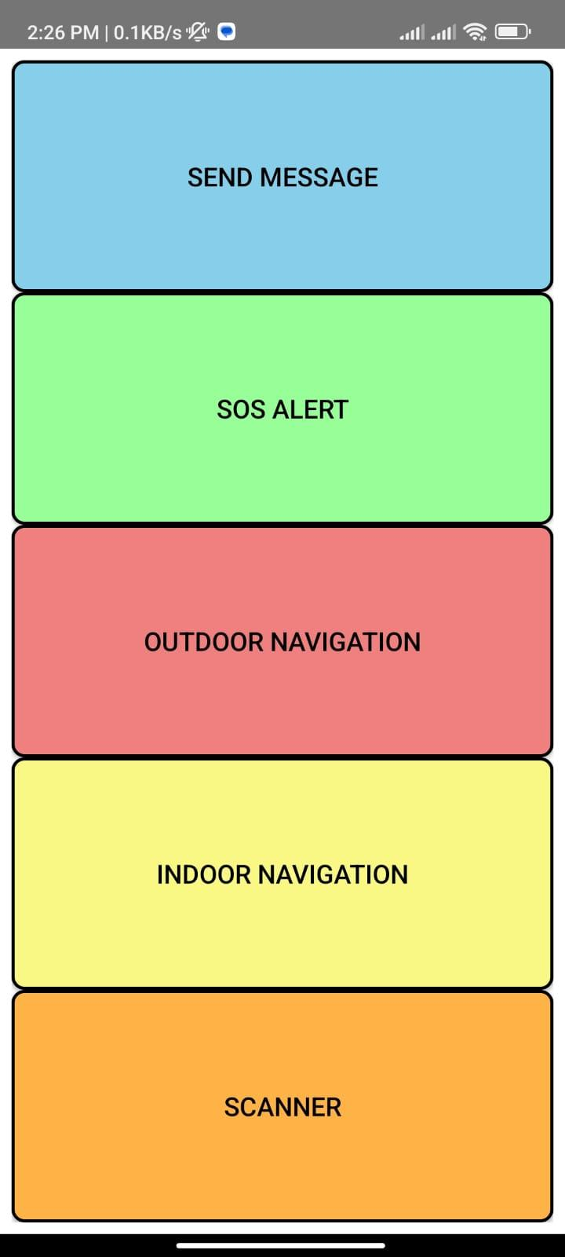
Fig 10.1.1 Home Screen Layout

10.2 Messages App

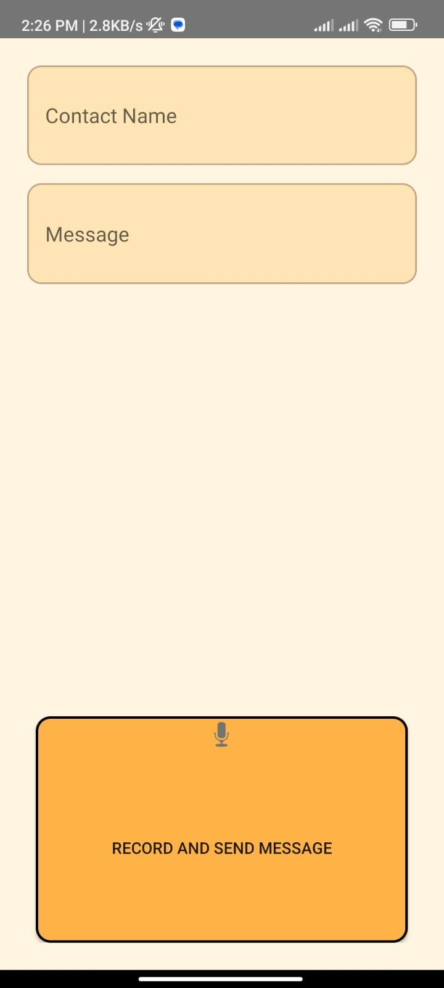
Fig 10.2.1 Home Screen

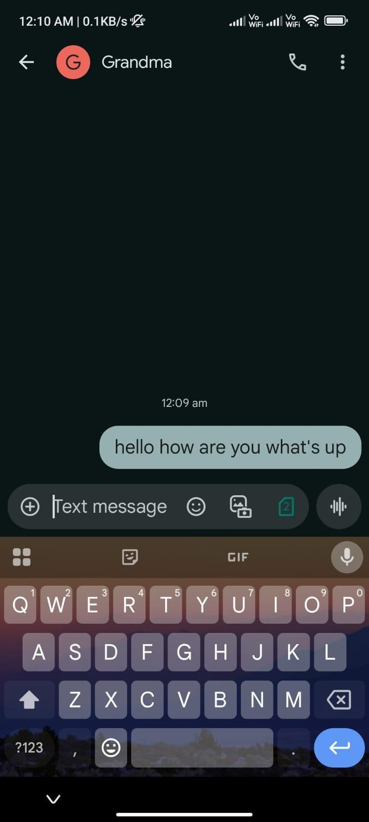
Fig 10.2.2 Message Screen.

10.3 Indoor Navigation App

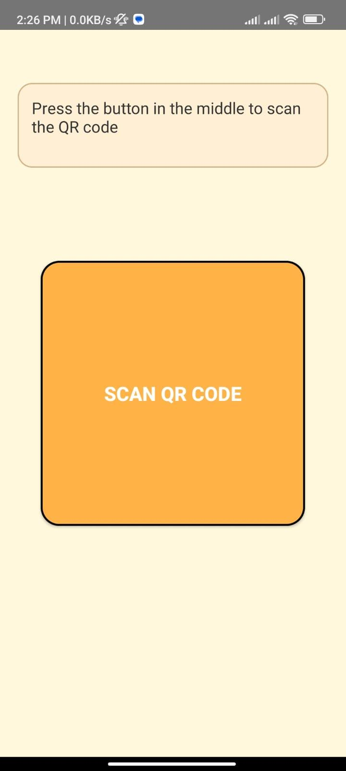
Fig 10.3.1 Home screen.
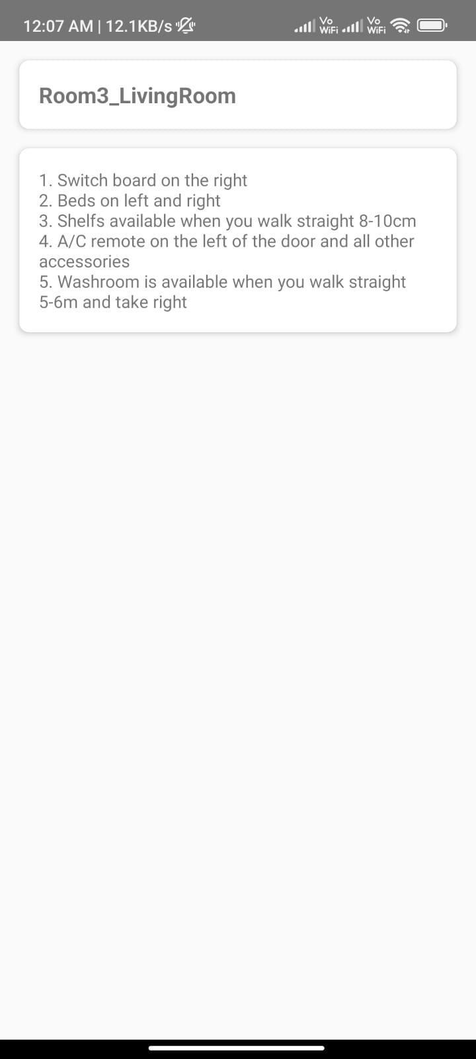
Fig 10.3.2 Room Details Screen.

10.4 Outdoor Navigation App

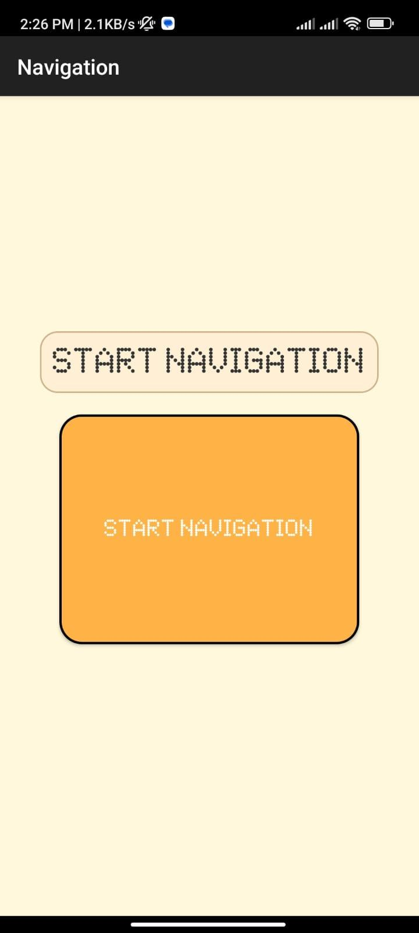
Fig 10.4.1 Home Screen

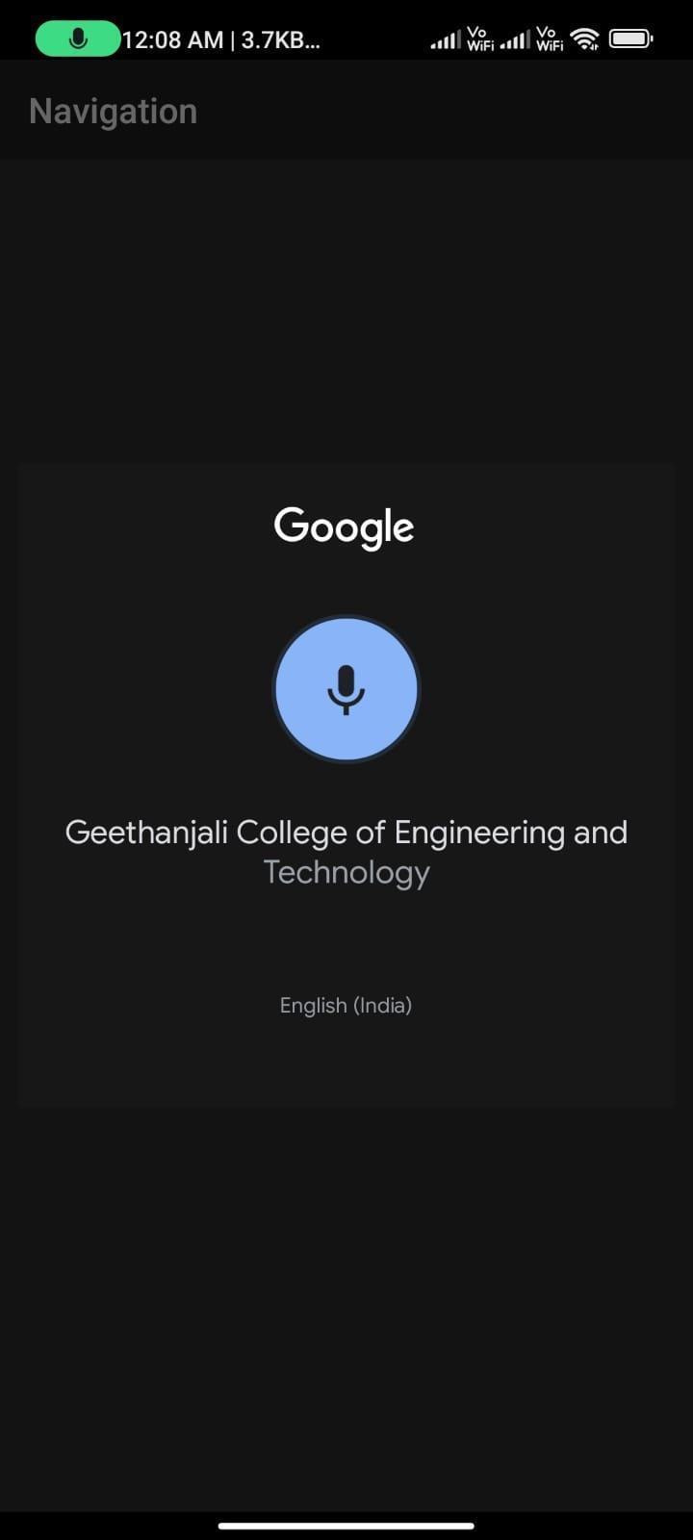
Fig 10.4.2 TTS Screen
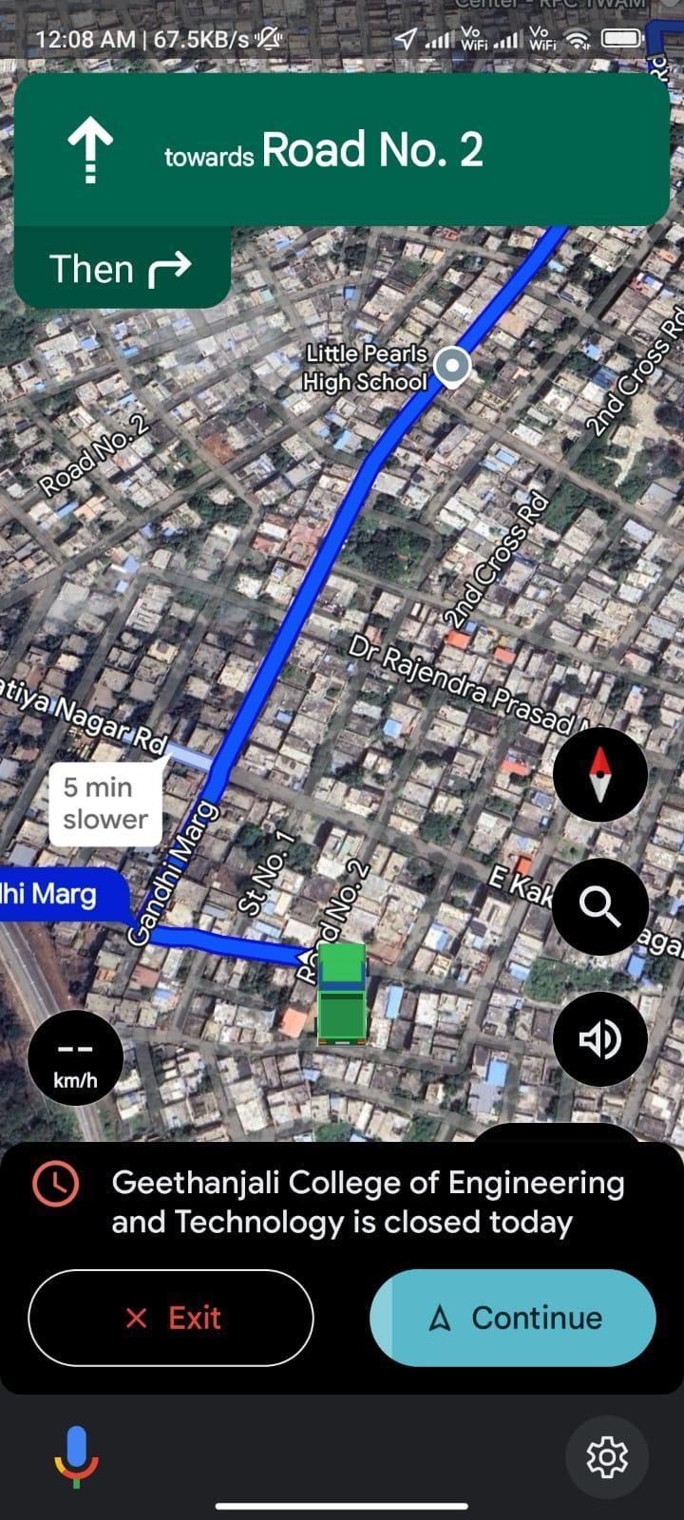
Fig 10.4.3 Navigation Screen.

10.5 SOS Alert App

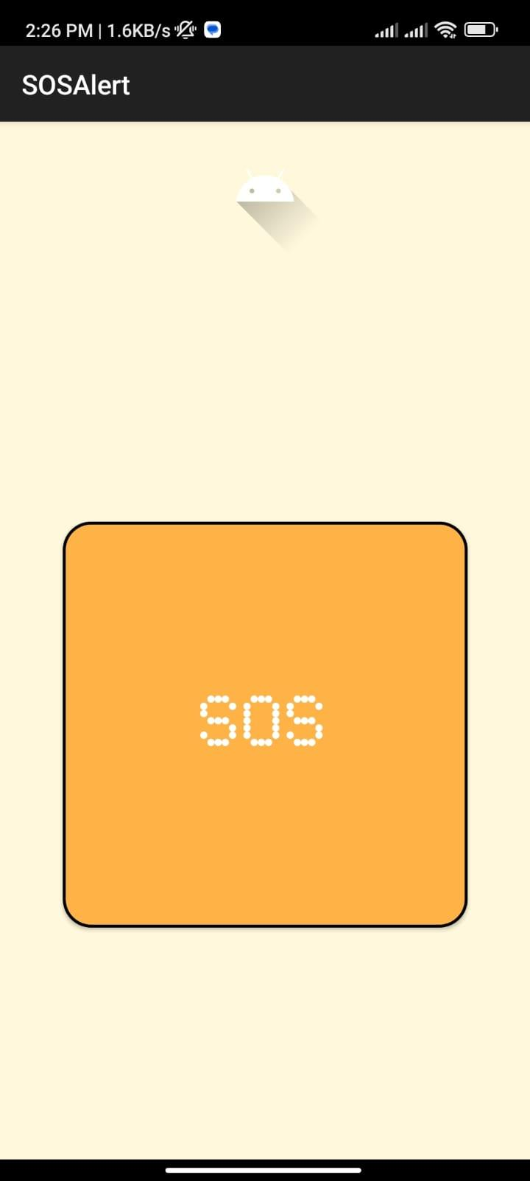
Fig 10.5.1 Home Screen.

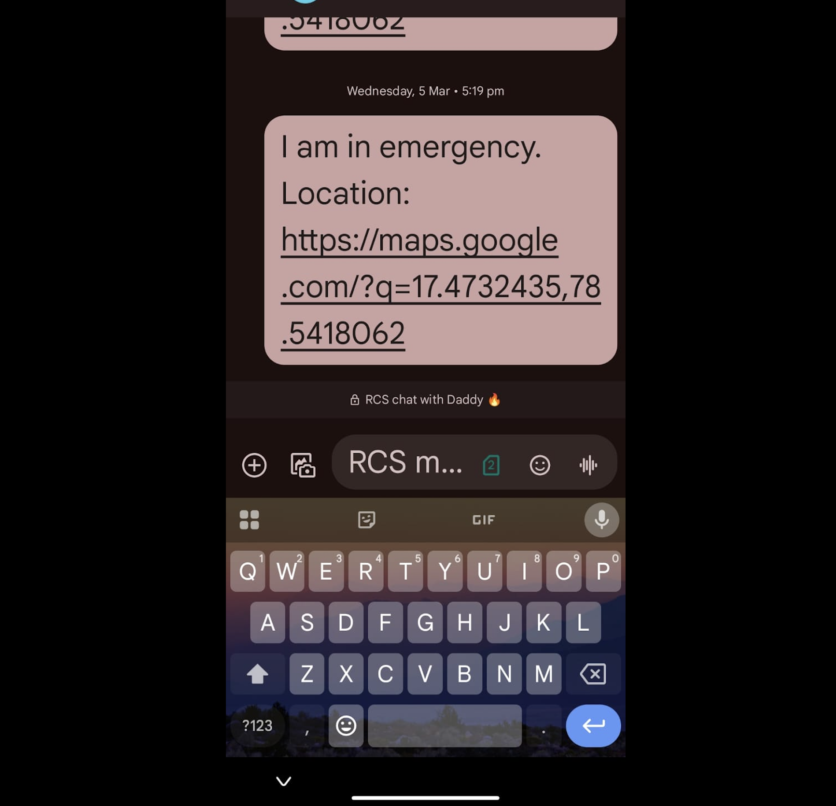
Fig 10.5.2 Emergency message Screen.

10.6 Object Detection

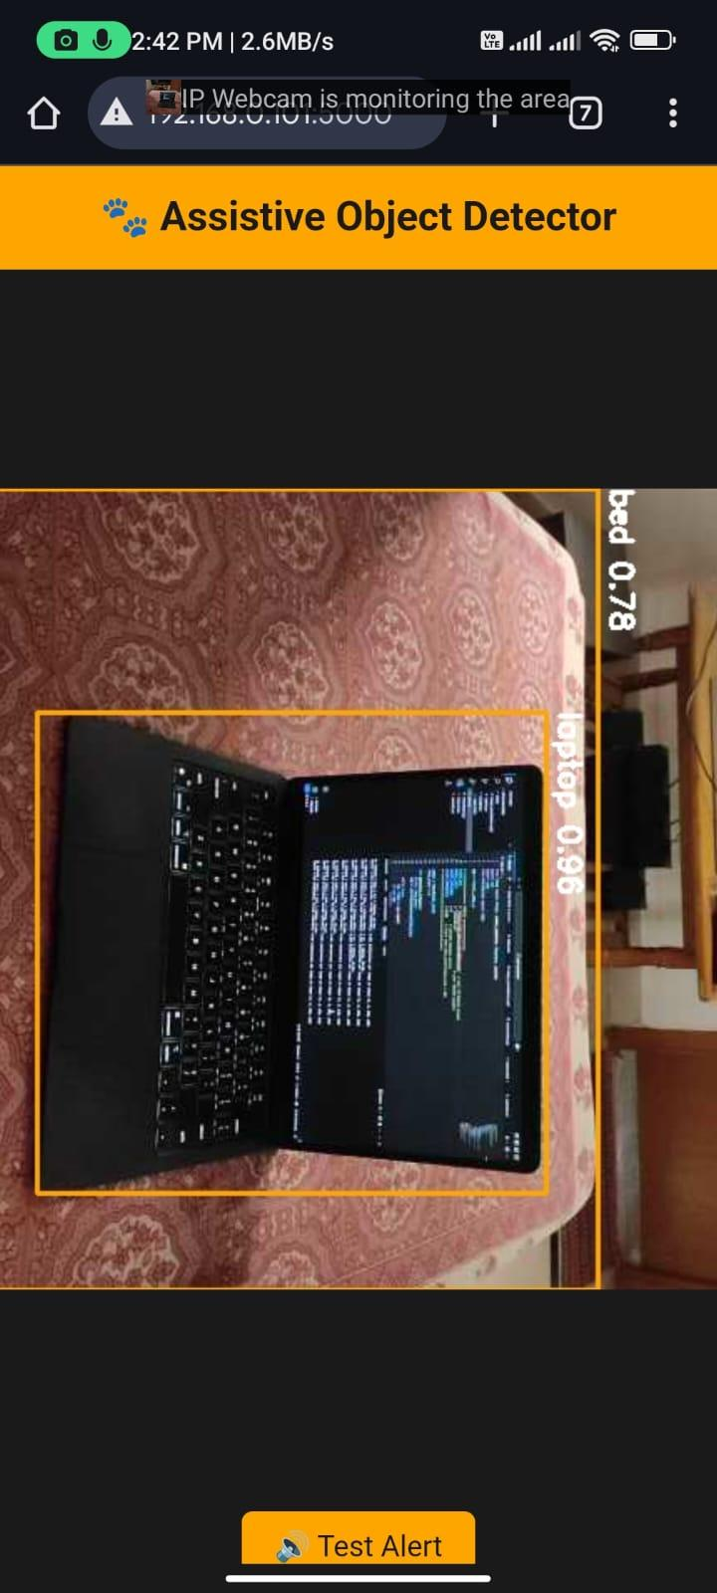
Fig 10.6.1 Object Detection.

11. CONCLUSION

The Vision-Voice: Smart Assistant for Visually Impaired project serves as a significant step toward enhancing the independence and quality of life for visually impaired individuals. By integrating cutting-edge technologies such as QR code scanning, GPS-based navigation, text-to-speech (TTS) systems, and real-time object detection, this app addresses several key challenges faced by individuals with visual impairments. The combination of indoor and outdoor navigation, SOS alerts, object recognition, and product identification in supermarkets provides a comprehensive and versatile tool for users to navigate their surroundings with greater confidence and ease.
One of the standout features of the project is its focus on accessibility and user-friendliness. The mobile application offers intuitive voice-based guidance, allowing users to interact with the app hands-free. This is crucial for visually impaired users, who rely on clear, timely, and accurate audio feedback. Additionally, the inclusion of real-time object detection using the YOLO model and OpenCV ensures that users can avoid obstacles and move freely in unfamiliar environments, thus minimizing risks of accidents. Similarly, the SOS alert function empowers users by providing a quick and reliable way to communicate emergencies and share their precise location with loved ones, enhancing their safety in outdoor settings.
The successful implementation of these features demonstrates how technology can be leveraged to provide practical solutions to everyday challenges faced by visually impaired individuals. By using widely available technologies like Google Maps, Android programming, and TTS systems, the project ensures that it can be adopted and used without requiring highly specialized hardware.
In conclusion, Vision-Voice is not only a tool for assisting visually impaired individuals but also a testament to how innovation and thoughtful design can bridge the gap between disability and independence. This project paves the way for future enhancements, with the potential to incorporate additional features and make the app even more versatile, ultimately improving the lives of its users.

12. FUTURE SCOPE

The Vision-Voice: Smart Assistant for Visually Impaired project holds significant potential for future expansion and enhancement, driven by advancements in technology and user feedback. One key area of future development lies in improving object detection. As machine learning models like YOLO continue to evolve, more accurate and faster object detection can be integrated into the system. In the future, the object detection feature could recognize a broader range of objects, including smaller or more specific items, and provide more detailed feedback to users, such as object dimensions or real-time hazard alerts, making navigation in complex environments even safer.
Another area of improvement is enhanced indoor navigation. Currently, the system relies on QR code scanning to guide users inside buildings. In the future, the app could incorporate Bluetooth beacons or indoor positioning systems (IPS) to provide more seamless, real-time indoor navigation without the need for QR codes. This would allow visually impaired users to navigate shopping malls, airports, hospitals, and other large indoor spaces independently and with greater ease. By utilizing technologies like Wi-Fi triangulation or ultrasonic sensors, indoor navigation could become more dynamic and responsive to changes in the environment.
In terms of outdoor navigation, the integration of augmented reality (AR) and computer vision could greatly enhance the user experience. For example, future versions of the app could provide vibrational feedback in addition to audio cues, guiding users more intuitively through streets and crowded environments. Furthermore, integrating crowdsourced data from other users or leveraging city-level data on obstacles, traffic, and construction zones could improve route planning and make the app more adaptive to real-world conditions.The supermarket assistance feature could also be expanded by including voice-command integration with online shopping platforms, allowing visually impaired users to shop independently from home.
In summary, Vision-Voice has the potential to grow into a more powerful, multi-functional tool, leveraging emerging technologies such as augmented reality, machine learning, and cloud services.

13. BIBLIOGRAPHY
1.“QR Code Based Indoor Navigation System for Visually Challenged People” – Sensors and Actuators A: Physical, 2023.
2.“Speech Recognition and TTS Integration for Mobile Accessibility Tools” – Journal of Assistive Technologies, 2024.
3.“AI-Powered Object Detection and Voice Output for Visually Handicapped” – Nature Digital Medicine, 2024.
4.“Smartphone-Based Assistive Technologies for the Blind: A Review” – IEEE Transactions on Human-Machine Systems, 2023.
5.“Voice-Based Smart Navigation App for the Visually Impaired Using Google APIs” – International Journal of Innovative Technology and Exploring Engineering, 2024.
6.“Design and Implementation of an AI Assistant for Blind People” – Elsevier: Computers in Biology and Medicine, 2022.

7.“Improved YOLOv5-Based Lightweight Object Detection Algorithm for People with Visual Impairment to Detect Buses” – Applied Sciences, 2023.

8.“Visual Impairment Spatial Awareness System for Indoor Navigation” – Journal of Imaging, 2023.

9.“AIris: An AI-Powered Wearable Assistive Device for the Visually Impaired” – arXiv, 2024.

10.“Yolo-Based Real-Time Object Detection with Voice Assistance for Visually Impaired” International Journal of Research Publication and Reviews, 2024.

11.“Intelligent Navigation App for the Visually Impaired” – Journal of Emerging Technologies and Innovative Research, 2024.

12.“AI Assistant for Visually Impaired People” – International Journal of Scientific Development and Research, 2024.

13.“Smart Cap for Visually Impaired People Using Machine Learning” – Journal of Scientific and Engineering Research, 2024.

14.“Implementing Visual Assistant Using YOLO and SSD for Visually-Impaired Persons” – Journal of Automation, Mobile Robotics and Intelligent Systems, 2024.

15.“Google Maps APIs: A Tool for Building Location-Aware Applications” – Proceedings of the 2020 IEEE International Conference on Computing, Communication, and Intelligent Systems (ICCCIS), 2020.

16.“Blind's Eye: Employing Google Directions API for Outdoor Navigation of Visually Impaired Pedestrians” – Mehran University Research Journal of Engineering and Technology, 2017.

