Internal File Management System

1. Project Overview

1.1 Project Background
In modern organizations, the management and secure transfer of digital files are essential to ensure operational efficiency and data confidentiality. However, most existing systems rely on manual processes such as email or third-party cloud-sharing platforms that do not provide proper access control, approval workflows, or file expiration mechanisms.
This often leads to unauthorized access, accidental deletions, and version mismatches between departments. To address these issues, the Internal File Management System was conceptualized to offer a centralized, multi-level, and time-controlled file management environment.
The system enables employees, HODs, admins, and super admins to han- dle organizational files securely with automated approvals, role-based permis- sions, and temporary access sessions, ensuring total traceability and compli- ance with security standards.

1.2 Introduction
The Internal File Management System is a secure and centralized platform designed to streamline the process of file handling, permission control, and activity monitoring within an organization. It provides a role-based access structure that includes Employee, HOD (Head of Department), Admin, and Super Admin panels — each with defined responsibilities and controlled ac- cess levels.
This system enables users to upload, share, edit, or delete files under proper authorization, ensuring data security and transparency. Every action performed in the system — such as file uploads, permission requests, ap- provals, and transfers — is recorded in the Activity Logs for accountability.
A key feature of the system is the “Time Section” (Timed Access/Transfer), which allows any user (Employee, HOD, Admin, or Super Admin) to share or grant file access for a limited duration (for example, 1 hour). Once the set time expires, the file access is automatically revoked, and the session is ter- minated, redirecting the user to the login page. This feature enhances data protection, prevents unauthorized prolonged access, and supports temporary sharing scenarios like reviews, collaborations, or approvals.
ment systems inefficient, insecure, and vulnerable to data misuse and breaches.

1.4 Proposed Solution
Internal File Management System resolves these challenges by combining:
- The Internal File Management System is designed to eliminate these challenges by integrating automation, security, and controlled access mechanisms.
- It uses Role-Based Access Control (RBAC) to assign specific permis- sions to Employees, HODs, Admins, and Super Admins, ensuring that each user can perform only authorized actions.
- An Automated Virus Scanning (ClamAV) module scans every uploaded file, protecting the system from malicious content. The innovative Time-Limited File Transfer (Section Feature) allows users to share files for a fixed duration — after which access automatically expires, en- hancing data security and control.
- A Hierarchical Approval Workflow streamlines the decision process, where requests flow systematically from Employee → HOD → Admin
→ Super Admin. Finally, the system maintains comprehensive Activity Logs, recording every action for full transparency and traceability.
- Together, these features ensure a secure, efficient, and accountable dig- ital file management environment suitable for modern organizational needs.
This ensures secure, traceable, and controlled digital file management.

2. Project Goals and Objectives

2.1 Goals:
- Secure File Handling: The system ensures that every uploaded file is automatically scanned using an integrated antivirus engine (such as ClamAV) before being stored. This prevents the upload of malicious or corrupted files that could compromise system security. It also val- idates file types and formats to allow only authorized extensions (like PDF, DOCX, MP4, Audio, Video, JPG etc.), ensuring that the system maintains data safety and reliability at all times.
- Hierarchical Control: The platform implements a Role-Based Access Control (RBAC) structure where permissions and privileges are as- signed according to user roles — Employee, HOD, Admin, and Super Admin. Each role has defined capabilities and limitations; for exam- ple, Employees can upload files and send requests, HODs can approve or reject them, Admins can manage users and data, and Super Ad- mins can oversee the entire system. This hierarchy maintains proper authorization and prevents unauthorized actions.
- Time-Limited Sharing: The system introduces a “Time Section” or Time-Limited File Transfer feature that allows users to share files with others for a specific duration (for example, 1 hour or 30 minutes). After the set time expires, the system automatically revokes access to the shared file and logs the event. The user session is terminated, and on page refresh, the system redirects them to the login page. This feature ensures that access is temporary, controlled, and secure, preventing long-term unauthorized file usage.
- Transparency: Every operation performed in the system — such as uploads, deletions, approvals, rejections, transfers, and logins — is recorded in the Activity Log. These logs provide a detailed audit trail that helps track “who did what and when.” Transparency ensures ac- countability for all actions, simplifies issue tracking, and supports com- pliance with organizational policies or audits.
- Efficiency: The system eliminates manual delays by automating ap- provals, notifications, and virus scanning. For example, when an Em- ployee uploads a file or sends a request, the HOD receives an instant no- tification, and approval status updates are automatic. This automation reduces human effort, speeds up workflows, and ensures faster commu- nication between roles, improving the overall operational efficiency of the organization.
- Data Integrity : This system ensures that files remain accurate, con- sistent, and unaltered except through authorized operations. Unau- thorized modifications, deletions, or tampering attempts are restricted through role-based controls and audit tracking. The system also main- tains version control and secure file storage, protecting data from cor- ruption, loss, or misuse. This guarantees the reliability and authenticity of organizational files.

2.2 Objectives:
- Ensure all uploaded files are virus-free and validated: This objective focuses on protecting the system and users from malicious or infected files. Every time a user uploads a file (image, PDF, video, zip, etc.), the system automatically performs a virus scan to detect any harm- ful content. Only files that pass the scan are accepted and stored in the system. Additionally, validation checks ensure the file type, size, and format meet organizational policies. This step strengthens data security and prevents cyber threats like malware or ransomware.
- Maintain clear role-based access permissions: Different users — such as Employees, HODs, Admins, and Super Admins — have varying re- sponsibilities and access rights. For example, employees can upload and view their files, HODs can approve or reject them, and admins or super admins can manage the entire system. This Role-Based Access Control (RBAC) ensures that only authorized users can perform spe- cific actions, maintaining data privacy and operational discipline across the organization.
- Provide time-controlled file transfer functionality: his feature allows files to be shared with other users or departments for a limited period.
After the set time expires, access is automatically revoked. It helps in secure collaboration while ensuring sensitive data doesn’t remain acces- sible indefinitely. For example, a report shared with a client for review can automatically expire after 7 days, reducing the risk of unauthorized data exposure.
- Record all activities in detailed system logs: Every action—like file uploads, deletions, approvals, downloads, or permission changes—is au- tomatically recorded in activity logs. These logs capture information such as the user ID, time, action type, and status. This ensures ac- countability and traceability, making it easy to audit system behavior and detect any unusual or unauthorized activity. It also builds trust and clarity among all users.
- Automate approval and notification processes: To reduce manual work and delays, the system automatically triggers notifications and approval workflows. For instance, when an employee uploads a file, the respec- tive HOD receives an automatic approval request, and once approved, the employee gets an instant notification. This automation improves workflow efficiency, speeds up operations, and minimizes human errors.
- Prevent unauthorized modifications or deletions : This objective en- sures that files and system data remain authentic and unchanged unless proper authorization is granted. The system restricts who can edit or delete files, protecting against data tampering. Additionally, backup mechanisms and version control may be used to recover or verify the original data if needed. Maintaining integrity is crucial for ensuring reliability, especially in sensitive or regulated environments.

3. Target Audience

Internal File Management System is designed for:
- Corporate offices with multi-level data handling: These are organi- zations where employees, managers, and administrators work across multiple departments and levels. The system helps maintain a hier- archical file flow — for example, employees upload reports, managers review them, and admins oversee the overall process. This ensures se- cure, traceable, and efficient document management across all levels of the company.
- Educational institutions (Faculty–HOD–Admin): Colleges and uni- versities often need to handle numerous files like assignments, reports, and student data. The IFMS provides a clear structure — Faculty can upload academic documents, HODs can review or approve them, and Admins can monitor the entire process. This promotes accountability, transparency, and reduces paperwork, making academic file manage- ment seamless.
- IT and government organizations handling confidential files: In IT firms and government departments, data confidentiality and file in- tegrity are critical. The system provides secure upload, virus scanning, restricted access, and audit logs, ensuring that only authorized per- sonnel can view or modify sensitive files. It helps these organizations comply with data protection policies and cybersecurity standards.
- Enterprises requiring temporary file access control: Some companies and project-based teams need to share files for a limited duration (e.g., client review, internal approval, or project submission). The IFMS supports time-controlled sharing, where access automatically expires after the set duration, ensuring no unauthorized access after the shar- ing period ends. This feature is especially useful for consultancies, contractors, and short-term collaborations.

4. Project Scope

4.1 In-Scope
- Role-based authentication (JWT): The system uses JSON Web To- kens (JWT) for secure user authentication and session management. Each user (Employee, HOD, Admin, Super Admin) has specific access rights based on their role. This ensures that no unauthorized person can access restricted files or panels, maintaining a secure and structured workflow.
- File uploads (PDF, Image, Video, Audio, ZIP): Employees and other authorized users can upload various file types including documents (PDF), images, videos, audios, and ZIP files. This flexibility allows the system to support different organizational needs, from document management to multimedia file handling.
- File scanning via ClamAV : Every file uploaded to the system under- goes an automated virus scan using ClamAV, an open-source antivirus engine. This ensures that only clean, virus-free files are stored in the system, protecting it from malware, ransomware, and other security threats.
- Edit/Delete/Update requests with approval workflow: Employees can- not directly modify or delete files. Instead, they must send a request to their HOD for approval. Once approved, the employee can perform the requested action. This hierarchical approval system ensures account- ability, prevents unauthorized actions, and maintains data integrity.
- Time-limited section-based file transfer: Users (Employee, HOD, Ad- min, Super Admin) can share files temporarily with others by setting a time limit (e.g., 1 hour). After the set duration expires, access is au- tomatically revoked. This feature enhances security by ensuring that shared files are not permanently accessible and prevents misuse or data leaks.
- Automatic logout after expiration: When the time-limited section ex- pires, the system automatically logs out the user or closes access to that file/transfer session. After refreshing the page, the user must re-login. This adds another layer of security by enforcing strict time-based access control.
- Activity logs and reporting: Every user action (upload, download, edit request, approval, rejection, transfer, etc.) is recorded in activity logs. These logs can be viewed by Admins or Super Admins for transparency and auditing. Reports can be generated to analyze user activity, file transfer patterns, and system usage.

4.2 Out-of-Scope
- Mobile application version: The current project is focused on a web- based system only. No Android or iOS application is included in this phase. However, mobile versions may be considered for future updates.
- Third-party cloud integrations: The system does not integrate with external cloud platforms like Google Drive, Dropbox, or OneDrive. All file management operations are handled internally to maintain security and privacy.
- AI-based content search: Advanced features such as AI-driven content search or document categorization are not part of the current scope. The focus is on secure and efficient file management rather than content intelligence.
- Offline desktop version: The system will operate only in online (web- based) mode. There is no offline or standalone desktop version avail- able. Users need an active internet connection to access the IFMS platform.

5. System Architecture & Technology Stack

5.1 Technology Stack

Layer

Technology

Front
-
End

Back
-
End
Database
Authentication
Handling
File
Notifications
Deployment
Version

Control

HTML, CSS, JavaScript, Bootstrap / React (optional)
Node.js with Express.js

MongoDB
JWT,

bcrypt

Multer,

ClamAV

Real
-
time

pop
-
up

alerts
Render,
Vercel,
AWS
Git, GitHub

5.2 Architecture Flow
• Users authenticate via JWT on login:
- Login flow: User provides credentials (email/username + password)
→ server validates credentials against the user table (hashed password with salt, e.g., bcrypt).
- JWT issuance:On success the server issues a JWT access token (short- lived, e.g., 15–60 minutes) and optionally a refresh token (longer-lived, stored securely, e.g., httpOnly cookie).
- Claims RBAC:JWT payload includes user id, role (Employee / HOD
/ Admin / Super Admin), and any role-specific permissions or scopes. Server uses the role claim for authorization checks on every protected endpoint.
- Token validation :Each request to protected APIs includes the JWT (Authorization header). The server validates signature and expiry, then applies RBAC rules to allow or deny the action.
- Best practices :Use HTTPS, rotate signing keys periodically, set short access token lifetimes, and store refresh tokens securely (httpOnly cookie or secure storage).
• Files are uploaded and scanned using ClamAV:
- Upload request:User uploads file via a secured API endpoint (multipart/form- data). The server first validates file metadata — allowed types, max size, file name sanitization.
- Temporary storage (staging):Store the uploaded file in a staging loca- tion (temp folder or a staging bucket) rather than directly committing to production storage. Save file metadata (uploader id, original file- name, mime type, size) to DB with status scanning.
- Virus scan:The server invokes ClamAV (via clamd socket/HTTP inter- face or command-line clamscan/clamdscan) to scan the file in staging.
If clean, update DB status to available, move the file to permanent storage (object store or secured file server), and create an activity log entry: upload success.
If infected, mark DB record as rejected, delete staging file, and notify uploader with upload virus found. Optionally quarantine the file for analysis.
- Storage metadata:In permanent storage keep the file (object path / storage ID) and store metadata in DB: file id, ownerid, path, hash (SHA256), upload time, scan status, version, visibility, etc. Use file hash for deduplication and integrity checks.
• Requests flow through: Employee → HOD → Admin → Super Ad- min:
- Request creation: When a user requests Edit/Delete/Update, the server creates a request record with fields: request id, file id, requester id, action type, reason, current status (Pending), current assignee (HOD), created at.
- Routing logic:Requests follow the hierarchical flow:
- Employee → HOD: HOD reviews and either Approves or Rejects.
- If HOD Approves →request forwarded to Admin.
- Admin Approves →Super Admin (if required by policy) or the action is executed automatically depending on your rules.
- State transitions:Implement finite-state machine for request states:
Pending(HOD) → Approved(HOD) → Pending(Admin) → Approved(Admin)
→ Executed or Rejected (stop). Each transition is recorded with actor id, timestamp, and comment.
- Notifications:On each state change, send a notification (email, in-app notification, webhook) to the next approver and the requester (status update).
- Execution:After final approval, the system performs requested opera- tion (edit/delete/update) using an audit-safe routine (e.g., soft-delete with deleted at and retention policy).
• Section Feature provides timed access: This is central — timed access must be secure and enforceable. Design elements
- Transfer record:When a user grants timed access, create a transfer record: transfer id, file id, granter id, grantee id, start time, end time, access type (read/write), status(active/expired/terminated), created at.
- Permissions check:esource access endpoints enforce two checks: 1) role- based permission (from JWT + file ACL), and 2) time check (current server time [start time, end time]) for the transfer record. If either fails, deny access.
- Timer mechanism (expiry enforcement):
- Option A — Scheduled Worker: A background worker (cron or queue worker) periodically scans transfer rows where status=active and end time ¡= now() and marks them expired. On expiry it revokes access (removes ACL entry), logs the action, and sends notifications.
- Option B — Real-time check per request: No worker required for en- forcement if every file access checks DB for the transfer validity on each request. Still use a worker to mark expired for reporting and UI.
- Recommended: Combine both — always check DB on request (strong security), and have a worker to cleanup and update statuses, trigger notifications, and remove stale tokens or cache.
- System maintains detailed logs for every operation: When access expires you must ensure the client can’t continue using an existing session or cached token to access the resource:
If using API tokens that grant only file-level access, ensure server-side permission checks will fail after expiry (DB-backed ACL). Even if JWT still valid, the file access endpoint must consult DB/ACL and fail.
If you need to force the user to login again on page refresh, set the front- end to treat 403/401 responses from protected file pages as a trigger to redirect to login. Optionally maintain a per-user session version or token revocation list in DB to immediately invalidate tokens.
UI updates: Show countdown timers in UI for active transfers; when expired, show access expired and redirect on refresh.

6. Panel-Wise Functional Flow

6.1 Employee Panel
Overview: The Employee Panel is designed for general users (employees) who interact with the system primarily for uploading, managing, and trans- ferring their files. Employees have restricted access rights and must follow an approval workflow for any file modification or deletion. Responsibilities:
• Upload files :
- Employees can upload files in allowed formats (PDF, Image, Video, Audio, ZIP).
- Every uploaded file undergoes a ClamAV virus scan.
- Clean files are successfully uploaded, while infected files are auto- matically rejected.
- Upload details (file name, size, upload time) are logged in the system.
• Request edit/delete permissions:
- Employees cannot directly edit or delete files once uploaded.
- They must send a request to their HOD specifying the reason for modification or deletion.
- Requests are stored in the database with status “Pending.”
- Employees receive notifications when their request is approved or rejected.
• Transfer files with time limits:
- Employees can share their uploaded files with others for a limited time (e.g., 1 hour, 1 day).
- After the set time expires, access to the transferred file automatically closes.
- If the employee tries to access after expiration, they are redirected to the login page, ensuring session control.
• View personal logs:
- Employees can view all their past activities (uploads, requests, ap- provals, transfers).
- Logs help maintain transparency and allow employees to track their actions.
Workflow:
- Employee logs in securely using JWT authentication.
- Dashboard opens showing uploaded files, pending requests, and activity logs.
- Employee uploads files → System scans via ClamAV → Clean files saved.
- If changes needed → Employee sends edit/delete request to HOD.
- Employee can transfer files with time limits.
- Logs and notifications update automatically for every activity.
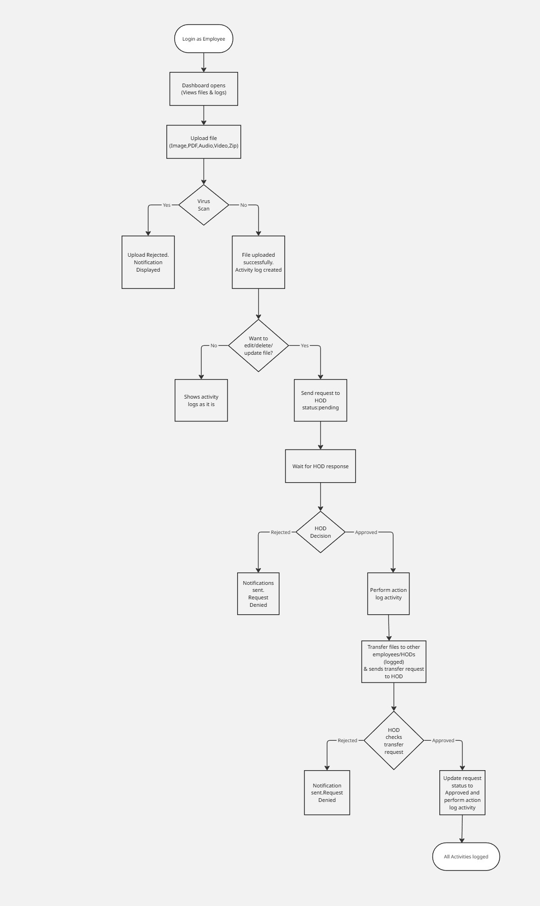
Figure 6.1: Employee Panel

6.2 HOD Panel
Overview: The Head of Department (HOD) Panel acts as the intermediate authority between employees and the admin. The HOD reviews and manages requests from employees and ensures departmental file security. Responsibilities:
• Review employee requests:
- The HOD receives all edit/delete/update requests submitted by employees.
- Each request includes details like file name, action type, reason, and employee ID.
- HOD reviews and either approves or rejects the request.
• Approve/Reject changes:
- If the HOD approves, the request moves to the Admin for final verification.
- If rejected, the employee is notified automatically with the rejection reason.
• Request Admin approval for own file edits:
- HODs have their own files in the system.
- When they wish to modify or delete a file, they must send an approval request to the Admin.
• File Upload Management:
- HODs can upload departmental files which will also undergo virus scanning.
- They can view and monitor files uploaded by employees within their department.
• Activity Tracking:
- Every action (approval, rejection, upload, file transfer) is recorded in the activity log.
- HOD can review logs to ensure departmental compliance.
Workflow:
- Login to HOD dashboard using credentials.
- View all pending employee requests.
- Review file details and reasons for request.
- Approve or reject with comments.
- Upload and manage personal or departmental files.
- Forward approved requests to Admin.
- Track all activities through the activity log.
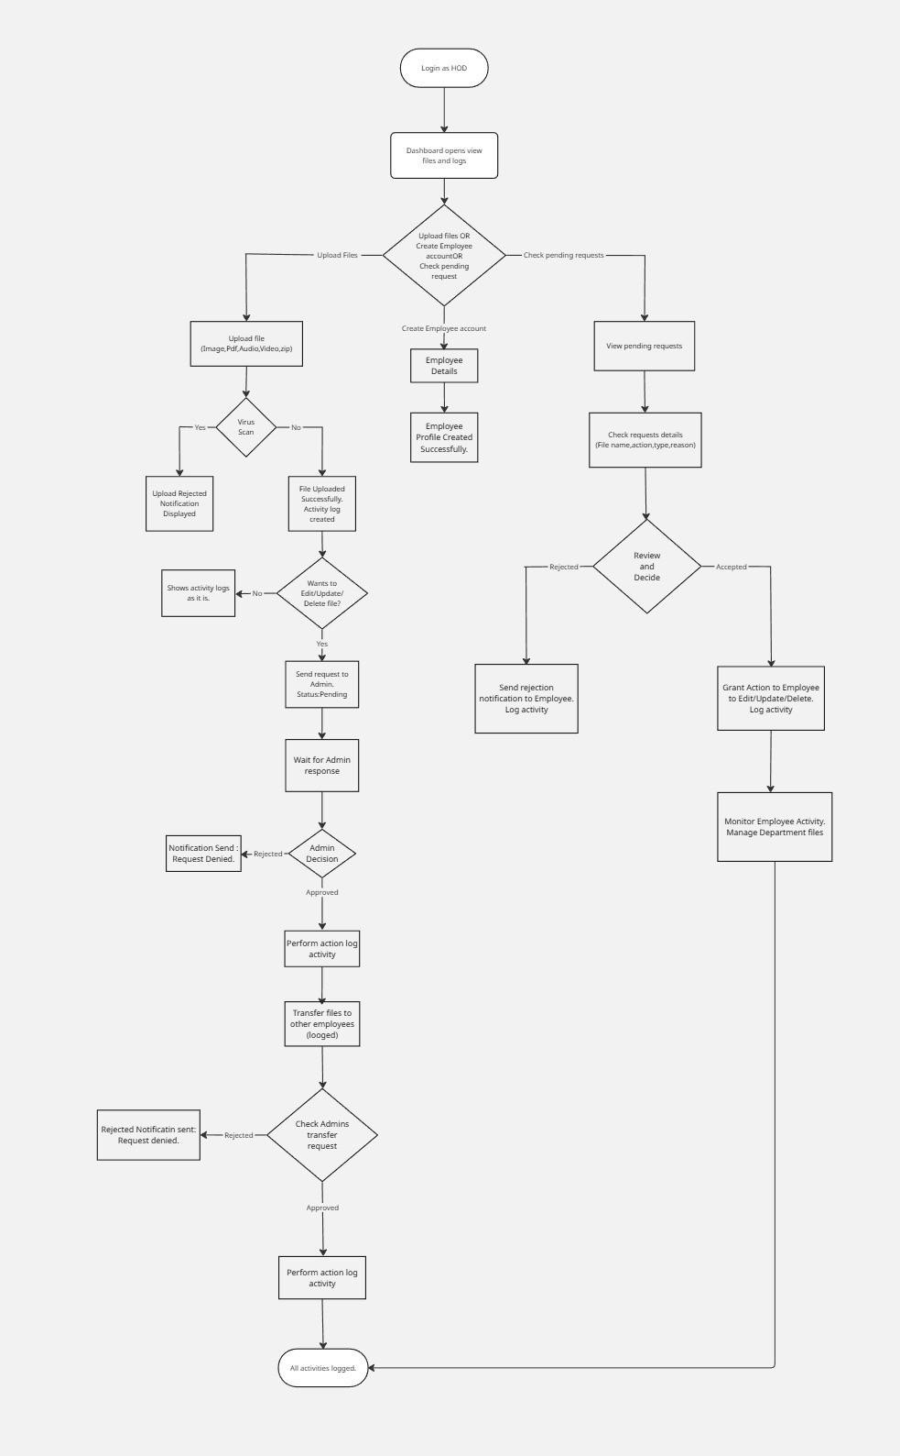
Figure 6.2: HOD Panel

6.3 Admin Panel
Overview: The Admin Panel is the central authority that manages system- wide operations. Admins oversee all users, handle higher-level approvals, and ensure organizational data integrity. Responsibilities:
• Approve HOD requests:
- The Admin reviews all requests forwarded by HODs.
- Based on policies or file sensitivity, the Admin either approves or rejects.
- Approved actions are executed automatically (e.g., allowing file dele- tion or updates).
• Manage users:
- Admins manage user accounts for Employees and HODs (add, up- date, deactivate).
- They assign roles and permissions to maintain access hierarchy.
- Can reset passwords or revoke access when needed.
• Handle organization-level files:
- Admins can view all uploaded files across departments.
- They can transfer or archive files as needed.
- Perform periodic audits to ensure compliance and data security.
• Log Monitoring Reporting:
- Admins can view system-wide logs and generate reports.
- They monitor activity trends to detect anomalies or unauthorized access attempts.
• Security Oversight:
- Admin ensures all uploaded files are virus-free and that time-limited transfers follow policy.
- They maintain system settings related to storage, approval chains, and access rules.
Workflow:
Admin logs in using JWT authentication.
Dashboard displays pending HOD requests and recent activities.
Admin reviews and approves/rejects HOD requests.
Admin manages users and department configurations.
Monitors activity logs and file status reports.
Coordinates with the Super Admin for system-wide updates or escalations.
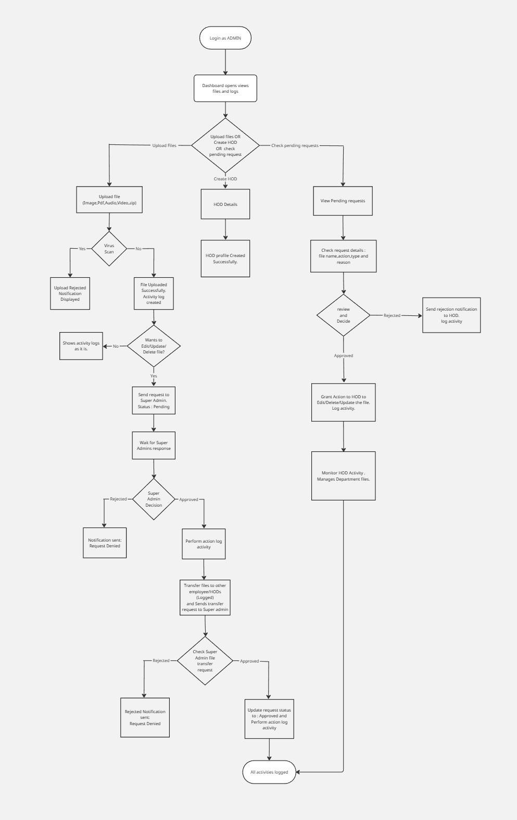

Figure 6.3: Admin Panel

6.4 Super Admin Panel
Overview:The Super Admin Panel represents the highest level of control in the Internal File Management System. The Super Admin oversees the entire system, including Employees, HODs, and Admins. They are responsible for system maintenance, user control, and backups. Responsibilities:
• Full system control:
- Super Admin can access all panels (Employee, HOD, Admin).
- They have the authority to modify, delete, or restore any file in the system.
- Can intervene in any workflow when needed.
• Approve Admin Requests:
1. Any high-level changes or system-wide requests from Admins require Super Admin approval.
Example: Adding new departments, changing configurations, or restor- ing deleted files.
• System Maintenance Backups:
- Responsible for database backups, storage management, and recov- ery procedures.
- Ensures the system runs smoothly with no data loss or corruption.
• Reports Monitoring:
- Super Admin generates global reports including:
- File activity summary
- User activity logs
- System performance and security reports
- Monitors usage to ensure compliance with data policies.
• User Management Across Roles:
- Add, update, or remove Admins, HODs, and Employees.
- Manage system roles and privileges.
- Monitor suspicious activities or policy violations.
• System Security Oversight:
- Regularly reviews virus scan reports, login attempts, and expired file transfers.
- Handles escalated security alerts or access breaches.
Workflow:
Super Admin logs in and accesses the global dashboard.
Monitors activities from Employee → HOD → Admin hierarchy.
Approves or rejects requests escalated by Admins.
Generates and reviews system reports. Performs backups and maintenance tasks.
Adds or removes users and roles as needed.
Oversees overall system health and data security.

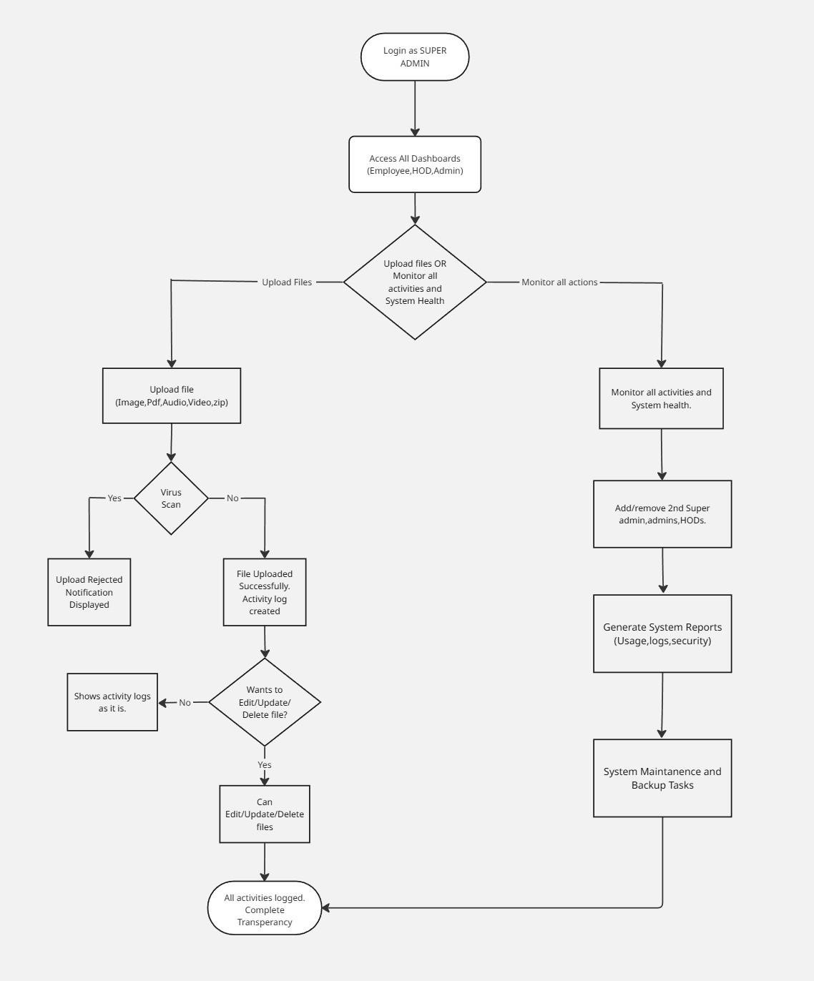
Figure 6.4: Super Admin Panel

7. Security Features

- JWT authentication:
Purpose: To ensure that only verified users can access the system.
Explanation: When a user logs in, the system generates a JWT token containing user details and permissions. This token is sent with every request to verify the user’s identity without needing to log in again.
It eliminates the need to store sessions on the server.
Each token has an expiration time for extra security.
If someone tries to use an expired or tampered token, access is denied.
Example: An employee logs in → gets a JWT token → uses it to upload files or request edits → token expires after a set time.
- bcrypt password hashing:
Purpose: To securely store passwords and protect them from being stolen or exposed.
Explanation: When a user sets or changes their password, it is en- crypted using bcrypt, a strong hashing algorithm.
Even the system admin cannot see the actual password.
If hackers gain database access, they’ll only see unreadable hashed pass- words.
bcrypt also uses salt (random data added to the password) to make every hash unique.
Example: Password “Admin@123” → stored as a long encrypted hash like “2a105u9f0n...” in the database.
- ClamAV virus scanning : Purpose: To prevent malware or viruses from entering the system through uploaded files.
Explanation: Whenever a file (PDF, image, video, ZIP, etc.) is up- loaded, it is automatically scanned using ClamAV, an open-source an- tivirus engine.
If the file is clean → upload allowed.
If a virus is detected → upload rejected, and a notification is sent.
Example: An employee uploads a ZIP file → ClamAV scans it → virus found → upload blocked and activity logged.
- Automatic section-based access expiry: Purpose:
To ensure files shared for a specific time automatically lose access after expiration.
Explanation: When users share files between sections (e.g., Employee → HOD), they can set a time limit (e.g., 24 hours, 7 days).
After that time, access is automatically revoked.
Prevents unauthorized long-term access to sensitive documents.
Example: A report shared with a department for 2 days → after 48 hours, the file becomes inaccessible automatically.
- RBAC for strict access control:
Purpose: To limit what each user can do based on their role (Employee, HOD, Admin, Super Admin).
Explanation: Every user role has specific permissions:
Employee: Upload files, request edits, view logs.
HOD: Approve employee requests.
Admin: Manage users and organization files.
Super Admin: Full system control.
This prevents unauthorized access or actions by lower-level users.
Example: An Employee cannot delete files directly — must request HOD approval.
- Encrypted MongoDB TLS connections:
Purpose: To protect data while it is transmitted between the applica- tion and the database.
Explanation: All communication with the MongoDB database uses TLS (Transport Layer Security) encryption.
Prevents hackers from intercepting or reading data during transmission.
Ensures data confidentiality and integrity between the app and database server.
Example: When a user uploads a file or logs in, all data sent to the MongoDB database travels through a secure, encrypted connection.

8. Testing and Quality Assurance

1. Unit Testing:
Area:File Upload and Virus Scanning
Purpose: To check that individual components (modules) of the system function properly in isolation.
Explanation: In this phase, developers test each feature separately — for example, the file upload module, virus scanning, and authentication func- tions.
Ensures each small unit (function/class/API) performs its intended job.
Detects bugs early before integration.
Outcome: Core modules (uploading, scanning, authentication, etc.) work correctly and independently without errors.
Example: Testing if ClamAV correctly identifies a virus during a single file upload.
2. Integration Testing:
Area: Workflow Hierarchy (Employee → HOD → Admin → Super Ad- min) Purpose: To verify that all modules and roles interact smoothly when connected together.
Explanation: After unit testing, all components are combined and tested as a group. The goal is to ensure that data flows correctly between system parts.
Checks that requests, approvals, and notifications move properly through each user level.
Detects issues in communication or data exchange between modules.
Outcome: Smooth coordination between Employee uploads, HOD ap- provals, Admin actions, and Super Admin monitoring.
Example: Testing if a file uploaded by an Employee reaches the HOD for approval and continues through the correct chain.
3. Security Testing:
Area: Virus Detection, JWT Authentication, and Role-Based Access Purpose: To identify vulnerabilities and ensure that the system is secure from internal and external threats.
Explanation: This phase checks all security layers of IFMS, including:
ClamAV scanning for malware prevention.
JWT authentication for secure login and session management.
Role-Based Access Control (RBAC) for permission handling.
Outcome: The system prevents unauthorized access, virus uploads, and data breaches.
Example: Testing if a user without an Admin role can access Admin files — should be denied.
4. User Acceptance Testing (UAT):
Area: Full Role Simulation (Employee, HOD, Admin, Super Admin) Purpose: To validate the system from an end-user’s perspective and ensure it meets real-world needs.
Explanation: This is the final testing stage where actual users or testers simulate real tasks using the system.
Confirms that workflows are easy, intuitive, and functionally complete.
Helps identify usability or approval flow issues before deployment.
Outcome: All user roles can perform their operations smoothly — system is ready for real use.
Example: Simulating a full file lifecycle: upload → approval → time- limited sharing → automatic expiry → log verification

9. Development Roadmap

Phase | Task | Duration
Phase 1 | Requirement Analysis & Architecture | 1 Week
Phase 2 | Frontend UI Development | 2 Weeks
Phase 3 | Backend API & Role Logic | 2 Weeks
Phase 4 | Security Setup & Testing | 1 Week
Phase 5 | Deployment & Documentation | 1 Week

10. Future Enhancements

- Integration with cloud storage platforms: This means connecting the system with cloud services like Google Drive, OneDrive, or AWS. It allows users to store, access, and back up files online easily and securely.
- AI-based file classification: Artificial Intelligence automatically ana- lyzes and categorizes files (like documents, images, or videos) based on their content. This helps users quickly find and organize files without doing it manually.
- Email-based approval alerts: Whenever a user requests file approval or any action is taken, the system sends an automatic email notification to the concerned person (like HOD or Admin). This keeps everyone informed in real-time.
- Download tracking analytics: This feature records and analyzes how many times files are downloaded, by whom, and when. It helps track file usage and ensures accountability.
- Role-based dashboard insights: Each user (Employee, HOD, Admin, Super Admin) gets a custom dashboard showing data relevant to their role — like pending requests, uploaded files, or approval status.
- Multi-language interface:The system supports multiple languages, al- lowing users to choose their preferred language (like English, Hindi, Marathi, etc.) for better accessibility and understanding.

11. Conclusion

The Internal File Managment System provides a comprehensive and reliable solution for modern organizational file management challenges. By integrat- ing automated virus scanning, role-based access control, hierarchical approval workflows, and time-limited file transfer features, the system ensures that ev- ery file operation is secure, transparent, and efficiently managed. It enhances accountability through detailed activity logs and safeguards data integrity by preventing unauthorized access or modifications. Overall, IFMS promotes a secure, efficient, and well-regulated digital environment for organizations of all sizes.

12. References

- Ferraiolo, D. F., Kuhn, D. R. (1992). Role-Based Access Controls.
NIST. [PDF] magentahttps://www.researchgate.net/publication/
24164143_Role-Based_Access_Controls
- Sandhu, R. S., Coyne, E. J., Feinstein, H. L., Youman, C. E. (1996).
Role-Based Access Control Models. IEEE Computer. [PDF] magentahttps:
//csrc.nist.gov/csrc/media/projects/role-based-access-control/ documents/sandhu96.pdf
- Junior, M. A. de C., Bandiera-Paiva, P. (2018). Health Information System Role-Based Access Control: Current Security Trends and Chal- lenges. Journal of Healthcare Engineering.magentahttps://www. ncbi.nlm.nih.gov/pmc/articles/PMC5836325/
- Dien, N. K., et al. (2014). Memory-Based Multi-pattern Signature
Scanning for Clam Antivirus (ClamAV). Springer. magentahttps:// link.springer.com/chapter/10.1007/978-3-319-12778-1_ 5
- Detecting and Sanitizing Malicious File Uploads in Web Applications.
(2022). ACM Digital Library.magentahttps://dl.acm.org/doi/
10.1145/3538969.3538999
- Malicious file upload detection with Uploadcare’s ClamAV integra- tion. (2024) Uploadcare Blog.magentahttps://uploadcare.com/ blog/malicious-file-detection/
- Securing Own cloud from Malicious File Uploads Using ClamAV. (PDF)magentahttps:
//ijiird.com/wp-content/uploads/040252.pdf
- Role-based access control (RBAC) – Definition, Benefits and Examples.
Pathlock (2025)magentahttps://pathlock.com/blog/role-based-access-control

