40 Days of LeetCode Challenge

40 days, 40 problems
DAY :2
LEETCODE PROBLEM NO. 1281 : Subtract the Product and Sum of Digits of an Integer
Problem Link : https://leetcode.com/problems/subtract-the-product-and-sum-of-digits-of-an-integer/description/
Easy · Bit Manipulation / Simulation
STEP BY STEP SOLUTION:-

Step 1. Understand the question :-
We are given a positive integer n, return the difference between the product of its digits and the sum of its digits. That is we need to:
- Find the product of its digits — multiply all the digits together.
- Find the sum of its digits — add all the digits together.
- Subtract the sum from the product.
The final result is:
Answer = Product of digits - Sum of digits

Step 2. Translating it into simpler language with examples :-
Imagine that every digit in the number is a separate value.
Example 1:
Input: n = 234
Output: 15
Explanation:
Product of digits = 2 * 3 * 4 = 24
Sum of digits = 2 + 3 + 4 = 9
Result = 24 - 9 = 15
For the number 234, we have the digits 2, 3, and 4.
- First, multiply them together. Then, add them together.
- Finally, subtract the addition result from the multiplication result.
n = 234
2 3 4
digit1 digit2 digit3

Multiply the digits 2 x 3x 4 = 24
Add the digits 2 + 3 + 4 = 9
FINAL RESULT 24 - 9 = 15

Example 2:
Input: n = 4421
Output: 21
Explanation:
Product of digits = 4 * 4 * 2 * 1 = 32
Sum of digits = 4 + 4 + 2 + 1 = 11
Result = 32 - 11 = 21
For the number 4421, we have the digits 4, 4, 2, and 1.

- First, multiply them together. Then, add them together.
- Finally, subtract the addition result from the multiplication result.

n = 4421
4 4 2 1
digit1 digit2 digit3 digit4

Multiply the digits 4 x 4 x 2 x 1 = 32
Add the digits 4 + 4 + 2 + 1 = 11
FINAL RESULT 32 - 11 = 21

Step 3. Identify the pattern
The main pattern is repeated digit extraction using arithmetic operations.
Java provides two operators that make this problem straightforward.

A. Modulo operator %
The expression n % 10 returns the last digit of a positive integer.
For example:
- 234 % 10 = 4
- 23 % 10 = 3
- 2 % 10 = 2

B. Integer division /
The expression n / 10 removes the last digit when both operands are integers and n is non-negative.
For example:
- 234 / 10 = 23
- 23 / 10 = 2
- 2 / 10 = 0
Together, these operations allow us to process the digits from right to left without converting the number into a string.

How digit extraction works:-

234 4
% 10

234 23
/ 10
Extract the last digit, process it, and remove it. Repeat until no digits remain.

We also need two accumulators:
- product, initialized to 1, because multiplying by 1 preserves the first digit.
- sum, initialized to 0, because adding 0 does not change the first digit.
We repeat this process in a while loop until n becomes zero.

Step 4. Build the logic
Algorithm :-
- Initialize product = 1 and sum = 0.
- While n > 0:
- Extract the last digit using n % 10.
- Multiply that digit into product.
- Add that digit to sum.
- Remove the last digit using n / 10.
- Return product - sum.

Pseudocode :-
FUNCTION subtractProductAndSum(n):
product = 1
sum = 0

WHILE n > 0:
digit = n % 10
product = product * digit
sum = sum + digit
n = n / 10

RETURN product - sum

NOTE :-
Why initialize product to 1 instead of 0?
Because if we initialize it to zero, every multiplication would remain zero. Starting at one allows the digits to build the correct product.
Why update n using n / 10?
If we do not remove the last digit, the loop will keep processing the same number indefinitely.

Step 5. Code in Java
This is the standard arithmetic solution for LeetCode 1281.

class Solution {
public int subtractProductAndSum(int n) {
int product = 1;
int sum = 0;

while (n > 0) {
int digit = n % 10;
product = product * digit;
sum = sum + digit;
n = n / 10;
}

return product - sum;
}
}

How to submit
- Open LeetCode Problem 1281.
- Select Java as the programming language.
- Enter the method in the provided Solution class, replacing the existing method if necessary.
- Click Run to test the examples.
- Click Submit after the tests pass.

Step 6. Explanation & dry-run

Explanation of the code :-
Statement | Purpose
int product = 1; | Stores the product of digits.
int sum = 0; | Stores the sum of digits.
while (n > 0) | Continues while digits remain.
int digit = n % 10; | Extracts the last digit.
product = product * digit; | Updates the running product.
sum = sum + digit; | Updates the running sum.
n = n / 10; | Removes the last digit.
return product - sum; | Returns the required difference.

Dry run: num = 234
Let's trace n = 234 iteration by iteration. Initially:
- product = 1
- sum = 0
- n = 234
Iteration | n | Extracted digit | product | sum | Updated n
1 | 234 | 4 | 4 | 4 | 23
2 | 23 | 3 | 12 | 7 | 2
3 | 2 | 2 | 24 | 9 | 0
Once n = 0, the loop terminates.

The return statement calculates: 24 - 9 = 15
Output: 15.

7. Analyze complexity and optimization
Let d represent the number of digits in n.
Time complexity: (O(d))
Each loop iteration processes exactly one digit. Since there are (d) digits, the loop executes (d) times.
Equivalently, for a positive integer (n), the time complexity can be expressed as (O(logn)), because the number of decimal digits grows logarithmically with the value of \(n\).
Auxiliary space complexity: (O(1))
We use a fixed number of integer variables regardless of the number of digits. No additional arrays, lists, or strings are required.
NOTE:-
Can it be optimized?
This solution is already optimal for the normal digit-by-digit approach : every digit must contribute to the product and sum. Processing each digit once is sufficient, and extra space remains constant.
Converting the number into a string is another possible approach, but it requires string processing and does not improve the asymptotic complexity.

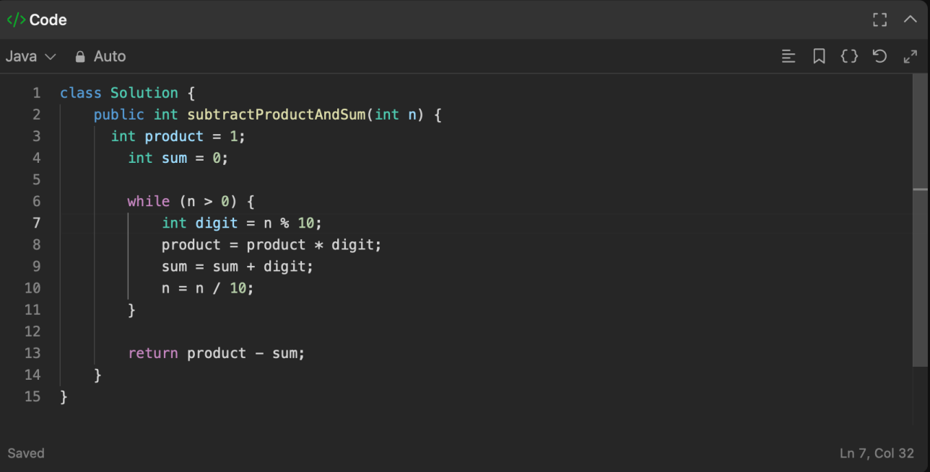
SCREENSHOT:-

