AOOP_Week_1
Name: S. Vaibhava Sree
Roll No:2520030398
1.Student.java
class Student {
int studentId;
String name;
int age;

void display() {
System.out.println("Student ID: " + studentId);
System.out.println("Name: " + name);
System.out.println("Age: " + age);
}

public static void main(String[] args) {
Student s1 = new Student();
s1.studentId = 101;
s1.name = "Ravi";
s1.age = 19;

Student s2 = new Student();
s2.studentId = 102;
s2.name = "Priya";
s2.age = 20;

Student s3 = new Student();
s3.studentId = 103;
s3.name = "Kiran";
s3.age = 18;

s1.display();
s2.display();
s3.display();
}
}
OUTPUT: 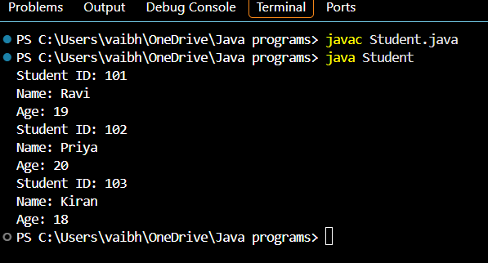
2. Employee.java
class Employee {
int empId;
String name;
double salary;

Employee(int id, String n, double s) {
empId = id;
name = n;
salary = s;
}

void display() {
System.out.println("Employee ID: " + empId);
System.out.println("Name: " + name);
System.out.println("Salary: " + salary);
}

public static void main(String[] args) {
Employee e1 = new Employee(101, "Rahul", 30000);
Employee e2 = new Employee(102, "Priya", 40000);

e1.display();
e2.display();
}
}
OUTPUT:
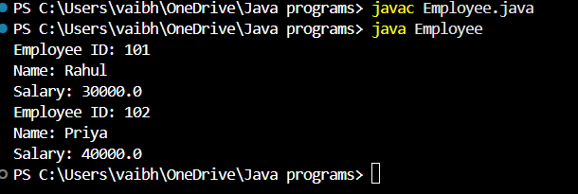
3. BankAccount.java
class BankAccount {
int accountNumber;
double balance;

BankAccount(int acc, double bal) {
accountNumber = acc;
balance = bal;
}

void deposit(double amount) {
balance = balance + amount;
System.out.println("Deposited: " + amount);
}

void withdraw(double amount) {
if (amount <= balance) {
balance = balance - amount;
System.out.println("Withdrawn: " + amount);
} else {
System.out.println("Insufficient Balance");
}
}

void display() {
System.out.println("Account Number: " + accountNumber);
System.out.println("Balance: " + balance);
}

public static void main(String[] args) {
BankAccount b = new BankAccount(12345, 5000);

b.display();
b.deposit(2000);
b.withdraw(1000);
b.display();
}
}
OUTPUT:
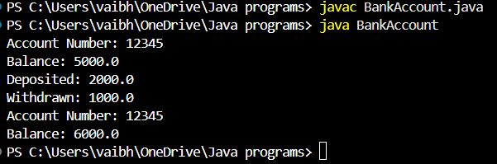
4. Rectangle.java
class Rectangle {
double length;
double width;

Rectangle(double l, double w) {
length = l;
width = w;
}

void calculate() {
double area = length * width;
double perimeter = 2 * (length + width);

System.out.println("Area: " + area);
System.out.println("Perimeter: " + perimeter);
}

public static void main(String[] args) {
Rectangle r = new Rectangle(10, 5);
r.calculate();
}
}
OUTPUT:
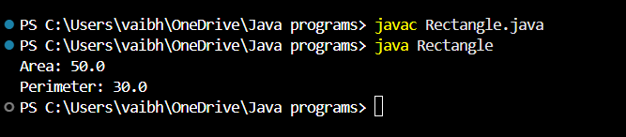
5. Book.java
class Book {
String ISBN;
String title;
double price;

Book(String i, String t, double p) {
ISBN = i;
title = t;
price = p;
}

void display() {
System.out.println("ISBN: " + ISBN);
System.out.println("Title: " + title);
System.out.println("Price: " + price);
}

public static void main(String[] args) {
Book b1 = new Book("9781234567890", "Java Programming", 450);
Book b2 = new Book("9789876543210", "Python Programming", 550);

b1.display();
b2.display();
}
}
OUTPUT:


