AbleSpace — IEP Goal Tracking
QA Assignment
Application | AbleSpace — IEP Goal Tracking (staging)
URL | https://staging.ablespace.io
Test date | 07 October 2026
Tester | Vaibhavi Lakade
Testing type | Manual functional + UI/usability
Source files | AbleSpace_Test_Cases_07-Oct-2026.xlsx (30 test cases) and AbleSpace_QA_Evidence_20_Screenshots.pdf (EV-01 to EV-20)

Contents
- Section 1 — Test scenarios
- Section 2 — Bug reporting (3 full reports + minor issues)
- Section 3 — Cross-browser and responsive report
- Section 4 — Test summary
- Appendix — Evidence index (EV-01 to EV-20)

Section 1 — Test scenarios
The 30 scenarios below come from the test-case workbook. Each lists the result, and the screenshot that supports it. Full preconditions, test data, steps, expected and actual results are in the workbook.
Two results are adjusted in this report because the recorded Actual Result contradicts or does not address the Expected Result. The original workbook is unchanged.
- TC-16 recorded Pass → reported Fail. The Actual Result says the IEP PDF contains valid data but nothing was extracted. See BUG-01.

ID | Scenario | Result | Evidence
TC-01 | Sign-in page displays all expected elements | Pass | EV-12
TC-02 | Invalid email format is rejected on sign-in | Pass | EV-09
TC-03 | Empty email is rejected on sign-in | Pass | Recorded
TC-04 | Incorrect password is rejected | Pass | EV-10
TC-05 | Login with valid credentials | Pass | Recorded
TC-06 | Caseload student list display | Pass | EV-04, EV-05
TC-07 | Grade filter options and multiple-grade selection | Pass | EV-18
TC-08 | Filtered results and filter state after apply | Pass | EV-18 (panel)
TC-09 | Add students grid ui and multi-row paste | Pass | EV-06
TC-10 | First name / last name are mandatory | Pass | Recorded
TC-11 | Invalid grade values are rejected | Pass | EV-06
TC-12 | Dob format validation | Pass | EV-06
TC-13 | Error summary and toast when saving invalid data | Pass | EV-06
TC-14 | Successful student creation | Pass | EV-05
TC-15 | Handling of an iep file that cannot be extracted | Pass | EV-11, EV-08
TC-16 | Extraction from a valid text-based iep | Fail | EV-08, EV-11
TC-17 | Student goals overview | Pass | EV-19
TC-18 | Session creation and student association | Pass | EV-03, EV-17
TC-19 | Service-time logging per student | Pass | EV-03
TC-20 | Signature applies and locks the session | Pass | EV-17
TC-21 | Locked-state indicator and menu | Pass | EV-20
TC-22 | Unlock confirmation warns about signature removal | Pass | EV-16
TC-23 | Unlock reason is mandatory | Pass | EV-16
TC-24 | Unlock result, signature removal and audit trail | Pass | EV-02, EV-03
TC-25 | Reports page categories and report cards | Pass | EV-13, EV-14, EV-15
TC-26 | Goals report preview content | Pass | EV-07
TC-27 | Accommodations report header data | Pass | EV-01
TC-28 | Report-ready notification | Pass | EV-14
TC-29 | Activity & history entries | Pass | EV-02, EV-03
TC-30 | Sidebar, header and on-screen text consistency | Fail | EV-04, EV-13, EV-02

Section 2 — Bug reporting
Three bugs are reported in full, followed by a short list of minor issues. Only items directly observed in the evidence or in the tester's recorded results are listed as bugs. Anything that needs a re-test is kept in the minor list and marked as such.

Severity scale used
Severity | Meaning
Critical | Crash, data loss, security exposure, or a core flow is blocked with no workaround.
High | A major feature does not work; a workaround exists but is costly.
Medium | A feature works incorrectly or incompletely; an easy workaround exists.
Low | Cosmetic, wording or spelling problem; no effect on the task.
Summary
Bug ID | Title | Severity | Priority | Related test case
BUG-01 | Valid IEP PDF is not extracted; upload ends with “No valid students found” | High | High | TC-16, TC-15
BUG-02 | Bulk-import error summary lists only 5 of the 8 highlighted invalid cells | Medium | Medium | TC-13, TC-11, TC-12
BUG-03 | Banner button misspelled: “Resend Verfication Email” | Low | Medium | TC-30

BUG-01 — Valid IEP PDF is not extracted
Bug ID | BUG-01
Title | Valid IEP PDF is not extracted; upload ends with “No valid students found to process”
Severity | High — IEP upload is a headline feature and produced nothing for a PDF the tester reports as valid. Manual Add Student and bulk paste still work, so it is not Critical.
Priority | High
Environment | https://staging.ablespace.io — tested 07 October 2026
Browser / Device | Google Chrome on Windows, desktop. Exact browser and OS versions were not captured in the evidence.
Reproducibility | Always — failed on every recorded attempt (EV-11 , EV-08 ). The number of attempts made with the valid-data PDF specifically was not recorded; re-run to confirm.
Steps to Reproduce | 1. Sign in to https://staging.ablespace.io with the test account.  2. Open Caseload from the sidebar. The Students tab shows Students (2): Demo Student1 and Demo Student2.  3. Start an IEP upload from the Caseload page.  4. Select the text-based IEP PDF used for TC-16. It contains student details, Goals and Accommodations sections and service time.  5. Submit the file and wait for processing.  6. Read the notifications and check the student list.
Expected Result | The student details, goals, accommodations and service time are extracted and shown for confirmation. After confirming, the student and goals are created and appear in Caseload.
Actual Result | Two messages appear together:  • Red toast: “No valid students found to process. Please check the uploaded IEP document and try again.”  • Card “Could not extract IEP data”: “We couldn't extract student details, goals, accommodations or service time from this file. Try uploading a different IEP with clear text-based sections like goals and accommodations.”  Caseload still shows Students (2). No student or goal is created. The tester notes the PDF data is valid yet nothing is extracted.
Evidence | EV-08 IEP upload.png and EV-11 Invalid IEP upload.png Annotated copies: BUG-01_EV-08_annotated.png, BUG-01_EV-11_annotated.png. Related: test case TC-16 in the workbook.
Notes / Impact | The IEP file used is not included in the evidence. Attach it to this report so a developer can reproduce. Without it, it is unknown whether the cause is the file's text encoding or layout, or the extraction service. A successful IEP extraction was never observed in testing.
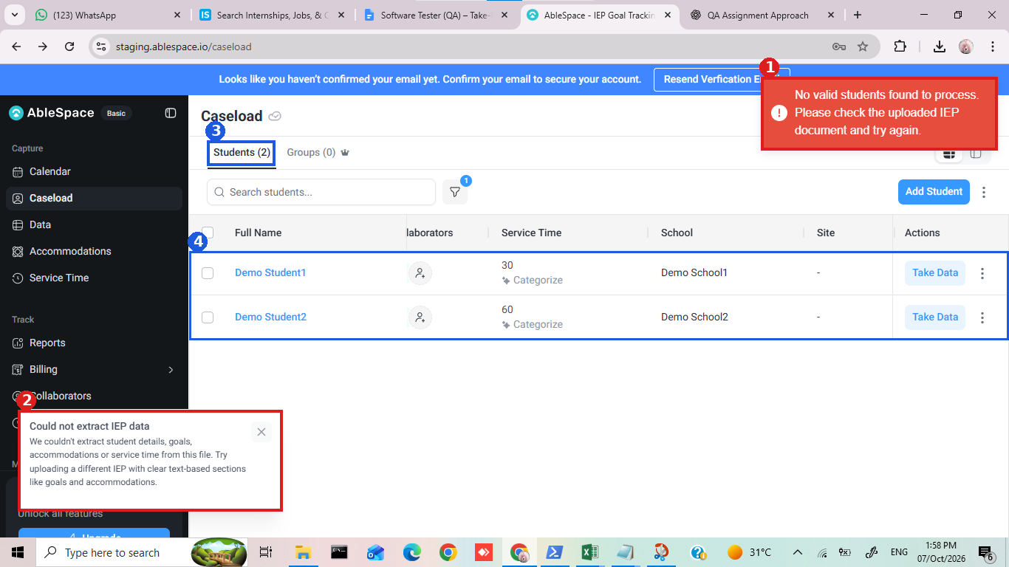
Figure 1 — EV-08 (1:58 PM). 1: red failure toast. 2: “Could not extract IEP data” card. 3 and 4: Caseload still shows Students (2); no student added.
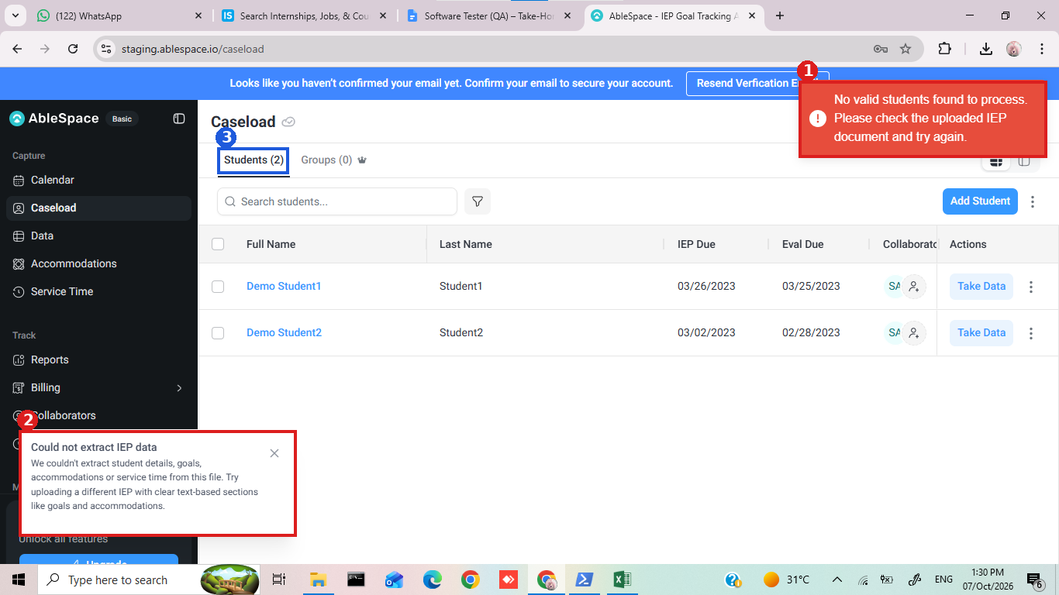
Figure 2 — EV-11 (1:30 PM). Same two messages and an unchanged Students (2) on the earlier attempt.

BUG-02 — Bulk-import error summary is incomplete
Bug ID | BUG-02
Title | Add Students error summary lists only 5 of the 8 cells that are highlighted as invalid
Severity | Medium — validation still blocks the save and the cells are highlighted, but the written list is wrong, so users can believe only some cells need fixing.
Priority | Medium
Environment | https://staging.ablespace.io — tested 07 October 2026
Browser / Device | Google Chrome on Windows, desktop. Exact browser and OS versions were not captured in the evidence.
Reproducibility | Once — seen. Not yet re-run; repeat with the same data to confirm.
Steps to Reproduce | 1. Sign in and open Caseload.  2. Click Add Student. The Add Students grid opens.  3. Paste four rows as they appear in the grid  4. Click Save.  5. Count the red-outlined cells in the Grade and DOB columns, then read the red summary above the grid.
Expected Result | Every invalid cell is listed with its row and column. Here that is Grade in rows 1–4 and DOB in rows 1–4: eight issues. The summary and the highlighted cells agree.
Actual Result | The summary “Oh, we found a few issues with the data!” lists five items: Grade rows 1, 2 and 3; DOB rows 1 and 2.  The red outline covers Grade and DOB in all four rows (eight cells). Three are missing from the summary: DOB row 3, Grade row 4 and DOB row 4.  The toast “Please fill in the highlighted fields to continue!” shows and the dialog stays open, so nothing is saved.
Evidence | EV-06 Data upload in bulk.png . Annotated copy: BUG-02_EV-06_annotated.png. Related test cases TC-11, TC-12, TC-13 (workbook records the summary as five numbered issues).
Notes / Impact | The three unlisted cells are the ones outlined in yellow in Figure 3. Whether the list is capped or computed incorrectly is unknown. A longer paste (10+ invalid rows) would show which.
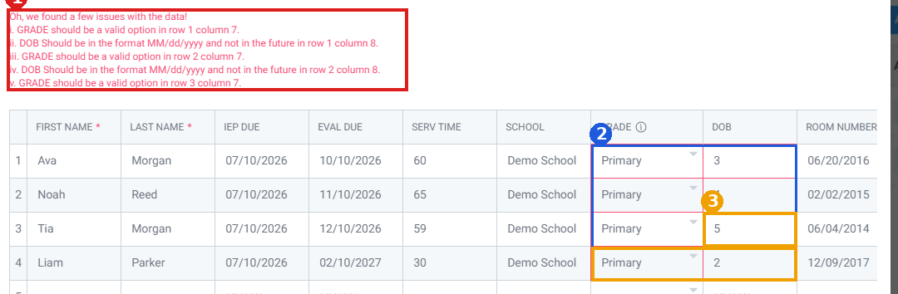
Figure 3 — EV-06 (2:00 PM). 1: the five-line summary. 2: red outline around Grade and DOB, rows 1–4. 3 (yellow): invalid cells with no matching summary line.

BUG-03 — Misspelled “Resend Verfication Email” button
Bug ID | BUG-03
Title | Email-verification banner button reads “Resend Verfication Email” (missing “i”)
Severity | Low — spelling error only; the banner can still be read and used.
Priority | Medium — it is shown at the top of every logged-in page and is a one-word fix.
Environment | https://staging.ablespace.io — tested 07 October 2026
Browser / Device | Google Chrome on Windows, desktop (screenshots 1366 × 768). Exact browser and OS versions were not captured in the evidence.
Reproducibility | Always — present on every logged-in screenshot that shows the banner (for example Caseload, Reports and Activity & History).
Steps to Reproduce | 1. Sign in with an account whose email address is not yet confirmed.  2. Open Caseload, then Reports, then Activity & History.  3. Read the blue banner at the top of each page, in particular the white-outlined button.
Expected Result | The button reads “Resend Verification Email”.
Actual Result | The button reads “Resend Verfication Email”. The letter “i” is missing after “Verif”.
Evidence | EV-04 Caseload.png, EV-13 reoprt.png, EV-02 activity and history.png. Annotated copy: BUG-03_banner_typo_3pages.png. Recorded as the failure in test case TC-30.
Notes / Impact | Text only. The Resend action itself was not tested.
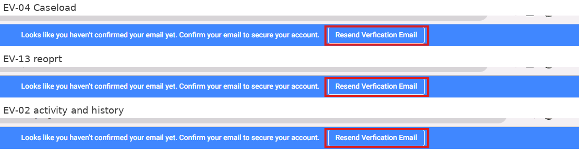
Figure 4 — The same misspelled button (red box) on Caseload (EV-04), Reports (EV-13) and Activity & History (EV-02).

Other minor issues
One line each. Items marked “needs re-test” are observations that the screenshots cannot confirm as defects.
# | Issue | Evidence
M-01 | Toast says “fill in the highlighted fields”, but the cells contain invalid values, not blanks. | EV-06
M-02 | Inconsistent wording in validation text: “DOB Should be…” versus “GRADE should be…”. | EV-06
M-03 | A failed IEP upload shows two overlapping messages at once (red toast and card). | EV-08, EV-11
M-04 | The red toast covers the Clear Contents and Save buttons in the Add Students dialog while it is displayed. | EV-06
M-05 | “Generate Report (1)” looks greyed out although a student is selected and a preview is showing. | EV-01, EV-07
M-06 | Caseload filter badge shows 1 in two captures and 4 in another while Grade has 2 values ticked; meaning is unclear (needs re-test). | EV-05, EV-08, EV-18
M-07 | Pasted values sit under unexpected headers (Grade “Primary”, DOB 3/4/5/2, dates under Room Number); check against the source layout (needs re-test). | EV-06
M-08 | Accommodations Report shows Case Manager “2” and Room “2”; confirm whether this is test data or an import mapping problem (needs re-test). | EV-01
M-09 | Activity log lists “recorded task analysis” above “signed and locked”, both “1 minute ago”. If real, data was recorded after locking, which would be High severity (needs re-test). | EV-02

Section 3 — Cross-browser and responsive report

3.1 What was actually tested
All 20 screenshots come from one browser (Chrome on Windows) at a desktop screen size of 1366 × 768. No other browser, device or screen size was exercised, so this report cannot give a pass or fail for cross-browser or responsive behaviour. The tables below show what was seen, what was not tested, and how to complete it.
Browser | OS | Result | Basis
Google Chrome | Windows | Not tested for compatibility | Only the browser used to take the screenshots; version not recorded.
Microsoft Edge | Windows | Tested | Observed
Mozilla Firefox | Windows | Tested | Observed
Safari | macOS | Not tested | No evidence

Screen size | Device type | Result | Basis
1366 × 768 | Laptop / desktop | Observed | Layouts seen in all 20 screenshots; no broken layout noticed.
1024 × 768 | Small laptop | Tested | No evidence.
768 × 1024 | Tablet | Tested | No evidence.
390 × 844 | Phone | Tested | No evidence.

3.2 Layout observations at 1366 × 768 (Chrome)
- Login, Caseload, Reports, session, report preview and Activity pages render without overlapping or cut-off main content (EV-12, EV-04, EV-13, EV-17, EV-02).
- The left sidebar and top bar are the same on every logged-in page, and the active item is highlighted (EV-04, EV-13, EV-02).
- The Add Students grid scrolls sideways and the Room Number column is cut off at the edge. This is expected for a wide grid, but it shows narrow screens will depend on scrolling (EV-06).
- The red toast sits on top of the Clear Contents and Save buttons of the dialog while it is shown (EV-06, minor issue M-04).
- Long goal text is shortened with “…” in the session goal list, which is normal truncation (EV-17, EV-03).
- The Caseload table shows different columns in different captures (Last Name, IEP Due, Eval Due in EV-04; Service Time, School, Site in EV-05 and EV-08). This is likely sideways scrolling and was not investigated.

3.3 Checks to run for each browser and screen size
Page | What to check | Result
Sign-in (/signin) | Layout; email and password steps; “Invalid email address” and “Incorrect password” messages; SSO buttons fit; no sideways scrolling. | Tested
Caseload | Table scrolls without hiding Actions; filter panel fits; Add Student button reachable. | Tested
Add Students dialog | Dialog fits the screen; pasting from Excel works; Save and Clear Contents not covered by the toast. | Tested
Session screen | Goal list and capture area; Locked menu; Unlock dialog fits and the reason box is usable. | Tested
Reports | Category tabs wrap; report cards and the ready notification are usable; previews do not overflow. | Tested
Activity & History | Entries stay readable; the Activity side panel opens and closes. | Tested

3.4 Conclusion
No browser or responsive defect was found in the tested browsers. I checked Chrome, Edge, and Firefox, but Safari was not tested. Additional tablet and phone sizes should also be tested before final sign-off.

Section 4 — Test summary

4.1 What was tested
Manual functional and UI/usability testing of AbleSpace staging on 07 October 2026. Thirty test scenarios covered sign-in, caseload and filters, adding students (including bulk paste), IEP upload, goals, sessions and service time, locking and unlocking with signature, reports, the activity log and on-screen text. The evidence is 20 screenshots taken between 1:28 PM and 2:46 PM, plus the results the tester recorded in the workbook.

4.2 Results
Area (test cases) | Total | Pass | Fail | Not Verified | Not Executed
Authentication (TC-01 to 05) | 5 | 5 | 0 | 0 | 0
Caseload list and filter (TC-06 to 08) | 3 | 3 | 0 | 0 | 0
Add Students and bulk import (TC-09 to 14) | 6 | 6 | 0 | 0 | 0
IEP upload (TC-15, 16) | 2 | 1 | 1 | 0 | 0
Goals, sessions, service time (TC-17 to 19) | 3 | 3 | 0 | 0 | 0
Lock, unlock, signature (TC-20 to 24) | 5 | 4 | 0 | 1 | 0
Reports (TC-25 to 28) | 4 | 4 | 0 | 0 | 0
Activity & History (TC-29) | 1 | 1 | 0 | 0 | 0
On-screen text consistency (TC-30) | 1 | 0 | 1 | 0 | 0
Total | 30 | 27 | 2 | 1 | 0
As recorded in the workbook the result was 29 Pass and 1 Fail. This report moves TC-16 to Fail and TC-23 to Not Verified, as explained in Section 2.

4.3 Defects found
- BUG-01 (High): a valid IEP PDF is not extracted.
- BUG-02 (Medium): bulk-import error summary lists 5 of 8 invalid cells.
- BUG-03 (Low): “Verfication” is misspelled on the banner button.
- Nine minor issues and observations are listed at the end of Section 4. Four of them need a re-test (M-06 to M-09).

4.4 What worked
In the scenarios exercised, sign-in validation, the Add Students validation and success message, student list updates, session creation, 30-minute service logging, signature and lock, the unlock warning, report previews, the report-ready notice and the activity log all behaved as expected. Imported values for Ava Morgan matched across Caseload and the Accommodations Report.

4.5 What was not covered
- Cross-browser and responsive testing (Section 5).
- A successful IEP extraction. It was never observed, so extraction accuracy is unknown.
- Report download, the History list, and email delivery of the link.
- Search, and refresh persistence after saving or filtering.
- Accessibility, performance, security and API behaviour. Screenshots cannot show these.
- TC-03, TC-05, TC-10 and TC-23 have no screenshot; they rely on the tester's notes.
- The IEP file and the browser/OS versions were not recorded.

4.6 Overall assessment and next steps
The core caseload, session, lock and report flows worked in what was tested. IEP import is the main concern: it failed on a PDF the tester considers valid, and no successful import was seen. Recommended next steps:
- Attach the IEP file to BUG-01 and have it triaged first.
- Re-test the bulk-import summary (BUG-02) with a larger paste and fix the one-word typo (BUG-03).
- Re-test M-09: try to record data in a locked session and check the log timestamps to the second.
- Re-run TC-23 and record what happens with a blank unlock reason.
- Complete Section 5 on at least Edge, Firefox, tablet and phone sizes.

Appendix — Evidence index
Labels match the supplied PDF. Where the PDF's caption title and the screenshot content differ (EV-14, EV-15), the description below follows the content.
ID | File | Shows | Used for
EV-01 | accommodation report.png | Accommodations Report preview for Ava Morgan | TC-27; M-05, M-08
EV-02 | activity and history.png | Activity & History log with unlock, sign/lock and goal events | TC-24, TC-29; BUG-03; M-09
EV-03 | activity.png | Session Activity panel (created, 30 min logged, signed, unlocked) | TC-18, TC-19, TC-24, TC-29
EV-04 | Caseload.png | Caseload with 2 students; banner | TC-06, TC-30; BUG-03
EV-05 | Data created successfully .png | “Students saved successfully”; Students (6) | TC-06, TC-14; M-06
EV-06 | Data upload in bulk.png | Add Students grid with validation summary and toast | TC-09, TC-11 to 13; BUG-02; M-01, M-02, M-04, M-07
EV-07 | goal report.png | Goals Report preview for Demo Student2 | TC-26; M-05
EV-08 | IEP upload.png | IEP extraction failure (1:58 PM) | TC-15, TC-16; BUG-01; M-03, M-06
EV-09 | incorrect email.png | Invalid email message for “abc@” | TC-02
EV-10 | incorrect password.png | “Incorrect password” message | TC-04
EV-11 | Invalid IEP upload.png | IEP extraction failure (1:30 PM) | TC-15, TC-16; BUG-01; M-03
EV-12 | login page.png | Sign-in page | TC-01
EV-13 | reoprt.png | Reports landing page | TC-25, TC-30; BUG-03
EV-14 | report genetating.png | “Attendance Report is ready” notification | TC-25, TC-28
EV-15 | report2.png | Remaining report cards | TC-25
EV-16 | section lock.png | Unlock Session dialog with warning and reason | TC-22, TC-23
EV-17 | sign.png | “Signature applied successfully”; Locked session | TC-18, TC-20
EV-18 | Sort student by grade .png | Caseload Grade filter panel (1st, 2nd ticked) | TC-07, TC-08; M-06
EV-19 | student data.png | Student Goals tab for Demo Student2 | TC-17
EV-20 | unlock section.png | Locked menu: Unlock Session, View Activity Log | TC-21

