Library Management System

- Tables In the Iibrarydb
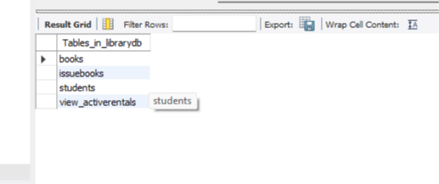
- Books:-
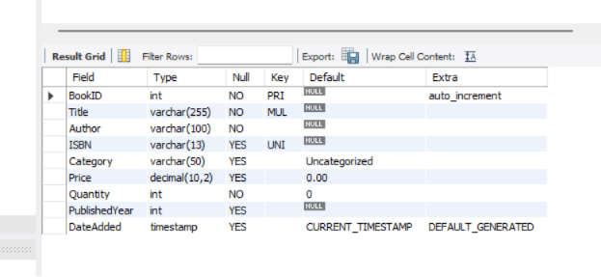
Books Table

- Issuebooks :- 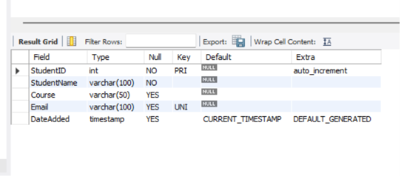
Issuebooks Table

- Students:-
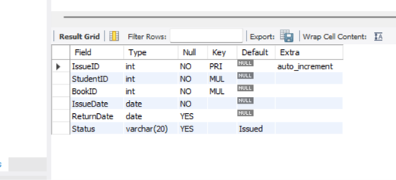
Students Details Table

- View_activerentals :-

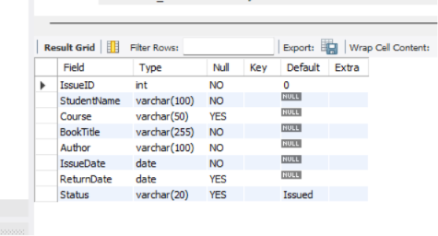
View_activerentals

