import pandas as pd

data = pd.read_csv("sample_data.csv")

print(data.head())

#output

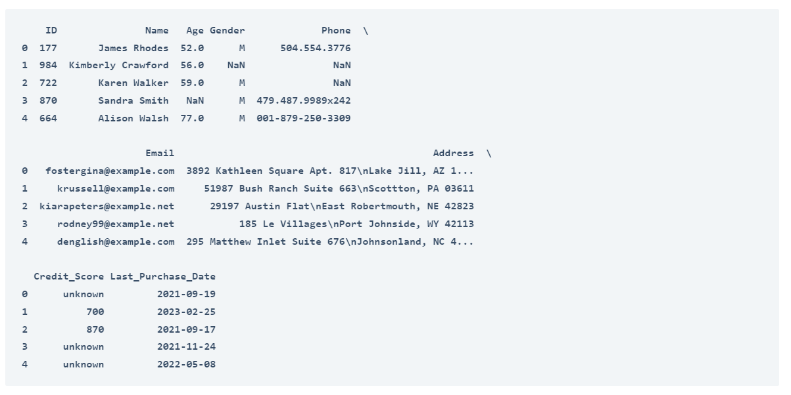

data.info()

#output

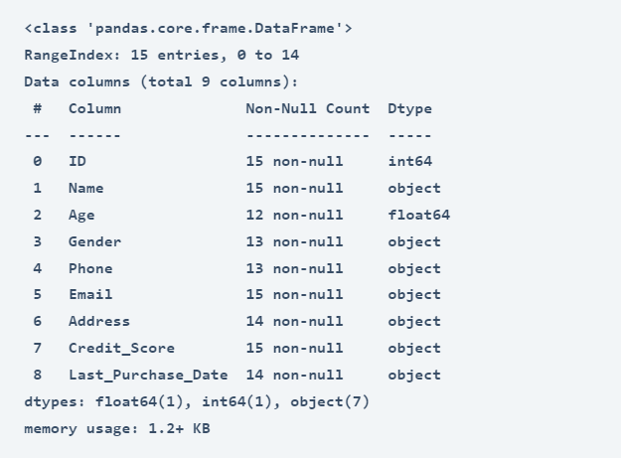

#cleaning the age column

# Convert 'Age' column to integer type

data['Age'] = data['Age'].astype('Int64')

median_age = data['Age'].median()

median_age = round(median_age)

# Fill missing ages with the median value

data['Age'].fillna(median_age, inplace=True)

# Handling missing values in 'Gender', 'Phone', and 'Address'

data['Gender'].fillna('Unknown', inplace=True)

data['Phone'].fillna('Unknown', inplace=True)

data['Address'].fillna('Unknown', inplace=True)

# Handling missing values in 'Last_Purchase_Date'

most_recent_date = pd.to_datetime(data['Last_Purchase_Date']).max()

data['Last_Purchase_Date'].fillna(most_recent_date, inplace=True)

# Convert 'Credit_Score' to numeric type and replace 'unknown' with NaN

data['Credit_Score'] = pd.to_numeric(data['Credit_Score'],

errors='coerce')

# Calculate the mean of the available credit scores

mean_credit_score = data['Credit_Score'].mean()

# Fill missing credit scores with the mean value

data['Credit_Score'].fillna(mean_credit_score, inplace=True)

#droping duplicate rows from the data

data.drop_duplicates(inplace=True)

print(data.head())

