CrowdShield: Real-Time AI-Driven, Cloud-based Crowd Safety & Stampede Prevention System
(Detailed architecture document)
Live Demo Links: Authority Dashboard | Attendee Mobile App
Demo Credentials:
• Authority Dashboard- user: admin/Password: crowd2026 | Attendee App- code: SHIELD2026
1. Executive Summary & Project Overview
Problem Statement
Mass gatherings such as cultural events, religious pilgrimages, concerts, and sports events face serious risks of crowd crushes, bottlenecks, and stampedes. Traditional security relies heavily on human monitoring and static surveillance, making it difficult to detect sudden crowd-density spikes, dangerous movement patterns, or bottlenecks in real time. Emergency communication is also often delayed and limited to centralized, single-language announcements, leaving people unaware of hazards and safe evacuation routes. Therefore, there is a need for an autonomous, end-to-end system that can analyze live video, predict crowd risks, trigger physical interventions, and deliver timely, targeted alerts.
Solution Overview
CrowdShield is an integrated crowd safety and intelligence platform designed to prevent stampede risks through continuous computer vision, graph-based decision-making, and real-time interfaces. Built on a decoupled, asynchronous microservices architecture, it processes high-frame-rate video through three interconnected analytical tiers:
- Module 1 (Perception Engine): Uses YOLOv11 and ByteTrack for real-time person detection and tracking. It divides the venue into zones and continuously measures crowd density, speed, movement direction, entropy, and bottlenecks.
- Module 2 (Decision & Recommendation Engine): Uses perception data with hysteresis-based rules, NetworkX graph routing, and Google Gemini for multilingual alerts. It optimizes gate operations, security deployment, evacuation routes, and emergency announcements.
- Module 3 (User Interface Tier): Provides two interfaces: an Authority Dashboard for security personnel and an Attendee Mobile App for real-time navigation, location-based alerts, and safety checks.
Target Audience & Operational Stakeholders
CrowdShield serves two distinct user groups through dedicated frontend interfaces:
Command Center Personnel & Venue Authorities
- Interface: CrowdShield Authority Dashboard.
- Operational Scope: Designed for event organizers, venue security commanders, and emergency response teams.
- Capabilities: Provides a centralized, top-down tactical overview of the entire venue map. Features real-time zone risk telemetry, active gate closure/opening controls, proportional staff deployment orders, automated reasoning logs, and manual emergency override broadcast tools.
Event Attendees & Ground Visitors
- Interface: CrowdShield Attendee Mobile App.
- Operational Scope: Designed for general public attendees navigating high-density physical spaces.
- Capabilities: Delivers localized venue navigation, POI discovery (medical hubs, washrooms, exits), location-aware congestion warnings, multi-lingual emergency announcements, direct incident reporting, and mandatory "I am safe" safety check modals during critical incidents.
2. System Architecture & Data Flow
2.1 High-Level Architecture Diagram
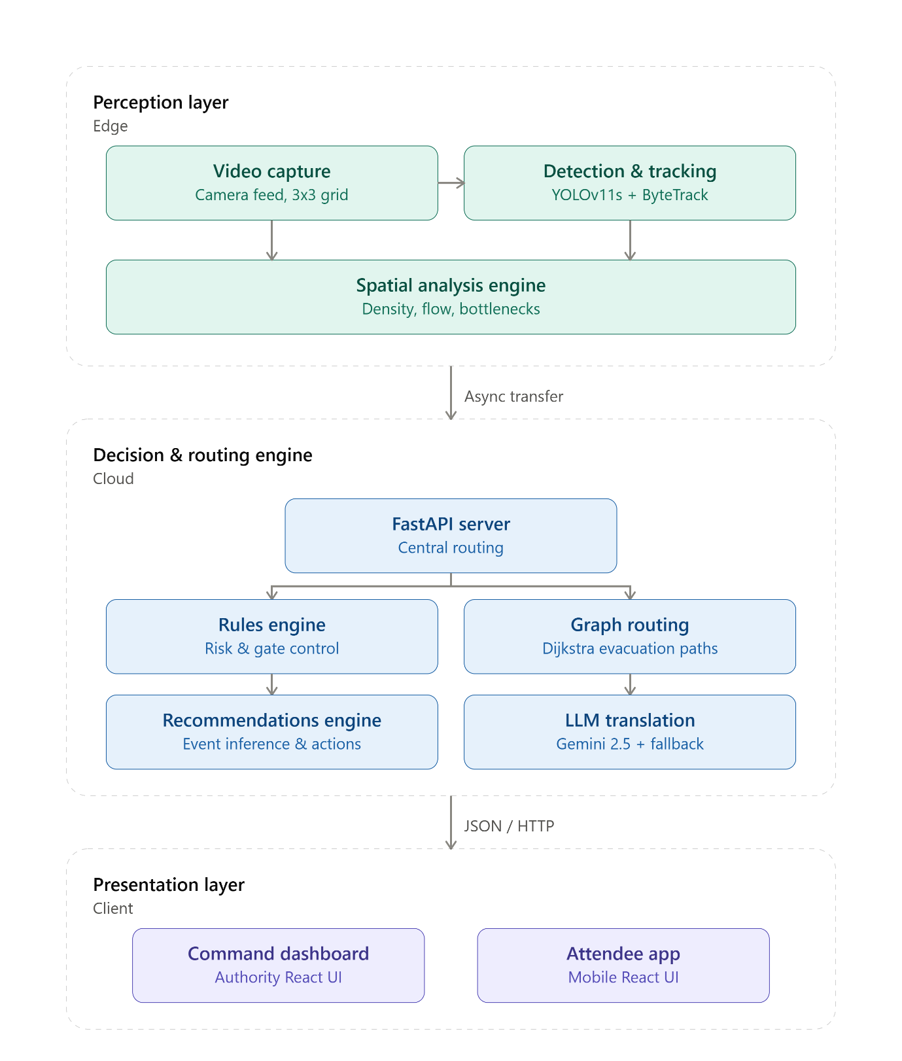
2.2 Module 1: Perception Engine Breakdown
The Perception Engine is the sensory layer of CrowdShield, converting live CCTV footage into structured, real-time crowd intelligence. It uses a dual-pipeline architecture to separate real-time monitoring from detailed telemetry and analysis.
Frame Ingestion & Spatial Partitioning The CCTV stream is processed frame-by-frame using OpenCV. The camera view is divided into a 3 × 3 grid of nine monitoring zones, allowing crowd conditions to be analyzed spatially rather than as a single global measurement.
Person Detection & Tracking YOLO11s detects people in each frame, while ByteTrack assigns persistent IDs to track individual movement across consecutive frames. These trajectories provide the basis for analyzing crowd flow and movement behavior.
Crowd Dynamics Analysis For every zone, the engine calculates key crowd metrics:
- Density & Trend: Measures localized crowd concentration and its rate of change.
- Velocity & Flow: Determines average movement speed and dominant movement direction.
- Inflow / Outflow: Tracks people entering and leaving each zone to identify accumulation.
- Flow Entropy: Measures directional variation to detect chaotic or disorganized movement.
- Bottleneck Detection: Identifies conditions where high density, low speed, and positive inflow indicate potential congestion.
Vision-Based Risk Mapping The combined metrics are used to assign each zone a risk level from 0–4, creating a localized representation of crowd safety conditions and highlighting emerging hotspots.
Dual-Pipeline Architecture The module separates processing into two complementary pipelines:
- Operational Pipeline: Maintains real-time metrics in memory and generates a lightweight JSON state for the backend and authority dashboard.
- Telemetry Pipeline: Records detailed zone features and risk events into structured CSV files for post-event analysis, debugging, threshold tuning, and system validation.
Overall, Module 1 converts raw CCTV footage into actionable, zone-level crowd intelligence, providing the essential perception layer for CrowdShield's downstream decision-making and emergency response systems.
2.3 Module 2: Decision Engine Breakdown
The Decision Engine acts as the intelligence and response layer of CrowdShield, transforming the risk information generated by the Perception Engine into structured, deterministic safety actions. It evaluates sustained crowd conditions, manages venue resources, computes safer evacuation routes, and generates appropriate emergency communications.
Zone Risk Aggregation The risk metrics received from the Perception Engine are consolidated into a structured zone-to-risk representation, providing the Decision Engine with a clear view of the current safety state across the venue.
Stateful Gate & Staff Management The engine evaluates risk across multiple consecutive frames to prevent false positives caused by temporary fluctuations. When a gate zone maintains critical risk, a closure can be recommended. Safety constraints also ensure that enough entry points remain operational, while security staff deployment is calculated proportionally to crowd demand and capped at the available 30-person staff pool.
Risk-Weighted Evacuation Routing The venue is represented as a directed NetworkX graph, with zones and connections forming the evacuation topology. Dijkstra's algorithm is enhanced with exponential risk penalties for dangerous nodes, particularly zones with high risk, causing evacuation routes to dynamically prioritize safer paths and steer crowds away from bottlenecks.
Event Inference & Hysteresis The engine translates combinations of risk conditions into meaningful event states such as SUDDEN_SURGE, BOTTLENECK_WARNING, and GENERAL_EVACUATION. A 15-second state cooldown prevents rapid state switching and UI flickering during short-term metric fluctuations.
Structured Emergency Communication Approved emergency messages are passed to Google Gemini 2.5 Flash using strict Pydantic response schemas, ensuring type-safe and consistently structured announcements. If the LLM service fails or times out, the system automatically falls back to predefined multilingual templates in English, Hindi, Odia, and Bengali.
Reliable & Resilient Architecture The Decision Engine uses strict contracts, graceful degradation, hysteresis, proportional resource allocation, and non-blocking APIs to keep safety decisions consistent and responsive during sensor or service failures.
Overall, Module 2 converts raw risk intelligence into coordinated safety actions, forming the decision-making bridge between CrowdShield's perception layer and its authority dashboard, mobile application, and emergency response mechanisms.
3. Technical Choices & Third-Party APIs
3.1 Perception Stack: Real-Time Vision Processing
To enable real-time crowd analytics, the perception layer uses lightweight, efficient video-processing components:
- YOLOv11s (PyTorch): Provides fast and accurate person detection with low inference latency, making it suitable for cloud CPU environments.
- ByteTrack: Enables lightweight multi-object tracking by maintaining persistent IDs across frames, allowing extraction of speed, direction, and trajectory data with minimal overhead.
- OpenCV-Headless: Handles fast frame extraction, video decoding, and spatial zone partitioning in headless cloud environments.
3.2 Backend & Routing: Non-Blocking State Management
- FastAPI: Provides an asynchronous backend architecture, running continuous YOLO/OpenCV processing in the background while keeping /state, /notify, and /safety-check endpoints responsive for multiple clients.
- NetworkX (Graph Routing): Models the venue as a directed graph and uses Dijkstra’s algorithm with congestion-based penalty weights to dynamically route evacuation paths around high-risk zones.
3.3 External APIs: Deterministic Multilingual Communication
- Google Gemini API (Gemini 2.5 Flash): Dynamically translates evacuation instructions into regional languages such as Hindi, Odia, and Bengali.
- Schema-Enforced Execution: Uses strict Pydantic schemas and temperature 0.0 to ensure consistent, safe, and controlled outputs.
- Graceful Degradation: If the API is unavailable, pre-vetted local templates automatically generate messages using runtime variables, ensuring uninterrupted emergency communication.
3.4 Deployment: Decoupled Monorepo Architecture
- Render (Backend API): Hosts the Dockerized FastAPI and PyTorch backend, with required Linux dependencies such as OpenCV and FFmpeg configured through a custom Dockerfile.
- Vercel (Frontend UIs): Hosts the Authority Dashboard and Attendee Mobile App built with React and Vite, using VITE_API_BASE_URL to connect dynamically to the live backend without hardcoded addresses.
4. Human-Centered UX/UI Design Philosophy
Emergency systems often fail due to information overload or panic inducement. CrowdShield implements a deliberate, role-specific user experience philosophy across both user interfaces:
1. Authority Command Dashboard: Cognitive Load Reduction
- Heatmap-Centric Design: Keeps the live 9-zone density heatmap central, with secondary metrics and controls accessible but unobtrusive.
- Clear Visual Hierarchy: Color-coded risk levels (0–4) enable rapid assessment, while logs and manual controls remain available when needed.
2. Attendee Mobile App: Panic Prevention & Utility
- Anti-Panic Design: Hides technical risk metrics and presents information in a calm, user-friendly manner.
- Contextual Map: Shows the user's location, key points of interest, and evacuation routes.
- Utility-First Features: Provides nearby POI discovery, hazard/lost-person reporting, and calm multilingual guidance for safer movement.
5. Constraint Mitigation & System Resilience
CrowdShield is designed to remain reliable, cost-effective, and practical under real-world event constraints.
- Limited Infrastructure: Dynamically switches between GPU and CPU execution, using lightweight YOLOv11s and ByteTrack for efficient processing on constrained hardware.
- Low-Cost Deployment: Uses open-source vision frameworks and cost-effective cloud hosting, with lightweight frontends deployed separately from the backend.
- Network Outages: Uses local, pre-vetted translation templates as a fallback when the Gemini API is unavailable, ensuring uninterrupted safety communication.
- High Scalability: Runs video processing in a background thread, keeping the FastAPI server responsive to concurrent dashboard and mobile-app requests.
- Data Privacy: Processes video in memory without storing raw footage or capturing facial/PII data, extracting only anonymous crowd telemetry.
- Real-Time Performance: Lightweight tracking and graph-based routing enable low-latency crowd analysis and evacuation path calculation.
- False Alarm Reduction: Stateful hysteresis and a 15-second cooldown prevent alerts from fluctuating due to temporary crowd spikes or occlusions.
- Ease of Use: The authority dashboard uses a heatmap-centric interface and 0–5 risk scale, enabling rapid decisions without requiring extensive training.

