DATA TRANSFORMER SYSTEM
Comprehensive Database Case Study & Operational Analytics Report
Student Name: VAIBHAVI SONIGRA
Course / Subject: Data Analysis & Management
Database Platform: MySQL Engine (via phpMyAdmin)

1.Database Setup & Initialization

CREATE DATABASE `data transformer`;
USE `data transformer`;
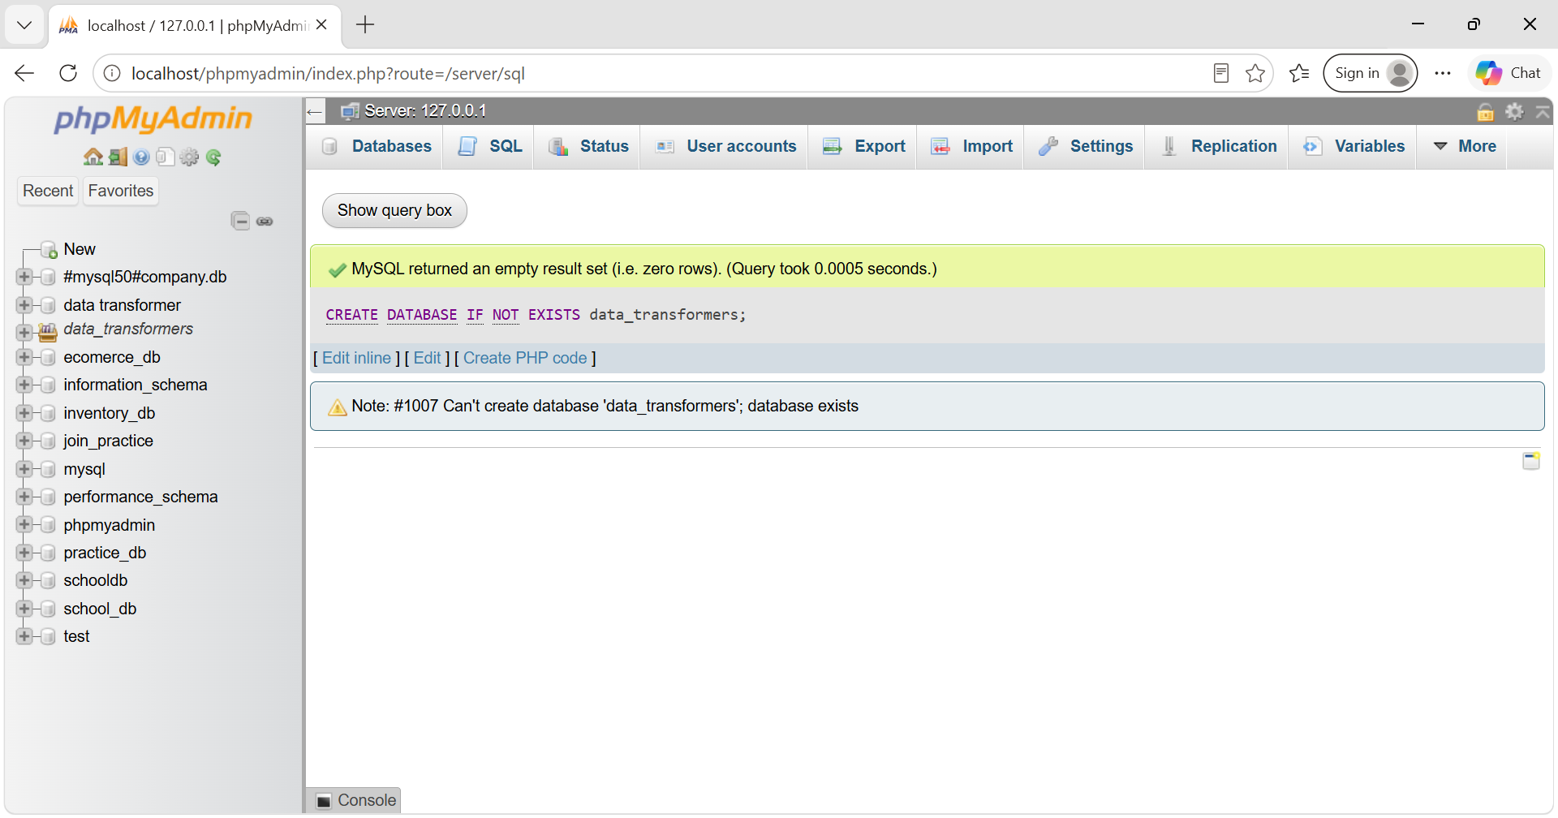

2. Component Schema Architecture & DDL Definitions
2.1 Customers Table
CREATE TABLE Customers (
CustomerID INT PRIMARY KEY,
FirstName VARCHAR(50),
LastName VARCHAR(50),
Email VARCHAR(100),
RegistrationDate DATE
);
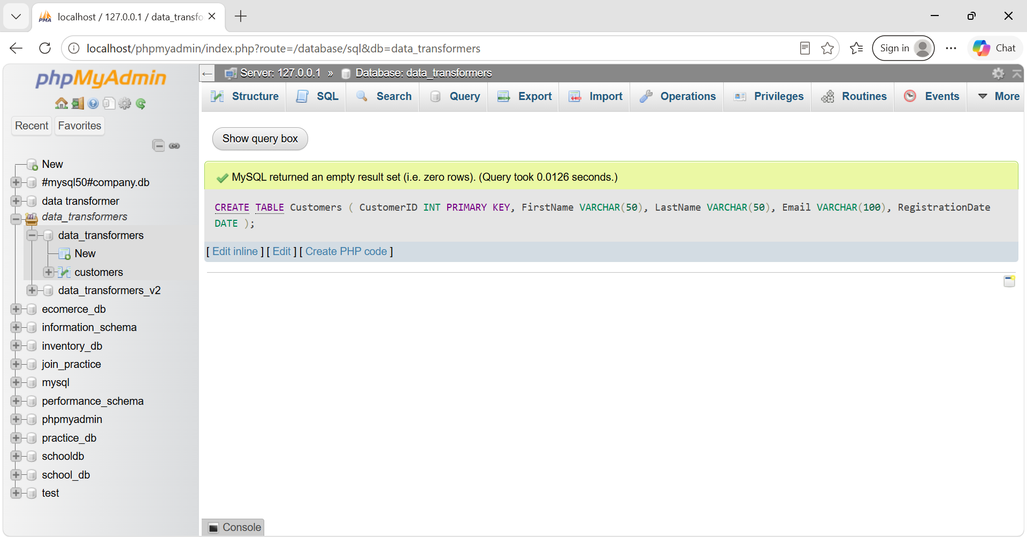

2.2 Orders Table
CREATE TABLE Orders (
OrderID INT PRIMARY KEY,
CustomerID INT,
OrderDate DATE,
TotalAmount DECIMAL(10, 2),
FOREIGN KEY (CustomerID) REFERENCES Customers(CustomerID)
);
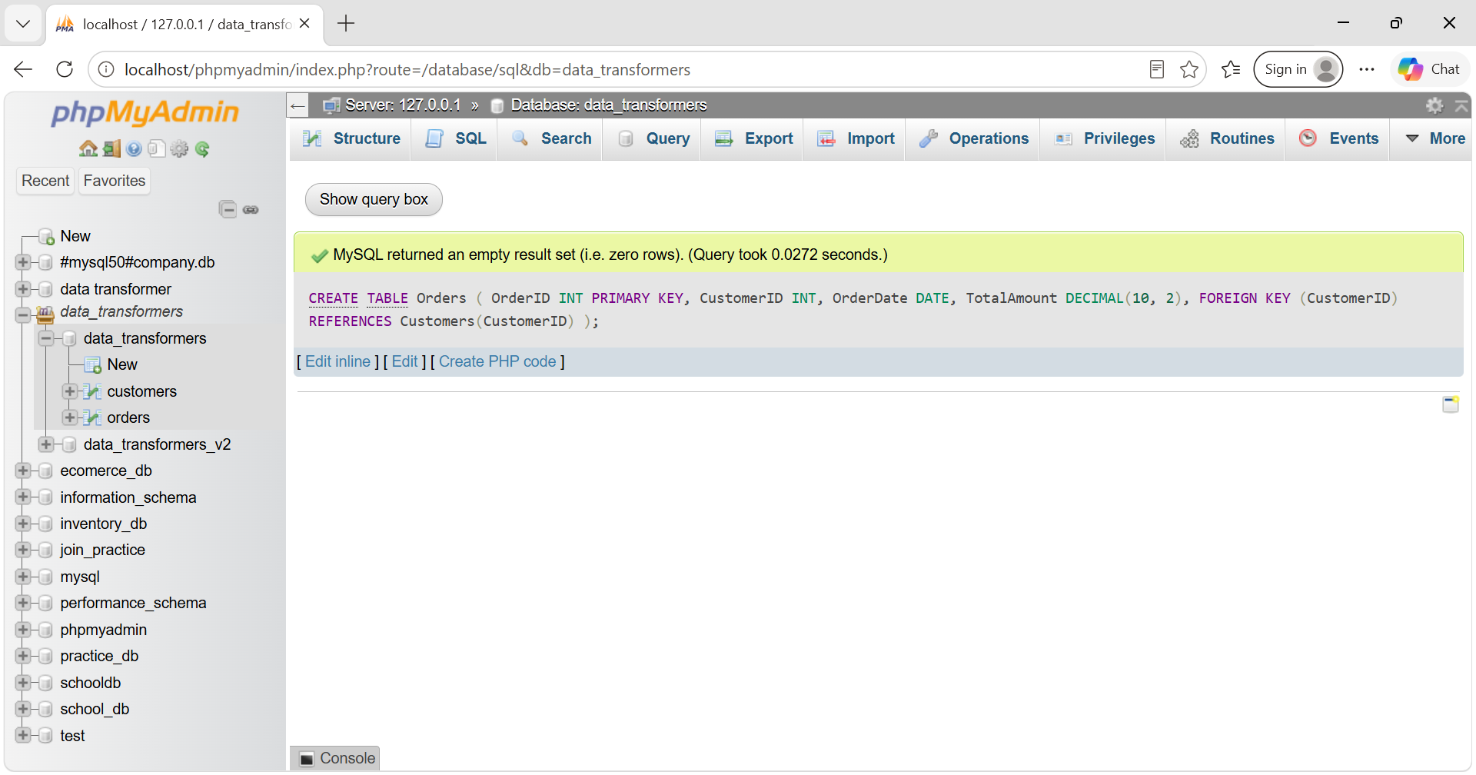

2.3 Employees Table
CREATE TABLE Employees (
EmployeeID INT PRIMARY KEY,
FirstName VARCHAR(50),
LastName VARCHAR(50),
Department VARCHAR(50),
HireDate DATE,
Salary DECIMAL(10, 2)
);
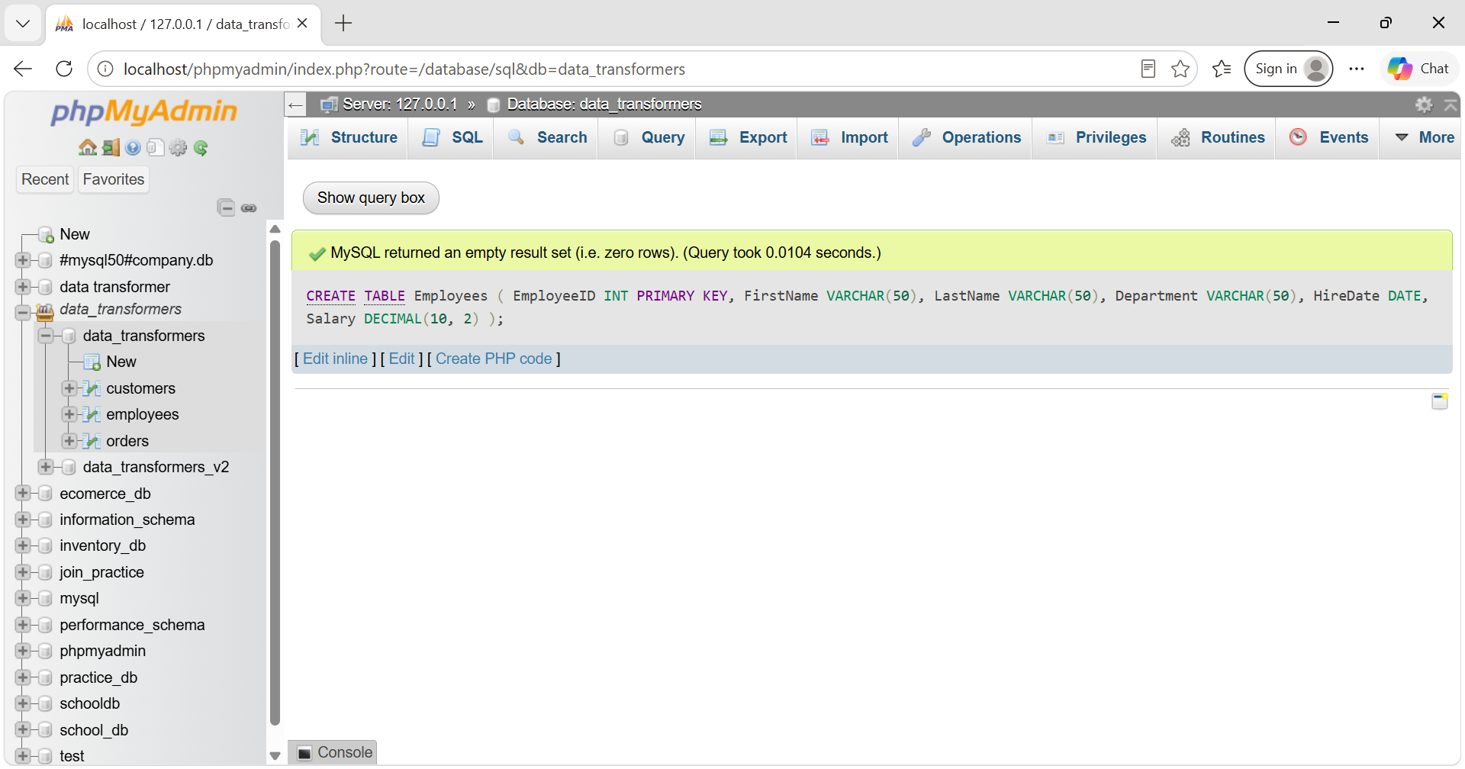

3. Mock Data Seeding & Records Population
3.1 Seeding Customers Data
INSERT INTO Customers (CustomerID, FirstName, LastName, Email, RegistrationDate) VALUES
(1, 'John', 'Doe', 'john.doe@email.com', '2022-03-15'),
(2, 'Jane', 'Smith', 'jane.smith@email.com', '2021-11-02')
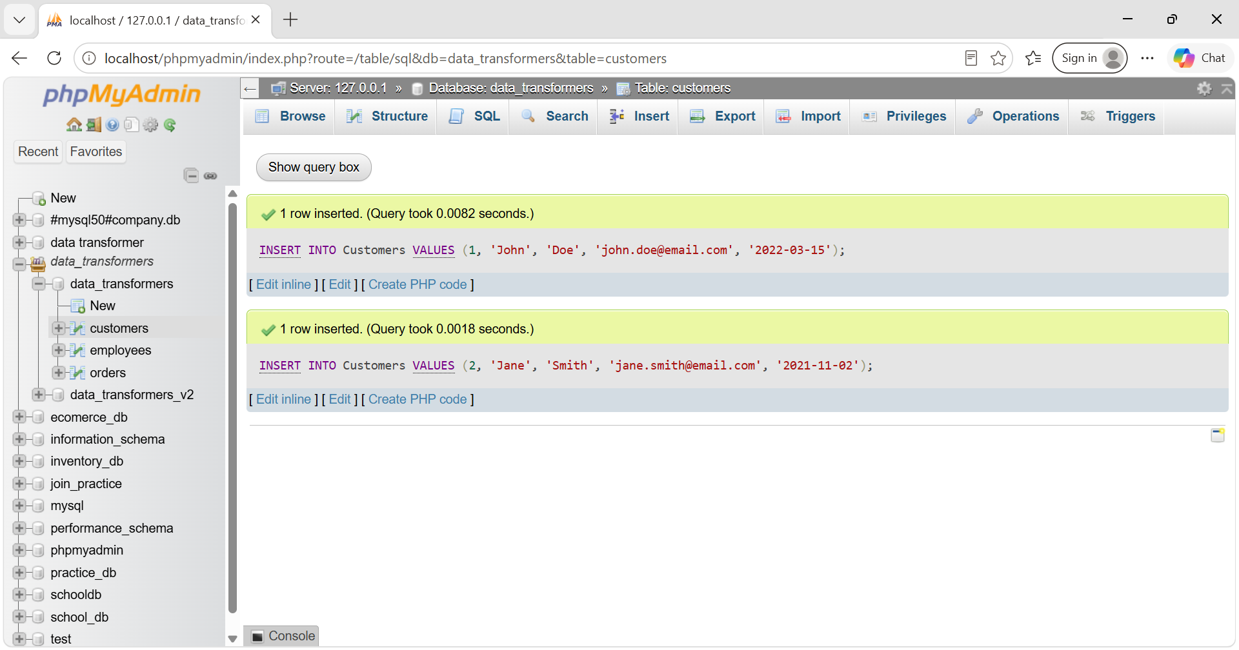

3.2 Seeding Orders Data
INSERT INTO Orders (OrderID, CustomerID, OrderDate, TotalAmount) VALUES
(101, 1, '2023-07-01', 150.50),
(102, 2, '2023-07-03', 200.75);
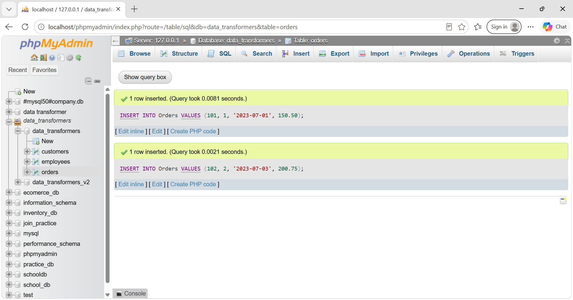

3.3 Seeding Employees Data
INSERT INTO Employees (EmployeeID, FirstName, LastName, Department, HireDate, Salary) VALUES
(1, 'Mark', 'Johnson', 'Sales', '2020-01-15', 50000.00),
(2, 'Susan', 'Lee', 'HR', '2021-03-20', 55000.00);
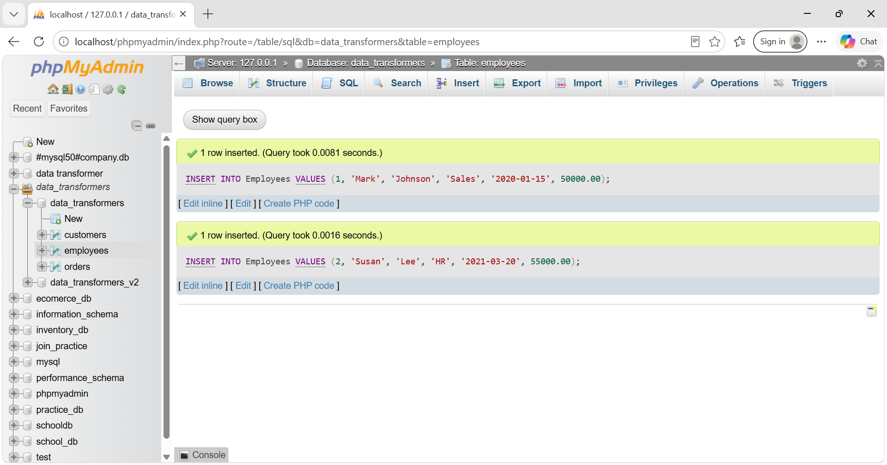

4. System Operational System Analytical Reporting (1-17)

Task 1: INNER JOIN Matrix Evaluation

SELECT * FROM Orders
INNER JOIN Customers ON Orders.CustomerID = Customers.CustomerID;
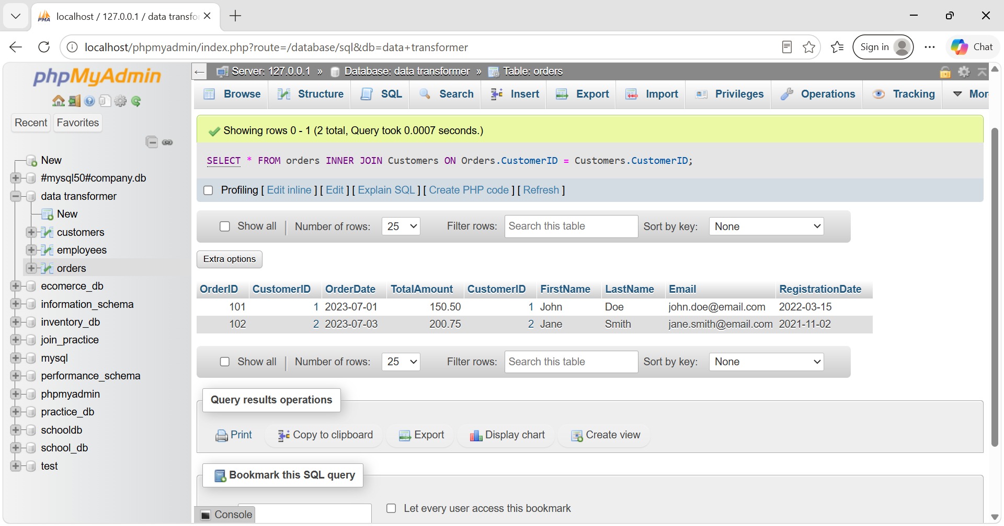

Task 2: LEFT OUTER JOIN Extraction

SELECT * FROM Customers
LEFT JOIN Orders ON Customers.CustomerID = Orders.CustomerID;
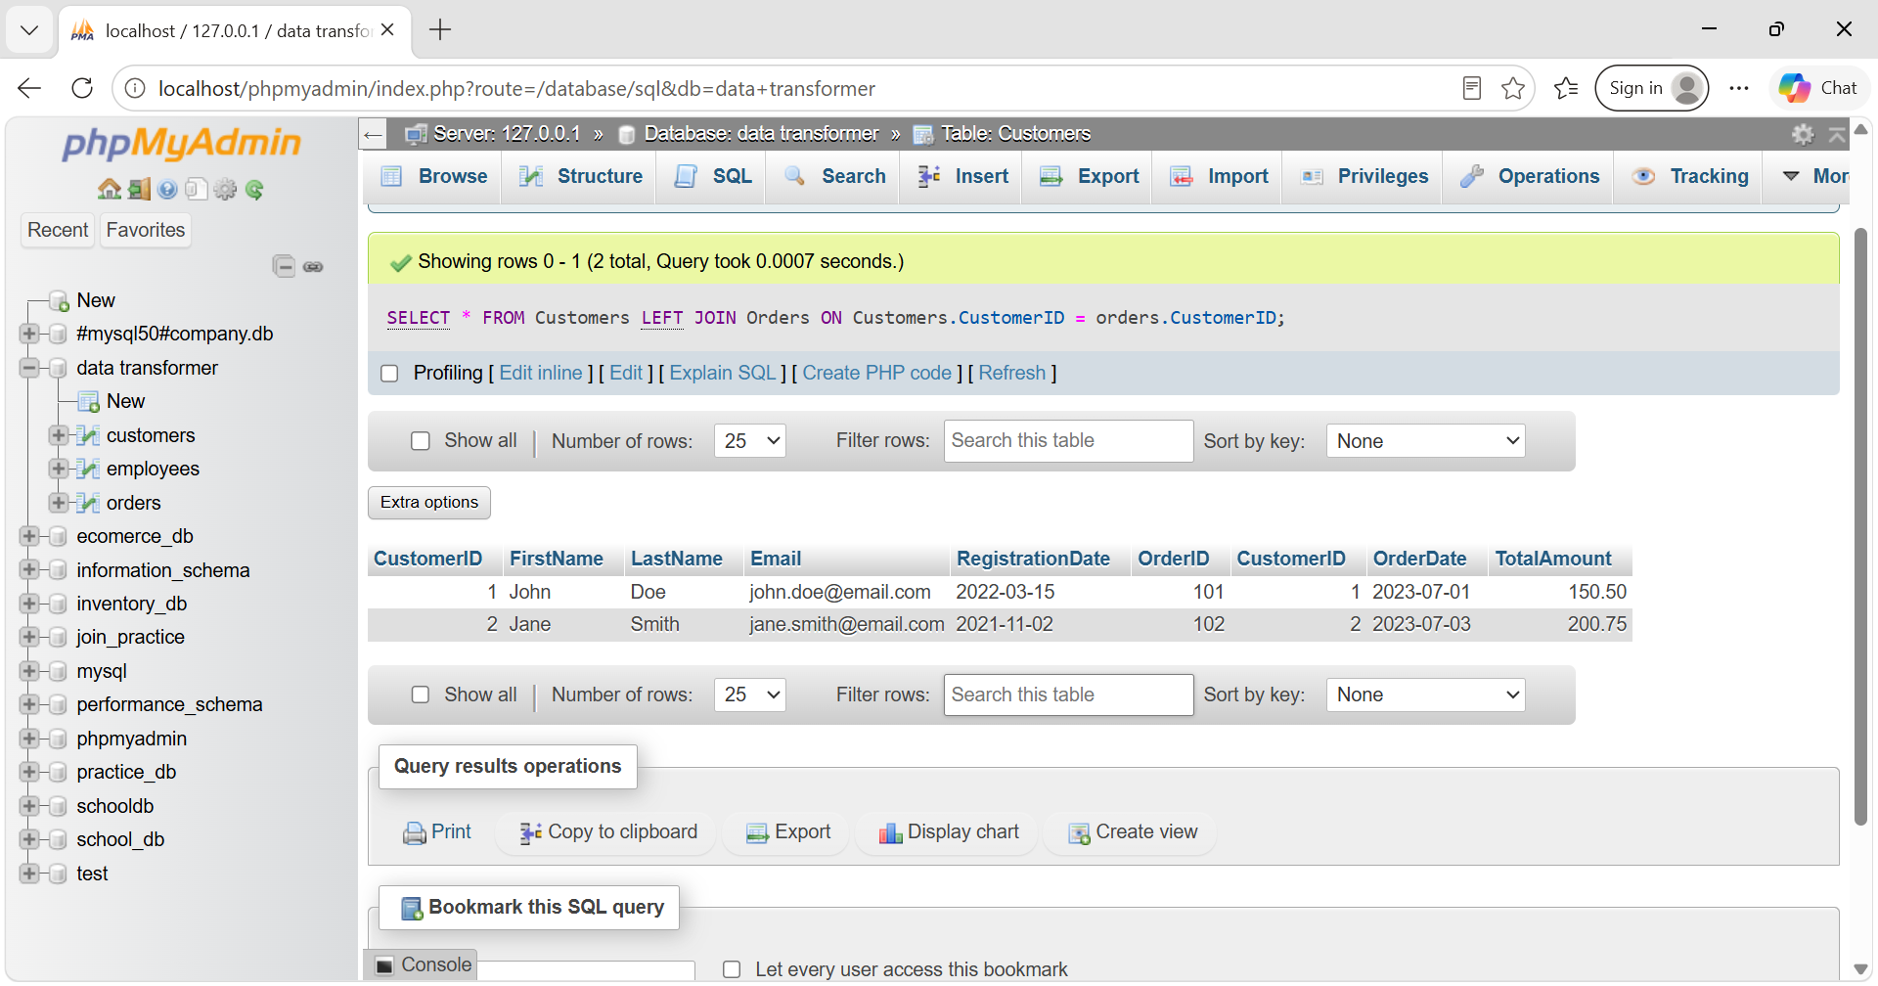

Task 3: RIGHT OUTER JOIN Register

SELECT * FROM Customers
RIGHT JOIN Orders ON Customers.CustomerID = Orders.CustomerID;
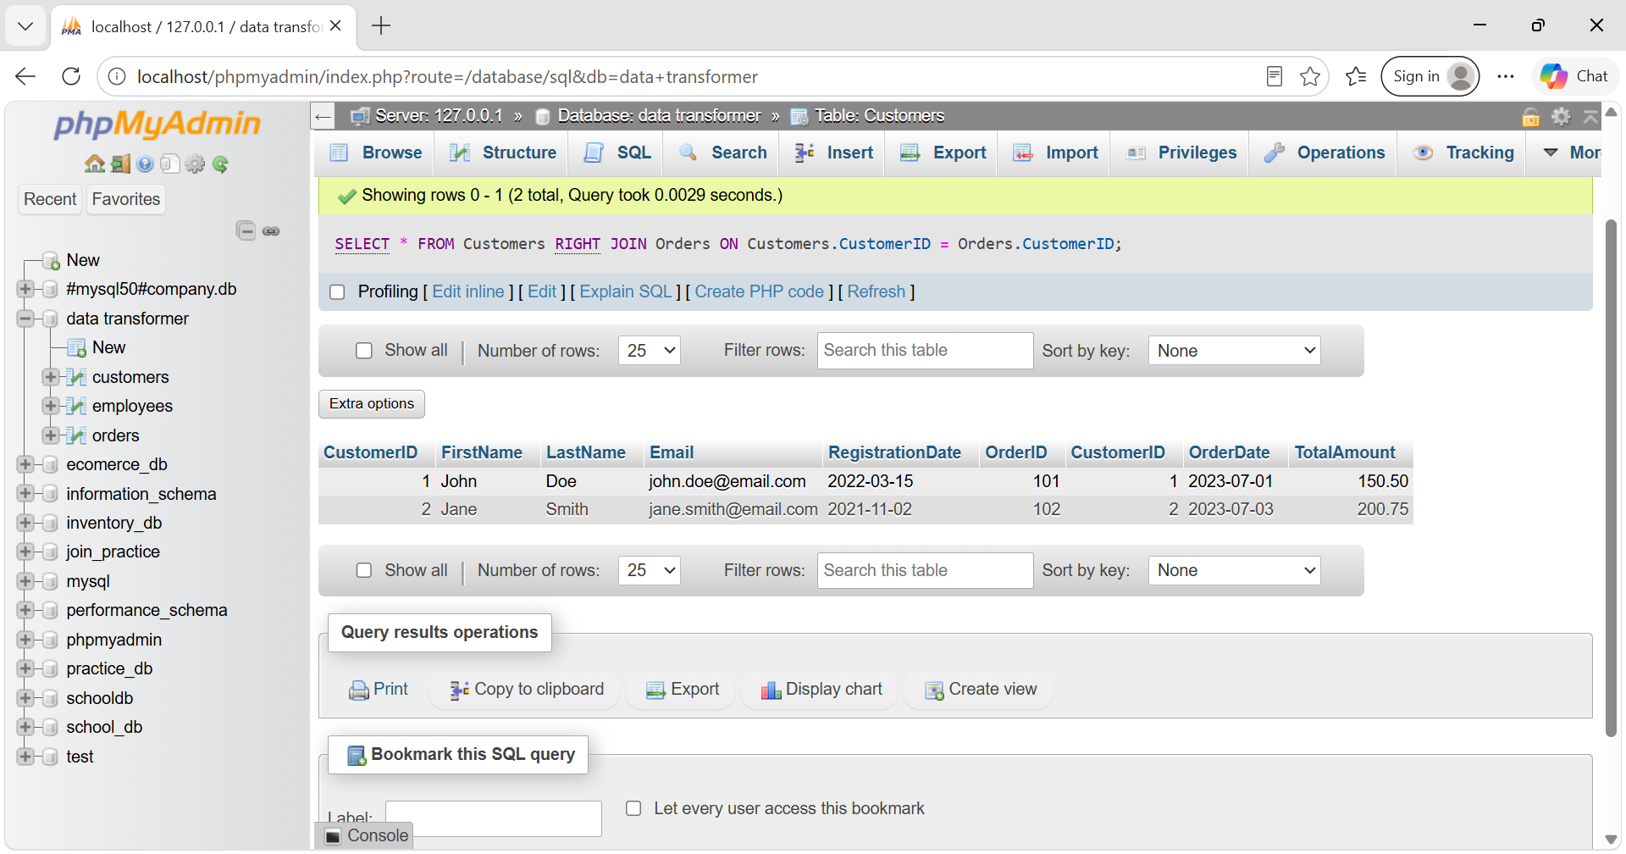

Task 4: FULL OUTER JOIN Emulation

SELECT * FROM Customers LEFT JOIN Orders ON Customers.CustomerID = Orders.CustomerID
UNION
SELECT * FROM Customers RIGHT JOIN Orders ON Customers.CustomerID = Orders.CustomerID;
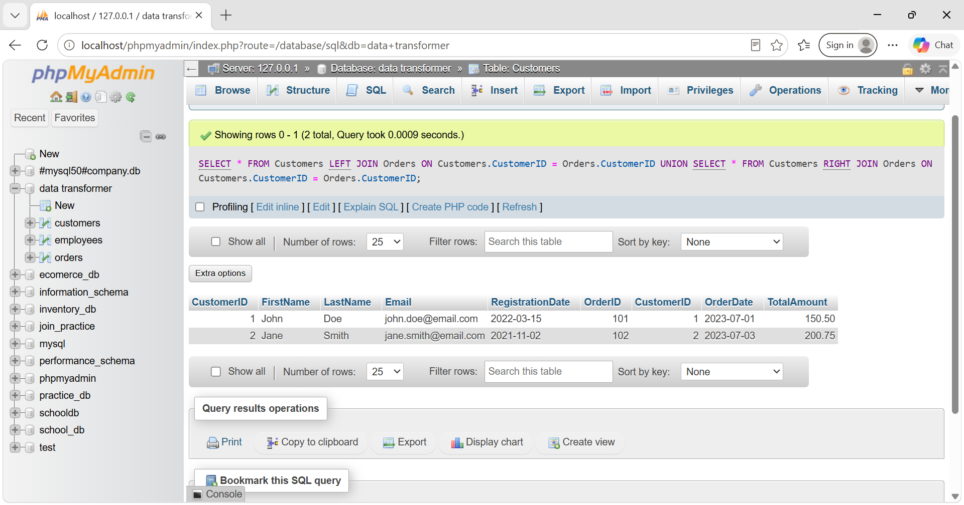

Task 5: Subquery Optimization (Premium Customer Filter)

SELECT * FROM Customers
WHERE CustomerID IN (
SELECT CustomerID FROM Orders
WHERE TotalAmount > (SELECT AVG(TotalAmount) FROM Orders)
);
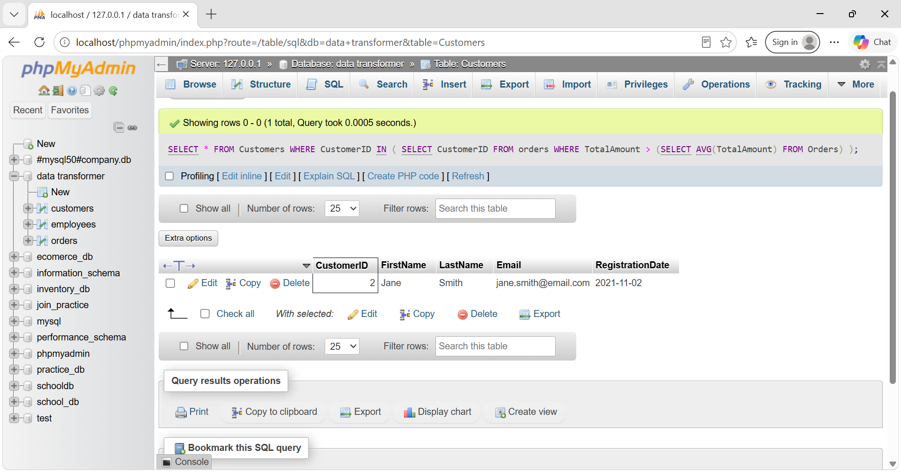

Task 6: Subquery Compensation (Elite Workforce Cluster)

SELECT * FROM Employees
WHERE Salary > (SELECT AVG(Salary) FROM Employees);
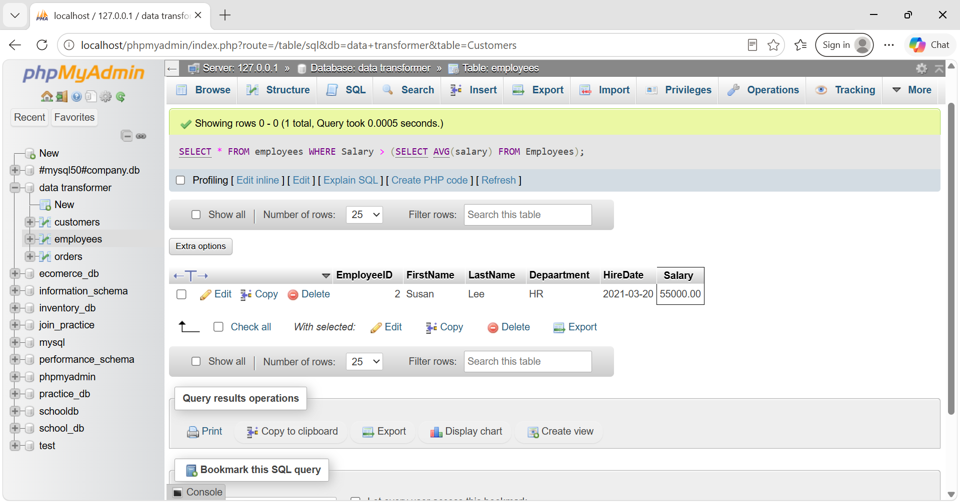

Task 7: Chronological Date Vectors (Year/Month Segments)

SELECT OrderID, YEAR(OrderDate) AS OrderYear, MONTH(OrderDate) AS OrderMonth FROM Orders;
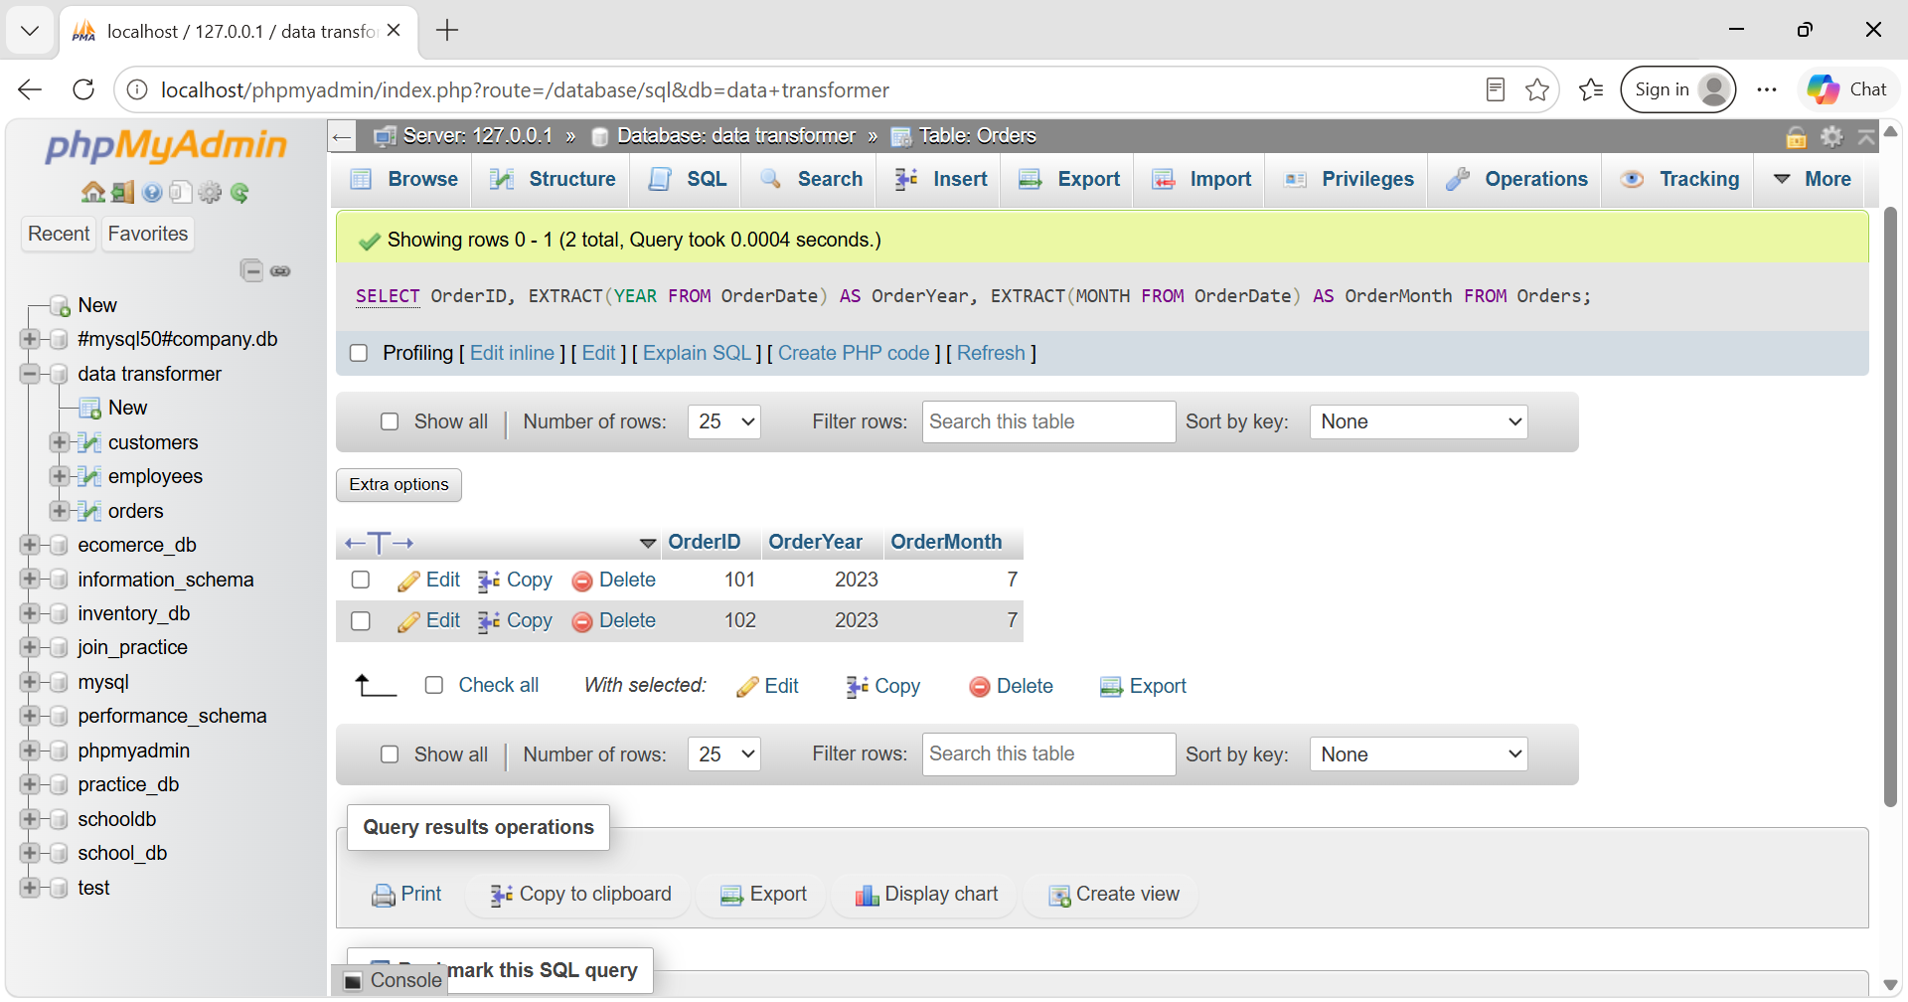

Task 8: Customer Portfolio Lifecycle (Date Difference Calculation)

SELECT OrderID, OrderDate, CURDATE(), DATEDIFF(CURDATE(), OrderDate) AS DaysDifference FROM Orders;
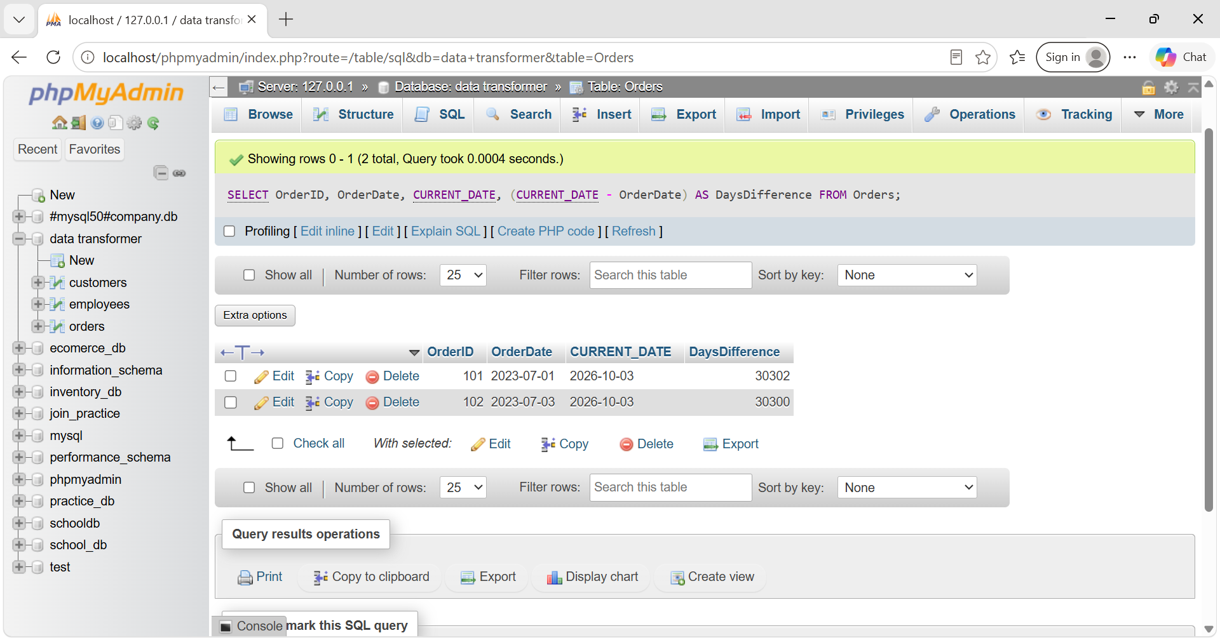

Task 9: Dynamic Executive Presentation Reporting (Date Format)

SELECT OrderID, DATE_FORMAT(OrderDate, '%d-%m-%Y') AS FormattedOrderDate FROM Orders;
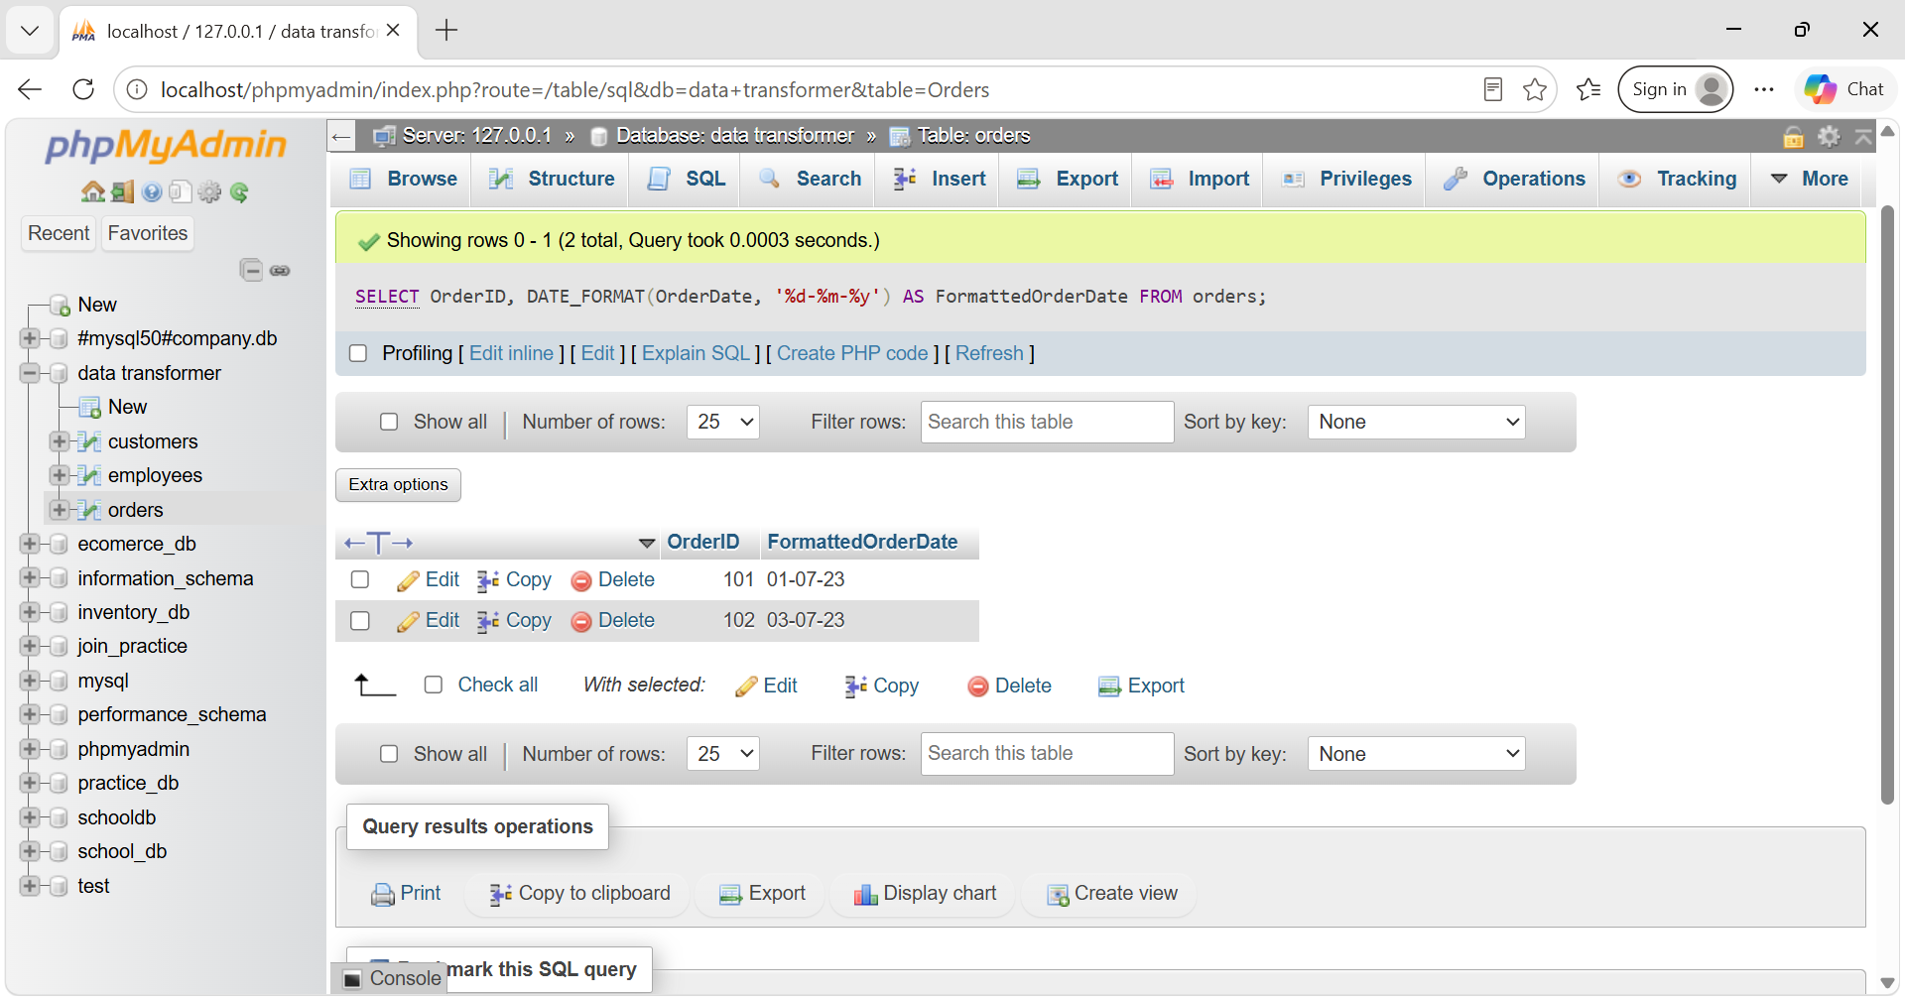

Task 10: Structural Identity Assembly (String Concatenation)

SELECT CustomerID, CONCAT(FirstName, ' ', LastName) AS FullName FROM Customers;
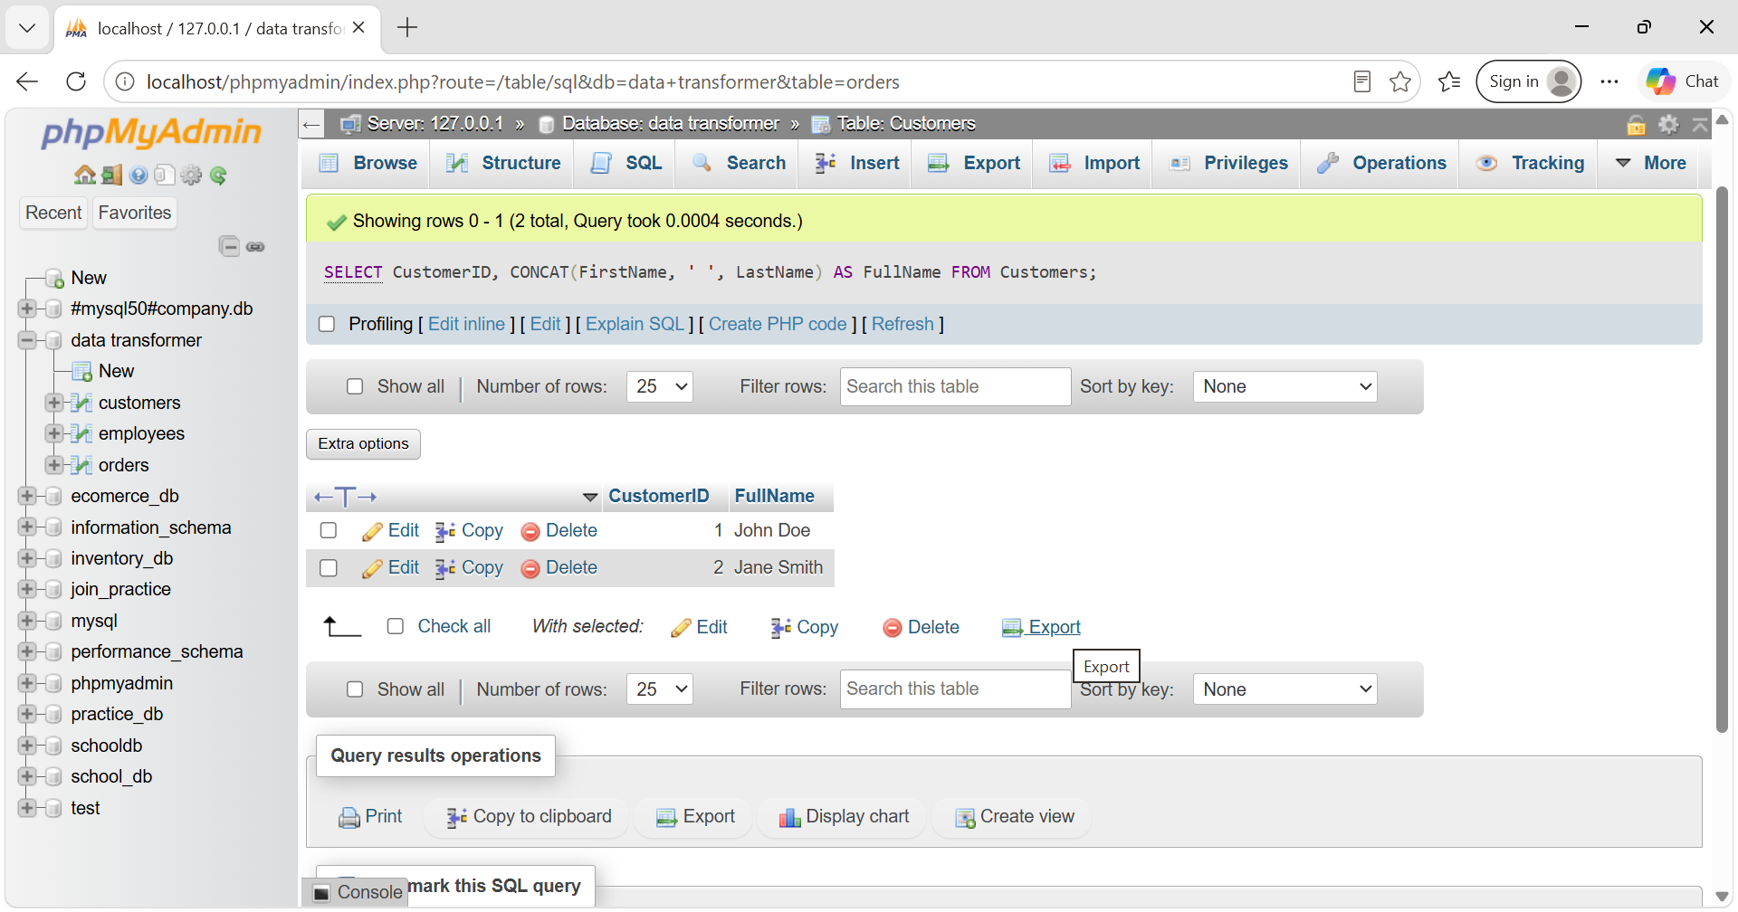

Task 11: Dynamic System Vector Modification (String Replacement)

SELECT EmployeeID, REPLACE(FirstName, 'Mark', 'Jonathan') AS NewFirstName, LastName FROM Employees;

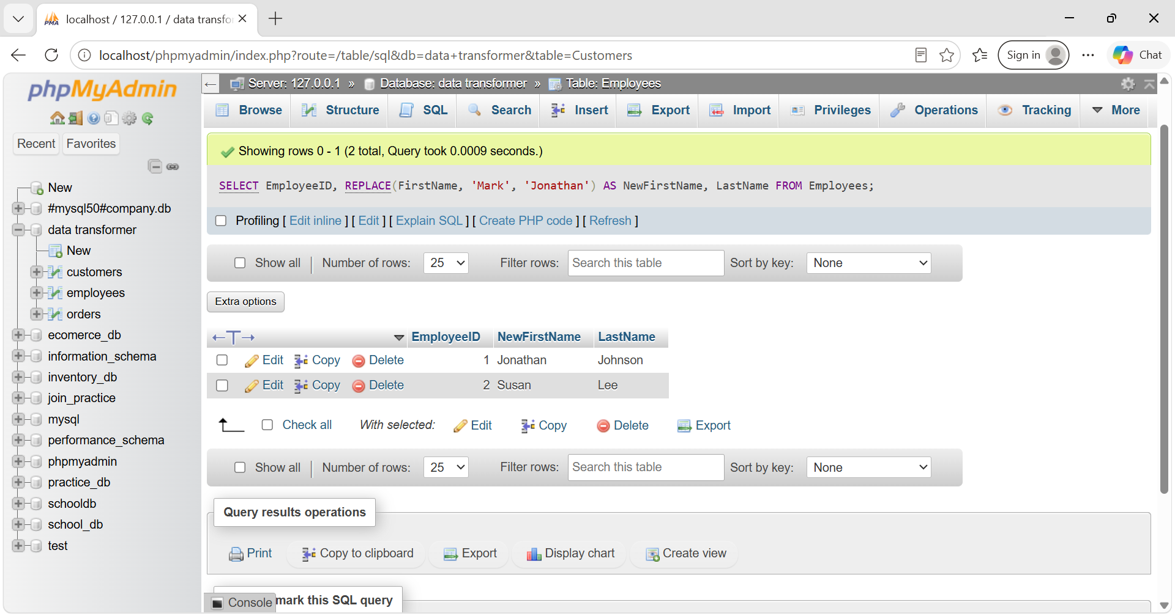

Task 12: Structural Typographical Standardization

SELECT EmployeeID, UPPER(FirstName) AS UpperFirstName, LOWER(LastName) AS LowerLastName FROM Employees;
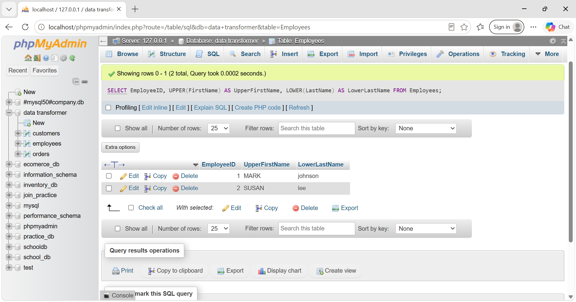

Task 13: Data Cleaning Execution (Whitespace Trimming)

SELECT CustomerID, TRIM(Email) AS CleanedEmail FROM Customers;

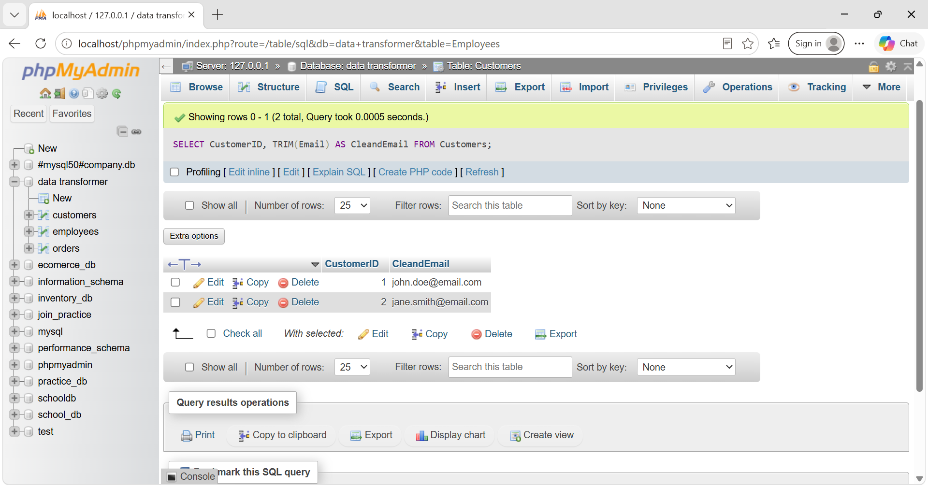

Task 14: Revenue Growth Trajectory Modeling (Running Total)

SELECT OrderID, CustomerID, OrderDate, TotalAmount,
SUM(TotalAmount) OVER(ORDER BY OrderDate) AS RunningTotal
FROM Orders;
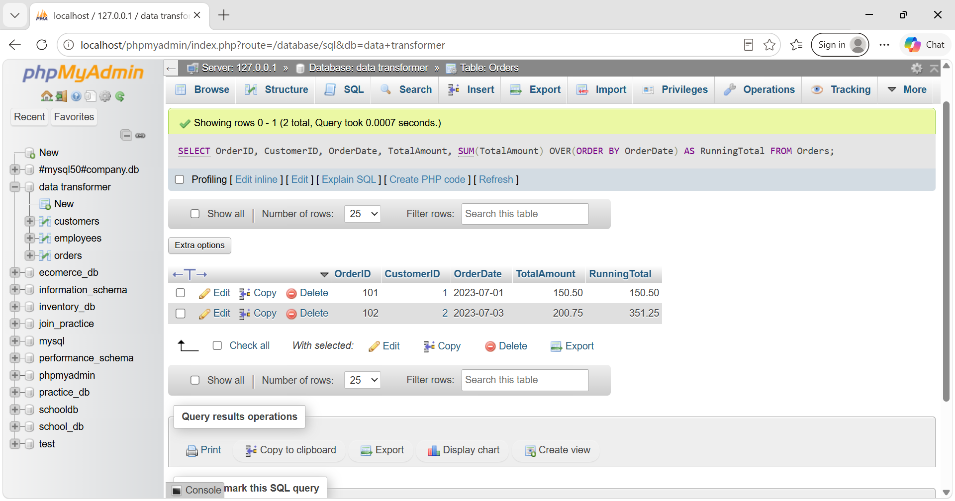

Task 15: Volumetric Rank Indexing Optimization (RANK Function)
Objective: Evaluate top-tier financial ledger logs using proper structural ranking blocks.
SELECT OrderID, CustomerID, TotalAmount,
RANK() OVER(ORDER BY TotalAmount DESC) AS OrderRank
FROM Orders;
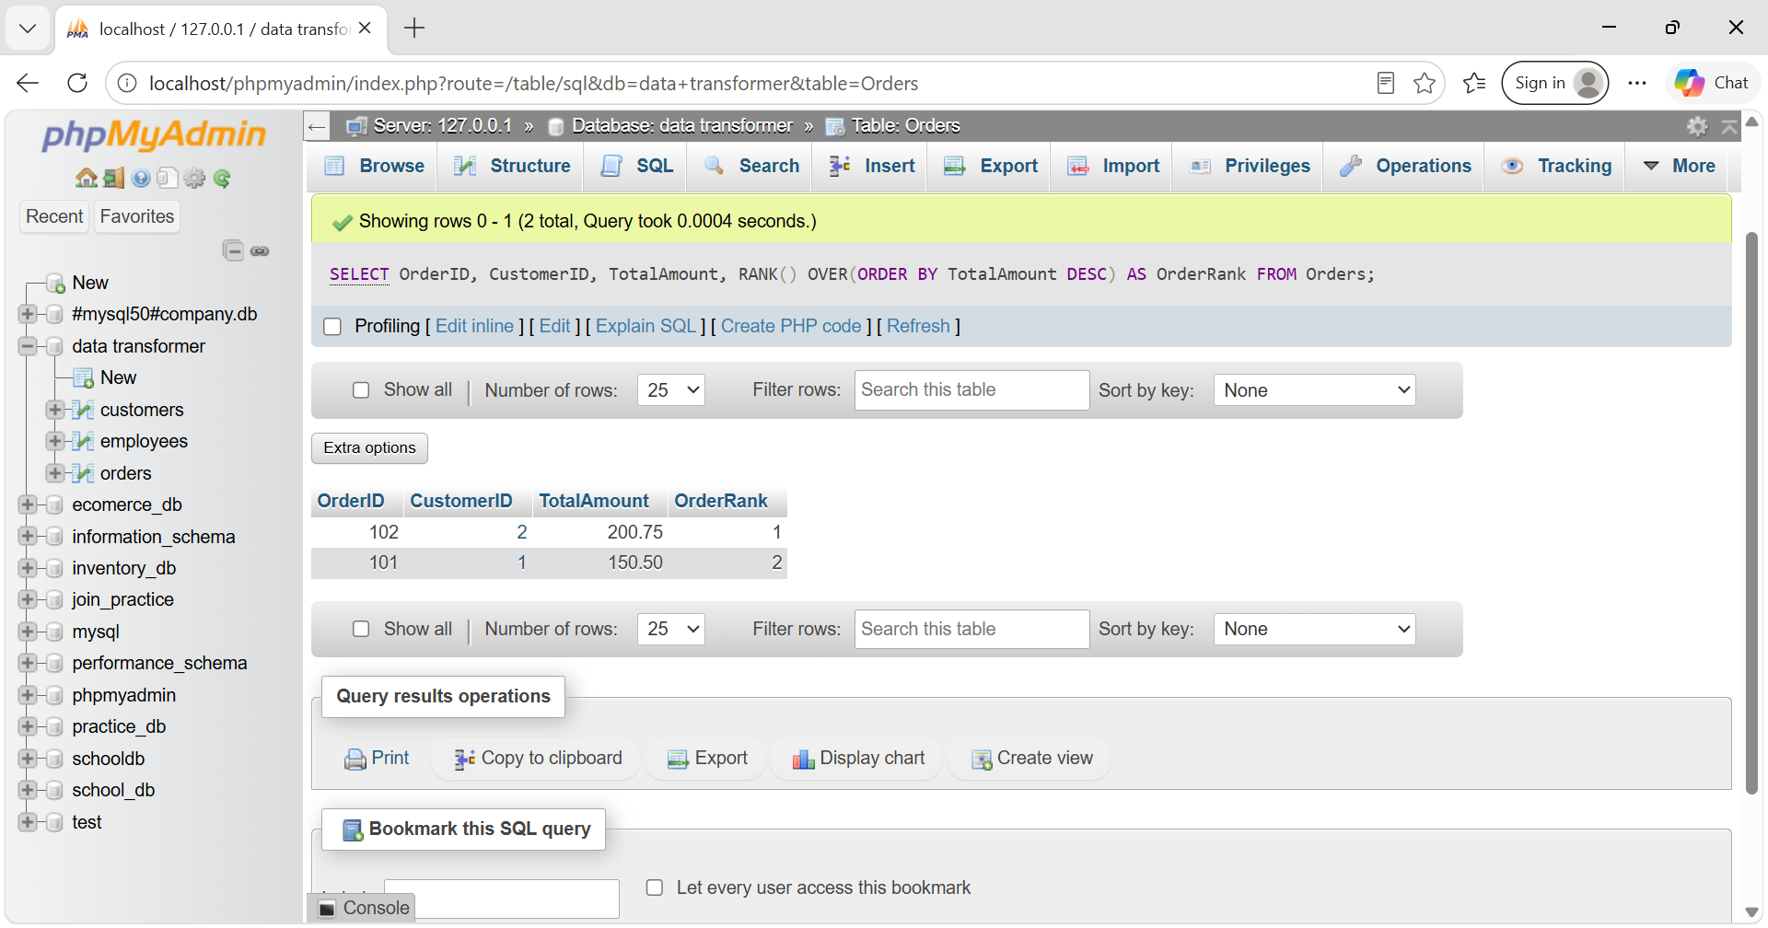

Task 16: Conditional Discount Optimization (Control Flow CASE)

SELECT OrderID, TotalAmount,
CASE
WHEN TotalAmount > 1000 THEN '10% Off'
WHEN TotalAmount > 500 THEN '5% Off'
ELSE 'No Discount'
END AS DiscountApplied
FROM Orders;
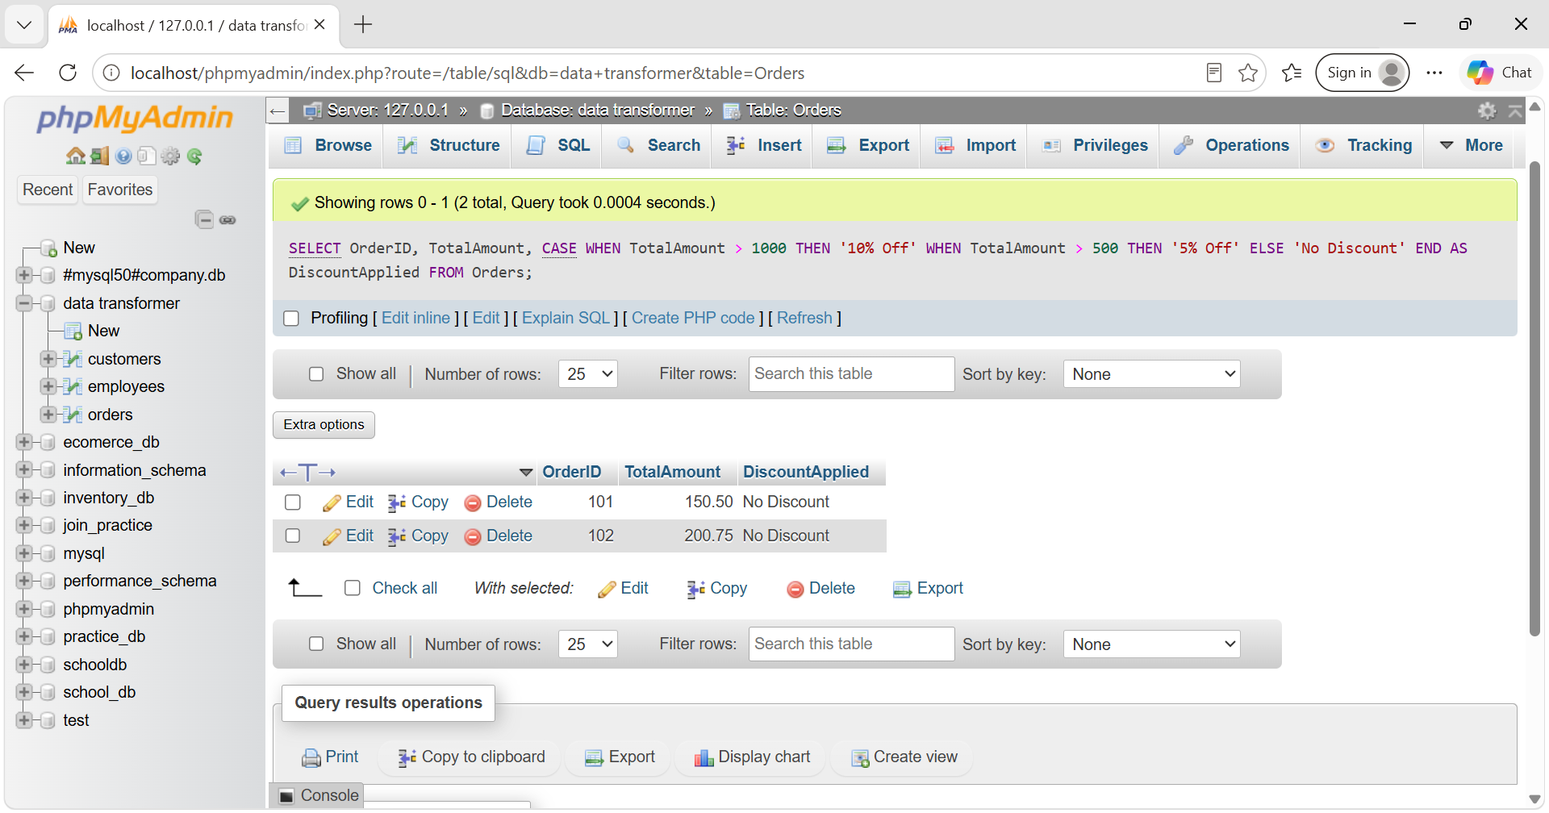

Task 17: Employee Salary Compensation Bracket Matrix (CASE Logic)

SELECT EmployeeID, FirstName, LastName, Salary,
CASE
WHEN Salary > 60000 THEN 'High'
WHEN Salary BETWEEN 40000 AND 60000 THEN 'Medium'
ELSE 'Low'
END AS SalaryCategory
FROM Employees;
