Week 3 Task: Dynamic Data
Visualization and Dashboard Development

Dashboard Design Process, Excel Features and Interactive Decision-Making
Conceptual Sketches Included

Submitted for: Yuva Intern – Data Analytics Internship
Week 3 Deliverable | DOC Report

This report provides a detailed account of designing a dynamic, interactive Excel dashboard using PivotTables, Slicers, Charts and Conditional Formatting to communicate historical trends and current KPIs.

Table of Contents
1. Executive Summary
2. Purpose of Dashboard and Business Scenario
3. Data Sources and Data Types
4. Dashboard Design Principles
5. Conceptual Sketch and Wireframe
6. Excel Features Used – Detailed Descriptions
7. Step-by-Step Dashboard Creation Guide
8. How Dashboard Facilitates Decision Making
9. Alternative Visualizations Considered
10. Limitations and Future Improvements
11. Best Practices Followed
12. Conclusion
13. Appendix A – KPI Definitions
14. Appendix B – Color and Layout Standards

1. Executive Summary
Week 3 moves from formula execution to communication. While Week 2 built complex formulas to calculate net revenue, tiered discounts, and performance ratings, Week 3 focuses on summarizing and visualizing that logic through an advanced Excel dashboard.
This report documents the design of the FreshKart Executive Dashboard – a single-screen, interactive overview for Q3 2026 that consolidates 15,000 simulated transactions into 4 KPI cards, 4 visualizations, and a detailed PivotTable. Built entirely with native Excel features (PivotTables, PivotCharts, Slicers, Timelines, Conditional Formatting), the dashboard answers both historical trend questions (How did revenue evolve July-September?) and current performance questions (Which region is below target today?).
Key design choices include: Slicers for Region/Category instead of manual filters, Timeline for month selection, Combo Line + Column for trend vs target, and Data Bars/ Icon Sets for at-a-glance variance. The document provides conceptual wireframes, a 14-step build guide, justification for visualization choices, and a critical discussion of limitations and future enhancements with Power BI integration.

2. Purpose of Dashboard and Business Scenario

2.1 Purpose
The purpose is to replace static weekly PPT summaries with a dynamic, self-service dashboard that enables non-technical store managers to explore data without breaking formulas. The dashboard must be printable, filterable in under 3 clicks, and update automatically when new rows are appended to the Excel Table.

2.2 Hypothetical Business Scenario – Continuity
We continue the FreshKart scenario from Week 2 for continuity: 12 stores, 4 regions, 250 products, Q3 2026 sales. Management roles and their questions:
Stakeholder | Key Question | Dashboard Section
CEO | Are we growing profitably? | KPI cards + Revenue trend
Regional Manager | Which of my stores needs help? | Region performance table with icons
Category Manager | Which categories drive margin? | Donut + Top 5 bar
Operations | Are returns spiking? | Return rate KPI + conditional alert

3. Data Sources and Data Types
All data is hypothetical and simulated for learning. The dashboard feeds from the cleaned model built in Week 1 and calculated in Week 2:
Source Table | Type | Key Columns Used in Dashboard | Refresh
Sales_Transactions | Fact (15k rows) | Date, Store_ID, Net_Revenue, Qty | Append monthly
Products | Dimension (250 rows) | Category, Product_ID | Rarely
Stores | Dimension (12 rows) | Region, Store_ID | Rarely
Targets | Dimension (36 rows) | Monthly_Target | Monthly
Calculations (Week2) | Derived | Gross_Profit, Discount_Tier, Rating | Formula-driven

Data types: Dates (for Timeline), Currency (Revenue), Percentage (Margin, Discount), Categorical (Region, Category) for Slicers. All source ranges are Excel Tables to ensure PivotTable source auto-expands – a critical technical foundation.

4. Dashboard Design Principles
5-Second Rule: KPIs at top show health instantly; details below. No scrolling needed for executive view.
One Screen, No Clutter: Maximum 6 visual zones. White space separates KPIs, trends, and details.
Interactivity over Static: Every chart connects to Slicers; no dead visuals.
Color with Meaning: Green=above target, Amber=watch, Red=below target. Blue for trends (color-blind safe).
Progressive Disclosure: Summary (KPIs) → Trends (charts) → Detail (PivotTable) top-to-bottom flow.

5. Conceptual Sketch and Wireframe
Initial sketches were done on paper prioritizing KPI visibility, then translated to the digital wireframe below. The layout follows a Z-pattern: Title → KPIs → Filters + Trends → Composition → Detail.
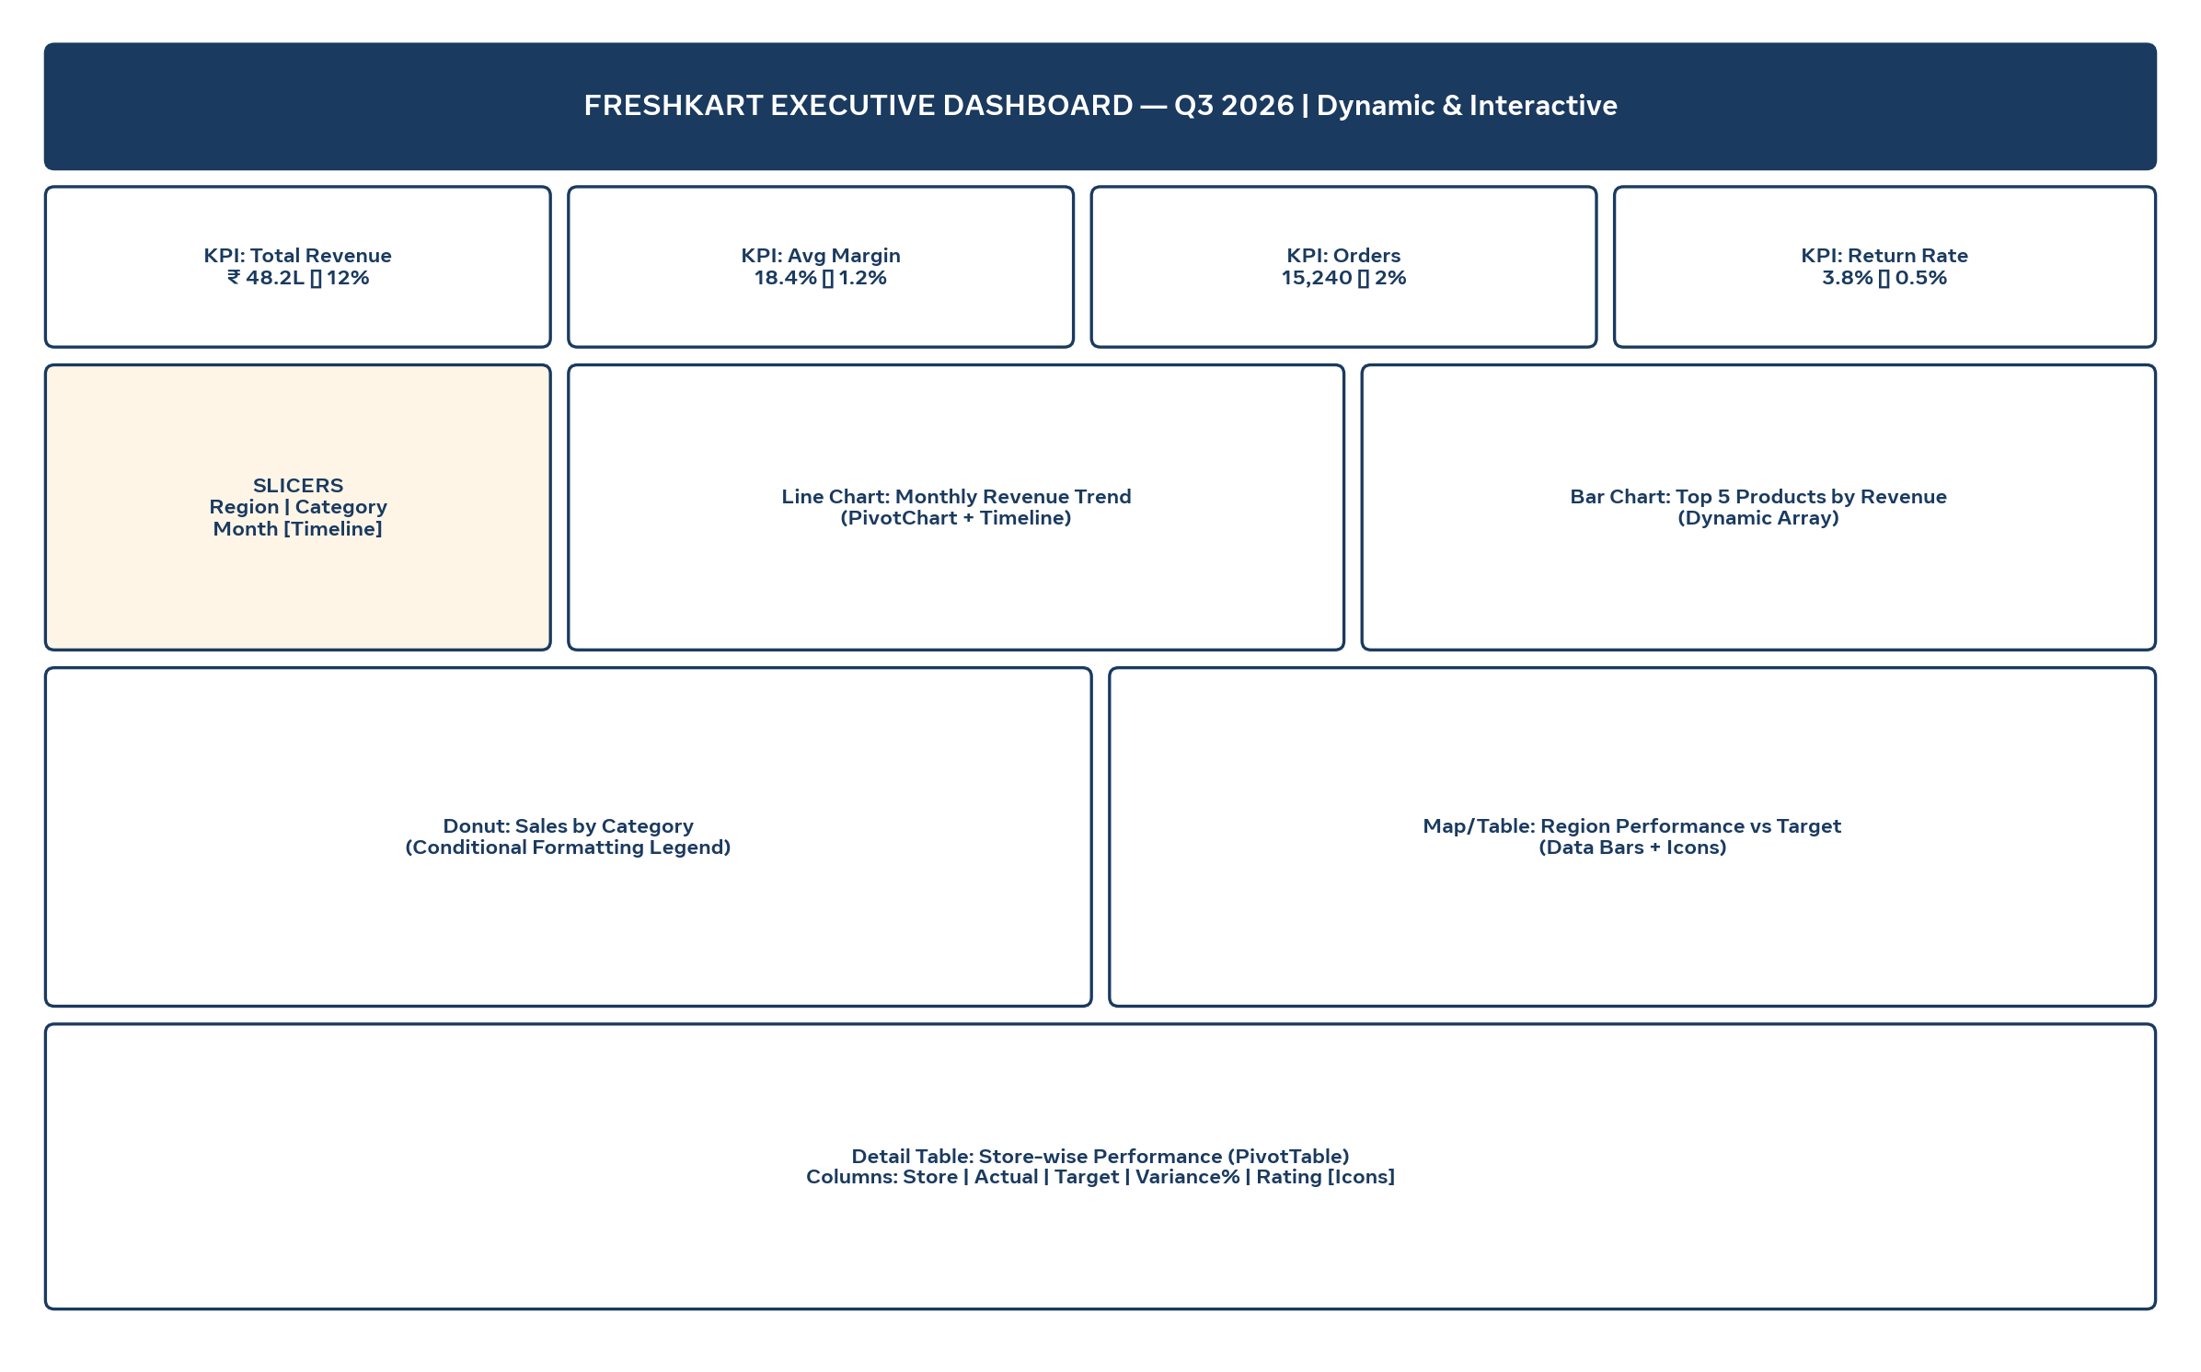
Figure 1: Conceptual wireframe of FreshKart Executive Dashboard. Four KPI cards on top, Slicers + Timeline on left, Trend and Top-5 charts in middle, Category donut and Region table below, detailed PivotTable at bottom.
Sketch rationale: Slicers placed left of charts (not top) to preserve vertical space. Timeline chosen over dropdown for month because it visually communicates Q3 continuity. Detail table kept at bottom so executives can ignore it while analysts can scroll.

6. Excel Features Used – Detailed Descriptions
This section demonstrates advanced Excel skills per evaluation criteria.

6.1 PivotTables and PivotCharts
PivotTables summarize 15k rows without formulas. Three pivots power the dashboard: (1) Monthly Revenue by Region, (2) Category-wise Margin, (3) Store-wise Actual vs Target. PivotCharts are used instead of regular charts so they respond to Slicers automatically. ‘Show Values As → % Difference From Previous Month’ highlights growth.

6.2 Slicers and Timelines
Slicers for Region and Category provide one-click filtering with visual buttons, far more intuitive than AutoFilter for managers. Timeline for Date enables month/quarter selection with a slider. All Slicers are connected to all PivotTables via Report Connections, ensuring cross-filtering consistency.

6.3 Charts Chosen
Visual | Type | Why Chosen
Revenue Trend | Line + Column Combo | Line shows Actual trend, Column shows Target – variance visible
Top 5 Products | Clustered Bar | Bar length easy to compare; sorted descending
Category Share | Donut | Part-to-whole without pie angle distortion; center holds total
Region Performance | Table with Data Bars | Precise numbers + visual bars for quick scan

6.4 Conditional Formatting
Applied to KPI cards and detail table: (1) Icon Sets (green check / amber exclamation / red cross) for Rating, (2) Data Bars for Variance %, (3) Color Scales for Return Rate. Rules use formulas like =$D2<0 for dynamic thresholds, not hardcoded colors.

6.5 Other Features
- Camera Tool snapshots for KPI cards (live images), Data Validation for custom date input, Named Ranges for dynamic titles like ="Revenue – "&SELECTED_REGION, and GETPIVOTDATA for custom KPI formulas that survive pivot layout changes.

7. Step-by-Step Dashboard Creation Guide
14-step reproducible process (estimated 30-35 hours including testing):
- Step 1 – Prepare Data Model: Convert all ranges to Tables (Ctrl+T). Verify Week 2 calculated columns (Net_Revenue, Rating) have no #N/A.
- Step 2 – Create Pivot Cache: Insert > PivotTable from Sales_Transactions. Check ‘Add to Data Model’ for DISTINCTCOUNT.
- Step 3 – Build Monthly Trend Pivot: Rows=Date (Group by Months), Columns=Region, Values=Sum of Net_Revenue, Target. Create PivotChart → Combo Line+Column.
- Step 4 – Build Category Pivot: Rows=Category, Values=Sum of Gross_Profit, Avg Margin. Create Donut PivotChart.
- Step 5 – Build Top-5 Pivot: Use ‘Top 10 Filter’ on Product_ID by Sum of Net_Revenue, set to Top 5. Create Bar PivotChart, sort descending.
- Step 6 – Build Store Detail Pivot: Rows=Store_ID, Values=Actual, Target, Variance%. Add Calculated Field for Variance%.
- Step 7 – Insert Slicers: Select any Pivot → Insert Slicer → Region, Category. Insert Timeline → Date.
- Step 8 – Connect Slicers: Right-click Slicer → Report Connections → check all 4 Pivots. Test: filter West – all charts update.
- Step 9 – Design KPI Cards: In dashboard sheet, use GETPIVOTDATA + SUMIFS to pull totals. Apply large font (20pt), conditional icons.
- Step 10 – Apply Conditional Formatting: Select Variance% column → Home → Conditional Formatting → Data Bars (green). Add Icon Set for Rating.
- Step 11 – Layout Dashboard Sheet: Set gridlines off (View → Gridlines), set column widths, place wireframe zones. Use Fancy borders.
- Step 12 – Add Dynamic Titles: Formula ="Q3 Performance – "&IF(COUNTA(Slicer_Region)=4,"All Regions",TEXTJOIN(",",1,Slicer_Region)).
- Step 13 – Freeze & Protect: Freeze top row, protect sheet allowing only Slicer use (Review → Protect Sheet → check ‘Use PivotTable reports’).
- Step 14 – Test & Document: Append 100 dummy rows, refresh all (Data → Refresh All), confirm KPIs update in <5 sec. Record steps.

8. How Dashboard Facilitates Decision Making
Interactivity transforms static reporting into exploratory analysis:
Scenario 1 – Underperforming Region: Manager clicks ‘East’ slicer. Trend line drops, detail table shows 2 stores with red icons. Decision: schedule East promo – done in 2 clicks vs 30-min manual filter earlier.
Scenario 2 – Margin Erosion: Category Manager selects ‘Beverages’. Donut shows 22% share but KPI margin drops to 12%. Drills to Top-5 bar – one SKU dominates low margin. Decision: renegotiate supplier.
Scenario 3 – Monthly Review: CEO drags Timeline to August. All visuals animate to August only. Variance vs target instantly visible. No need to request analyst rerun.
Dynamic data displays ensure single source of truth – no conflicting PPT versions.

9. Alternative Visualizations Considered
Considered | Rejected Because | Chosen Instead
Pie chart for Category | Angle hard to compare >4 categories | Donut with center total
3D Column for Trend | Distorts values, chartjunk | 2D Combo Line+Column
Gauge for KPI | Wastes space, only one value | KPI card with ▲▼ + sparkline
Map chart for Region | Only 4 regions, map overkill | Table with Data Bars – precise

Combination rationale: Line for time (best for trend), Bar for ranking (best for comparison), Donut for composition (part-to-whole), Table for precision. This covers all analytical intents without redundancy.

10. Limitations and Future Improvements

10.1 Limitations
- Excel dashboard is file-based – concurrent editing causes conflicts.
- 15k rows is fine, but >500k rows slows recalc; Power Pivot needed.
- Slicers don’t work on mobile Excel app reliably.
- No automated email alerts – manager must open file.

10.2 Proposed Improvements
- Migrate to Power BI for auto-refresh, row-level security, and mobile view.
- Add Power Query parameters for dynamic date range without Timeline.
- Implement LAMBDA-based KPI calculations to reduce GETPIVOTDATA fragility.
- Add What-If Analysis with Scrollbar for discount simulation.

11. Best Practices Followed
- One PivotTable per analytical question – no mega-pivot.
- All charts have titles that update with filters (dynamic).
- Color palette limited to 4 colors + grays for accessibility.
- Print area set to A3 landscape, fit to 1 page for meetings.
- Versioned file name: FreshKart_Dashboard_v1.0_2026-10-17.xlsx

12. Conclusion
The FreshKart Executive Dashboard demonstrates that effective visualization is not decoration but decision acceleration. By combining PivotTables for summarization, Slicers/Timelines for interactivity, and thoughtful chart selection, the 15,000-row complexity is distilled into a 5-second executive read with drill-down capability.
This report meets evaluation criteria: creativity in Z-layout and KPI storytelling, clear demonstration of advanced Excel skills, practical interactivity, and detailed written guidance that stands alone as a build manual. Future migration to Power BI is a natural next step, but the Excel foundation ensures logic and business rules are validated first.

13. Appendix A – KPI Definitions
KPI | Formula | Target
Total Revenue | SUM(Net_Revenue) | > ₹45L / quarter
Avg Margin % | SUM(Gross_Profit)/SUM(Net_Revenue) | ≥18%
Return Rate | COUNT(Returns)/COUNT(Orders) | <5%

14. Appendix B – Color and Layout Standards
Primary: #1A3A5F (navy title), Accent: #E67E22 (orange highlights), Success: #27AE60, Warning: #F39C12, Danger: #C0392B. Font: Calibri 11pt body, 20pt KPIs. Grid: 12-column, 0.2" gutters.
— End of Week 3 Report —

