INFORMATION GATHERING

Project Profile : -
Sr.no | Title | Detail
1 | Group No. | 27
2 | Project Title | Talent Flex
3 | Front-End Tool | PHP
4 | Back-End Tool | MY SQL
5 | Project Type | Web Application
6 | Duration
7 | Project Team Size | Two (2)
8 | Submitted By | Vibhavi j. Vaghasiya (2024008456)  Urmi M. Usdad(2024008448)
9 | Stream | T.Y.B.C.A.(sem-5)
10 | Guided By | Prof. Purvi Abhani
11 | Submitted To | Shree V.N. Borad Mahila BCA Collage,  Joshipura, Junagadh.

Introductions: -

Title: TalentFlex – Job Portal

TalentFlex is a web-based Job Portal developed using PHP and MySQL. The main objective of this project is to provide an online platform where job seekers and employers can connect easily and efficiently.
Job seekers can register, log in, create their profiles, upload resumes, search for suitable jobs, and apply online. Employers can register their companies, post job vacancies, manage job listings, and review applications submitted by candidates.
The project also provides an Admin Panel for managing users, employers, job categories, job postings, applications, feedback, and contact messages. TalentFlex reduces manual recruitment work, saves time, improves communication between recruiters and applicants, and provides a secure and user-friendly recruitment platform.

Scope : -

- Provide an online recruitment platform for job seekers and employers.
- Allow employers to post and manage job vacancies.
- Allow job seekers to search and apply for jobs.
- Maintain candidate profiles and resumes.
- Provide an Admin Panel for managing users, companies, job categories, and applications.
- Develop a responsive website that works smoothly on desktops, tablets, and mobile devices.

Objective : -

            - To simplify the recruitment process.
            - To provide an online platform for employers and job seekers.
            - To allow employers to post job vacancies easily.
            - To enable candidates to search and apply for jobs online.
            - To maintain secure user and company information.
            - To reduce paperwork and improve recruitment efficiency.

Advantages : -

Easy online job searching.

Simple job posting for employers.

Resume upload facility.

Fast recruitment process.

User-friendly interface.

Secure login and registration.

Available 24×7 from anywhere.

Limitation : -
    - Internet connection is required.
    - Fake job postings require admin verification.
    - Resume upload size may be limited.
    - Email verification depends on internet connectivity.
    - Online recruitment cannot completely replace face-to-face interviews.

Pages : -
- Admin side :-

- Dashboard
- Login
- Manage-companies
- Job-Categories
- Applications
- Contact messages
- Feedbacks

- User side :-

- Home
- About Us
- Search Jobs
- Jobs Details
- Apply job
- My Applications
- Contact Us
- Register
- Feedback

- Company Side :-

- Home
- Register
- Login
- Dashboard
- Add Company
- Job-Manage
- View
- User Details
- Feedback

REQUIREMENT ANALYSIS

Tools & Technology : -

PHP :-
- PHP stands for “Hypertext Pre-Processer”. Its original name is “Personal HomePage”.
- PHP is a server-side scripting language and supports many database like.., MYSQL, Informix, Oracle, Generic ODBC, etc.
- Its HTML embedded scripting language. The goal of the language is to allow web developers to write dynamically generate pages quickly.
- PHP is an official module of Apache HTTP server.
- PHP is fully Cross-Platform.
- By the middle of 1997, PHP was being used on approximately 50,000 sites worldwide

Advantages of PHP :-
- Easy and simple to learn
- Extremely flexible
- Open Source
- Powerful library supports
- Built-in database connection modules

My Sql : -
- MYSQL is the world’s most widely used open source relation database management System.
- It is named after co-founder Michael widenious’s daughter.

Advantages of Mysql : -
- Open source
- Very fast, reliable, and easy to us
- Runs on a server
- Used for web application
- Ideal for both small and large application

Java Script :-
- Its object oriented language.
- There doesn’t require any special or separate editor for programs to be writer edited or compiled.
- Java scripting can generate HTML dynamically on the client.
- Java has no required any other platform because it is platform independent.
- Java is an interpreted Language.
- Java is easy to learn
- Java is designed for simple & small program.

CSS:-
- CSS stands for Cascading Style Sheet.
- CSS is a style languages used for describing the presentation semantics of a document written in a mark-up language.
- CSS is design primarily to enable the separation of document content from document presentation including element.
- CSS used in three format :

- Inline
- Internal
- External

XAMPP : -
- XAMPP stand for cross platform apache, mysql, php and perl
- XAMPP is simple light weight apache server
- XAMPP is a offend in both a full and a standard version

Hardware & Software Requirements :

Hardware :-
Hardware | Specification
Hard Disk | 500 GB
Processor | 3030 GHz
RAM | 4.00 GB

Software : -
Software | Specification
Operating System | MS Windows 10
Tools | Macromedia Dreamweaver
Back - End | MY SQL
System Type | 64 bit OS

User Characteristics :-

- At Zoofari, we welcome nature enthusiasts and adventure seekers alike. Our services cater to a wide range of users, each with unique characteristics that make every visit a memorable experience.
- Here’s a look at the different types of users we typically see:
- Nature Lovers
- Adventure Seekers
- Photographers and Filmmakers
- Eco-conscious Travelers
- Each user is provided with personalized experiences tailored to their preferences, ensuring that their time at Zoofari is both fulfilling and unforgettable.

PROJECT PLANNING

- We referred the tutorials from Internet with the help of them; we can make project more efficient & more reliable
- Project planning is part of project management which related to the use of schedules such as Gantt chart to plan and subsequently report progress within the project environment.
- Following this step, the durations for the various tasks necessary to complete the work are listed and grouped in to a work are breakdown structure.

Waterfall Model :-
- The waterfall model was first process model to be introduction it is also referred to as a liner sequential lifecycle model.
- It is very simple to understand and use in a waterfall model, each phase must be completed be for the next phase can being and there is no overlapping in the phases.
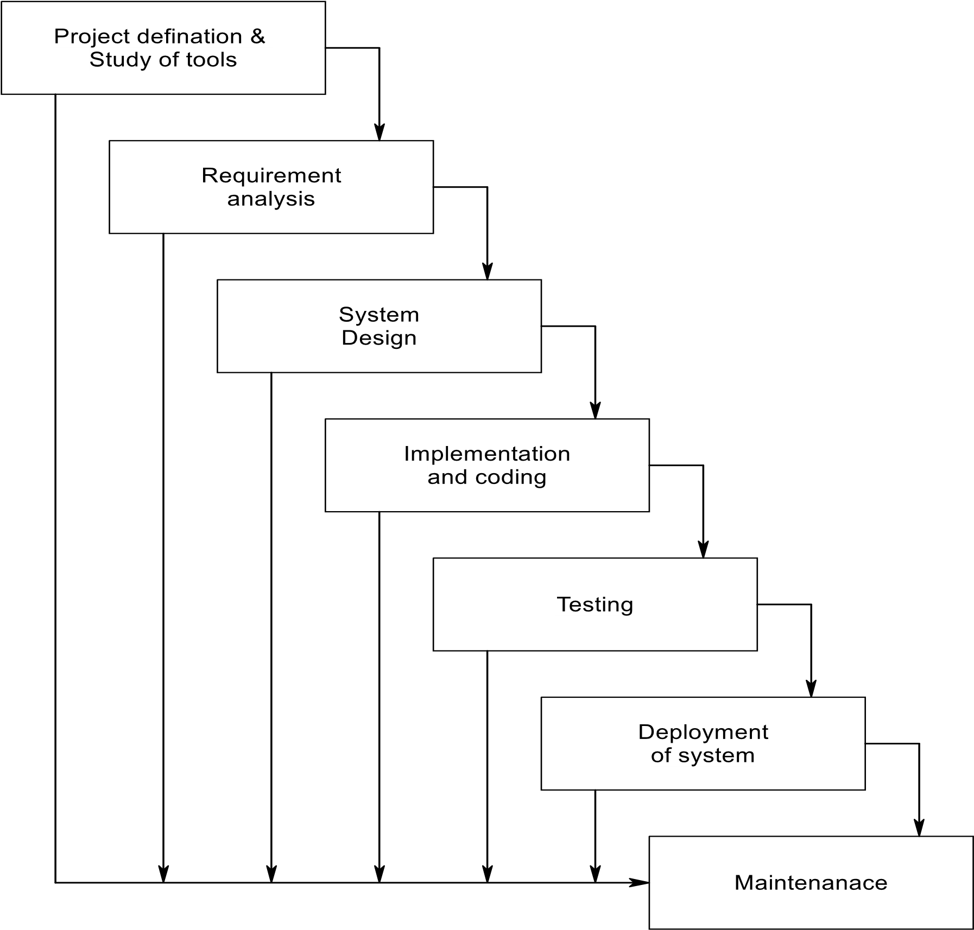

Project Definition & Study Tools :
- Our Project is basically used for to do business and provide business for people.

Requirements Analysis :
- The requirements gathering process makes stronger and focused specifically on business activities understanding requirement, an analyst can have clear idea about the nature of the software including function behavior, performance and interface requirements for the system recorded and evacuated with the user.

System Design :
      - Software design shows following four distinct components of a program.
        - Database Design
        - Software Architecture
        - Interface Design
        - Algorithm

- The process converts requirements into a symbolic representation of the software that can be used for static testing before coding like requirement the design is documented and turns out to be part of the software configuration

Implementation of Coding :
- The design must be converted into a machine, program the code generation step done this task. If design is performed in a correctly code generation can be done speedy and with more efficiency.

Testing :
- Once code developed program testing can be started. The testing process Covered by static and dynamic way. It also covers structure and functional testing. For quality testing also covers non-functional requirements.

Deployment of System :
- Once the functional and non-functional testing is done the product deployed in the customer environment or released in to the market.

Maintenance :
- There are some issues which come up in the client environment to fix those issues patches are released maintenance is done to deliver these changes in the customer environment.

Project Scheduling :-
- Project scheduling is corned with the techniques that can be employed to manage the activity that need to be undertaken during the development of a project.

Sr.no | Activity | Starting Date | Completion Date
1 | Requirement Analysis | 01-Jul-24 | 12-Jul-24
2 | System Analysis | 13-Jul-24 | 20-Jul-24
3 | Project Planning & Scheduling | 21-Jul-24 | 27-Jul-24
4 | System Design & Form Design | 28-Jul-24 | 24-Aug-24
5 | Coding & Implementation | 25-Aug-24 | 14-Sep-24
6 | Testing | 15-Sep-24 | 28-Sep-24
7 | Documentation | 01-Jul-24 | 28-Sep-24

Gantt Chart :

Task Date &  Time | 01 Jul to  12 Jul | 13 Jul to  20 Jul | 21 Jul To  27 Jul | 28 Jul to  24 Aug | 25 Aug to  14 Sep | 15 Sep to  28 Sep | 01 Jul to  28 Sep
Requirement analsysis
System analysis
Projectplanning
scheduling
System Design
Impletation & coding
Testing
Documentation

FEASIBILITY STUDY

- The initial investigation points to the question whether the project is feasible a feasibility is conducted to identity the best system that meets the all the requirements this includes an identification description and evaluation of the proposed system and selection of the best system for the job.
- The requirement of the system is specified with a set of constraints. Such as system objective and the description of the output. If is then duty of the analyst to evaluate the feasibility of the proposed system to generate the above results.

Technical Feasibility :-
- Technical current of technology supports the proposed system. The current setup is sufficient for the processing of the kind tasks.
- Management agreed to purchase extra devices for latest technology if necessary.
- The software needed to important and execute the system are already existing.
- Technical analysis evaluation technical merits of the system at the same time collecting additional information about performance, reliability, maintainability and productivity.

Operational Feasibility :-
- The proposed system will fulfill the company’s quarrymen.
- The proposed system covers all aspect of the current Manual system.
- The human sources required number of staff operationally for the company.
- Proposed system is helpful for all the users associated with the organization.
- The decision making process of their will also become faster with the use of data integration, consolidation so it is feasible to implement the system.

Social Feasibility :-
- Social feasibility addresses the influences that a proposed project may have on the social system in the project environment.
- It should be recognized that workers in certain industries may have certain status system within the society.
- The ambient social structure may be such that certain categories of workers may be in short supply or non-existent.
- The stages in social assessment are:
- Develop an effective public plan to involve all potentially affected public.
- Scoping to identify the full range of probable social impacts.
- Screening to determine the boundaries of the SIA.

Organizational Feasibility :-
- I have organizational feasibility as meaning whether the new system will fit in to the organization and meet the current goals and objectives.
- This involves questions such as whether the system has enough support to be implemented successfully whether it brings an excessive amount of change and whether the organization is changing two rapidly to it.
- Two of important factors in this are: -
- The passion that the sole entrepreneur or management team has for the business idea.
- The extent to which the management team or sole entrepreneur understand the markets in which the firm will participate

Economic Feasibility :-
- Economic feasibility is the most important and frequent used method for evaluating the effectiveness of the proposed system.
- It is very essential the main goal of the proposed system is to have economically better result along with increased efficiency cost benefit analysis is usually performed for the purpose.
- It is the comparative study of the cost versus the benefit and savings that are expected from the proposed system, since the organization is well equipped with the organization is well equipped with the required hardware the project was found to be economically.
- Cost Estimation:
- Working the estimation is given :
- 3Months and 3 days = 95 days
- Hours 1 days = 95 * 4 = 380 / 24 = 16 days
- Now , the expense & cost estimation :
Light Bill | 6000
Energy charge | 3000
Database design | 4000
Coding | 2000
Internet connection | 5000
Extra activity | 2000
Total | 22,000 Rs.

DATABASE DESIGN

Use case diagram :-

- Admin :

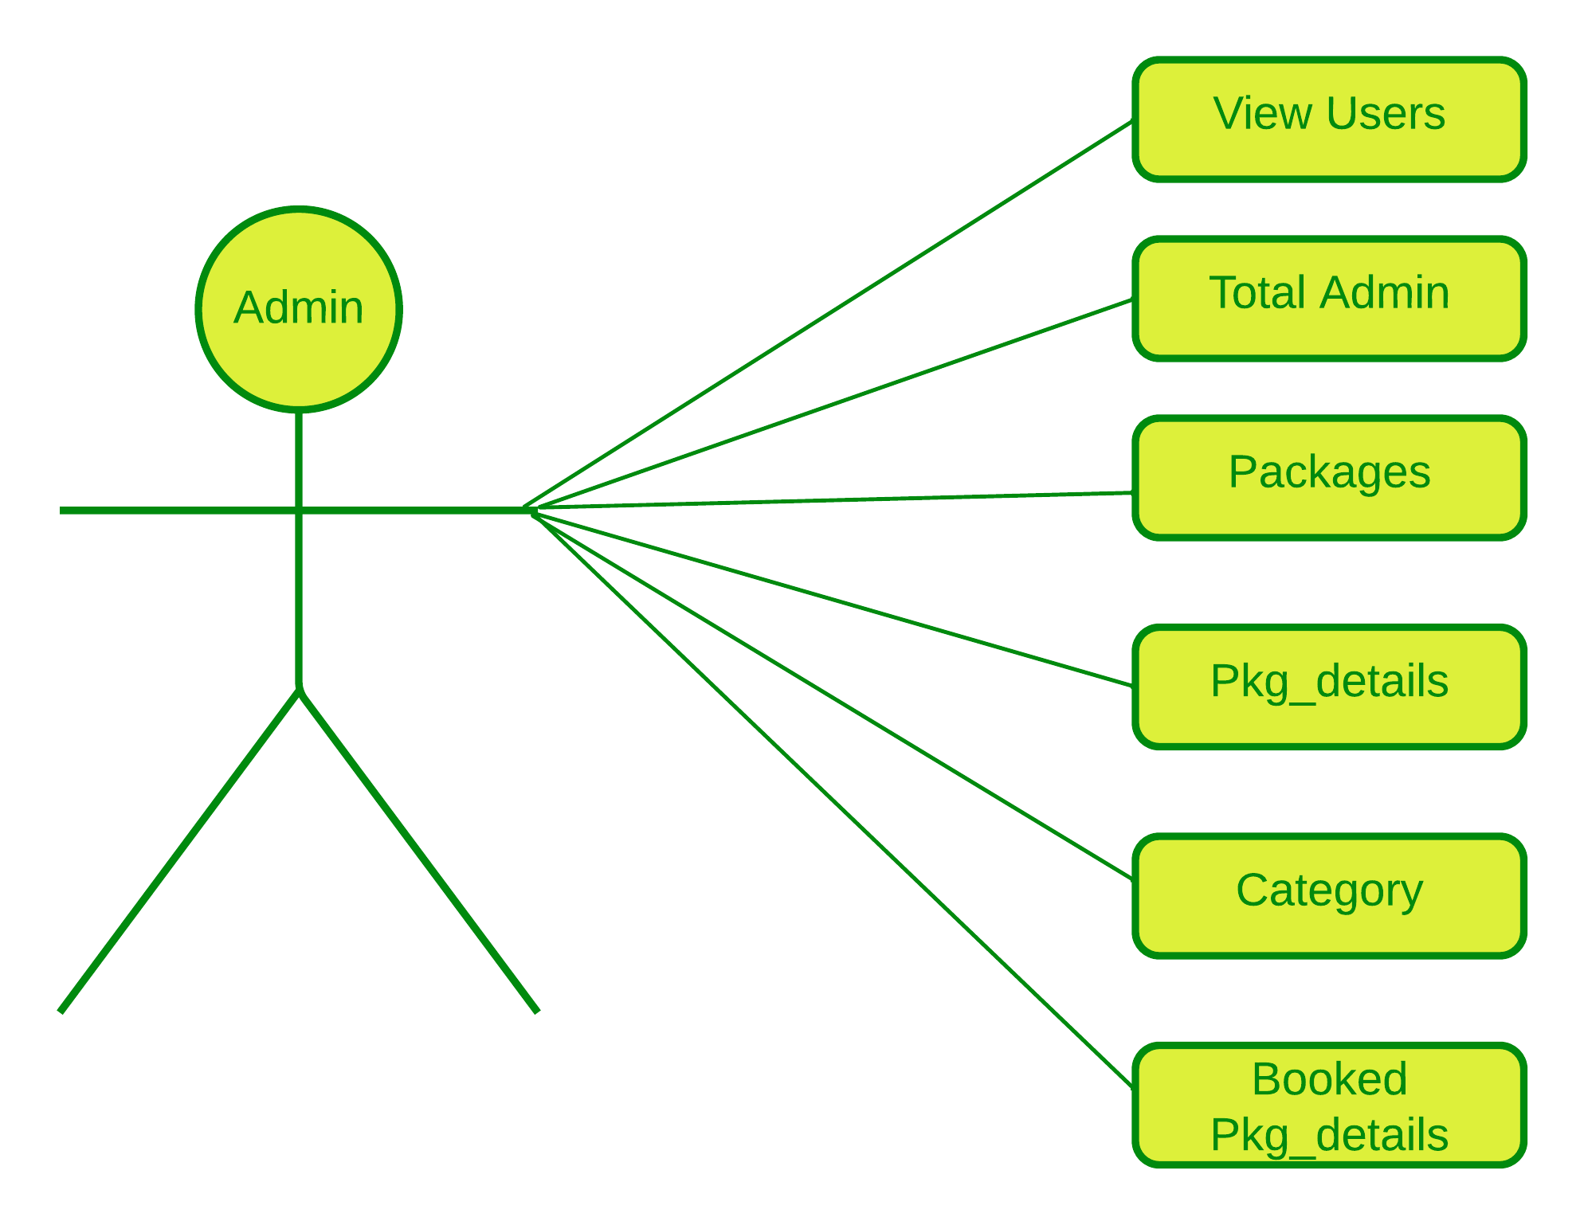

- User :
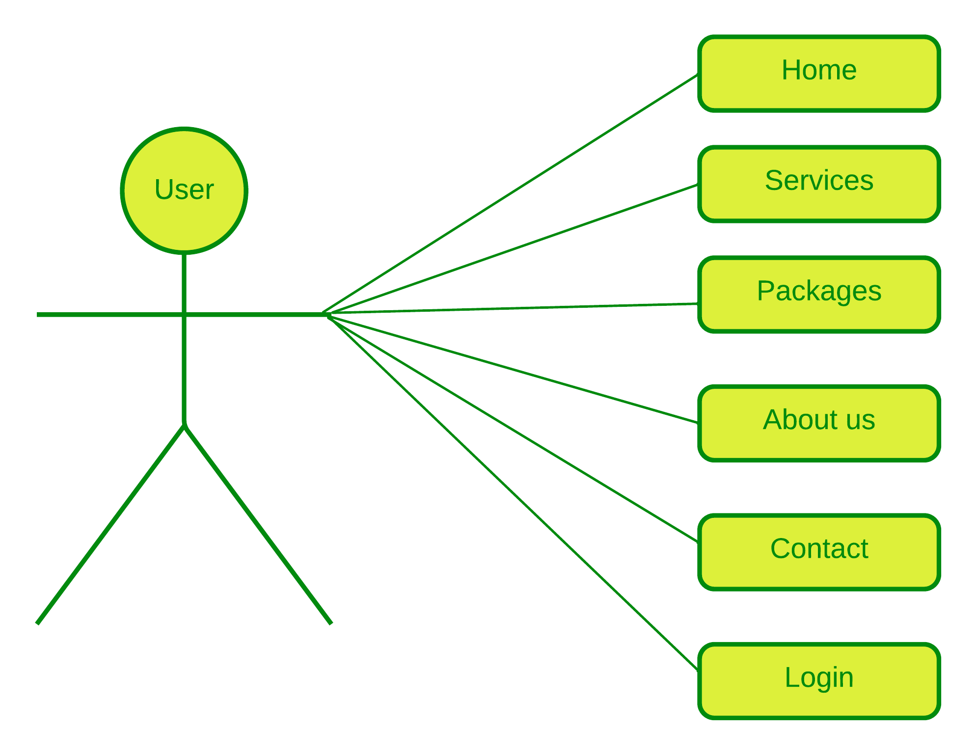

DFD (Data Flow Diagram) :
- Data is the life blood of any system. Diagram of flow of data in system and its processing which converts data into valuable information in known as data flow diagram. It will not show logic of the algorithm its shows only flow of the data from the process to the process or from the table or from external source to the external source to the external destination.
- Data Process :

- Data Store :

- External interaction :

- Dynamic Connector :

DFD :-
- Level-0 :
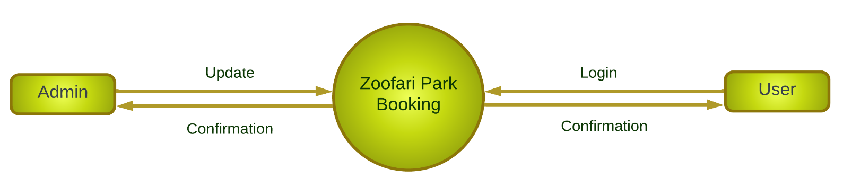
- Level-1-Admin :
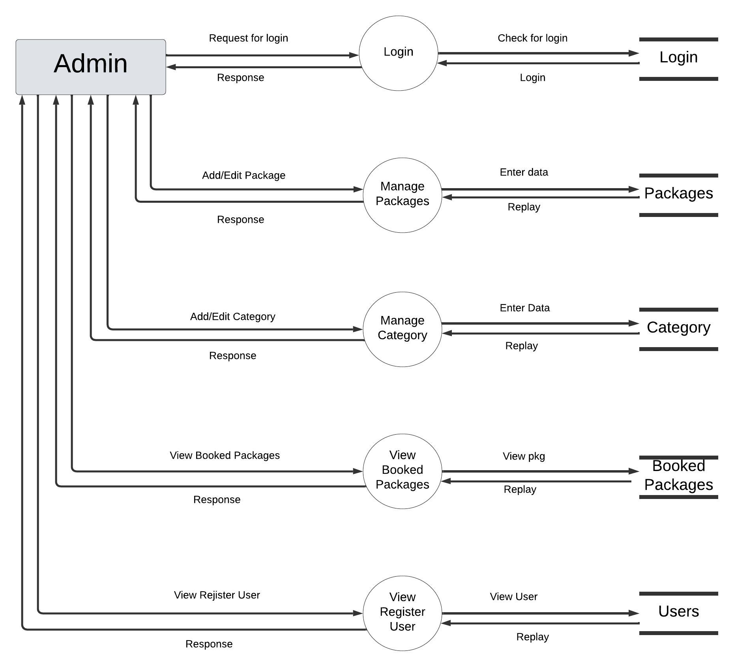
- Level-1 User :
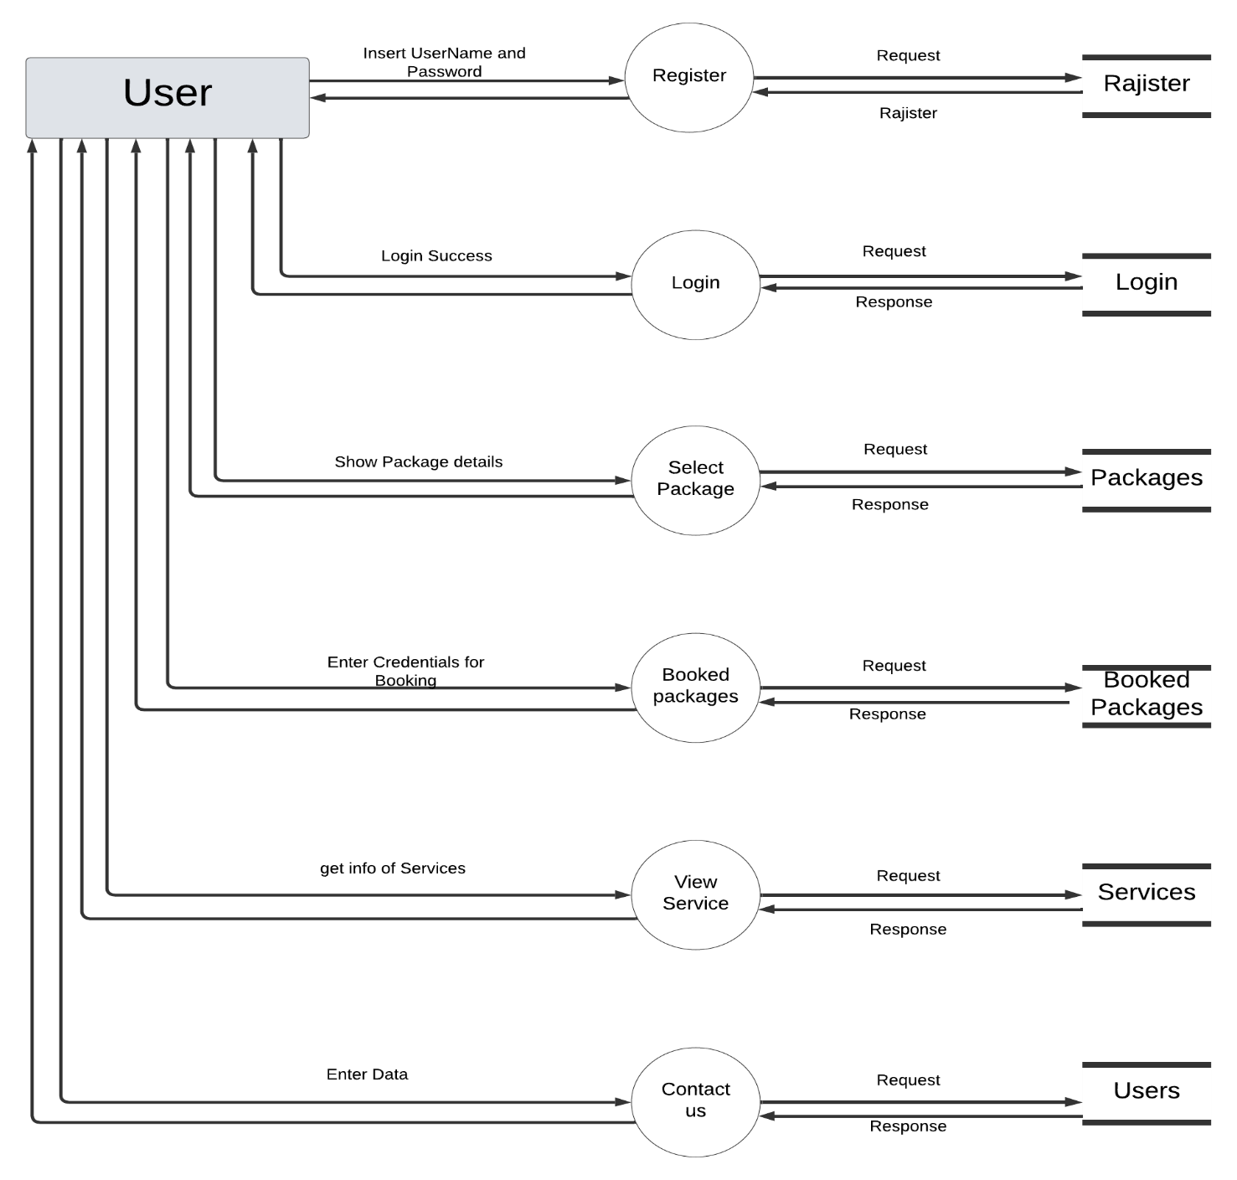

Class Diagram :
- User :

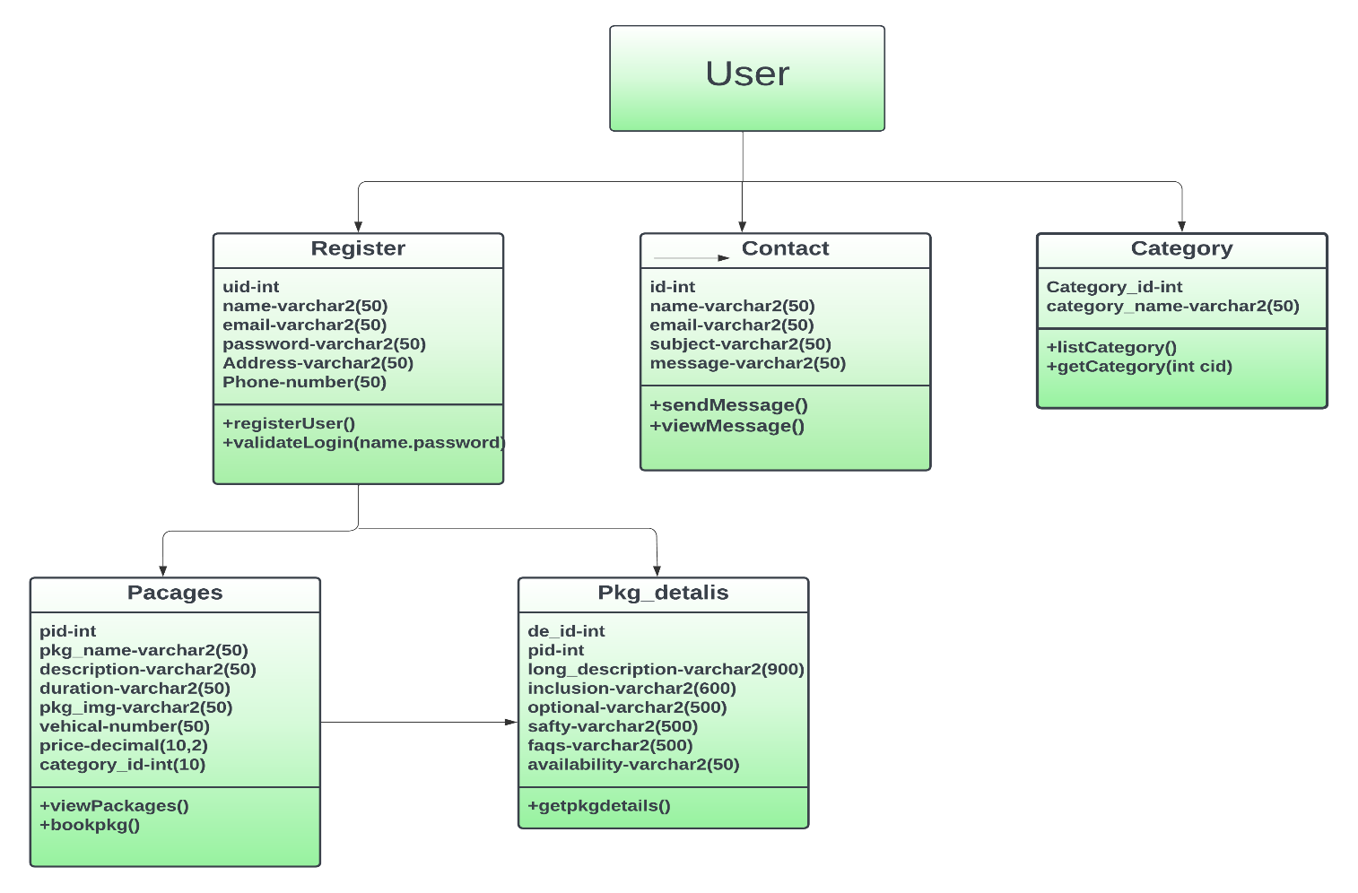

- Admin :
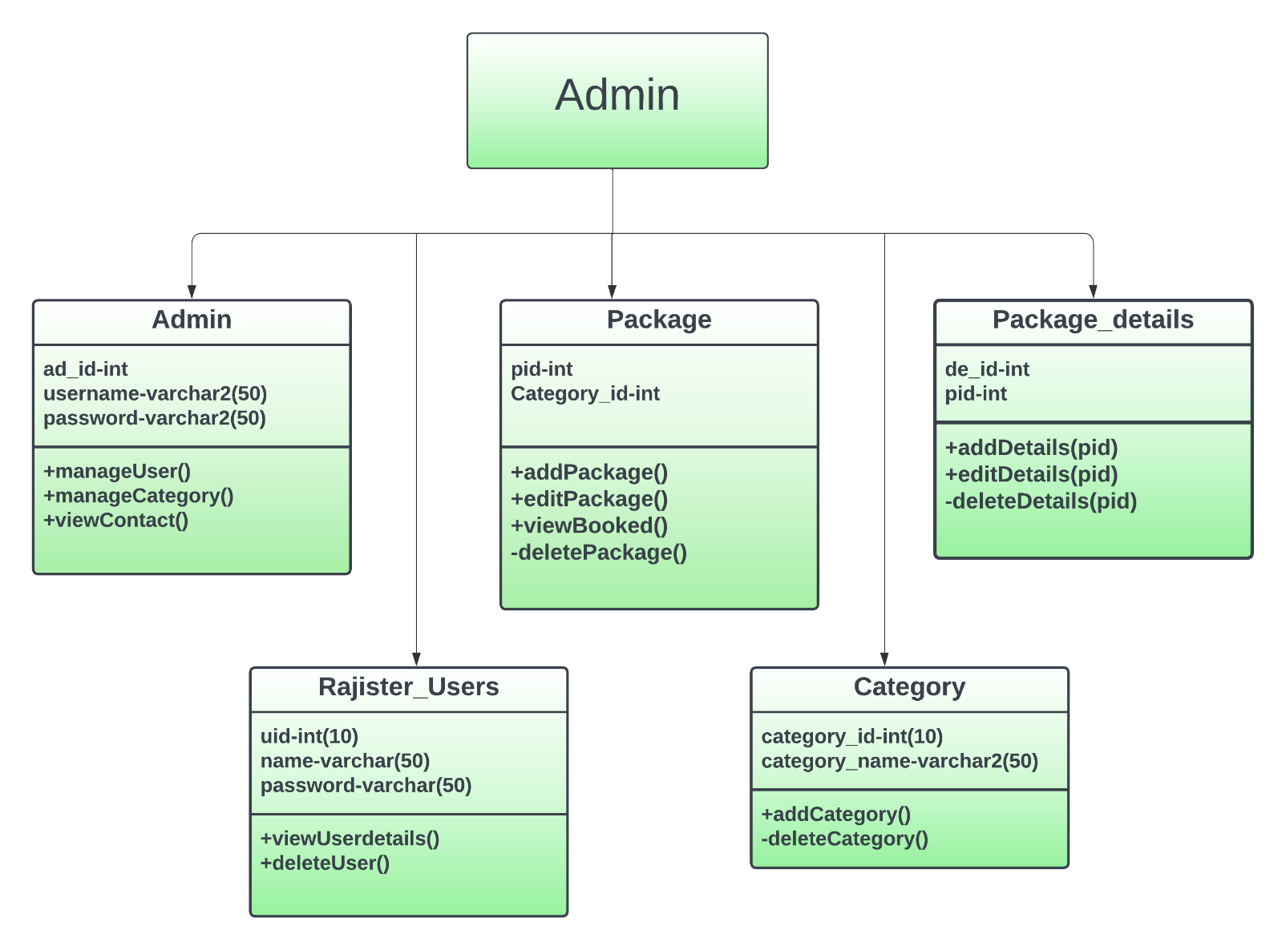

Data Dictionary :
- The Data Dictionary can be specifically defining as an exhaustively organized list of all data elements that are pertinent to the system with precise, rigorous understanding of inputs and outputs and the components of stores along with all the constraints and intermediate calculations.
- In other words, a data dictionary is a catalogue – a repository of element in a system. Here in a data dictionary one can find list of all the elements composing the data flowing through a system. The major elements are data flows, data stores and process.

Importance of data dictionary : -
- To manage the details in large system.
- To communicate a common meaning for all system elements.
- To document the features of a system. To facilitate analyst for the details in order to evaluate system requirements
- Following is the list of Tables which are used in my project. Consider Following Data Dictionary which denotes tables detail.
- User_register
- Packages
- Pkg_detail
- Category
- Contact
- Booked_pkg

- User_register :
Field name | Data type
Uid | Int(10)
Name | varchar(50)
Email | varchar(50)
Password | varchar(10)
Address | varchar(10)
phone | varchar(50)

- Packages :
Field name | Data type
Pid | Int(10)
Pkg_name | varchar(50)
Description | varchar(50)
Duration | varchar(10)
Pkg_image | varchar(10)
vehical | varchar(50)
price | Decimal(10,2)
Category_id | Int(10)
- Pkg_details:
Field name | Data type
De_id | Int(10)
Pid | Int(10)
Long_desc | varchar(50)
Inclusion | varchar(600)
Optional | varchar(600)
Safty | varchar(600)
Faqs | varchar (600)
- Category :
Field name | Data type
Category_id | Int(10)
Category_name | varchar(50)
- Contact :
Field name | Data type
id | Int(10)
Name | varchar(50)
Email | varchar(50)
Subject | varchar(10)
Message | varchar(10)
- Booked_pkg :
Field name | Data type
Booked_id | Int(10)
Uid | Int(10)
Pid | Int(10)
Booking_date | varchar(50)
Adults | number(50)
Child | number(50)
Total_price | decimal(10,2)
Payment_method | varchar(50)
Booking_status | varchar(50)

DATABASE NORMALIZATION

- Normalization :

- Normalization is the first step to design any database.
- Normalization is a database design technique which organize tables in a member that reduces redundancy and dependency of data. There are three types of normalization: -
- 1NF
- 2NF
- 3NF
- 1st NF:

- 1Nf means First Normalization Form.
- There are two rules of 1NF.
- First create a separate table for each set of related data.
- Identity each set of related data with primary key.
- All attributes are single values and non-repeating.

Table : User_Register

Field Name | Data Type | Size
Uid | int | 10
Name | varchar | 30
Email | varchar | 50
Password | varchar | 50
Address | varchar | 50
Phone | int | 10
isAdmin | Int | 10
Table : Packages
Field Name | Data Type | Size
Pid | int | 10
Pkg_name | varchar | 255
Description | varchar | 100
Duration | varchar | 50
Pkg_image | varchar | 255
vehical | varchar | 50
price | decimal | 10,2
Category_id | Int | 10
Table : Pkg_details
Field Name | Data Type | Size
De_id | int | 10
Pid | int | 10
Long_desc | varchar | 700
Inclusion | varchar | 600
Optional | varchar | 500
Safty | varchar | 600
Faqs | varchar | 50

Table : Category
Field Name | Data Type | Size
Category_id | int | 10
Category_name | varchar | 50

Table : Contact
Field Name | Data Type | Size
id | int | 10
Name | varchar | 50
Email | varchar | 50
Subject | varchar | 50
Message | varchar | 50

Table : Booked_pkgdetail
Field Name | Data Type | Size
Booked_id | int | 10
Uid | int | 10
Pid | int | 10
Booking_date | varchar | 50
Adults | number | 50
Child | number | 50
Total_price | decimal | 10,2
Payment_method | varchar | 50
Booking_status | varchar | 50

- 2nd NF:

- 2NF means second normal form.
- Create separate table for sets of values that apply to multiple records.
- Relate the tables with a foreign key.
- Records should not depend on anything other than a table’s primary key.
- Meet all the requirements the first normal form.
- Create relationship between these new tables and their predecessors
through the use of foreign keys.
- Remove subset of data that apply to multiple rows of a tables and place
them separate table.
Table : User_Register
Field Name | Data Type | Constraint
Uid | int(10) | Primary key
Name | varchar(30)
Email | varchar(50)
Password | varchar(50)
Address | varchar (50)
Phone | int(10)
isAdmin | int(10)
Table : Packages
Field Name | Data Type | Size
Pid | int(10) | Primary key
Pkg_name | varchar(255)
Description | varchar(100)
Duration | varchar(50)
Pkg_image | varchar(255)
vehical | varchar (50)
price | decimal(10,2)
Category_id | int(10) | Foreign key
Table : Pkg_details
Field Name | Data Type | Size
De_id | int(10) | Primary key
Pid | int(10) | Foreign key
Long_desc | varchar(700)
Inclusion | varchar(600)
Optional | varchar(500)
Safty | varchar (600)
Faqs | varchar(50)

Table : Category
Field Name | Data Type | Size
Category_id | int(10) | Primary key
Category_name | varchar(50)

Table : Contact
Field Name | Data Type | Size
id | int(10) | Primary key
Name | varchar(50)
Email | varchar(50)
Subject | varchar(50)
Message | varchar(50)
Table : Booked_pkgdetail
Field Name | Data Type | Size
Booked_id | int(10) | Primary key
Uid | int(10) | Foreign key
Pid | int(10) | Foreign key
Booking_date | varchar(50)
Adults | number(50)
Child | number(50)
Total_price | decimal(10,2)
Payment_method | varchar(50)
Booking_status | varchar(50)
- 3rd NF:

- 3NF means third normal form.
- Eliminate fields that do not depend on the primary key.
- Each non-primary key attributes must be dependent only on primary key.
- Here we converted Booked_pkgdetail in the 3NF.
- To remove the transitive dependencies and achieve 3NF we can break the table into two tables :

- Booked_pkgdetail
- Booked_pricedetail

Table : Booked_pkgdetail
Field Name | Data Type | Size
Booked_id | int(10) | Primary key
Uid | int(10) | Foreign key
Pid | int(10) | Foreign key
Booking_date | varchar(50)
Payment_method | varchar(50)
Booking_status | varchar(50)

Table : Booked_pricedetail
Field Name | Data Type | Size
price_id | int(10) | Primary key
Booked_id | int(10) | Foreign key
Adults | number(50)
Child | number(50)
Total_price | decimal(10,2)

SCREEN SHOTS

- User Side:
- Index Page

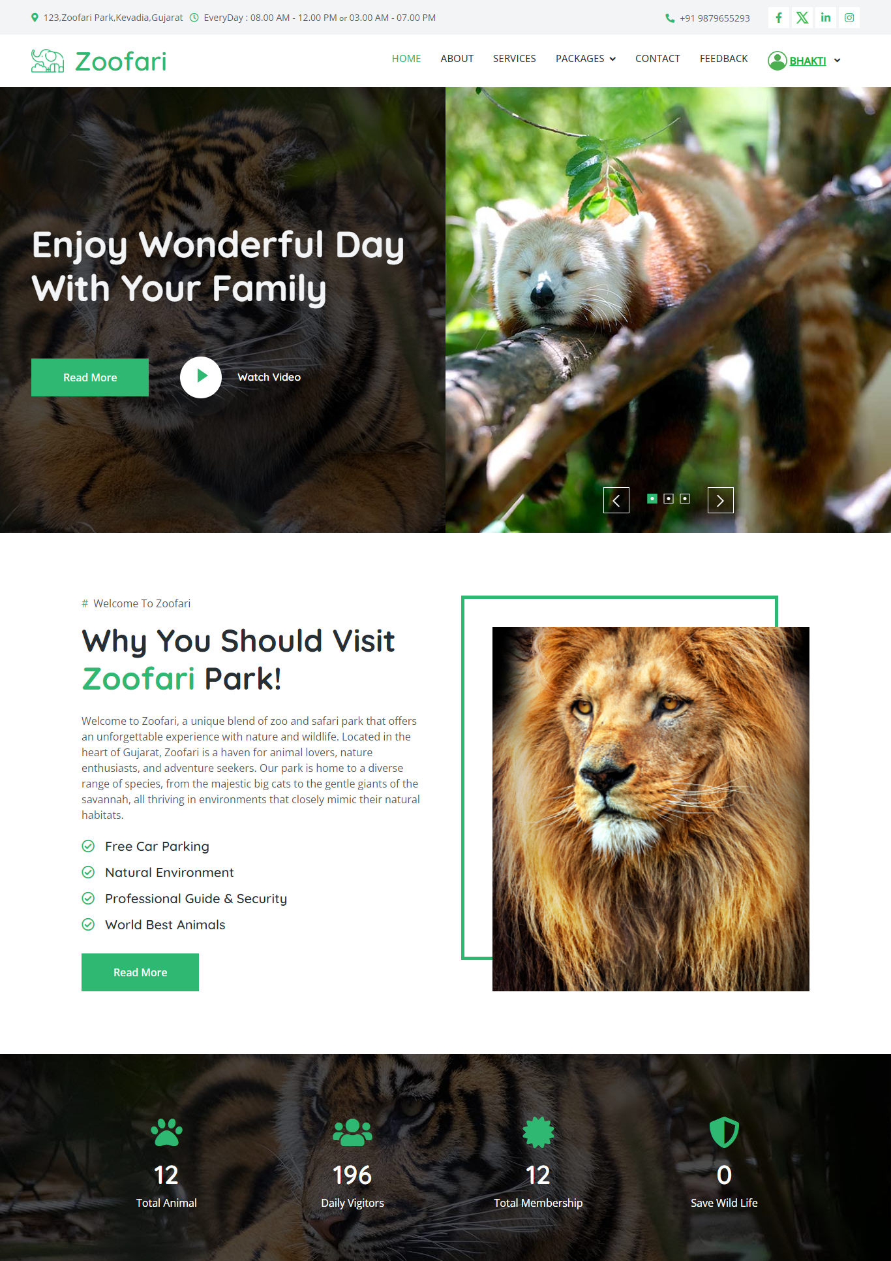

- Login Page

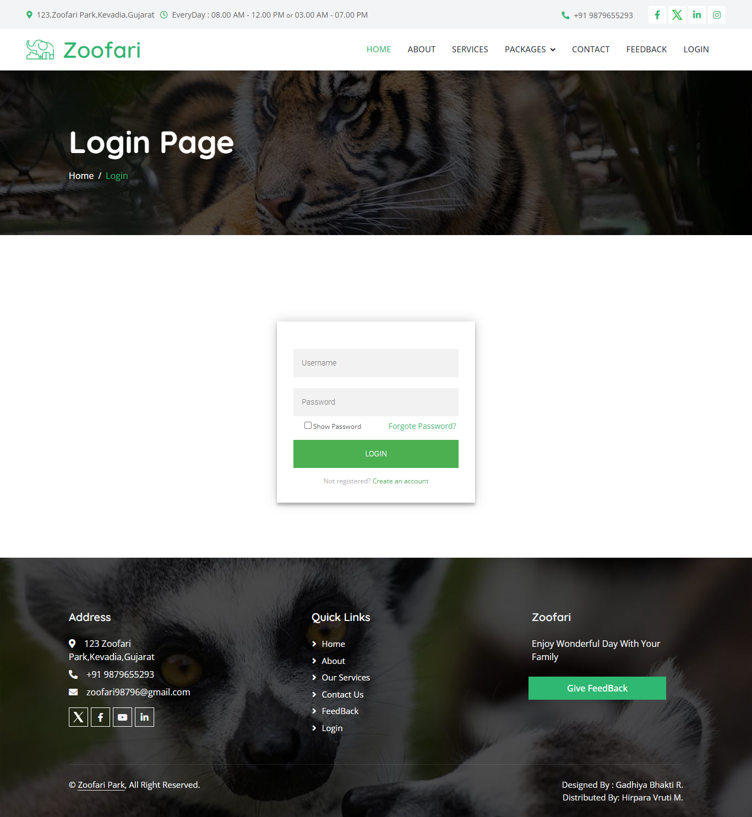

- Package page

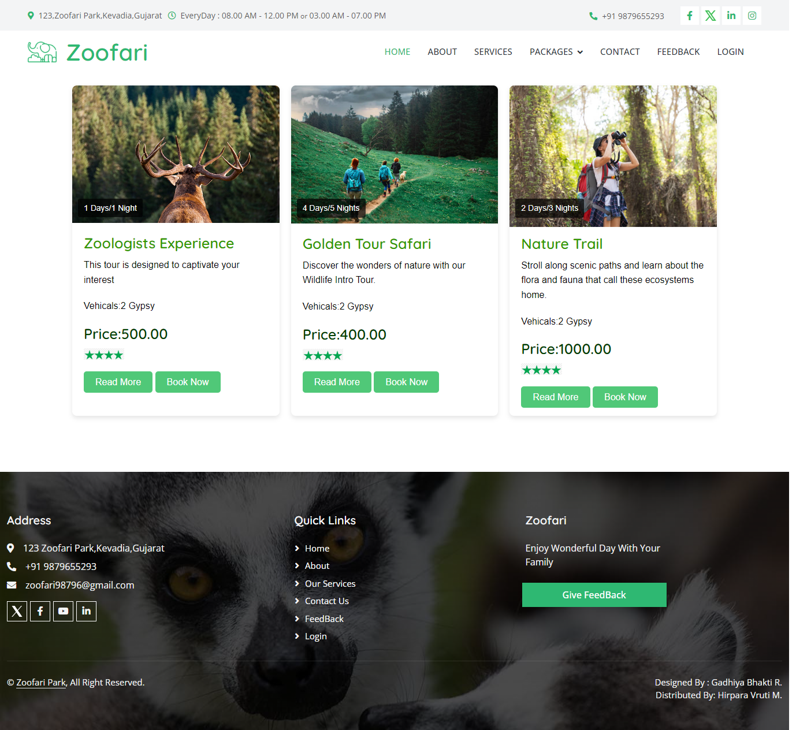

- About Page
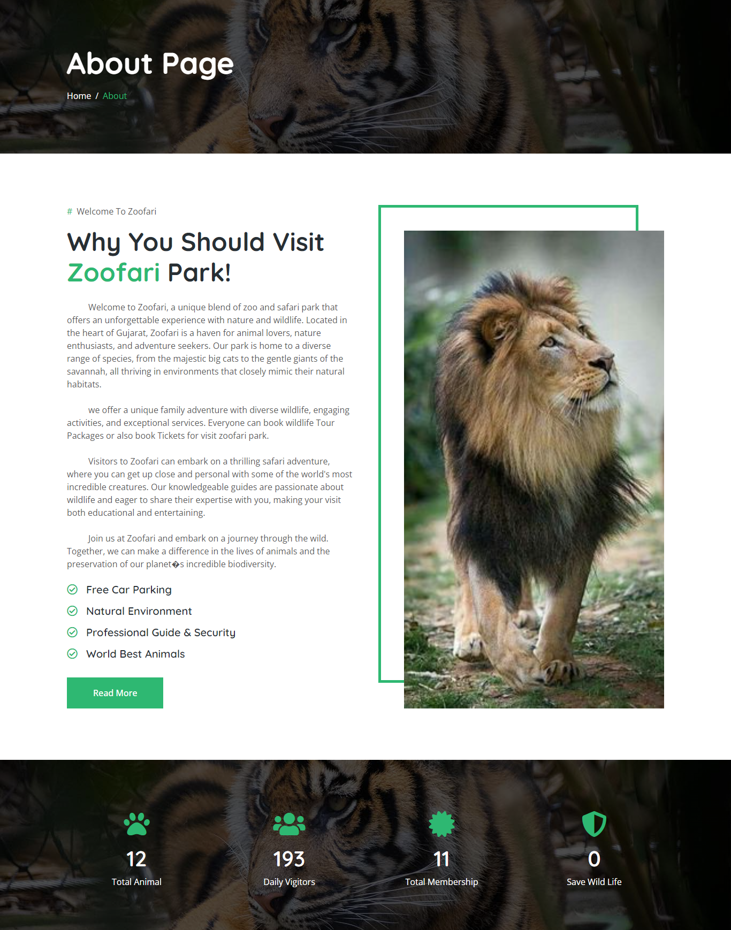
- Service Page

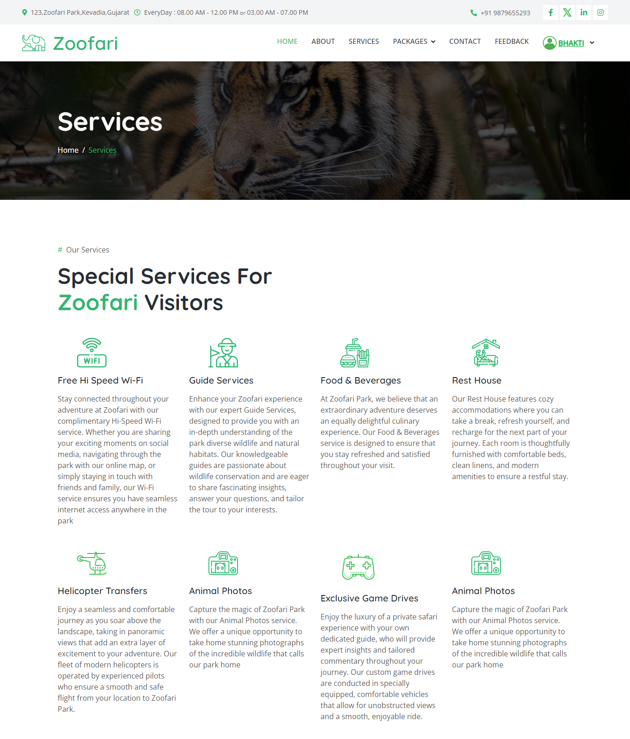

- Book package page
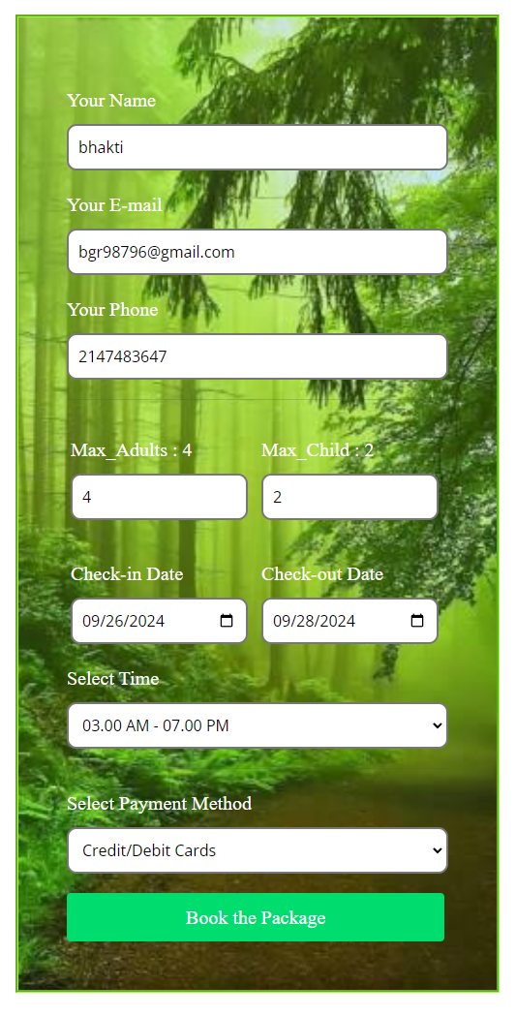
- After Booking package you got message box that conform you about booking success like below.
- Booking confirm message


- Booking Details

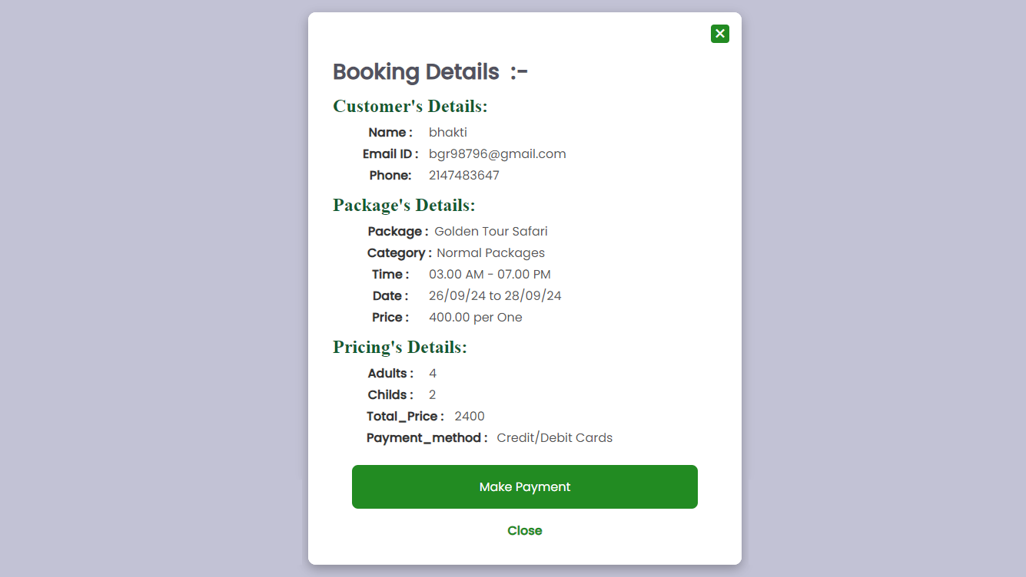

- Contact page

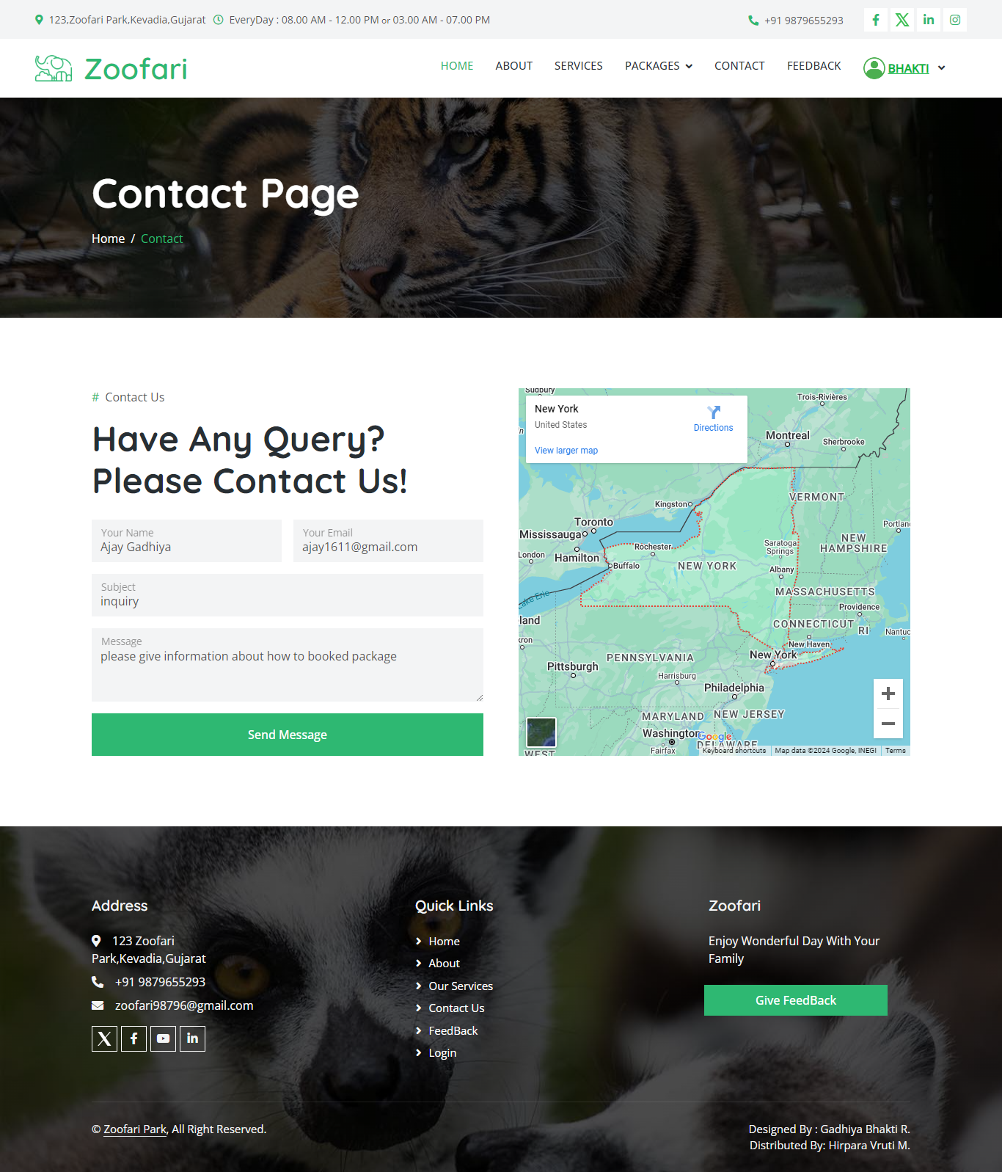

- Admin Side:
- Dashboard
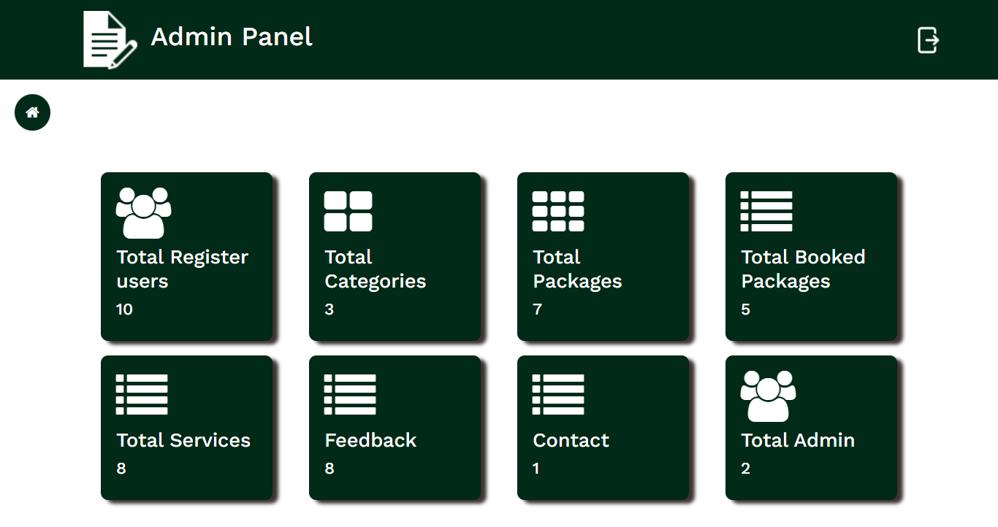

- Total Register User
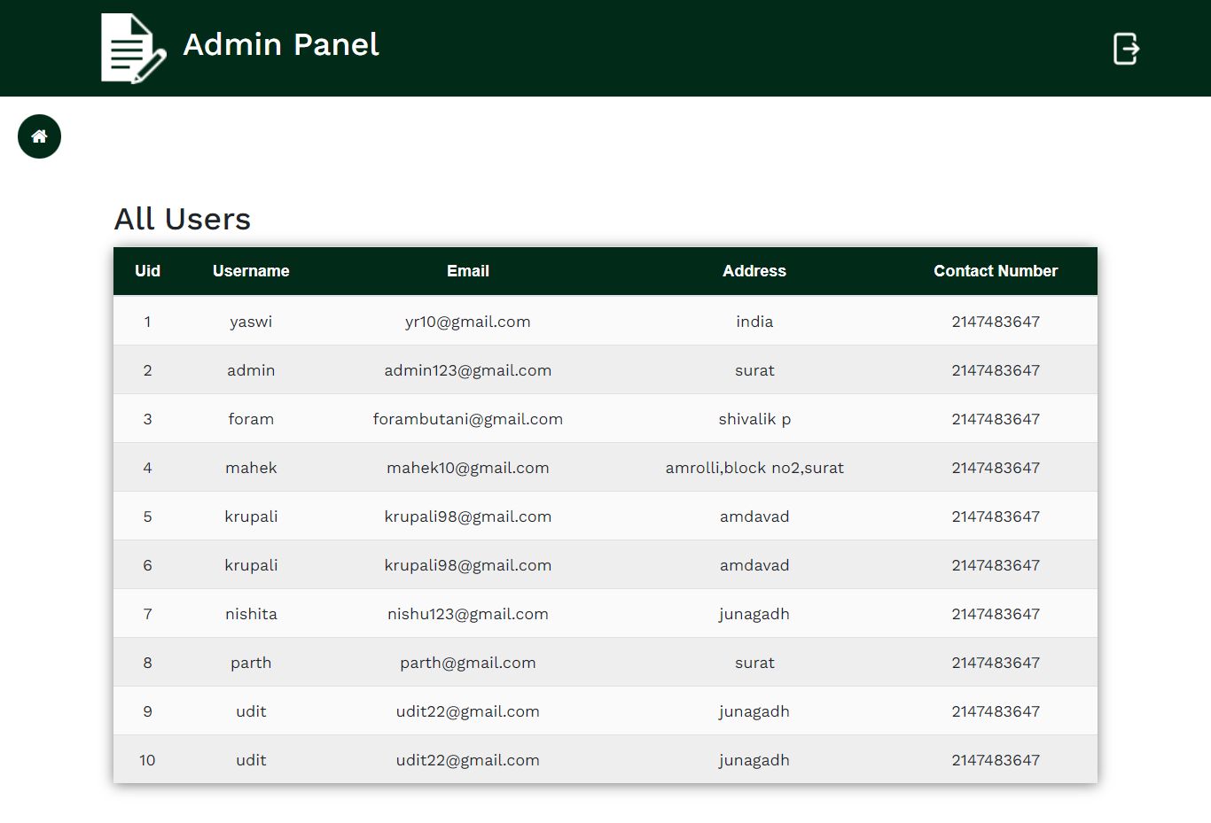
- Total Packages
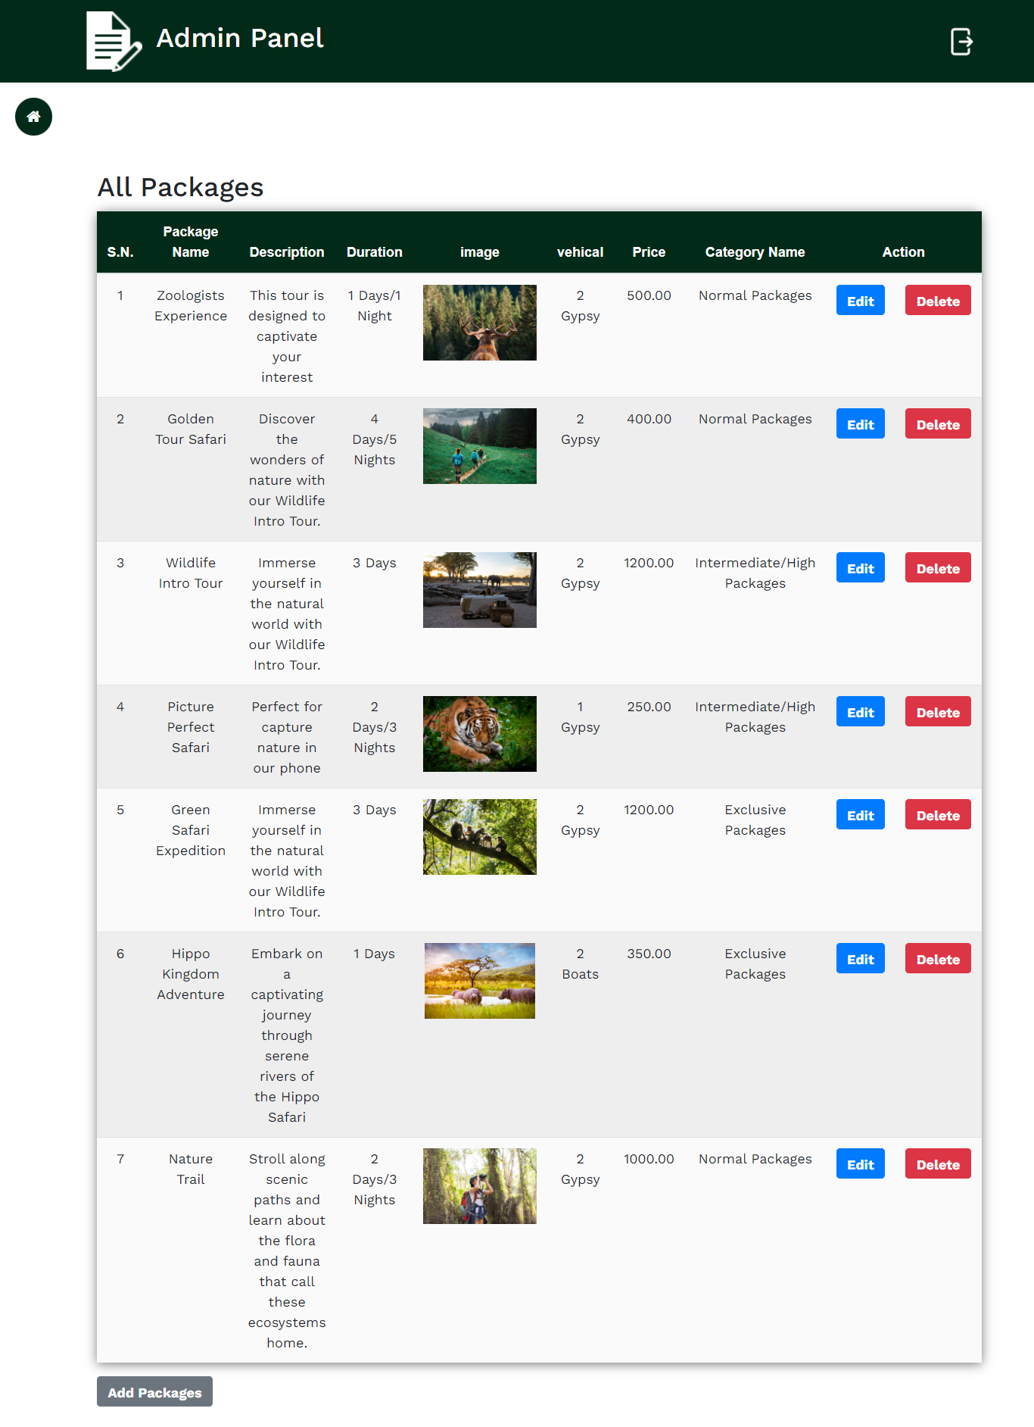
- Total Category
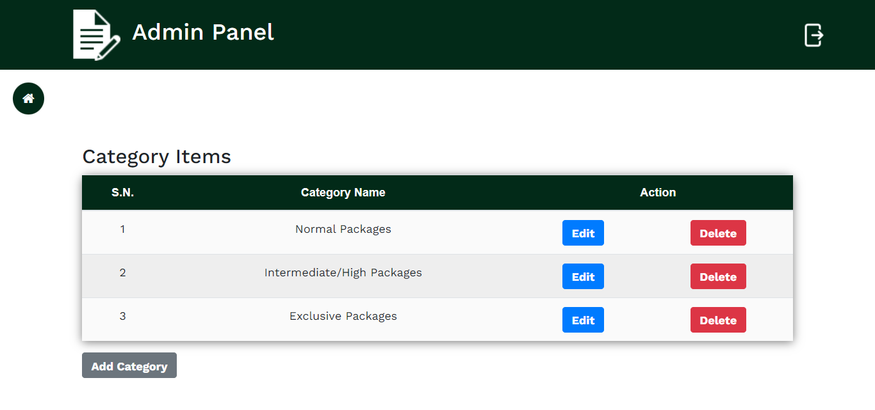

- Booked Packages
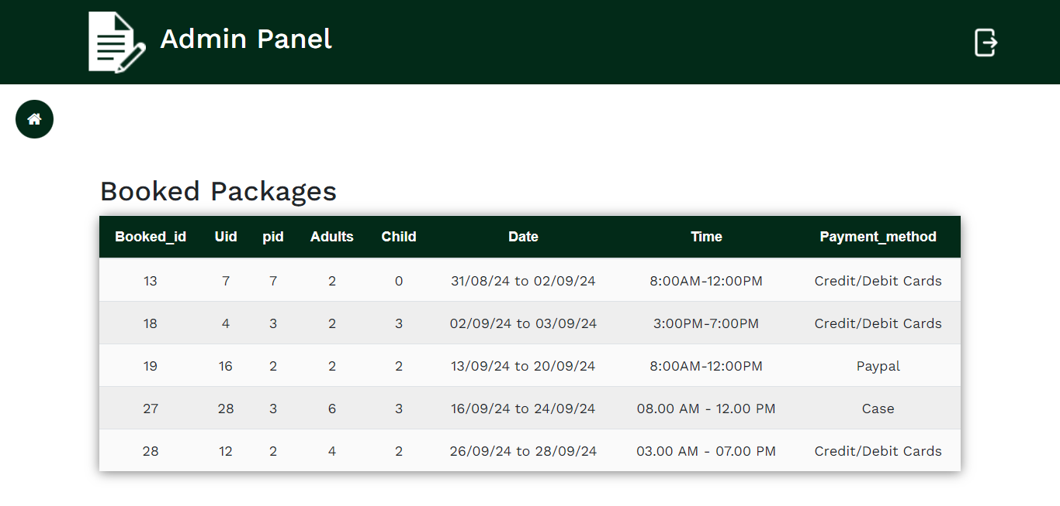

- Total Services
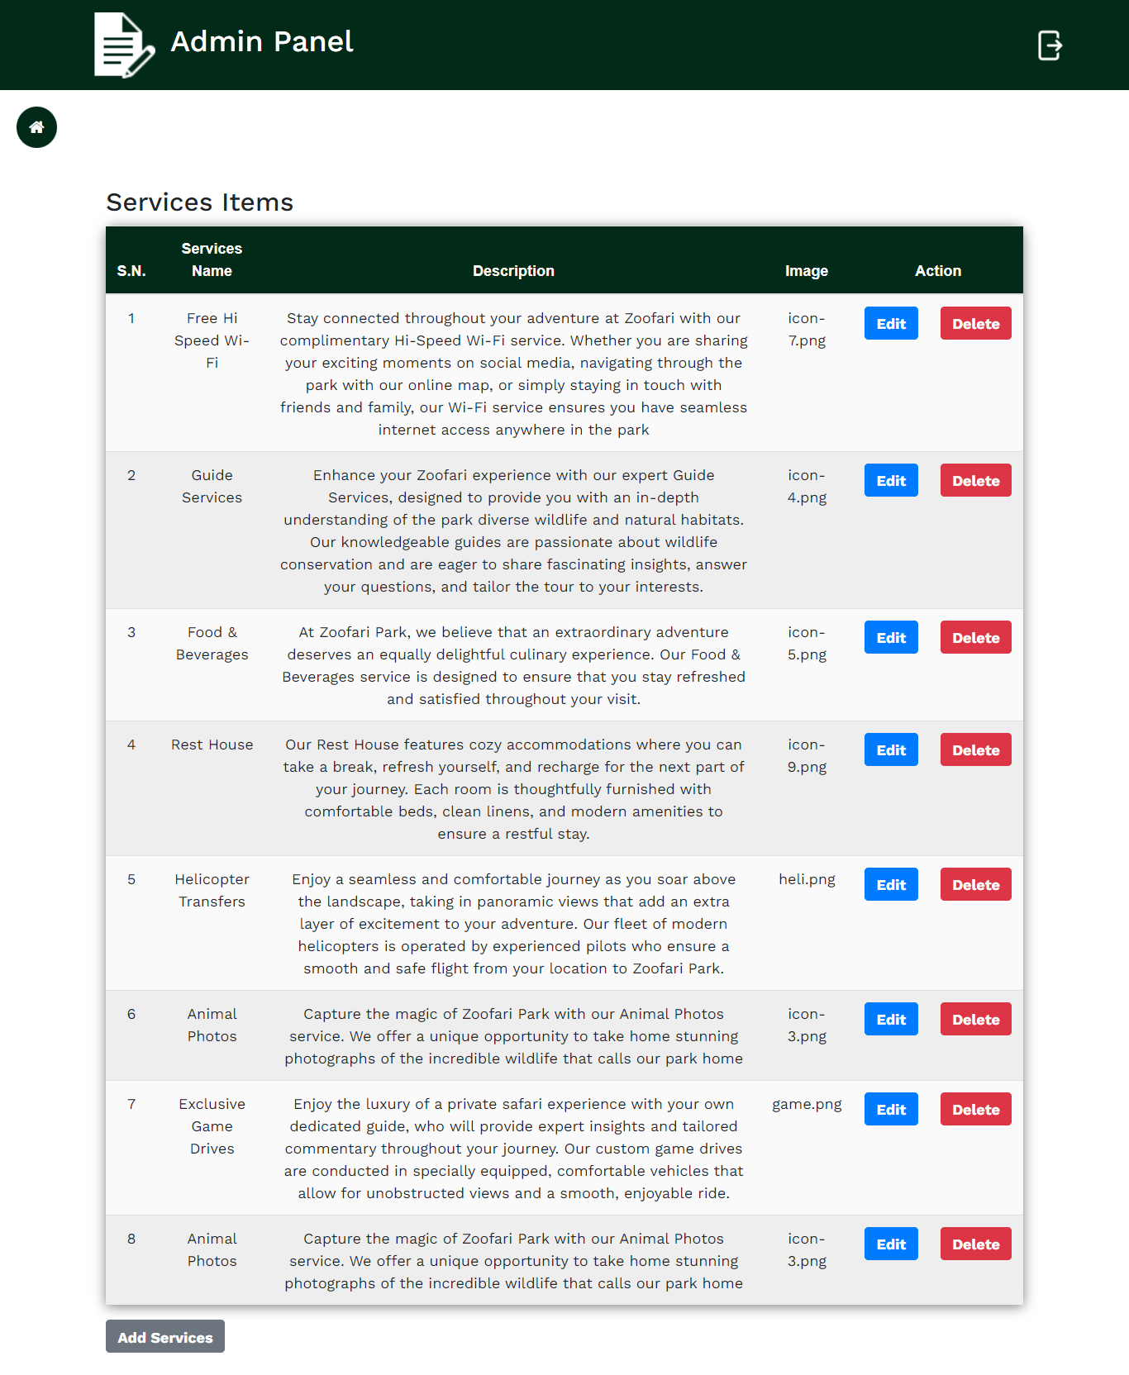

- Log-In Page Code:
<?php include 'header.php'; ?>
<!DOCTYPE html>
<html lang="en">
<head>
<meta charset="UTF-8">
<meta name="viewport" content="width=device-width, initial-scale=1.0">
<title>Registration Form</title>
</head>
<body>
<div class="form">
<form class="login-form" method="post" >
<input type="text" placeholder="Username" class="txt" name="unm" required/>
<input type="email" placeholder="Email" class="txt" name="email" required/>
<input type="password" placeholder="Password" class="txt" name="pwd" id="pwd" required/>
<label style="font-size:12px;margin-right:150px;padding-bottom:10px">
<input type="checkbox" id="showPassword" />&nbsp;Show Password

</label>
<textarea id="message" name="add" rows="4" cols="27" placeholder="Enter Addresss"></textarea><br><br>
<input type="phone" placeholder="Phone number" class="txt" name="pnum" required/>
<input type="submit" value="Submit" id="btn" name="submit"/>
<p class="message">Already registered? <a href="login.php">Login In</a></p>
</form>
</div>
</div>
<?php
if (isset($_POST['submit'])
// Get form data
$name = $_POST['unm'];
$email = $_POST['email'];
$password = $_POST['pwd'];
$address = $_POST['add'];
$phone = $_POST['pnum'];
$isAdmin=0;
$sql = "INSERT INTO user_rajister (username, email, password, Address, phon, isAdmin) VALUES ('$name', '$email', '$password', '$address', '$phone', '$isAdmin')";

if ($conn->query($sql) === TRUE) {
echo '<script>alert("Register successfully!");</script>';
echo'<script>window.location.href = "login.php";</script>';
}
}
// $conn->close();
}
?>
<?php include 'footer.php'; ?>
</body>
</html>

SOFTWARE TESTING

- Software testing in values the executing of a software component or system component of evaluates one or more properties of interest.
- Meet the requirements that guided its design the development. Responds correctly to all kinds of inputs. Perform its function whether on acceptable time. Is sufficiently usable.

Types of Testing :-
- White Box Testing
- Black Box Testing
- Validation Testing
- Alpha
- Beta
- Manually

White Box Testing :
Componet code
Text Output
Test Data

- As per our project, we have used white box testing model because independent paths of PHP file and loop are the cornerstones of the vast majority of all algorithms implemented in the software.
- White box testing sometime called glass box testing.

Black Box Testing :

Input Text

Output
System

- It takes an external perspective of the test object to derive test cases. These tests can be functional or non-functional, though usually functional.
- The test designer selects valid and invalid input and determines the correct output.
- Interface errors.
- Errors data structures or external data base access.
- Behavior or performance errors.
- Initialization and termination error.

Validation Testing :
- In validation testing, the software is assembling as a package. Validation testing is completely associated with requirement satisfaction of customers. According to this test, project is tested and found to be satisfactory for functional characteristic, behavioral characteristics and performance requirement.

Alpha :
- Alpha is the first letter of the Greek alphabet. In the system of Greek numerals, it has value of 1. It was derived from the Phoenician letter alpha.
- Letter’s that arose from alpha include the Latin A and Cyrillic letter A. in English, the noun” Alpha” is used as a synonym for “beginning”, or” first”, Reflecting its Greek roots.

Beta :
- Beta is the second latter or the Greek alphabet. In system of Greek numerals has valued has of 2. In ancient Greek, beta represented the voiced bilabial plosive. In modem Greek it represents the voice labiodentals fricative. Letters that arose from beta include the roman letter (B) and Cyrillic letter (5) and (B).

Manually :
- We have done manual testing for over project all the web pages validation, redirection, navigation are manually test by us.

Test Strategy :
- A test strategy is an outline that describe testing approach of the software development cycle. it is created to inform project manages, testers, and developers about some key issues of the testing objective, methods of testing new functions, total time and resources required for the project, and the testing environment.
- Design document describe the functionality of the software to be enabled in the upcoming release’s corresponding test strategy should be created to test the new feature sets.

Test Case :
- A test case is a set of conditions or variable under which a tester will determine whether a system under test satisfies requirements or works correctly. The process of developing test case can also help find problems in the requirements or design of an application.
- Formal test case
- Informal test case
- Typical written test cases
- Error Handling

Formal Test Case :
- The formal test case is order to fully test that all the requirements of an application are met, there must be at least two test cases for each requirement positive test and one negative test.
- If a requirement has sub-requirements, each requirement must haveat least two test cases.
- A formal test-case is characterized by a known input and by an expected output, which is worked out before the test is executed.

Informal Test Case :
- Information is valuable because it can affect behavior , decision, or an outcome.
- For example, if a manager is told her company’s net profit decreased in the past month, he may use this information as a reason to cut financial spending for the next month.
- A piece of information is considered valueless if, after receiving it, things remain unchanged. For a technical definition of information see information theory.

Typical Written Case :
- A test case is usually a single step, or occasionally a sequence of steps, to test the correct behavior/functionally, features of an application. An expected result or expected outcome is usually given.
- A written test case should also contain a place for the actual result. The larger test case may also contain prerequisite states or steps, and descriptions.
- These steps can be stored in a word processor document, spreadsheet, database or other common repository.

Error Handling :
- ERROR 1: Validation Error
- SOLUTION : Except Valid Password

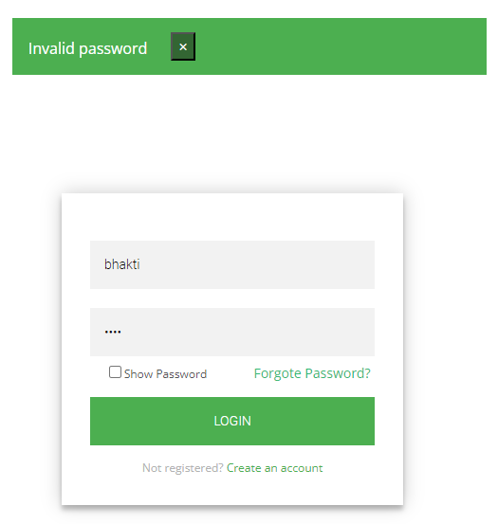

- ERROR 2: Login Error
- SOLUTION: Only authenticate person and logged person can access our site.

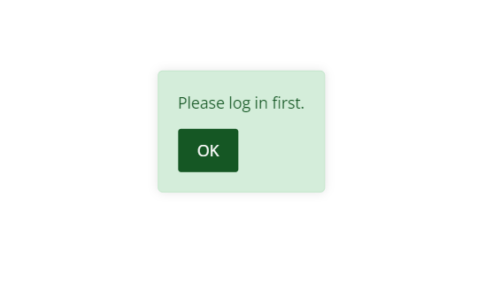

PROJECT IMPLEMENTATION

- Implementation simply means carrying out the activities description in your work plan.
- Executing a project of zoofari is a very complex mission, as it requires the coordination of a wide range of activities the overseeing if a team, the management of budget, the communication to the public, among other issues.
- Project implementation is the phase where visions and plans become reality. This is the logical, conclusion, after, evaluating, deciding, visioning, planning, applying for funds and finding the financial resources of a project.

User to function :
- A user define function is a programmed routine that has its parameters set by the user of the user of the system.

Admin:
- Admin is the heart of any application. In this project admin can view and manage all the details about the institute.
- The most important facility is to manage the input validation.
- Another thing is that, material update, delete by the admin and add tricks so user cannot make any change in profile details. This makes the database secure and reliable.

User :
- User an individual who uses as computer. This includes expert programmer as well as novice.
- An end user is any individual who runs an application program. User can login in the application with user id, password given after the registration

Secutity Features :
- Security is an important aspect of any software components, without reasonable level of security, the availability, the reliability and safety may be compromised if external attack causes some damage to the system.
- As our application web-based so network security is an aspect which should be provided by the servers where the application is deployed.
- User name and password should not accessible by any other user. Only administrator can delete users.
- Session is created as the user login and session is checked in all the modules.
- Session destroyed after the user logout to application.

LIMITATION AND FUTURE ENHANCEMENTS

Limitation :-
- In our park currently has limitations in offering enhanced animal photography tours, as we do not have professional photographers available to guide visitors.
- The Zoofari Park currently has limitations in providing a Wildlife Education Center, as we do not yet offer interactive exhibits, live demonstrations, or conservation workshops for visitors.
- The Zoofari Park currently has limitations in its conservation efforts, as we do not yet have a dedicated fund where a portion of every ticket sold contributes directly to wildlife conservation projects.
- The Zoofari Park currently has limitations, as guests are not able to participate in a formal adoption program at this time.
- The Zoofari Park currently has limitations in guest safety, as we do not yet have a GPS system to track animals and provide timely notices about potentially dangerous animals.

Enhancements :-
- In future, we plan to offer enhanced animal photography tours with professional photographers on hand to guide you.
- In future,we plan about Wildlife Education Center will offer interactive exhibits, live demonstrations, and conservation workshops for visitors.
- Our helicopter tours are getting an upgrade! Soon, guests will be able to enjoy longer routes, covering even more of the park’s stunning landscapes.
- In future, As part of our ongoing commitment to conservation, Zoofari is proud to announce the upcoming Save Wildlife Initiative. This program is designed to Protect wild animal
- In future we will establish a dedicated fund where a portion of every tickets sold will directly contribute to wildlife conservation projects.
- In future,Guest will soon be able to participate in out new adoption program
- In future, we will add GPS system to track animals so that we provide notice to the guest about violent animal as a safety.

CONCLUSION

- At Zoofari, we are dedicated to offering a seamless and memorable wildlife adventure experience.
- With our easy to use and user friendly online Booking system,you can plan your visit or safari in advance.
- Our secure platform ensures that once a package is booked.it remains reserved for you on your chosen date
- To access detailed information about our packages, simply log in to your account, and once you’ve booked your experience, a confirmation email will be sent directly to your gmail.
- We also offering a variety of packages categorized by functionality
- As we continue to grow and enhance our services,,our mission remain clear:to inspire a deep connection to the nature world.
- Together with your support we aim to create a sustainable future where wildlife therives and visitors leave with cherished memories
- Join us in exploring nature while ensuring a smooth and personalize experience from the moment you book until the moment you arrive.

BIBILOGRAPHIES

- Reference Book : -

No | Name | Author/Publication
1 | Modern PHP: New Features and Good Practices | Josh Lockhart(ORELLY)
2 | PHP Cookbook: Solutions & Examples for PHP Programmers | David Skylar and Adam  Trachtenberg (ORELLY)
3 | Programming PHP | Kevin Tatroe and Peter MacIntyre  (ORELLY)
4 | PHP for the Web: Visual QuickStart Guide (4th Edition) | Larry Ullman (Peachpit Press)

- Website :-

- https://www.php.net/manual/en/book.mysqli.php
- https://www.w3schools.com/php/
- https://www.tutorialspoint.com/index.htm

