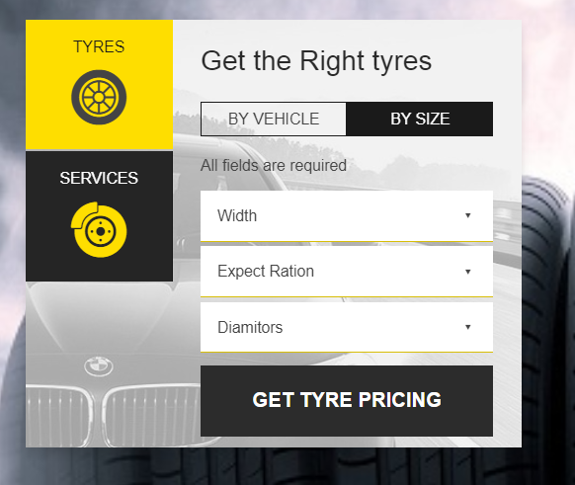

Add Image to show how they can check the size of the tyre. Check the following image.



<https://www.tyremarket.com/Car-Tyres>

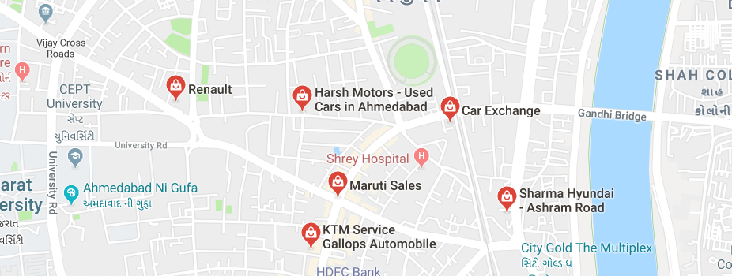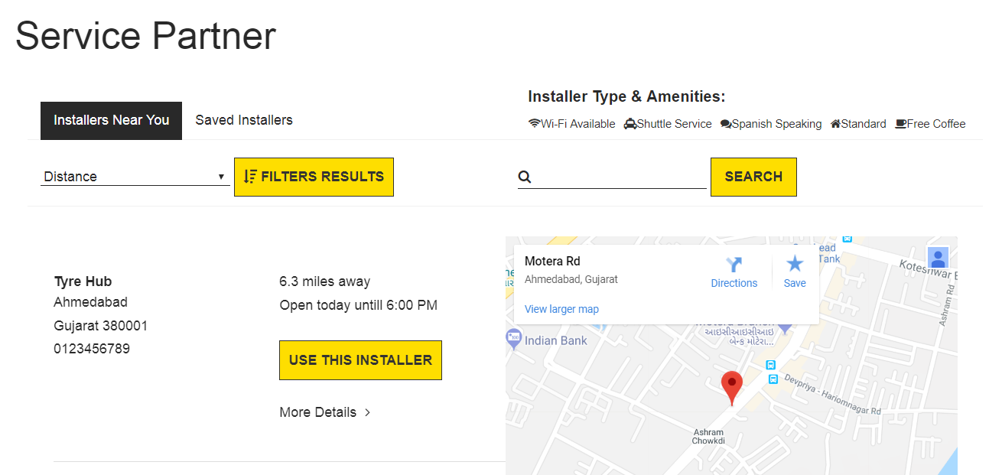

Installers List View

Installers Google View

Installers Google View

Installers List View

More Detail >

**Jay Ambee Tyres**

Shop No 15, 16, 3D Building,

Motera Cercal, Motera,

Ahmedabad 380005

**Phone: 91999 55555**