# **RBL ETL Tool**

Deployment

Features

Project code

# Deployment

1. Make sure Java is installed in system and classpath and path variables are set.
2. Extract the ZIP file anywhere. Preferably in C:/
3. Inside sql folder click in RBL.exe to launch the project.

# Features

## ParseSql

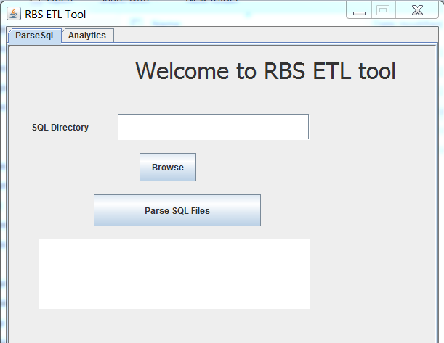

In Parse Sql Tab click on Browse button. Select the folder in which all sql files were pasted.

Software will fetch all the sql files available in the folder.

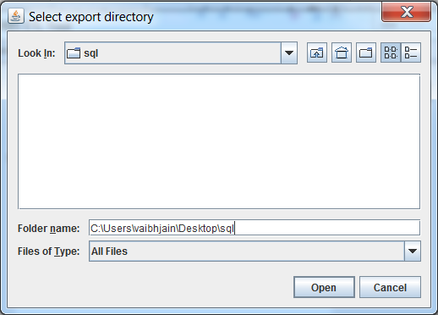

It will parse them and will create a results.csv file in the same folder from which sql files were fetched.

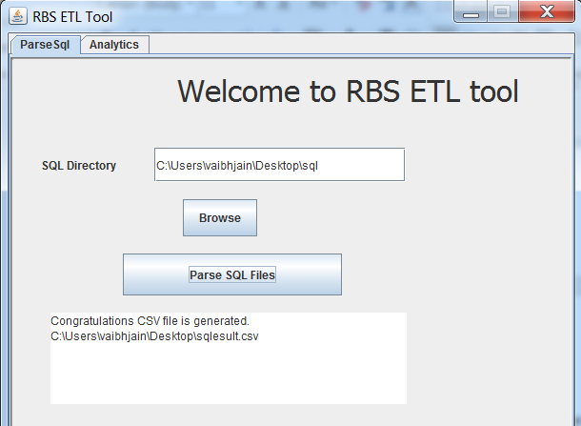

CSV File

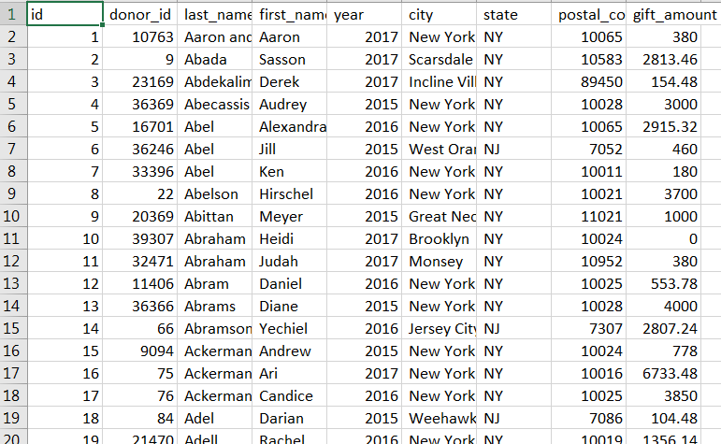

## Analytics

Once results.csv file is generated go to analytics tab

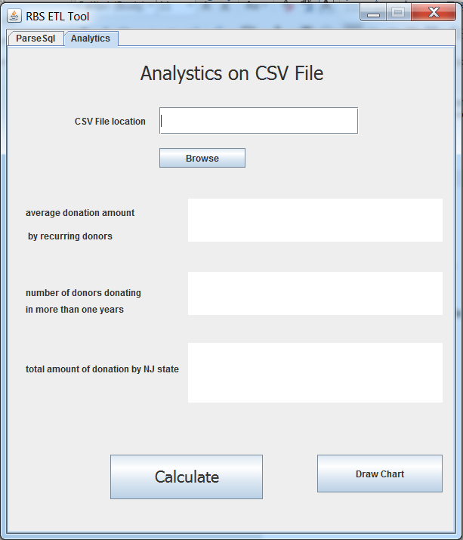

Select the results.csv file generated in previous tab.

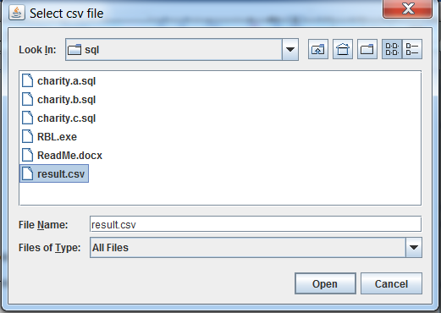

Click on Calculate button.

It will perform various analytics

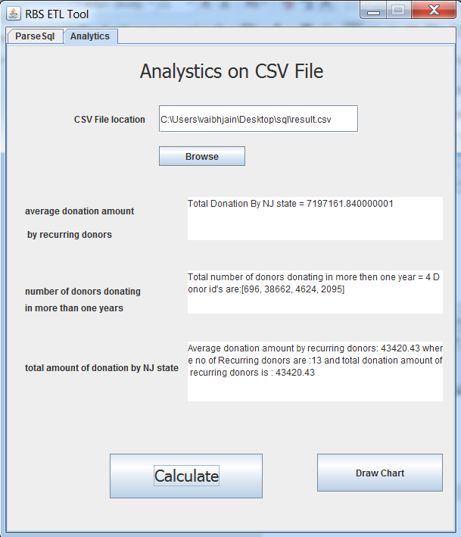

Once Analytics is done click on draw chart to see the citywise number of donors bar chart.

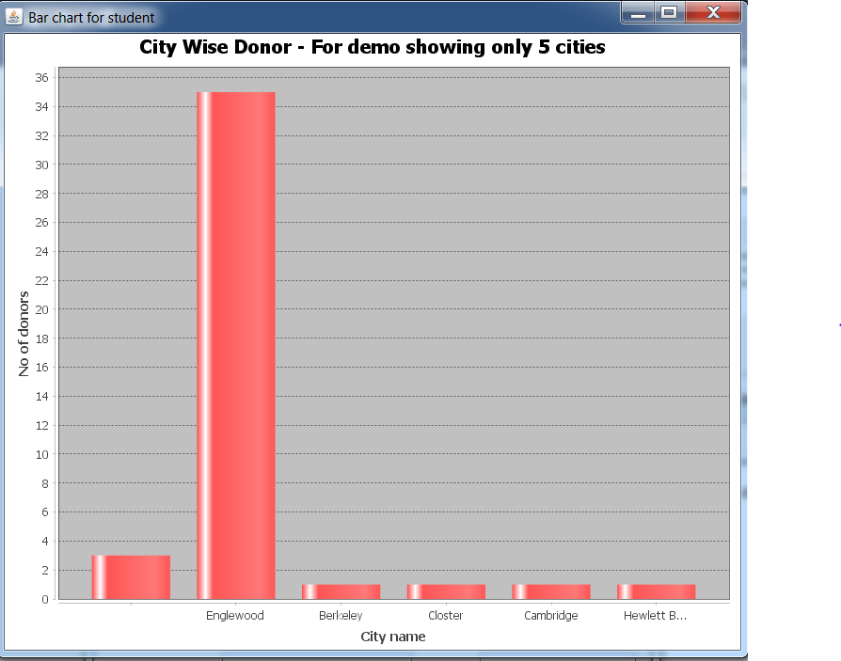

# Project Code

Project code is available in RBS ETL tool.zip file in the sql folder.

ParseSQLPanel.java contains the code for sql to csv parsing

AnalyticsOnFile.java contains the code for analytics and bar creation.

Please use this software carefully as not exception handling is done to restrict user from doing some wrong action.

You can contact me on [vaibhavjain_1@yahoo.com](mailto:vaibhavjain_1@yahoo.com) if you need any help for deployment of this project or for any other info.

Thank You - Vaibhav