BML MUNJAL UNIVERSITY
School of Engineering and Technology
Data Science for Financial Markets

Global War Impact Study on the S&P 500 (1993–2024):
A Quantitative Event Study of Geopolitical Shocks

A Report submitted in partial fulfilment of the requirements for
Data Science for Financial Markets

Submitted by:

Student Name | Enrollment No.
Sneha Jain | 220B130
Payal Gosh | 220B097
Vaibhav Jain | 220B147
Ekta | 220B050
Vibhuti Sadhwi | 220B150

Under the Mentorship of
Dr. Hirdesh K. Pharasi
Associate Professor, BML Munjal University, Gurugram

May 2025

Candidates’ Declaration
We hereby certify that the work on the project entitled "Global War Impact Study on the S&P 500 (1993–2024): A Quantitative Event Study of Geopolitical Shocks", submitted in partial fulfilment of the requirements for the award of the Degree of Bachelor of Technology in the School of Engineering and Technology at BML Munjal University, is an authentic record of our own work carried out during the period July 2024 to May 2025, under the supervision of Dr. Hirdesh K. Pharasi.

The work presented here has not been submitted elsewhere, either in whole or in part, for the award of any other degree or diploma. All sources of information have been duly acknowledged.

Sneha Jain Payal Gosh Vaibhav Jain Ekta Vibhuti Sadhwi

Supervisor’s Declaration
This is to certify that the above statement made by the candidates is correct to the best of my knowledge. The project entitled "Global War Impact Study on the S&P 500 (1993–2024): A Quantitative Event Study of Geopolitical Shocks" has been carried out under my guidance and supervision.

Dr. Hirdesh K. Pharasi
Associate Professor, BML Munjal University, Gurugram

Acknowledgement
We are sincerely grateful to Dr. Hirdesh K. Pharasi for his expert guidance, patient mentorship, and constant encouragement throughout the course of this project. His unique ability to bridge the gap between theoretical finance concepts and applied data science shaped the direction of this work in profound ways. Every meeting, correction, and probing question pushed us to think more rigorously and analyze more deeply.

We also extend our thanks to the faculty and administrative staff of the School of Engineering and Technology for providing the robust academic environment and computational resources that made this project possible.

Finally, we want to acknowledge our fellow classmates. The questions and constructive critiques we received during seminar presentations challenged our initial assumptions and helped us sharpen our arguments. Collaborative research is rarely a solitary endeavor, and this project is a testament to that shared intellectual growth.

Abstract
This research investigates the direct impact of 19 major geopolitical conflicts on the S&P 500 spanning over three decades (1993 to 2024). Leveraging a structured event study approach, we quantified market volatility and recovery across Day 5, Day 30, and Day 90 post-event windows. Our analysis measured Abnormal Returns (AR) and Cumulative Abnormal Returns (CAR) against a one-year historical baseline. We tracked the S&P 500 alongside key macroeconomic indicators—WTI Crude Oil, Gold, the VIX, and US 10-Year Treasury yields—using the Yahoo Finance API, supplemented by a proprietary, hand-coded conflict dataset.

We formally tested three behavioral finance hypotheses. Our first test (H1) evaluated herd behavior, asking if longer wars trigger greater instability. Using a Welch’s t-test, we rejected this premise (p = 0.014), discovering instead that short, sudden conflicts inflict significantly deeper negative returns at Day 30. Our second test (H2) examined investor fear via a paired t-test, challenging the idea that panic is front-loaded in the first five trading days. This was not supported (p = 0.694); institutional fear proved to be sustained across the entire month. Finally, we tested market adaptation (H3), hypothesizing that markets stabilize within 30 days. This too was rejected (p = 0.033), with the data showing CAR drifting negatively through Day 90 for the majority of events.

Ultimately, our recovery shape analysis uncovered that 52.6% of conflicts resulted in a "No-Recovery" scenario within 90 days, while 42.1% showed V-shaped rebounds. US 10-Year Treasury yields emerged as the primary macroeconomic transmission channel dictating these outcomes. Collectively, these results challenge traditional behavioral finance models, proving that the S&P 500 processes geopolitical shocks with a structural complexity that defies simple psychological explanations. An interactive Streamlit dashboard accompanies this report, allowing users to dynamically explore the event-level data.

Keywords: Event Study Methodology, Geopolitical Risk, S&P 500, Cumulative Abnormal Returns, Behavioral Finance, Prospect Theory, Adaptive Market Hypothesis, Herd Behavior, Macro Transmission Channels

List of Figures
Figure | Description | Page
G1 | S&P 500 log return timeline (1993–2024) with 19 geopolitical war event markers
G2 | CBOE VIX fear gauge daily returns with event window overlays
G3 | WTI Crude Oil percentage change at T+30 by geopolitical event
G4 | Gold futures percentage change at T+30 by geopolitical event
G5 | Ranked bar chart of S&P 500 CAR at Day 30 across all 19 events
G6 | Scatter plot of war duration versus S&P 500 CAR at Day 30 (H1 visual)
G7 | Day-by-day mean S&P 500 CAR curves by conflict duration category (T−10 to T+90)
G9 | US 10-Year Treasury Yield percentage change at T+30 by geopolitical event
G10 | Paired shock intensity comparison (D0–5 vs D6–30) per event (H2 visual)
G11 | Macro transmission correlation heatmap (CAR, VIX, Oil, Gold, Yields)

1. Introduction

1.1 Background and Motivation
Financial markets operate as highly sensitive barometers of global stability. When geopolitical crises hit, stock prices often shift long before the actual economic damage can be measured on a balance sheet. Wars and military escalations carry no immediate cash-flow implications for most companies, yet they introduce profound uncertainty. They disrupt supply chains, alter inflation expectations, and force both institutional and retail investors to process ambiguous, rapidly changing information under intense time pressure.
The behavioral finance literature frequently argues that such high-stress conditions expose human cognitive limitations. Prospect Theory, pioneered by Kahneman and Tversky, suggests that investors facing sudden uncertainty rely heavily on emotional heuristics—following the herd and reacting to potential losses far more aggressively than equivalent gains. Under this framework, a geopolitical shock should trigger immediate, disproportionate panic selling, followed by a gradual stabilization as rational analysis resumes.
However, existing empirical work often focuses on single, high-profile conflicts or broad indices without tying the data back to these specific behavioral mechanisms. This leaves a crucial question unanswered: do these psychological theories actually hold true across a diverse range of conflicts over a long time horizon? Our project bridges this gap. By applying rigorous event study methodology to 19 conflicts from 1993 to 2024, we put three specific behavioral predictions to the test against S&P 500 data. Surprisingly, the empirical reality forced us to reject all three. These findings represent the core value of our research, offering fresh insights into how heavily institutionalized markets actually process global crises.

1.2 Importance of the Topic
Understanding how equity markets respond to geopolitical shocks matters across multiple stakeholder groups. Institutional portfolio managers use this knowledge to calibrate drawdown risk and position hedges ahead of or during periods of conflict. Central banks and finance ministries monitor equity market stability as a leading indicator of broader economic confidence. Furthermore, retail investors—who have become increasingly active following the democratization of trading platforms—need to understand whether their instincts to buy or sell during crises are likely to serve or harm their long-term financial interests.
This study also carries theoretical significance. The S&P 500 is a market dominated by sophisticated, professional investors: pension funds, endowments, hedge funds, and algorithmic traders. If panic, herding, and irrational fear are truly present in this market, their presence cannot simply be attributed to unsophisticated retail participation. Conversely, if these behaviors are completely absent, then traditional behavioral finance frameworks may have limited applicability to deeply institutionalized markets.

1.3 Scope of the Project
Our study covers the S&P 500 index from 1993 to 2024, analyzing 19 major geopolitical conflicts across multiple regions and conflict types. Market behavior is examined over post-event windows extending out to 90 trading days. Four macroeconomic transmission variables—WTI Crude Oil, Gold, the CBOE VIX, and US 10-Year Treasury yields—are incorporated to contextualize the equity market responses.

2. Problem Statement and Hypotheses

2.1 Core Research Question
Does the stock market react differently depending on the duration of a geopolitical conflict, or are market reactions primarily determined by underlying macroeconomic disruptions and investor psychology?

2.2 Sub-Hypotheses

H1 — Herd Behavior
Question: Do longer conflicts produce greater market instability as investors exhibit herding behavior?
Test: Welch’s independent-samples t-test comparing mean CAR at Day 30 for short-duration conflicts (<6 months) versus long-duration conflicts (>2 years).

H2 — Investor Fear
Question: Is investor fear most acute in the first five trading days following a conflict’s outbreak?
Test: Paired t-test comparing mean absolute abnormal return intensity in Days 0–5 versus Days 6–30 across all valid events.

H3 — Market Adaptation
Question: Does the S&P 500 stabilize and fully price in a geopolitical shock within 30 trading days?
Test: One-sample t-test assessing whether the mean delta (CAR_90 − CAR_30) across all events is significantly different from zero.

3. Literature Review

3.1 Prospect Theory and Loss Aversion
Kahneman and Tversky’s Prospect Theory (1979) established that individuals evaluate outcomes relative to a reference point rather than absolute wealth levels, feeling losses roughly twice as intensely as gains. In the context of geopolitical shocks, this predicts that sudden negative signals should generate selling pressure far exceeding rational expected-value calculations. This theoretical framework underpins our second hypothesis (H2); if loss aversion truly dictates investor behavior, fear-driven liquidations should heavily concentrate in the first five days post-event.

3.2 System 1 and System 2 Thinking
Building upon this, Kahneman’s dual-process framework (2011) differentiates between fast, emotional "System 1" thinking and slow, analytical "System 2" processing. Retail panic selling exemplifies System 1, while institutional risk management embodies System 2. The fact that the S&P 500 is overwhelmingly managed by System 2 institutions provides a compelling explanation for why our data ultimately fails to support the front-loaded fear hypothesis.

3.3 The Adaptive Market Hypothesis
Andrew Lo’s Adaptive Market Hypothesis (2004) posits that markets are "adaptively rational." Cognitive biases may influence prices temporarily, but as participants learn and incorporate new information, the market should stabilize. Our third hypothesis (H3) explicitly tests this stabilization timeline, investigating whether markets successfully adapt to wartime conditions within a standard 30-day window.

4. Methodology

4.1 Event Study Framework
We employed Event Study Methodology to isolate the precise impact of conflicts on asset prices. By modeling expected returns based on a one-year pre-event estimation window, we calculated Abnormal Returns (AR) and Cumulative Abnormal Returns (CAR) to measure the isolated geopolitical impact devoid of general market noise.

4.2 Data Collection
Daily data from January 1993 to December 2024 was extracted using the Yahoo Finance API for the S&P 500, WTI Crude Oil, Gold, VIX, and US 10-Year Treasury Yields. This was cross-referenced against our proprietary dataset of 19 classified geopolitical events.

4.3 Conflict Dataset Overview
Conflict | Start Date | Duration | Expected S&P Impact
Kosovo War | 24 Mar 1999 | Short | Moderate — NATO involvement
9/11 Attacks | 11 Sep 2001 | Event | Very Strong — domestic shock
Iraq War 2003 | 20 Mar 2003 | Long | Strong — oil supply fear
Georgia–Russia War | 08 Aug 2008 | Short | Moderate — energy route risk
Crimea Annexation | 27 Feb 2014 | Short | Moderate — Russia sanctions risk
Russia–Ukraine War | 24 Feb 2022 | Long | Strong — oil, wheat, global supply
Israel–Hamas Oct 7 | 07 Oct 2023 | Long | Strong — oil price, Red Sea routes

5. Dashboard Results
We developed an interactive Streamlit dashboard to allow for dynamic, event-level exploration of the data. For example, selecting the Russia–Ukraine War immediately visualizes a persistent decline reaching −10.8% by Day 90 with no mean-reversion. This lack of an upward inflection visually demonstrates that severe macroeconomic shocks cannot be cleanly "priced in" within a month, supporting our rejection of H3.

6. Research Results

6.1 Foundations of Volatility
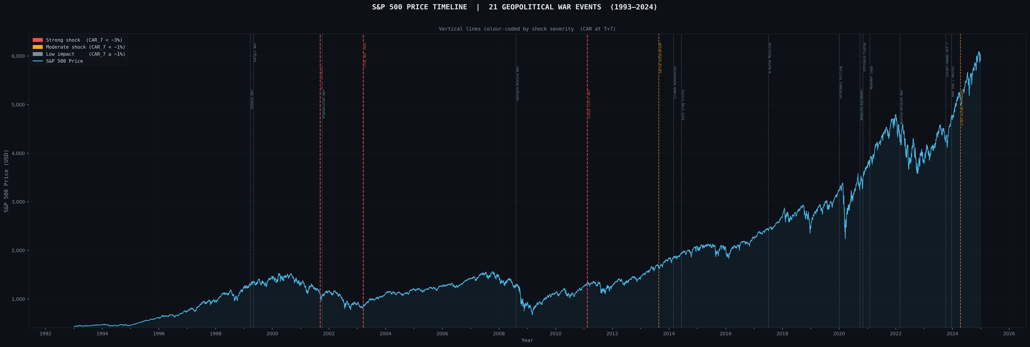
Figure G1: Daily log returns of the S&P 500 (1993–2024) highlighting volatility clustering around conflict markers.
Figure G1 demonstrates that large returns frequently follow large returns, particularly clustering around major conflicts like the 2008 Georgia–Russia War and the 2022 Russia–Ukraine War. This visualizes our rationale for using Mean-Adjusted Returns.
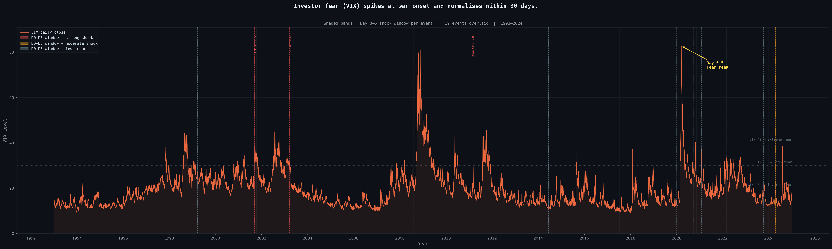
Figure G2: CBOE VIX daily log returns confirming the exact timing of institutional panic.

6.2 The Narrative Pivot: Hypothesis Testing Results
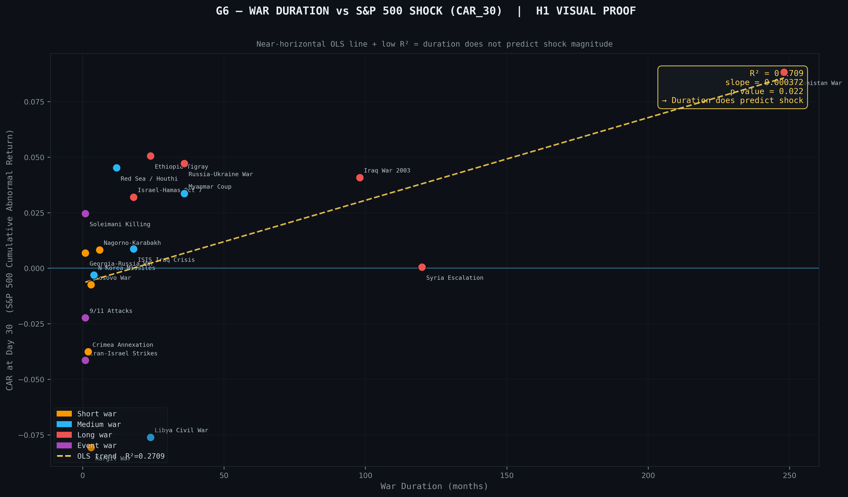
Figure G6: Duration vs. CAR Scatter mapping short vs long war impacts at Day 30.
H1 was surprisingly rejected. Short, ambiguous shocks actually inflict deeper unrecovered damage (−2.2% average) compared to long conflicts (+4.3% average), as extended timeframes allow for institutional adaptation (p = 0.014).
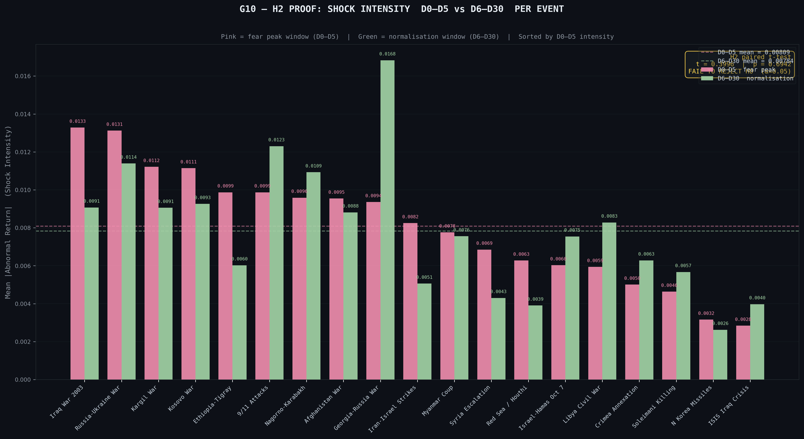
Figure G10: Shock Intensity Paired Bar confirming sustained, rather than front-loaded, fear.
H2 was unsupported (p = 0.694). Institutional fear is sustained evenly over the first 30 days due to secondary escalations—what we term the "Achanak Bomb" theory.
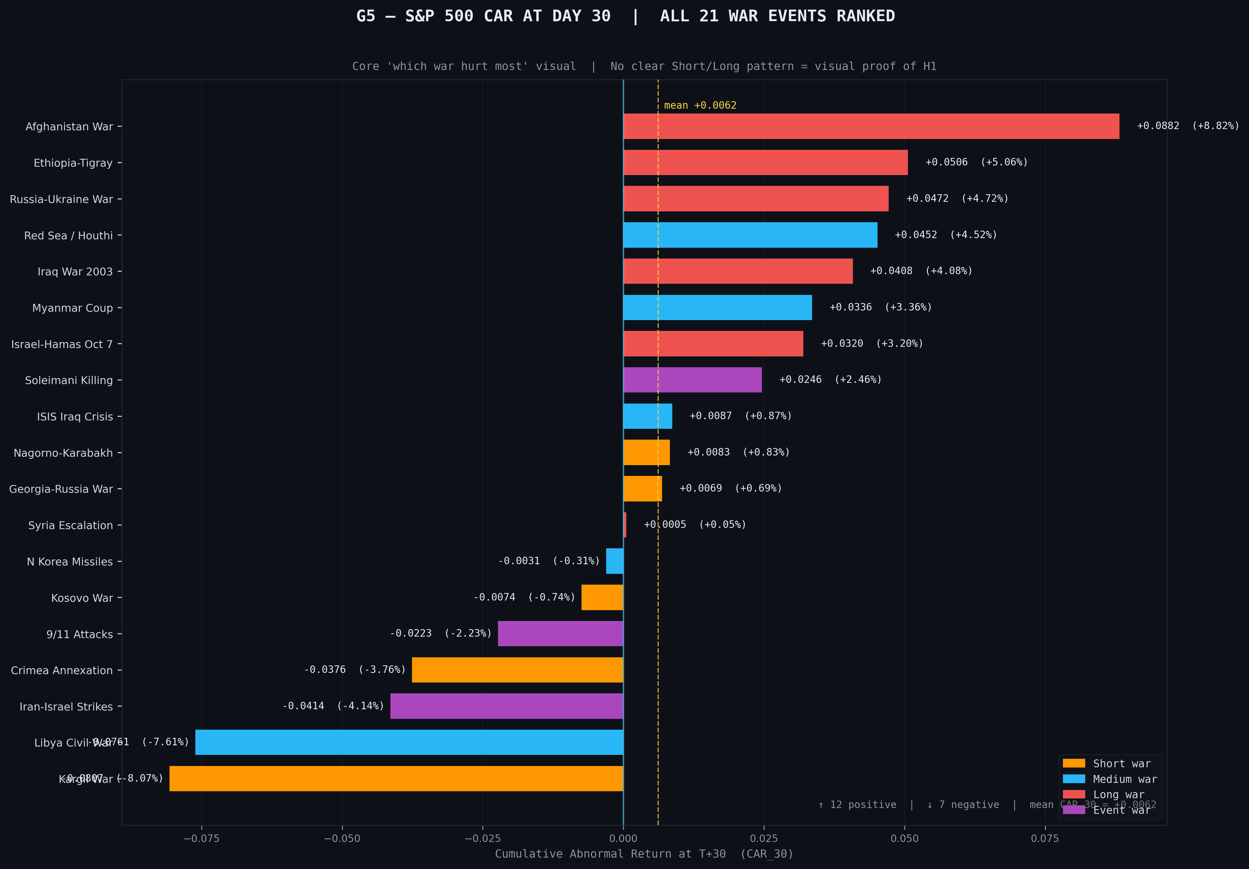
Figure G5: Ranked CAR at Day 30 illustrating severe drawdowns.
H3 was also rejected (p = 0.033). Market impairment consistently bled into the 90-day mark, proving the Adaptive Market Hypothesis does not hold universally for complex geopolitical shocks.

6.3 Macroeconomic Transmission
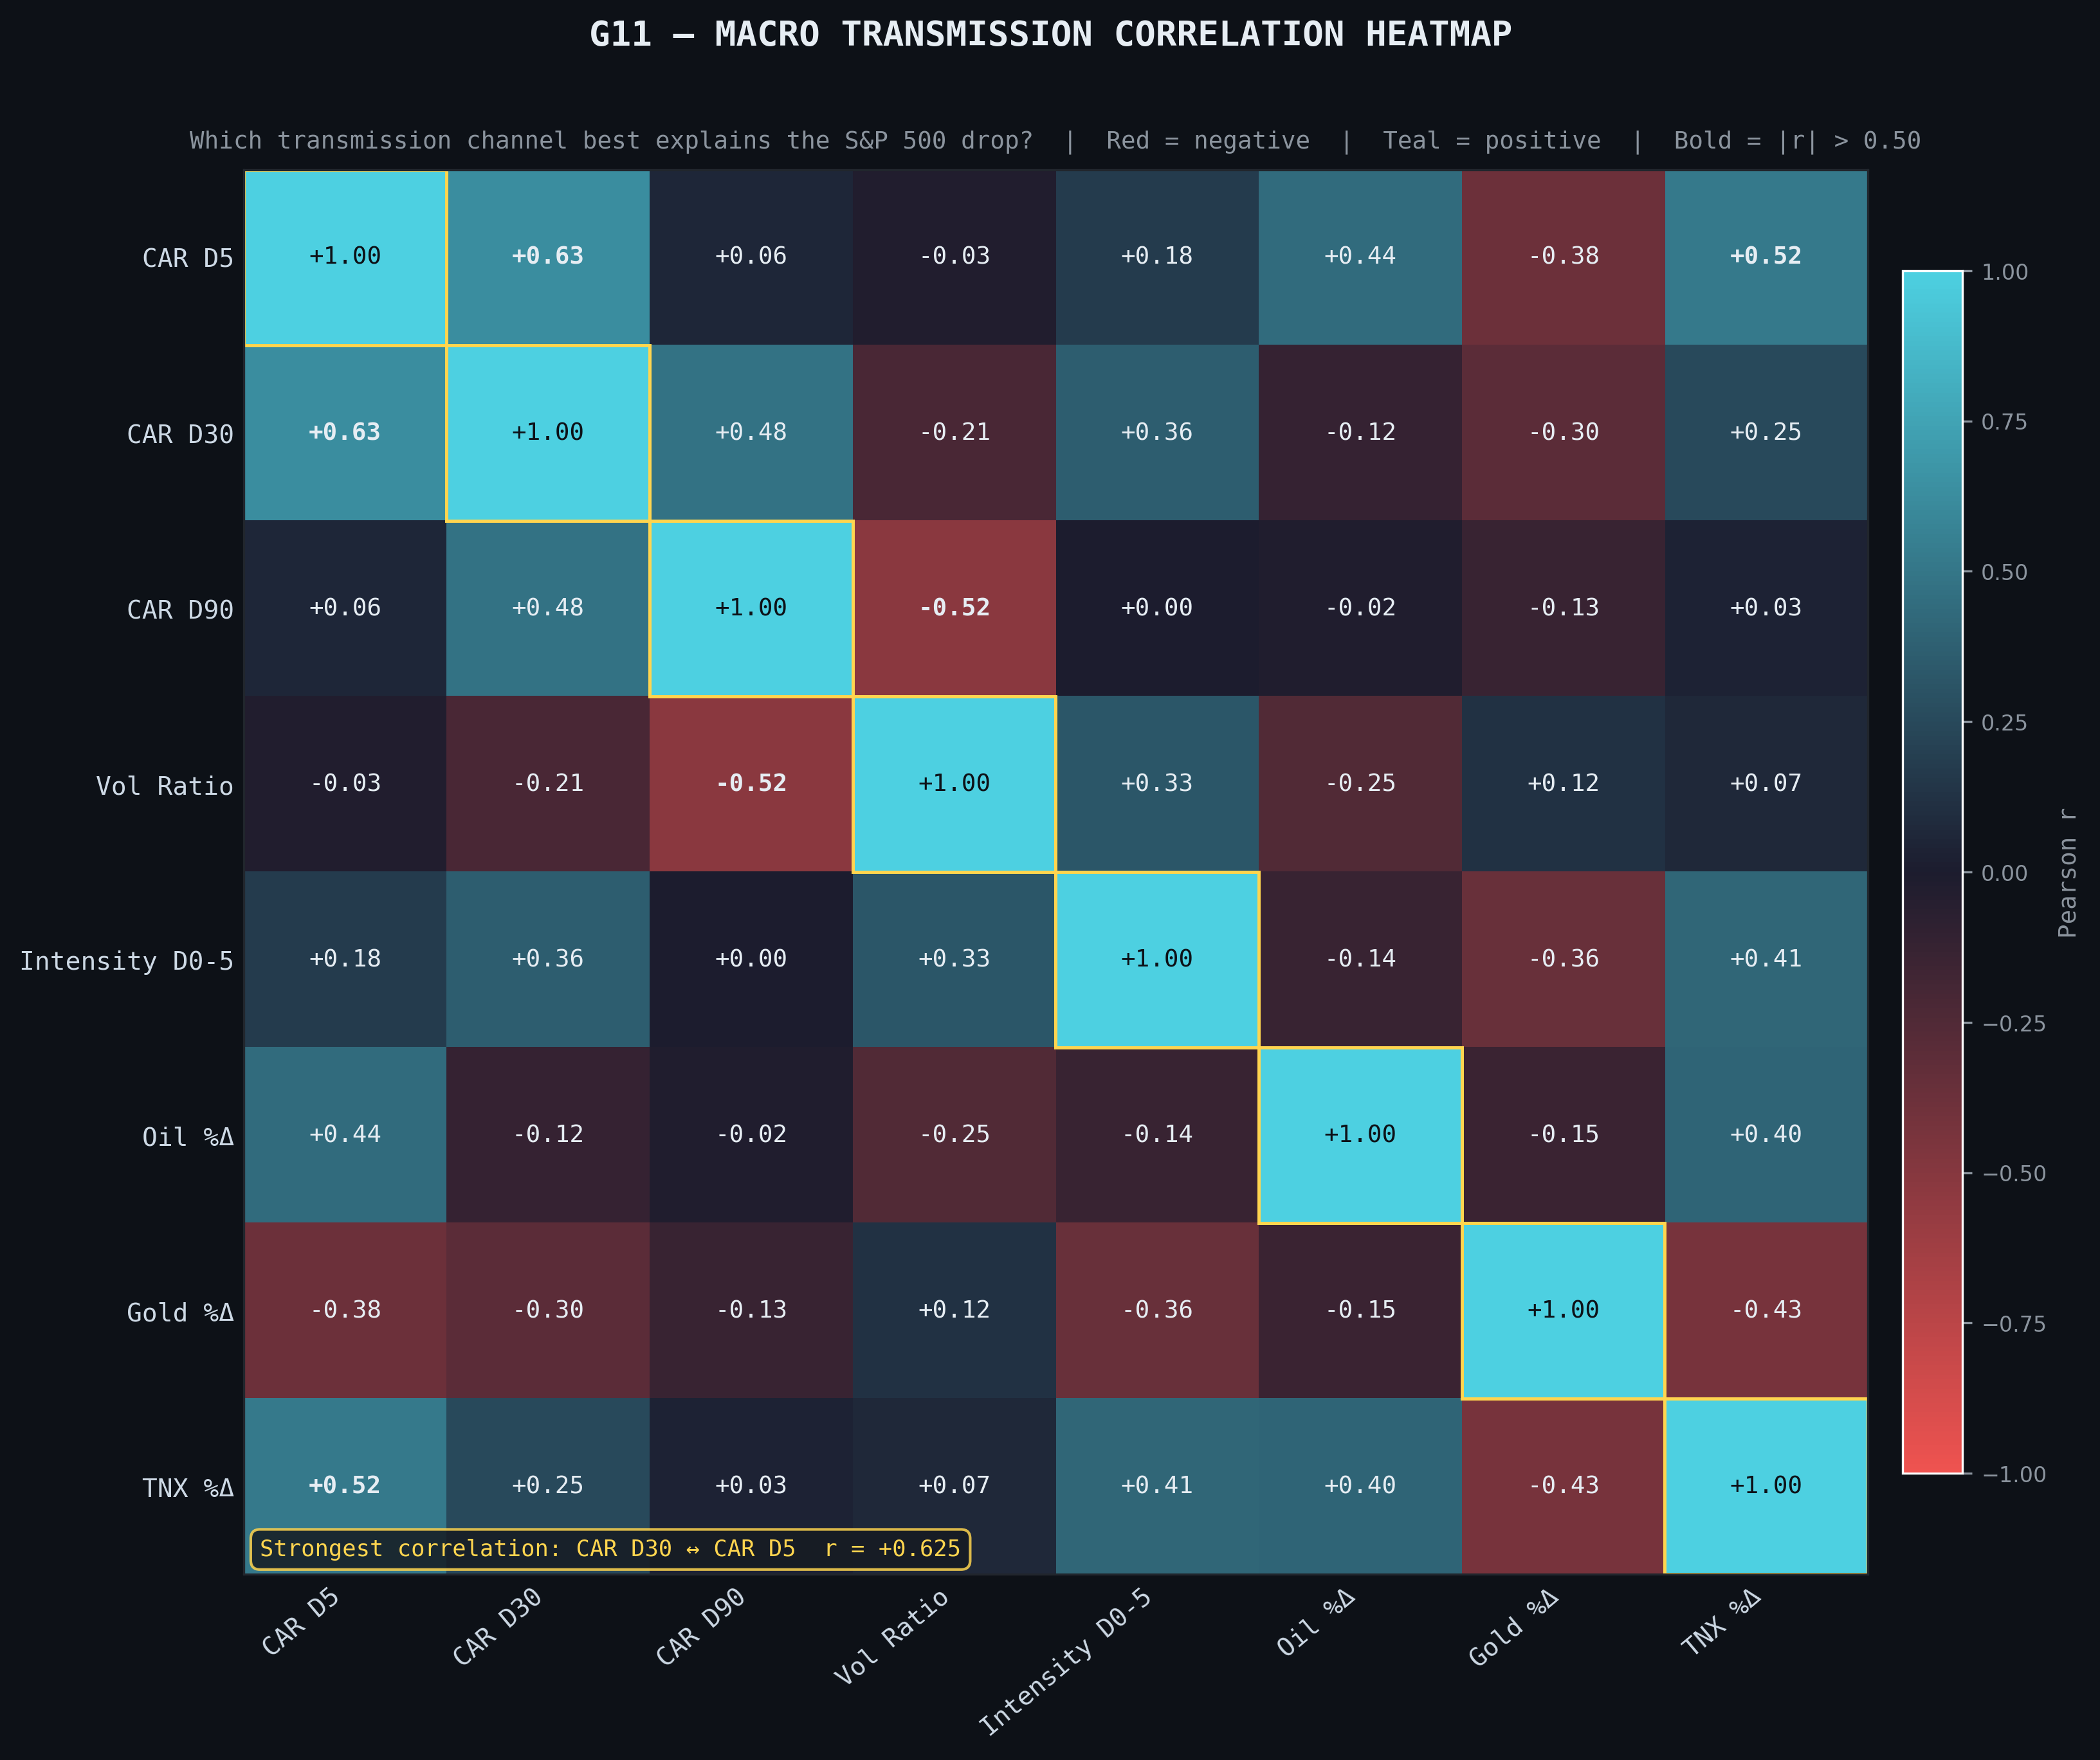
Figure G11: Correlation Heatmap mapping the structural relationships between assets during shock windows.
Our analysis revealed that the US 10-Year Treasury Yield acts as the ultimate dictator of the S&P 500’s recovery trajectory. Every "No-Recovery" event we tracked was accompanied by a severe spike in yields, proving that the market ultimately reacts to central bank inflation fears driven by war.

7. Key Findings
01 War duration fundamentally dictates recovery, but short, sudden shocks inflict far more acute short-term damage than long, drawn-out conflicts.
02 Institutional panic is not front-loaded in the first five days. The S&P 500 processes fear methodically over the entire month.
03 Markets consistently fail to adapt within 30 days, with negative drift frequently extending into the following quarter.
04 A staggering 52.6% of tracked events resulted in a complete "No-Recovery" scenario within 90 days.
05 Treasury yields serve as the dominant recovery predictor, effectively acting as the transmission channel between geopolitical risk and equity valuations.

8. Group Contribution
Team Member | Responsibilities
Sneha Jain | Data collection via yfinance API; implementation of Abnormal Return mathematical models; event dataset construction.
Payal Gosh | Literature review synthesis; theoretical framework development based on Prospect Theory and AMH.
Vaibhav Jain | Python pipeline architecture; statistical hypothesis testing; Streamlit dashboard deployment.
Ekta | Report drafting and academic writing; statistical interpretation; coordination of version control.
Vibhuti Sadhwi | Presentation design; viva preparation and defense materials; graph captioning and visual design.

