SKILLS DEVELOPMENT LAB

ASSIGNMENT 2 – HANGMAN

BY

VAIBHAV JAISWAL

PRN: 17070122071

FINAL YEAR, 2017-2021

**Problem Statement**

Build the Hangman Game using Python

**Logic**

1. Starts the game using play_hangman function.
2. Selects a word at random from words.py file
3. Hides the characters in the word randomly and replaces them with “_”
4. Displays the hangman states and asks the user to guess a character
5. On a correct guess, reveals the hidden states of those character and updates the list of hidden characters
6. On a wrong guess, reduces the number of tries by 1 and based on that changes the hangman states
7. If all the hidden words are guessed correctly then sets the guessed_word to True and displays the win message
8. If all the tries are gone I.e., tries = 0 and word is not yet guessed then displays the loser message as well as the loser state of hangman
9. End the game
10. Asks the user if they want to play another game or not.

**Code**

#HANGMAN code python

from words import word_list

from random import choice,sample,randint

import os

from time import sleep

class Hangman():  ## Define the Hangman class

    def __init__(self) -> None:

        self.hangman_states = stages = [  # final state: head, torso, both arms, and both legs

                """

                   --------

                   |      |

                   |      O

                   |     \\|/

                   |      |

                   |     / \\

                   -

                """,

                # head, torso, both arms, and one leg

                """

                   --------

                   |      |

                   |      O

                   |     \\|/

                   |      |

                   |     /

                   -

                """,

                # head, torso, and both arms

                """

                   --------

                   |      |

                   |      O

                   |     \\|/

                   |      |

                   |

                   -

                """,

                # head, torso, and one arm

                """

                   --------

                   |      |

                   |      O

                   |     \\|

                   |      |

                   |

                   -

                """,

                # head and torso

                """

                   --------

                   |      |

                   |      O

                   |      |

                   |      |

                   |

                   -

                """,

                # head

                """

                   --------

                   |      |

                   |      O

                   |

                   |

                   |

                   -

                """,

                # initial empty state

                """

                   --------

                   |      |

                   |

                   |

                   |

                   |

                   -

                """

        ]

    def get_word(self) -> str:

        """

        returns a random word at random

        Returns:

            str: random word

        """

        return str(choice(word_list).upper())

    def display_state(self,tries : int,word_completion_state : list) -> None:

        """

        This Function printes the current state of hangman with

        some preset messages as well as print the remaining tries

        Args:

            tries ([int]): Number of tries remaining

            word_completion_state ([list]): The current state of the hidden character

                                            in the word

        """

        print(f"{'-' * 20}HANGMAN{ '-' * 20}\n\n")

        print(self.hangman_states[-(tries+1)] + "\n")

        print(f"WORD ------> {' '.join(word_completion_state)}")

        print(f"Tries Remaining : {tries}")

    def play_hangman(self) -> None:

        """

        Initiates a game of hangman

        Use has 6 tries to complete the word selected at random

        after tries run out or word is guessed , display a win

        or loss message and exit the game

        """

        tries=6

        current_word=self.get_word()

        guessed_word = False

        word_hidden_states = [current_word[indx] for indx in sample(range(0, len(current_word)-1), randint(1, len(current_word)-2))]

        word_completion_state = [letter if letter not in word_hidden_states else "_" for letter in current_word]

        while tries > 0 and not guessed_word:

            os.system('cls' if os.name == 'nt' else 'clear') ## Clear the terminal for new lines to be printed

            self.display_state(tries,word_completion_state)

            guessed_char=str(input("Guess a Character : ")).upper()

            if guessed_char in word_hidden_states :

                print("\nCorrect Guess !!!!!! Updating..........")

                for indx,_ in enumerate(word_completion_state) :

                    if guessed_char == current_word[indx]:

                        word_completion_state[indx]=guessed_char

                word_hidden_states = [char for char in word_hidden_states if char != guessed_char]

                guessed_word = False if "_" in word_completion_state else True

                sleep(1)

            else :

                print("\nIncorrect Guess!!! Updating!!!!!!")

                sleep(1)

                tries=tries-1

        if tries == 0 and not guessed_word:

            os.system('cls' if os.name == 'nt' else 'clear') ## Clear the terminal for new lines to be printed

            print(f"{'-' * 20}HANGMAN{ '-' * 20}\n\n")

            print(self.hangman_states[-1] + "\n")

            print(f"No Tries Remaining , YOU LOST !!!!!")

            print(f"CORRECT WORD was ------> {current_word}")

            print(f"GAME OVER")

        if guessed_word:

            os.system('cls' if os.name == 'nt' else 'clear') ## Clear the terminal for new lines to be printed

            print(f"{'-' * 20}HANGMAN{ '-' * 20}\n\n")

            print(self.hangman_states[-tries] + "\n")

            print(f"YOU GUESSED THE WORD CORRECTLY !!!")

            print(f"WORD was ------> {current_word}")

            print(f"Congratulations You win")

if __name__ == "__main__":

    hangman=Hangman()

    continue_choice='y'

    while continue_choice == 'y':

        hangman.play_hangman()

        continue_choice=str(input("Do you want to play another game (Y/n) : "))

        os.system('cls' if os.name == 'nt' else 'clear') ## Clear the terminal for new lines to be printed

**OUTPUT**

Pass Condition

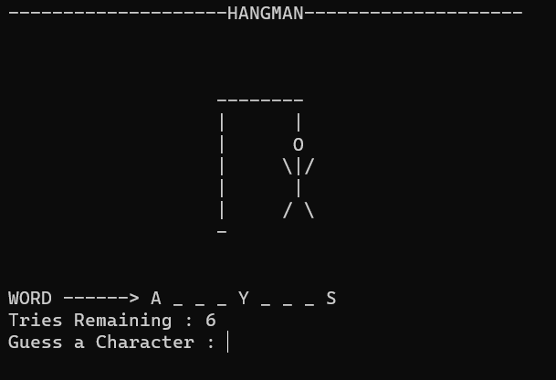

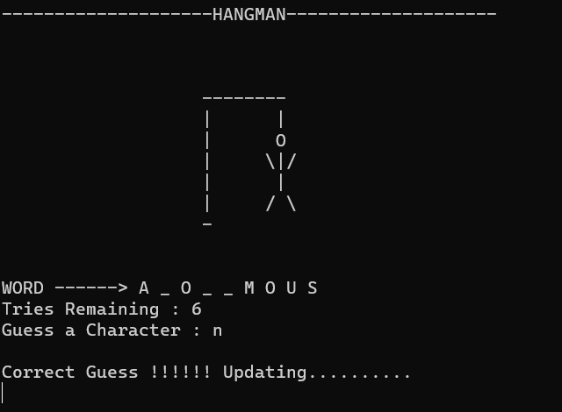

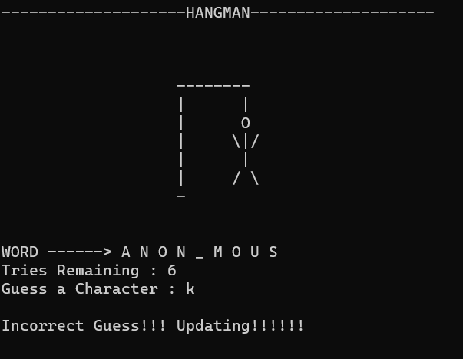

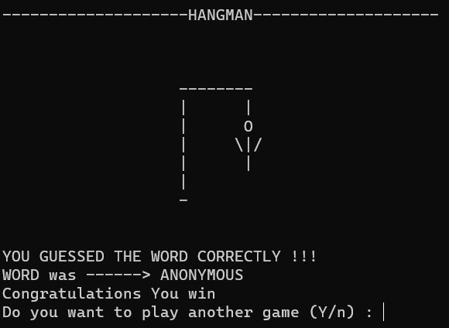

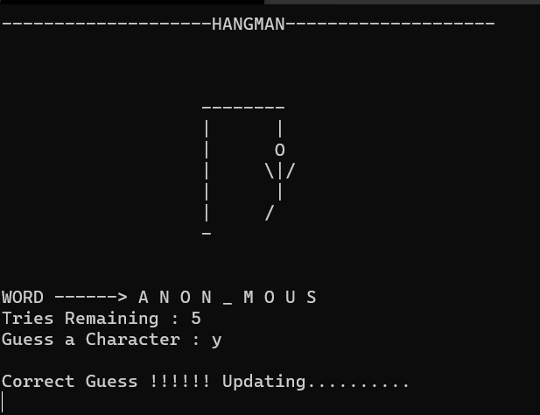

**FAIL**

