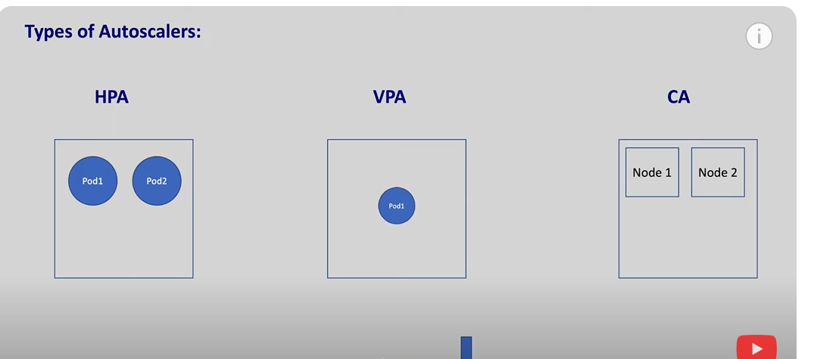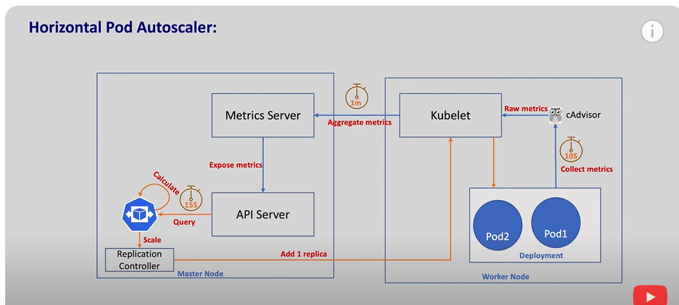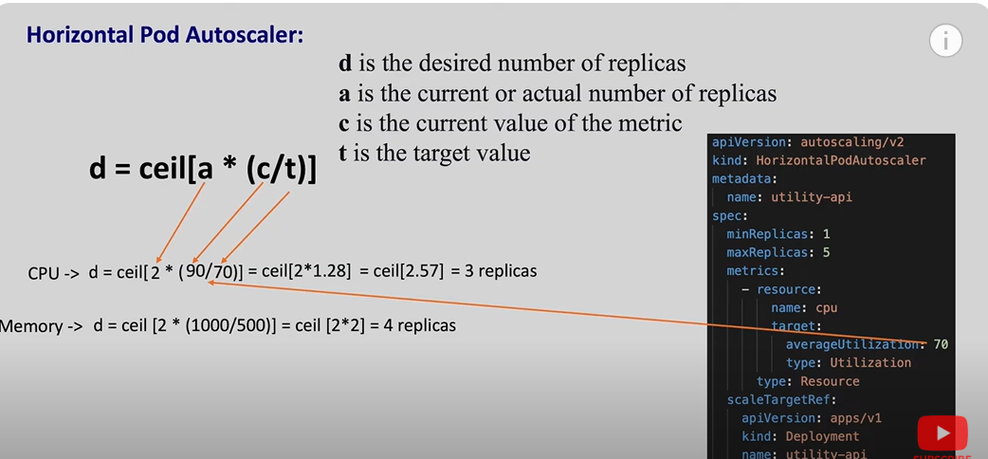

CLUSTER autoscaler:
# Variables
RESOURCE_GROUP="aks-autoscale-demo"
CLUSTER_NAME="aks-cluster"
LOCATION="eastus"

# Create Resource Group
az group create --name $RESOURCE_GROUP --location $LOCATION

# Create AKS with autoscaling enabled
az aks create \
--resource-group $RESOURCE_GROUP \
--name $CLUSTER_NAME \
--node-count 1 \
--enable-cluster-autoscaler \
--min-count 1 \
--max-count 3 \
--generate-ssh-keys

Deploy a sample app for testing:
kubectl create deployment autoscale-demo --image=nginx

# Scale to more replicas than 1 node can handle (simulate high load)
kubectl scale deployment autoscale-demo --replicas=50

kubectl get nodes -w

kubectl get pods -o wide

HPA:

Step 1: Define a Deployment with CPU and Memory Requests/Limits and also create a service
Let's start by creating a Deployment that requests both CPU and memory resources:
yaml
CopyEdit
# nginx-deployment-with-resources.yaml
apiVersion: apps/v1
kind: Deployment
metadata:
name: nginx-hpa-demo
spec:
replicas: 1
selector:
matchLabels:
app: nginx-hpa-demo
template:
metadata:
labels:
app: nginx-hpa-demo
spec:
containers:
- name: nginx
image: nginx
resources:
requests:
cpu: 100m
memory: 128Mi
limits:
cpu: 200m
memory: 256Mi
ports:
- containerPort: 80
Explanation:
- requests: The minimum amount of resources needed (used for scheduling).
- limits: The maximum amount of resources the container can use.
Apply the Deployment:
bash
CopyEdit
kubectl apply -f nginx-deployment-with-resources.yaml

Service :
# nginx-service.yaml
apiVersion: v1
kind: Service
metadata:
name: nginx-hpa-demo
spec:
selector:
app: nginx-hpa-demo
ports:
- protocol: TCP
port: 80
targetPort: 80
type: ClusterIP

📊 Step 2: Create an HPA for CPU Scaling
You can create an HPA that scales based on CPU usage:
bash
CopyEdit
kubectl autoscale deployment nginx-hpa-demo \
--cpu-percent=50 \
--min=1 \
--max=10
This means the number of pods will scale based on the CPU usage — if CPU usage exceeds 50%, Kubernetes will add more pods (up to 10).

🧠 Step 3: Create an HPA for Memory Scaling
Now, create a second HPA that scales based on memory usage:
bash
CopyEdit
kubectl autoscale deployment nginx-hpa-demo \
--metric="memory" --value=200Mi \
--min=1 \
--max=10
This will cause the deployment to scale if memory usage exceeds 200Mi.

🧪 Step 4: Trigger Load for Both Metrics
You can generate load to trigger scaling both for CPU and Memory. Here's how you can do that using busybox:
- Start the busybox pod to create CPU load:
bash
CopyEdit
kubectl run -i --tty load-generator --image=busybox /bin/sh
- Inside the busybox pod, generate CPU load:
sh
CopyEdit
while true; do wget -q -O- http://nginx-hpa-demo; done
- (Optional) If you want to also trigger memory usage, you can introduce a memory-intensive task inside the busybox pod:
sh
CopyEdit
while true; do dd if=/dev/zero of=/dev/null bs=10M; done
This will generate both CPU and memory load, causing the HPA to scale your pods.

🔍 Step 5: Monitor the HPA and Pod Scaling
You can watch the HPA and pod scaling in real-time:
- Check HPA status:
bash
CopyEdit
kubectl get hpa -w
You should see the current CPU and memory usage for scaling decisions.
- Watch the pod scaling:
bash
CopyEdit
kubectl get pods -l app=nginx-hpa-demo
You’ll see the number of pods scaling up as a result of CPU or memory pressure.

🧹 Step 6: Clean Up
Once you're done, you can delete the deployment and the HPAs:
bash
CopyEdit
kubectl delete deployment nginx-hpa-demo
kubectl delete hpa nginx-hpa-demo

📈 Bonus: Using Custom Metrics
You can also scale based on custom metrics, like the response time or number of requests. For that, you'd need to install the Custom Metrics Adapter and expose the custom metrics. Let me know if you want to explore that!

This setup allows your pods to scale based on either CPU or Memory, whichever comes first. Kubernetes will handle it automatically once the thresholds are met.
Would you like further help setting up custom metrics for more advanced scaling scenarios?
You said:
can you give me hpa yaml definition
ChatGPT said:
Certainly! Below is the HPA YAML definition that you can use to scale based on both CPU and Memory metrics in Kubernetes.
Since Kubernetes does not support multiple metrics in a single HPA directly, we'll create two separate HorizontalPodAutoscaler resources in the YAML — one for CPU and one for Memory.

🎯 HPA Definition for CPU and Memory
yaml
CopyEdit
# hpa-cpu-memory.yaml
apiVersion: autoscaling/v2
kind: HorizontalPodAutoscaler
metadata:
name: nginx-hpa-cpu
namespace: default
spec:
scaleTargetRef:
apiVersion: apps/v1
kind: Deployment
name: nginx-hpa-demo
minReplicas: 1
maxReplicas: 10
metrics:
- type: Resource
resource:
name: cpu
target:
type: Utilization
averageUtilization: 50 # Scale when CPU exceeds 50%

---
apiVersion: autoscaling/v2
kind: HorizontalPodAutoscaler
metadata:
name: nginx-hpa-memory
namespace: default
spec:
scaleTargetRef:
apiVersion: apps/v1
kind: Deployment
name: nginx-hpa-demo
minReplicas: 1
maxReplicas: 10
metrics:
- type: Resource
resource:
name: memory
target:
type: Utilization
averageUtilization: 60 # Scale when memory exceeds 60%

💡 Explanation:
- scaleTargetRef: This refers to the Deployment that we want to scale. In this case, nginx-hpa-demo is the name of the Deployment.
- minReplicas: The minimum number of pods to run.
- maxReplicas: The maximum number of pods to scale to.
- metrics:
  - The first HPA scales based on CPU utilization. When CPU utilization exceeds 50%, it will increase the number of pods.
  - The second HPA scales based on Memory utilization. When memory usage exceeds 60%, it will increase the number of pods.
- averageUtilization: This defines the target percentage of CPU or memory usage that triggers autoscaling.

🚀 Apply the YAML
Now, apply the YAML definition to your cluster:
bash
CopyEdit
kubectl apply -f hpa-cpu-memory.yaml

🧪 Trigger Load
To test the autoscaling, you can generate load as mentioned earlier using busybox:
- CPU Load:
bash
CopyEdit
kubectl run -i --tty load-generator --image=busybox /bin/sh
Inside the pod, generate CPU load:
sh
CopyEdit
while true; do wget -q -O- http://nginx-hpa-demo; done
- Memory Load:
Inside the load-generator pod, generate memory load:
sh
CopyEdit
while true; do dd if=/dev/zero of=/dev/null bs=10M; done

🔍 Monitor Scaling
To monitor the scaling behavior, use the following commands:
- Check the HPA status:
bash
CopyEdit
kubectl get hpa -w
- Check pod scaling:
bash
CopyEdit
kubectl get pods -l app=nginx-hpa-demo
You should see the pods scaling up and down as CPU or memory thresholds are met.

🧹 Clean Up
Once you're done, you can delete the HPA and the Deployment:
bash
CopyEdit
kubectl delete -f hpa-cpu-memory.yaml
kubectl delete deployment nginx-hpa-demo

🎯 Note:
- If you'd like to scale based on custom metrics (e.g., request count, response time), you will need to install the Custom Metrics Adapter.
- Make sure that the Metrics Server is running, as it provides the metrics (CPU, memory) used by HPA.
Let me know if you need further adjustments or explanations

