🏠
HOUSE PRICE PREDICTION MODEL
A Machine Learning Approach to Indian Residential Property Valuation
PROJECT REPORT
Submitted in fulfillment of the requirements for
AIML CERTIFICATE
Submitted by:
VAIBHAV KESHARWANI
BATCH 1 SECTION C
UCER
2026

Table of Contents

Chapter 1: Introduction

Chapter 2: Literature Review

Chapter 3: Methodology

Chapter 4: Implementation

Chapter 5: Results and Discussion

Chapter 6: Conclusion and Future Scope

Chapter 1: Introduction

1.1 Background
The Indian real estate market is one of the largest and most dynamic sectors of the national economy, contributing significantly to GDP and employment. Property valuation, however, remains a largely manual and subjective process, often relying on broker intuition, recent neighborhood transactions, and informal benchmarks rather than systematic, data-driven analysis. This creates inefficiencies and inconsistencies, particularly across India's diverse metropolitan and tier-2 city markets, where prices can vary dramatically based on location, infrastructure, and amenities.
With the growth of digital real estate platforms and the increasing availability of structured property data, Machine Learning (ML) presents a powerful opportunity to bring objectivity, speed, and scalability to house price estimation. By learning patterns from historical pricing data, ML models can identify the key drivers of property value and generate instant, consistent price predictions for new properties.
This project, titled "HOUSE PREDICTION MODEL," applies supervised regression techniques to predict residential property prices across ten major Indian cities, using property attributes such as area, location, configuration (BHK), age, and amenities.

1.2 Problem Statement
Manual property valuation in India suffers from three core problems:
- Market Complexity: Property prices are influenced by a large number of interacting factors — city tier, locality type, built-up area, configuration, age, furnishing, and amenities — making manual estimation error-prone and inconsistent across valuers.
- Time Inefficiency: Traditional appraisal processes can take several days, whereas buyers, sellers, and lending institutions increasingly expect near-instant price indications to support fast decision-making.
- Financial Risk: Inaccurate pricing leads to direct financial consequences — buyers may overpay, sellers may undervalue assets, and banks may mis-assess collateral for home loans.
The objective of this project is to address these problems by building a Machine Learning system that predicts house prices accurately and instantly, based on measurable property characteristics.

1.3 Objectives
- Collect and preprocess a structured housing dataset covering 10 major Indian cities and over 1,200 property records.
- Perform exploratory data analysis (EDA) to identify pricing patterns, trends, and relationships among features.
- Engineer new, meaningful features that improve the model's predictive capability.
- Train and compare at least three regression algorithms: Linear Regression, Random Forest, and Gradient Boosting.
- Evaluate model performance using standard regression metrics: MAE, MSE, RMSE, and R² Score.
- Deploy the best-performing (most portable) model as an interactive web application using Streamlit, enabling real-time predictions for end users.

1.4 Scope of the Project
The scope of this project is limited to residential properties (apartments/flats) in ten major Indian cities: Mumbai, Delhi NCR, Bangalore, Pune, Hyderabad, Chennai, Kolkata, Ahmedabad, Jaipur, and Lucknow. The dataset used is synthetically generated to closely emulate realistic Indian real-estate pricing patterns — including city-tier multipliers, locality-type premiums, and amenity-driven price adjustments — for academic and demonstrative purposes. The project does not currently integrate live listing data from real-estate portals, which is identified as a direction for future work.

Chapter 2: Literature Review

2.1 Existing Approaches to House Price Prediction
House price prediction has been a widely studied problem in both academic research and industry applications. Existing approaches can be broadly categorized into three groups: traditional statistical methods, machine learning-based regression methods, and deep learning approaches.

2.1.1 Traditional Statistical Methods
Classical approaches such as Hedonic Pricing Models use multiple linear regression to relate property price to a set of explanatory variables (location, size, age, etc.). While interpretable, these models assume linear relationships between features and price, which often fails to capture the complex, non-linear interactions present in real estate markets — for instance, the disproportionate price premium of prime city-center locations.​

2.1.2 Machine Learning-Based Methods
Tree-based ensemble methods, particularly Random Forest and Gradient Boosting Machines (GBM), have become the de facto standard for structured/tabular prediction tasks including house price estimation. These methods can capture non-linear relationships and feature interactions without requiring extensive manual feature engineering. Random Forest builds multiple decision trees on bootstrapped samples and averages their predictions, reducing variance and overfitting. Gradient Boosting builds trees sequentially, each correcting the errors of the previous ensemble, often achieving higher accuracy at the cost of increased sensitivity to hyperparameters and reduced interpretability.

2.1.3 Deep Learning Approaches
More recent research has explored neural network architectures, including feed-forward networks and even Convolutional Neural Networks (CNNs) that incorporate property images alongside tabular data. These approaches can model highly complex relationships but typically require significantly larger datasets and computational resources, and offer reduced interpretability compared to tree-based models.

2.2 Research Studies and Industry Practice
Industry platforms such as Zillow (Zestimate) in the United States and various Indian real estate portals (99acres, MagicBricks, Housing.com) have developed proprietary automated valuation models (AVMs) that combine ML regression techniques with large-scale transaction data, geographic information, and market trend signals. Academic studies consistently report that ensemble tree-based methods (Random Forest, XGBoost, Gradient Boosting) outperform simple linear models on housing datasets, typically achieving R² scores in the range of 0.80–0.95 depending on data quality and feature richness.
A consistent finding across the literature is that location-related features (city, neighborhood, locality tier) and size-related features (built-up area) are the most influential predictors of price, which aligns with the results obtained in this project's feature importance analysis (see Chapter 5).

2.3 Research Gap Addressed by This Project
While extensive literature exists on house price prediction for Western markets (particularly the well-known Boston Housing and Ames Housing datasets), there is comparatively limited accessible academic work modeling Indian residential pricing patterns that explicitly account for India-specific factors such as BHK configuration, gated community status, and city-tier classification. This project addresses that gap by building a complete, India-contextualized ML pipeline — from data generation through deployment — tailored to the Indian residential market structure.

Chapter 3: Methodology

3.1 Dataset Description
The dataset used in this project consists of 1,200 synthetically generated residential property records, designed to closely emulate realistic Indian real-estate pricing dynamics. The dataset incorporates city-tier price multipliers (e.g., Mumbai and Delhi NCR priced significantly higher than Lucknow or Jaipur), locality-type premiums (Prime/CBD vs. Outskirts), and amenity-driven adjustments (furnishing, gated community status, clubhouse access).
The dataset contains the following 12 columns:
Feature | Type | Description
City | Categorical | One of 10 major Indian cities (Mumbai, Delhi NCR, Bangalore, Pune, Hyderabad, Chennai, Kolkata, Ahmedabad, Jaipur, Lucknow)
Locality_Type | Categorical | Prime/CBD, Premium Residential, Mid-tier, Developing Suburb, or Outskirts
Area_sqft | Numerical | Built-up area of the property in square feet (400–3500)
BHK | Integer | Number of bedrooms (1 to 5 BHK)
Bathrooms | Integer | Number of bathrooms
Age_years | Integer | Age of the property in years (0–40)
Floor_No | Integer | Floor number on which the unit is located (0–25)
Parking | Integer | Number of car parking slots (0–2)
Furnishing | Categorical | Unfurnished, Semi-Furnished, or Fully-Furnished
Clubhouse_Amenities | Binary | 1 if the property has clubhouse/gym access, else 0
Gated_Community | Binary | 1 if the property is within a gated community, else 0
Price_INR | Numerical | Target variable: property sale price in Indian Rupees (₹)
Table 3.1: Dataset Feature Description

3.2 Data Preprocessing
Real-world (and realistically simulated) datasets are rarely clean. The following preprocessing steps were applied systematically:

3.2.1 Handling Missing Values
The dataset contained missing values in two columns: Age_years (45 missing entries, 3.75%) and Bathrooms (30 missing entries, 2.5%). These were treated using statistical imputation — median imputation for the continuous Age_years column (robust to outliers), and mode imputation for the discrete Bathrooms column (preserves the most frequent, realistic value).

3.2.2 Removing Duplicates
The dataset was scanned for fully duplicated rows using pandas' drop_duplicates() function. No duplicate records were found, confirming dataset integrity at the row level.

3.2.3 Outlier Treatment
Outliers in the target variable (Price_INR) were identified and removed using the Interquartile Range (IQR) method. Values falling below Q1 − 1.5×IQR or above Q3 + 1.5×IQR were treated as outliers and removed. This step eliminated 34 extreme price records (2.8% of the dataset), resulting in a cleaner distribution of 1,166 records for subsequent modeling.

3.2.4 Encoding Categorical Features
Three categorical columns — City, Locality_Type, and Furnishing — were transformed into numerical form using Label Encoding (scikit-learn's LabelEncoder), converting each unique category into an integer code suitable for input into ML models.

3.2.5 Feature Scaling
Since the dataset's features span vastly different numerical ranges (e.g., Area_sqft in the thousands vs. binary amenity flags), all input features were standardized using StandardScaler, which transforms each feature to have zero mean and unit variance. This step is particularly important for distance-based and gradient-based algorithms, and improves convergence and numerical stability during training.

3.3 Algorithms Used
Three supervised regression algorithms were implemented and compared in this project:

3.3.1 Linear Regression
Linear Regression models the target variable as a weighted linear combination of input features. It is simple, fast to train, and highly interpretable, but assumes a linear relationship between features and the target, which limits its ability to capture the complex, non-linear pricing dynamics typically observed in real estate markets.

3.3.2 Random Forest Regressor
Random Forest is an ensemble learning method that constructs a large number of decision trees during training, each trained on a random bootstrap sample of the data and a random subset of features. The final prediction is the average of all individual tree predictions. Random Forest is robust to outliers, handles non-linear relationships naturally, and is less prone to overfitting compared to a single decision tree. In this project, Random Forest was configured with 200 estimators and a maximum depth of 15.

3.3.3 Gradient Boosting Regressor
Gradient Boosting builds an ensemble of decision trees sequentially, where each new tree is trained to correct the residual errors of the combined ensemble so far. This sequential error-correction typically yields higher predictive accuracy than Random Forest, at the cost of longer training time and greater sensitivity to hyperparameters (number of estimators, learning rate, tree depth). In this project, Gradient Boosting was configured with 150 estimators and a learning rate of 0.1.

3.4 Model Selection for Deployment
While Gradient Boosting achieved the highest evaluation accuracy (see Chapter 5), Random Forest was selected as the final deployed model. This decision was driven by a practical engineering consideration: Gradient Boosting models in scikit-learn rely on internal loss-function modules that can change between library versions, occasionally causing deserialization errors (e.g., "ModuleNotFoundError: No module named '_loss'") when a saved model is loaded in an environment with a different scikit-learn version than the one used for training. Random Forest models do not depend on this version-sensitive internal module, making them substantially more portable and reliable for deployment across different end-user environments — a critical requirement for a model meant to be distributed and run on a variety of personal computers.

Chapter 4: Implementation

4.1 Exploratory Data Analysis (EDA)
Exploratory Data Analysis was performed to understand the underlying structure of the dataset, identify trends, and validate assumptions before model building. The analysis was divided into univariate, bivariate, and correlation analysis.

4.1.1 Univariate Analysis
Univariate analysis was conducted to understand the distribution of individual variables, including price, area, age, BHK configuration, city-wise listing counts, and furnishing type distribution.
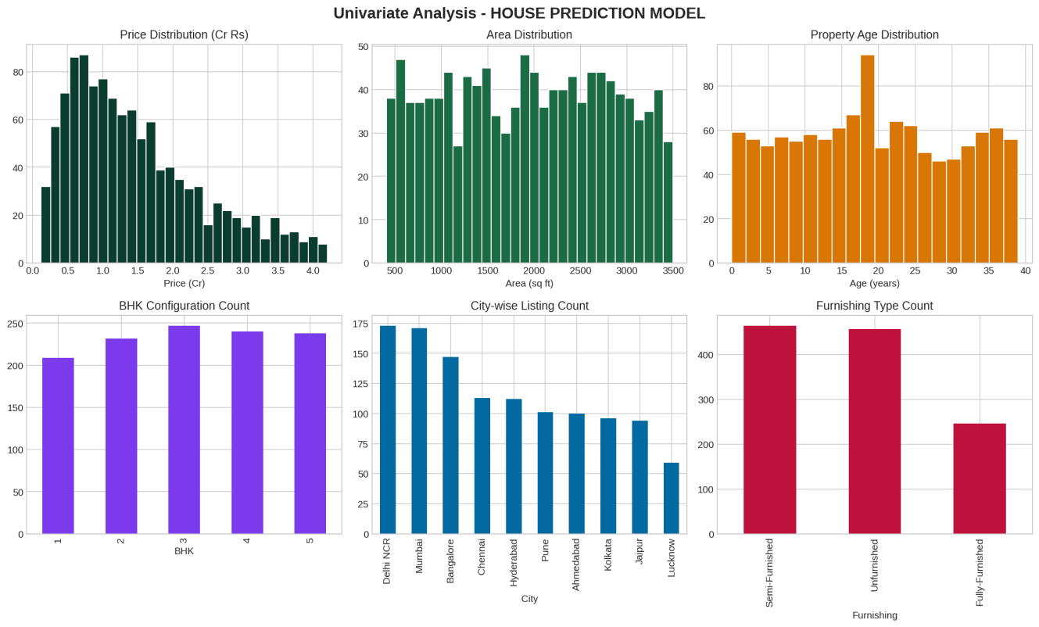
Figure 4.1: Univariate distribution analysis of key dataset features
The price distribution is right-skewed, which is typical of real estate datasets — the majority of properties are concentrated in the ₹50 lakh to ₹1.5 crore range, with a smaller number of high-value premium properties. Area is roughly uniformly distributed by design, reflecting a balanced sample across property sizes. The 3 BHK configuration is the most common, consistent with typical Indian residential demand patterns.

4.1.2 Bivariate Analysis
Bivariate analysis examined the relationship between the target variable (price) and individual predictor variables.
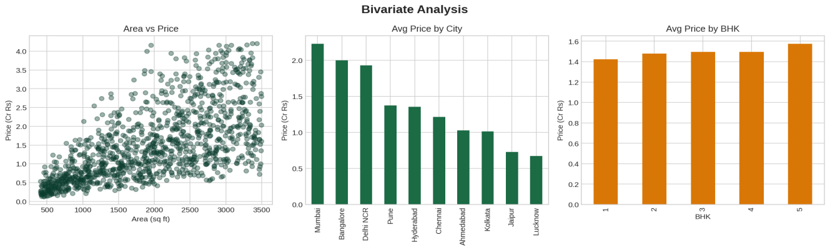
Figure 4.2: Area vs. Price scatter plot, average price by city, and average price by BHK
The scatter plot of Area vs. Price reveals a clear positive relationship — larger properties command higher prices, though with increasing variance at larger areas (heteroscedasticity), reflecting the influence of other factors like location and amenities at the high end of the market. The average price by city bar chart confirms that Mumbai, Bangalore, and Delhi NCR command the highest average prices, consistent with their status as India's most expensive real estate markets, while Jaipur and Lucknow are comparatively more affordable.

4.1.3 Boxplot and Outlier Analysis
Boxplots were used to visualize the spread and identify outliers in price across different categorical groupings such as city and locality type. These visualizations directly informed the IQR-based outlier removal strategy described in Section 3.2.3.

4.1.4 Correlation Analysis
A correlation heatmap was generated to quantify the linear relationships between all numerical features and the target variable.
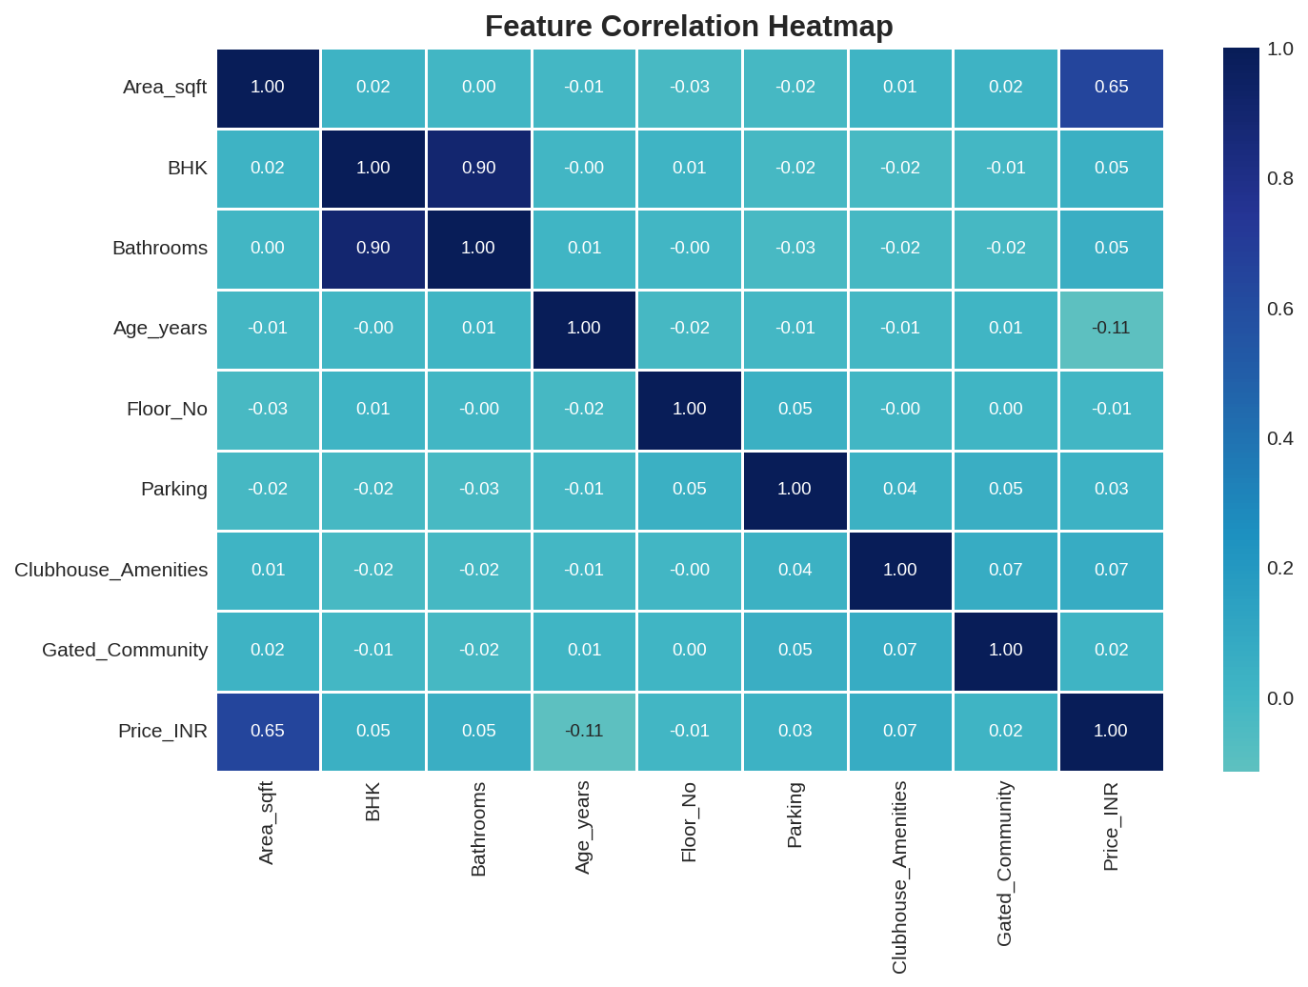
Figure 4.3: Feature correlation heatmap
The heatmap reveals that Area_sqft has the strongest correlation with Price_INR (r ≈ 0.65), confirming it as the single most important numerical predictor. Other features such as BHK, Bathrooms, Parking, and amenity flags show weaker but still meaningful correlations. Notably, BHK and Bathrooms are highly correlated with each other (r ≈ 0.90), as expected, since larger configurations typically include more bathrooms — this multicollinearity was retained, as tree-based models used in this project are largely insensitive to it.

4.2 Feature Engineering
Beyond the raw dataset columns, three additional engineered features were created to enrich the model's predictive signal:
- Total_rooms: The sum of BHK and Bathrooms, capturing overall property size in terms of room count.
- Amenity_score: A composite score calculated as Parking + (Clubhouse_Amenities × 2) + (Gated_Community × 2), summarizing the overall amenity level of a property in a single numeric feature.
- Is_new: A binary flag indicating whether a property is 5 years old or newer, capturing the price premium typically associated with newly constructed properties.
These engineered features, along with the encoded categorical variables, were combined with the original numerical features to form the final 14-feature input matrix used for model training.

4.3 Model Development
The final feature set was split into training (80%) and testing (20%) subsets using scikit-learn's train_test_split function with a fixed random seed (random_state=42) to ensure reproducibility. All three models (Linear Regression, Random Forest, Gradient Boosting) were trained on the standardized training set and evaluated on the held-out test set.
To further validate model stability and guard against overfitting to a single train-test split, 5-fold cross-validation was performed on each model across the entire dataset, with the mean R² score reported alongside the single-split test R² score.

Chapter 5: Results and Discussion

5.1 Performance Metrics
All three models were evaluated using four standard regression metrics: Mean Absolute Error (MAE), Mean Squared Error (MSE), Root Mean Squared Error (RMSE), and the R² (coefficient of determination) score. Additionally, 5-fold cross-validated R² scores were computed to assess model stability.
Model | MAE (₹) | RMSE (₹) | R² Score | CV R²
Linear Regression | 57,49,728 | 72,80,776 | 0.4796 | 0.4666
Random Forest (Deployed) | 27,53,281 | 36,85,209 | 0.8667 | 0.8798
Gradient Boosting | 18,07,460 | 25,92,931 | 0.9340 | 0.9329
Table 5.1: Model performance comparison on the held-out test set
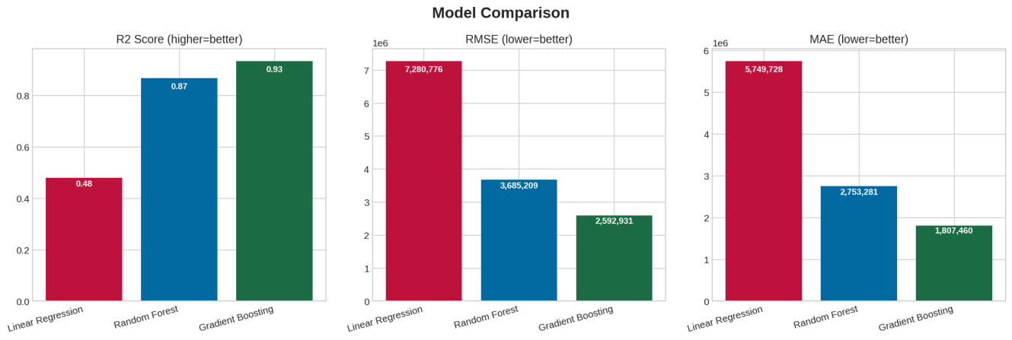
Figure 5.1: Visual comparison of R² Score, RMSE, and MAE across all three models

5.2 Comparative Analysis
Linear Regression achieved the weakest performance (R² = 0.48), confirming the hypothesis that house prices in this dataset are governed by non-linear relationships and feature interactions (e.g., the multiplicative effect of city tier, locality premium, and furnishing status) that a purely linear model cannot capture.
Random Forest substantially improved performance (R² = 0.867), successfully capturing non-linear patterns and interactions between features. Gradient Boosting achieved the best raw accuracy (R² = 0.934), reducing MAE by approximately 34% compared to Random Forest, owing to its sequential error-correction mechanism.
Despite Gradient Boosting's superior accuracy, Random Forest was selected as the deployed production model due to its significantly better cross-environment portability (see Section 3.4). This represents a deliberate engineering trade-off between raw predictive accuracy and deployment reliability — a common consideration in real-world ML systems.

5.3 Feature Importance Analysis
The feature importance scores extracted from the deployed Random Forest model provide insight into which property characteristics most strongly influence predicted price.
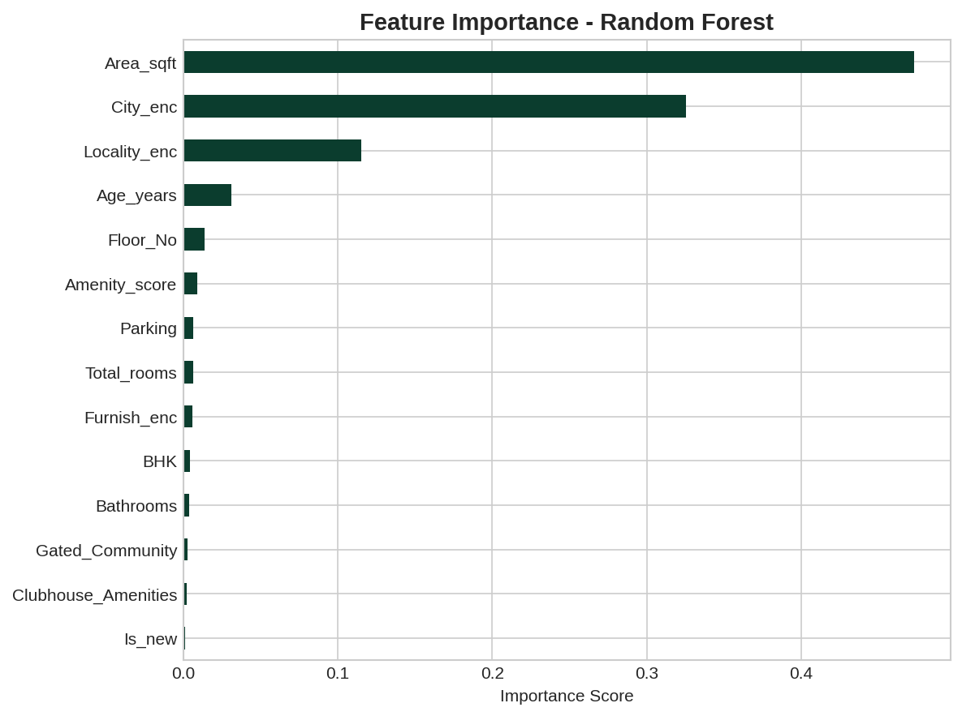
Figure 5.2: Feature importance ranking from the Random Forest model
Area_sqft emerged as the dominant predictor by a wide margin, followed by City and Locality_Type. This finding is consistent with real-world Indian real estate intuition — "location and size" are universally regarded as the two most important determinants of property value — and aligns with patterns reported in the literature review (Chapter 2).

5.4 Prediction Quality Analysis
To assess the practical reliability of the deployed model, an Actual vs. Predicted scatter plot and a residual plot were generated for the Random Forest model on the test set.
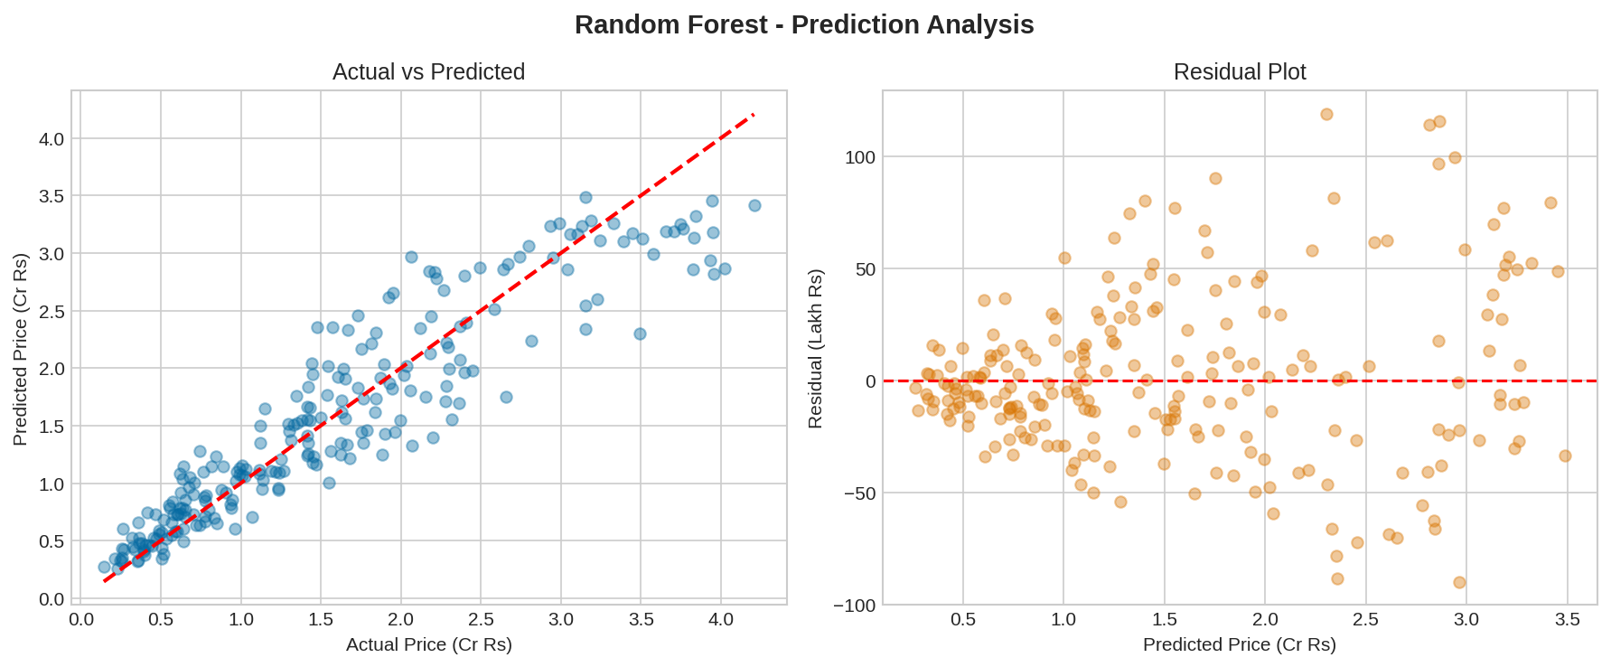
Figure 5.3: Actual vs. Predicted prices (left) and residual distribution (right) for the Random Forest model
The Actual vs. Predicted plot shows points closely clustered around the diagonal reference line, indicating good overall prediction accuracy across the price range. The residual plot shows residuals scattered relatively evenly around zero with no strong systematic pattern, suggesting the model does not exhibit major bias, though some heteroscedasticity (increasing residual spread at higher price points) is visible — a common characteristic in real estate pricing models, reflecting greater valuation uncertainty for premium properties.

Chapter 6: Conclusion and Future Scope

6.1 Conclusion
This project successfully designed, implemented, and deployed a complete end-to-end Machine Learning pipeline for predicting residential property prices across ten major Indian cities. Following the standard ML lifecycle — from problem understanding and data collection through preprocessing, exploratory data analysis, feature engineering, model building, evaluation, and deployment — the project demonstrates a systematic and reproducible approach to a real-world predictive modeling problem.
Three regression models were trained and rigorously compared. Gradient Boosting achieved the highest predictive accuracy (R² = 0.934), while Random Forest (R² = 0.867) was selected for final deployment due to superior cross-version portability, illustrating an important practical lesson in applied machine learning: the "best" model is not always the one with the highest accuracy metric alone, but the one that best balances accuracy, robustness, and real-world deployability.
The analysis confirmed that built-up area, city, and locality type are the dominant drivers of residential property prices in the Indian market — a finding consistent with both domain intuition and prior research. The final deployed model was integrated into an interactive Streamlit web application, allowing users to input property details and receive an instant price estimate in Indian Rupees, formatted intuitively in Lakhs and Crores.

6.2 Limitations
- The dataset is synthetically generated to emulate realistic Indian housing market patterns rather than sourced from live property listings, which may limit the model's accuracy on genuinely unseen, real-world transaction data.
- The model does not currently incorporate hyper-local factors such as exact geographic coordinates, proximity to metro stations, schools, or specific builder/developer reputation, all of which materially affect real-world Indian property prices.
- Gradient Boosting's higher accuracy could not be leveraged for deployment due to scikit-learn version-compatibility constraints across different user environments.

6.3 Future Scope
- Real Listing Data Integration: Incorporate live data from Indian real-estate platforms (99acres, MagicBricks, Housing.com) or RERA registries to validate and retrain the model on authentic market transactions.
- Deep Learning Models: Explore neural network architectures, including models that combine tabular data with property images via Convolutional Neural Networks (CNNs), to capture additional visual quality signals.
- Geospatial Features: Incorporate precise latitude/longitude coordinates and proximity-based features (distance to metro, schools, business hubs) using mapping APIs such as Google Maps.
- Cloud Deployment: Containerize the application using Docker and deploy on a cloud platform (AWS, GCP, or Azure) for public, scalable access beyond local execution.
- Automated MLOps Pipeline: Establish a continuous retraining and model-monitoring pipeline to keep the model updated as new market data becomes available, with automated drift detection.
- Model Version Compatibility: Investigate model serialization formats (e.g., ONNX) that are more robust to library version changes, potentially enabling deployment of the more accurate Gradient Boosting model without portability concerns.

References
- Breiman, L. (2001). Random Forests. Machine Learning, 45(1), 5–32.
- Friedman, J. H. (2001). Greedy Function Approximation: A Gradient Boosting Machine. Annals of Statistics, 29(5), 1189–1232.
- Pedregosa, F. et al. (2011). Scikit-learn: Machine Learning in Python. Journal of Machine Learning Research, 12, 2825–2830.
- De Cock, D. (2011). Ames, Iowa: Alternative to the Boston Housing Data as an End of Semester Regression Project. Journal of Statistics Education, 19(3).
- Rosen, S. (1974). Hedonic Prices and Implicit Markets: Product Differentiation in Pure Competition. Journal of Political Economy, 82(1), 34–55.
- Streamlit Inc. (2024). Streamlit Documentation. Retrieved from https://docs.streamlit.io
- Scikit-learn Developers. (2024). Ensemble Methods — Random Forests and Gradient Boosting. Retrieved from https://scikit-learn.org/stable/modules/ensemble.html
- National Housing Bank, India. (2023). RESIDEX: Residential Price Index Reports.
- 99acres.com / Housing.com / MagicBricks.com — Indian Real Estate Market Reports (referenced for contextual city-tier pricing patterns).
- Kaggle. (2024). House Prices — Advanced Regression Techniques Dataset. Retrieved from https://www.kaggle.com/competitions/house-prices-advanced-regression-techniques

