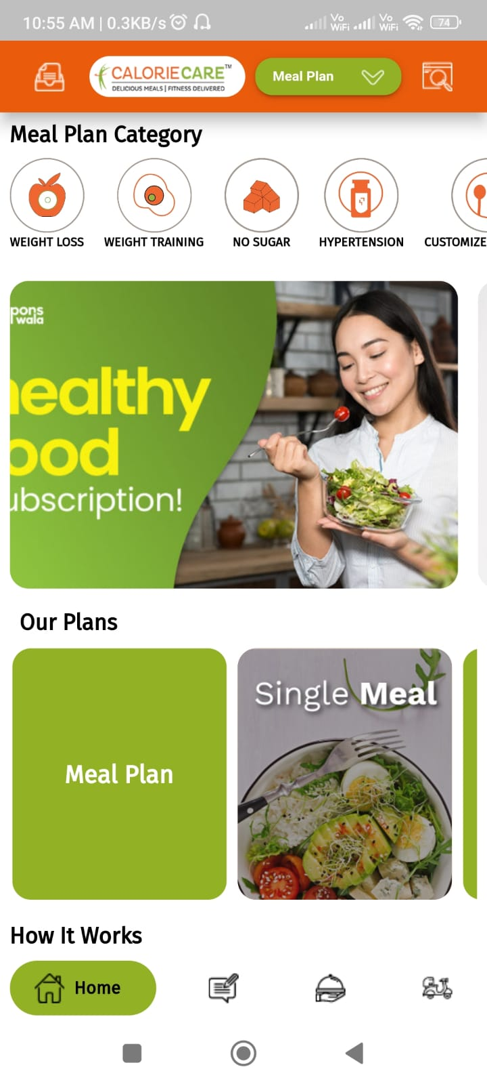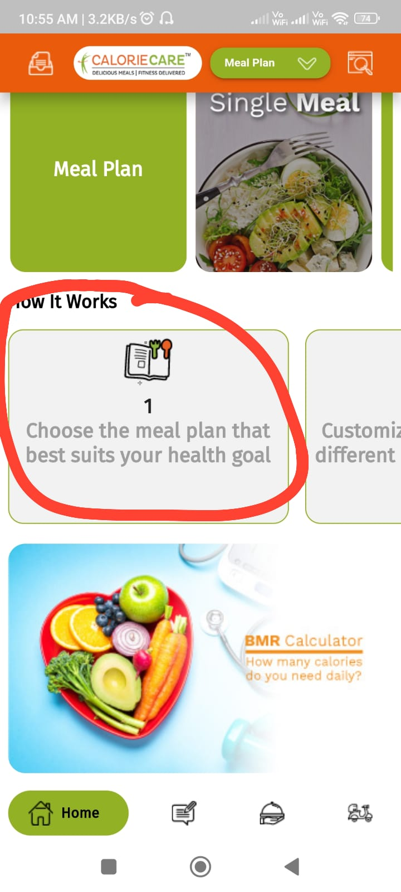-

Home page alignment between the tabs

How it works- change the look

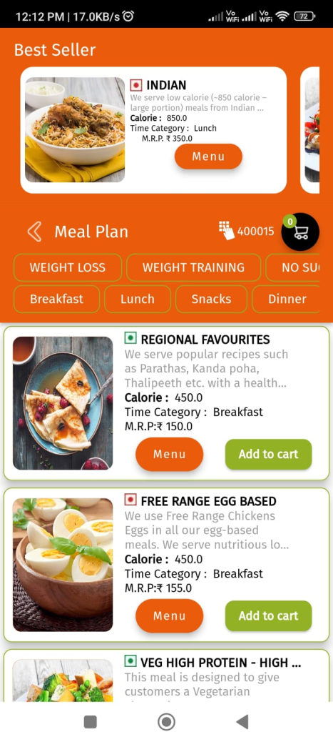

Once customer select pincode it does not take customer to cart page

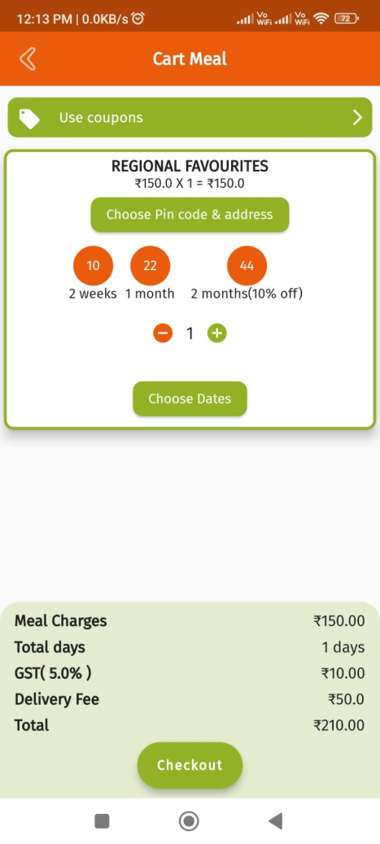

Address pop up rework

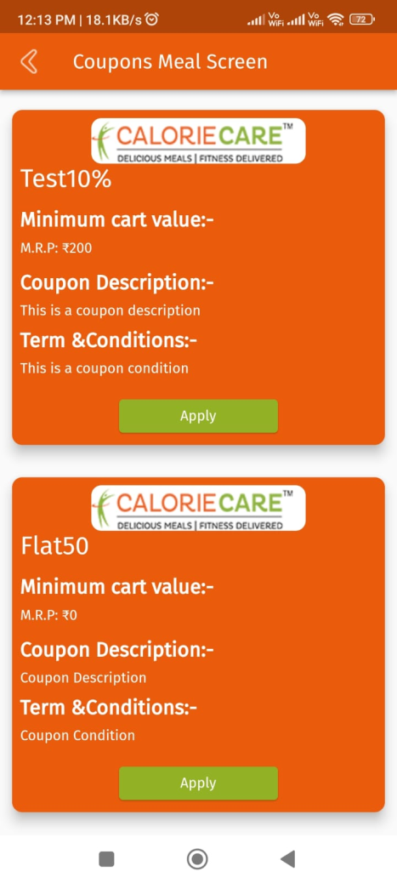

Coupon code page rework

Need to change the UI-UX of the user app, basically it shld be very prices and less click for order process till payment