Executive Summary
Total Matches: 1024
Total Runs Scored: 305093
Total Boundaries (4s & 6s): 39397
Top 10 Batsmen by Total Runs
1. Batsman ID 49752 – 7263 runs
2. Batsman ID 15887 – 6617 runs
3. Batsman ID 48739 – 6397 runs
4. Batsman ID 48405 – 6211 runs
5. Batsman ID 15716 – 5528 runs
6. Batsman ID 46533 – 5162 runs
7. Batsman ID 7593 – 5082 runs
8. Batsman ID 7568 – 4965 runs
9. Batsman ID 8742 – 4952 runs
10. Batsman ID 8813 – 4516 runs

Team Performance Analysis
Capitals: Total Runs = 11737, Average Runs/Match = 152.43
Chargers: Total Runs = 10885, Average Runs/Match = 145.13
Daredevils: Total Runs = 23011, Average Runs/Match = 142.93
Guj Lions: Total Runs = 4627, Average Runs/Match = 154.23
KKR: Total Runs = 34636, Average Runs/Match = 146.14
Kings XI: Total Runs = 28496, Average Runs/Match = 149.98
Kochi: Total Runs = 1758, Average Runs/Match = 125.57
Mumbai: Total Runs = 37475, Average Runs/Match = 151.72
Punjab Kings: Total Runs = 6668, Average Runs/Match = 158.76
RCB: Total Runs = 35750, Average Runs/Match = 148.96
Royals: Total Runs = 30507, Average Runs/Match = 148.81
Sunrisers: Total Runs = 24697, Average Runs/Match = 148.78
Super Giants: Total Runs = 4731, Average Runs/Match = 157.70
Super Kings: Total Runs = 34325, Average Runs/Match = 153.92
Supergiant: Total Runs = 2370, Average Runs/Match = 148.12
Supergiants: Total Runs = 1962, Average Runs/Match = 140.14
Titans: Total Runs = 5418, Average Runs/Match = 164.18
Warriors: Total Runs = 6040, Average Runs/Match = 134.22

Top 10 Run Scorers – Bar Chart
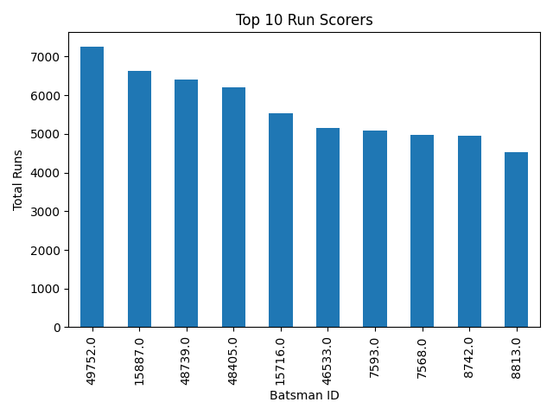

Dismissal Types – Pie Chart
